TUMS Email Administration v1.0 Installation Guide Manual

1. Installing and Configuring MySQL

1.1. Installing MySQL

1.2. Testing your installation

1.3 Configuring Your Installation

1.4. Setting up Users and Privileges

1.5. Creating a DB from DB script

2. Installing Java

3. Installing Apache Tomcat

3.1. Installing Tomcat

3.2. Configuring Environment

3.3. Testing Tomcat

3.4. Configuring server.xml file and Setting up Connection Pool

3.5. Copying required files to tomcat conf/lib directory#

3.6. Setting tomcat as a service

3.7. Installing Tums Email Administration Web Application

1. Installing and Configuring MySQL

1.1. Installing MySQL

1.1.1. Installing with windows

This MySQL installation guide is for Windows 95, 98, 2000, NT, XP, and .NET 2003. For all other versions of Windows, please refer to the source Web site at www.mysql.com

Proceed with the following steps to install MySQL:

- Visit source Web site, www.mysql.com, and click “downloads” on the navigation bar near the top of the page.

- Scroll down to the latest stable version of MySQL for Windows, and click that link.

- Scroll down to the Windows section of the downloadable files, and click Select a Mirror.

- Find a mirror and click to download (you may choose either HTTP or FTP to download).

- Unzip the file to a temporary directory of your choice.

- Click setup.exe to run the installation program. You will see the first of the Installation Wizard screens.

- Click Next to display the informational screen.

- We highly recommend that you read this screen before you continue.

- Click Next, which brings you to the Choose Destination Location screen.

- If the default directory is acceptable, simply click Next; otherwise, click Browse and select a different destination.

- Click Next.

- The next screen allows you to customize your installation; typical installation is sufficient for most users.

- Click the setup type you prefer, and click Next to begin the installation.

- After installing the appropriate files, the final screen will simply indicate the installation is complete. Click Finish to end the wizard.

1.1.2. Installing with Linux

The followings are the steps to install MySQL for a Linux system:

- Visit MySQL Web site (www.mysql.com) and download the latest stable version of the MySQL database server for Linux.

- The link for this file is most likely located at the bottom under the heading Source Downloads.

- Grab the tarball, named something along the lines of mysql-4.0.x.tar.gz.

- Open a console window and change the directory (cd) to the folder where you downloaded the tarball.

- If there isn’t a user on the system dedicated to run the MySQL daemon (typically mysql), you’ll need to create one. To do this, in the console, enter the following commands:

  - groupadd mysql
  - useradd –g mysql mysql

- Extract the tarball, and change to the directory it creates:

  - tar –xzf mysql-VERSION.tar.gz
  - cd mysql-VERSION

* VERSION is the (sub) version of the mysql source tarball you downloaded, ‘0.15a’

- Next, configure the source this way:

  - ./configure --prefix=/usr/local/mysql

* Using the --prefix switch tells the installer where to put the mysql libraries and binaries after they’re built.

- Compile the source:

  - make

- Install the libraries and binaries.

  - make install

- Note that you will need to be logged in as superuser (root) to perform this step and the following steps in the MySQL installation.

- If this is the first time MySQL has been installed on your machine (in other words, not an upgrade), run this script to install the initial database/tables:

  - scripts/mysql_install_db

- Fix permissions on installed files, and copy over the default configuration file.

  - chown –R root /usr/local/mysql
  - chown –R mysql /usr/local/mysql/var
  - chgrp –R mysql /usr/local/mysql
  - cp support-files/my-medium.cnf /etc/my.cnf

- Any changes you wish to make to customize MySQL should be made in this file.

- Start the MySQL daemon:

  - /usr/local/mysql/bin/mysqld_safe --user=mysql &

- You’ll probably want to add the previous command to whatever facilities are available to automatically start the daemon at boot. This varies by OS, so you’ll need to find out what works on your system. Here is one easy way to add this that works with most systems (but may not be the “best” way):

  - echo ‘/usr/local/mysql/bin/mysqld_safe --user=mysql &’ >> /etc/rc.local

1.2. Testing your installation

As before, it’s a good idea to test your installation. You can do this from a DOS prompt so that you can see any error message encountered by your MySQL server.

Follow these steps to test your installation:

- At the DOS prompt, change directories until you reach the MySQL server main directory (the default is c:\mysql\bin\).

- According to your O.S. type, do the following:

For Windows 95/98/Me, type
"c:\mysql\bin>mysqld"

For Windows 2000/XP/NT, type
"C:\>C:\mysql\bin\mysqld --install"

- You should see a “Service successfully installed” message.

- To start the MySQL server, type the following:

c:\>NET START MySQL

- Your screen will look like the one shown in figure below:

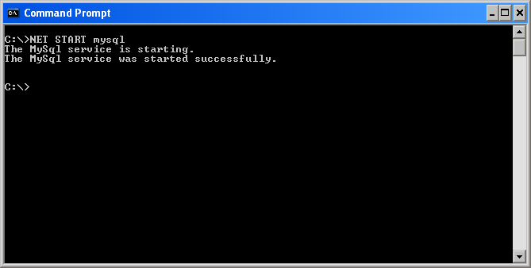

- To stop the server from running, type the following:

c:\>NET STOP MySQL

- Let’s test to make sure your MySQL server is running. While there are many possible ways to test the server, to keep things simple, let’s use the following:

C:\>c:\mysql\bin\mysql test

- Your screen should look something like the one shown in figure below
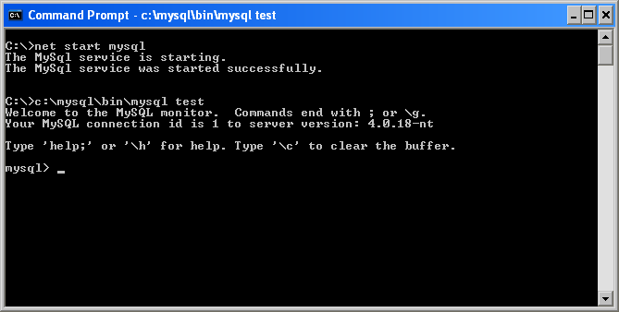

- To return to the DOS prompt, enter the following:

mysql> exit
OR
mysql> quit

- To shut down the MySQL service, type:

C:\>c:\mysql\bin\mysqladmin -u root shutdown

- It’s time to configure your system to improve security, set up some user permissions, and alter your settings according to your preferences.

1.3 Configuring Your Installation

Before you configure any of your settings, start the MySQL service again.

- Enter the following:

c:\>c:\mysql\bin\mysql mysql

- Now your screen should look like figure below:
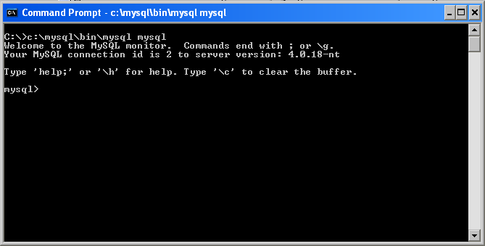

- By default, MySQL on Windows sets up all users with all privileges. In order to change this, enter the following:

mysql> DELETE FROM user WHERE Host=’localhost’ AND User=’’;

- You will get a response from MySQL that states:

Query OK, 1 row affected (x.yz sec)

* The time it takes to process the query may differ based on the speed of your computer, but the important thing here is that you get the “OK” from the MySQL gods.

- Then exit MySQL console and reset the users by entering the following:

mysql> quit
c:\> c:\mysql\bin\mysqladmin reload
c:\> c:\mysql\bin\mysqladmin -u root password choose_a_password

- Insert whatever password you would like for your root access.

- To reconnect to the server, try your new password:

C:\> c:\mysql\bin\mysql -h localhost -uroot –p

- You will be prompted for your password; in this case, we entered “mysqlpass,” but you should enter whatever you entered in the previous step; you should then see the prompt shown in Figure 1-8.

1.4. Setting up Users and Privileges

You should create a user with privileges to access mail db - where all user and conference and etc. are going to be stored. We are going to do this by running the sequence of commands listed below in mysql console. First run mysql:

/usr/local/mysql/bin/mysql (in linux)

OR

C:\> c:\mysql\bin\mysql -h localhost -u root –p (in windows)

And then enter these commands in mysql consule:

mysql> create database mail;
>Query OK, 1 row affected (0.01 sec)

mysql> grant INSERT,SELECT on root.* to tmail@localhost;
>Query OK, 0 rows affected (0.02 sec)

mysql> SET PASSWORD FOR tmail@localhost=PASSWORD('new_password');
>Query OK, 0 rows affected (0.25 sec)

mysql> grant CREATE, INSERT, SELECT, DELETE, UPDATE on mail.* to tmail@localhost;
>Query OK, 0 rows affected (0.02 sec)

mysql> grant CREATE, INSERT, SELECT, DELETE, UPDATE on mail.* to tmail;
>Query OK, 0 rows affected (0.02 sec)

mysql> exit
>Bye

Replace ‘new_password’ with a good password. It will be the tmail’s user account password to access mail DB and we are going to set it in tomcat server.xml file so our program can get authorized for accessing the mail DB.

1.5. Creating a DB from DB script

2. Installing Java

Download Java. Point your web browser to http://java.sun.com/j2se/. You’re looking for the latest version of the “java2 SDK, Standard Edition”, disregarding any beta versions that may be available. But we strongly recommend you to download the 1.4.x version

Install Java. Execute the file you’ve downloaded. J2SE version 1.4 on windows takes the "C:\j2sdk1.4.x_xx" for default installation directory, but feel free to install wherever you want. But substitute your custom path for C:\j2sdk1.4.x_xx wherever you see in this document.

3. Installing Apache Tomcat

You’ve now got Java, but for running the web applications, we’ll need one more tool: Tomcat. Tomcat is what’s known as a servlet container. In the Java world, a servlet container is responsible for receiving web requests and passing them to Java web application.

3.1. Installing Tomcat

Download Tomcat. Tomcat’s home is http://jakarta.apache.org/tomcat/ Surf on over there and grab the latest version of Tomcat 5.x

Install or Extract Tomcat. You may extract or install it (if you have got the windows installer version) into any location you desire.

3.2. Configuring Environment

You need to set the servlet.jar file in your CLASS_PATH; this file is included in "Tomcat \common\lib" directory.

For Linux version you need to set JAVA_HOME to where you had installed Java (for example: /usr/local/j2sdk_1.4.08) and then export it. You may edit the shell start-up script, .bash.rc file if you use shell or .tcshrc if you use tcsh and add these lines:

JAVA_HOME=/usr/local/j2skd_x_x_xx
export JAVA_HOME
CLASSPATH=/usr/local/Jakarta-tomcat-5.xx.xx/common/lib/servlet.jar:.
export CLASSPATH

* (You will need to start a new shell for these changes to take effect)

Also there are some other environment variables that are not necessary to be set by users with the current versions of Tomcat; one of them is CATALINA_HOME, the path to home directory of tomcat.

3.3. Testing Tomcat

On windows, the command to run Tomcat is:

c:\jakarta-tomcat-5.x-xx\bin\startup.bat

On Linux, the command is:

/usr/local/Jakarta-tomcat-5.x-xx/bin/startup.sh

Once Tomcat is up and running, open your favourite web browser and go to http://localhost:8080/. You should see something like the following page:

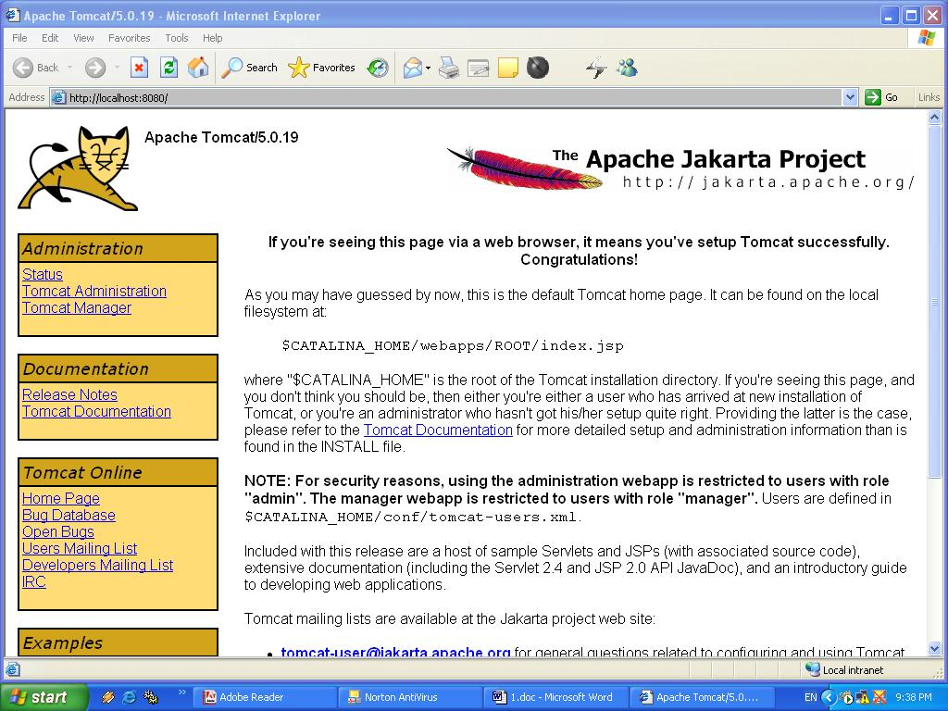

3.4. Configuring server.xml file and Setting up Connection Pool

Now we need to configure our web context, set its root directory and connection pool settings.

Open server.xml file, in "conf" directory of tomcat home directory (for example: C:\Apache Software Foundation\Tomcat 5.0\conf) and scroll down until you get to ‘</host> just before that line paste the lines below:

<Context path="/tumsmail" docBase="/usr/local/jakarta-tomcat-5.0.27/webapps/tumsmail" debug="0">
<Resource name="jdbc/TestDB" auth="Container"
type="javax.sql.DataSource"/>
<ResourceParams name="jdbc/TestDB">
<parameter>
<name>username</name>
<value>tmail</value>
</parameter>
<parameter>
<name>password</name>
<value>baran1</value>
</parameter>
<parameter>
<name>driverClassName</name>
<value>org.gjt.mm.mysql.Driver</value>
</parameter>
<parameter>
<name>url</name>
<value>jdbc:mysql://194.225.62.83:3306/mail?autoReconnect=true</value>
</parameter>
</ResourceParams>
</Context>

3.5. Copying required files to tomcat conf/lib directory

Copy all the files in the VideoConf CD from /tomcatlibs directory to (tomcat home)/common/lib (example of full path: C:\Apache Software Foundation\Tomcat 5.0\common\lib) "You should consider that the directory separator is "\" in Windows and is "/" in Linux"

3.6. Setting tomcat as a service

If you have downloaded Windows Installer version of mysql file then the service will automatically be set in windows services list. You may go to Control Panel, select Administrator tools and services and find Apache Tomcat service there. But, if you have downloaded the tar.gz file and just extracted it you need to write a service script as mentioned below:

Create a new file in /etc/rc.d/init.d directory and name it tomcat; edit it as shown below:

#!/bin/sh
#
# chkconfig:
# description: Start up the Tomcat servlet engine.

# Source function library.
. /etc/init.d/functions

RETVAL=$?
JAVA_HOME=/usr/local/j2sdk1.4.2_05
export JAVA_HOME
CATALINA_HOME="/usr/local/jakarta-tomcat-5.0.28"

case "$1" in
start)
if [ -f $CATALINA_HOME/bin/startup.sh ];
then
echo $"Starting Tomcat"
$CATALINA_HOME/bin/startup.sh
fi
;;
stop)
if [ -f $CATALINA_HOME/bin/shutdown.sh ];
then
echo $"Stopping Tomcat"
$CATALINA_HOME/bin/shutdown.sh
fi
;;
*)
echo $"Usage: $0 {start|stop}"
exit 1
;;
esac

exit $RETVAL

Now we need to create some link files in order to make the service started in linux start up on different run levels.

cd /etc/rc5.d
sudo ln -s ../init.d/tomcat S71tomcat

cd /etc/rc3.d
sudo ln -s ../init.d/tomcat S71tomcat

3.7. Installing Tums Email Administration Web Application

Now you just need to copy the tumsmail directory from the VideoConf CD anywhere you like to but remember to set the PATH of your Web Context in the server.xml file located in conf directory of tomcat home, where you copy the tumsmail directory.

