**Philosophy:**  
- Have the big picture of asset classes worldwide

* Don’t display something static, but dynamic, ALWAYS, for all the WS

**MARKETS**

Track the latest recent price movements across equities, bonds, forex, crypto, and commodities.

(written successively as css/js effect) + In the future add link to directly go to the sections  
  
**Global Equity Markets**

**Data needed:**

* Country and Index/ETF name
* For each periodicity:
  + Latest available Price
  + Oldest Price
* When it was fetched from yfinance

**Data calculated:**

* For each periodicity:
  + Chg. %
  + Difference of price

You click here to choose periodicity

**Data needed:**

* Time for each city
* Date for each city
* Stock Market opening and closing time
* Calendar for known closed dates / or use an API to or code to know opening state

(all adjustable for different periodicity (1D, 1W, 1M, 1Y, 10Y))

**All Countries, 1D Performance**

World Map

left

right

**US**

↗ **S&P 500 Index;** 5,995.56; +43.44; +3.40%

As of 13:00 GMT, Mon 11 Nov

When I hover a country (OS: I can use custom map with each square representing GDP)

Corresponds to the time where the latest data get captured

Developed vs Emerging vs World, 1M Performance Risk and Return, 1M

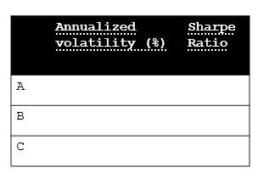

**MSCI World**

**iShares xxx ETF;** 5,995.56; +43.44; +3.40%

As of 13:00 GMT, Mon 11 Nov

Chart (MSCI ACWI vs World vs Emerging Markets)

(base 100)

**America**

North America, 1M Performance

In the legend:  
 ↗S&P 500 Index (US, +3.56%)

↘TRX 220 Index (CAN, -2.56%)

South America, 1M Performance

…

**Europe**

Western Europe, 1M Performance

Belgium, France, Netherland, Austria, Switzerland, Germany

Northern Europe, 1M Performance

PIGS

Nor, Den, Fin, Sweden, UK, Ireland

Southern Europe, 1M Performance

Romania, Poland, Hungary, Cz

CEE Europe, 1M Performance

**Asia**

East Asia + India, 1M Performance

China, Taiwan, HK, Jap, SK + India

ASEAN, 1M Performance

Indonesia, Malaysia, Philippines, Vietnam, Singapore, Thailand

Turkey, UAE, Sa Qatar, Israel

**Middle East**, 1M Performance

Australia, NZ

**Oceania**, 1M Performance

SA, ETF Africa

**Africa**, 1M Performance

**All Sectors, 1M Performance** (put just before specific regions) Fundamentals (Date)

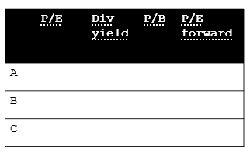

Build each sector using top 30 companies (by MC) for example, using market cap website