**Sales Data Report Documentation**

* Row ID: A unique identifier for each row in the table.
* Order_ID: The unique identifier for each order.
* Order_Date: The date the order was placed.
* Ship_Date: The date the order was shipped.
* Ship_Mode: The shipping method used for the order.
* Customer: The name of the customer who placed the order.
* Customer Segment: The customer segment that the customer belongs to.
* Country: The country where the customer is located.
* City: The city where the customer is located.
* State: The state where the customer is located (applicable for US only).
* Postal Code: The customer's postal code.
* Region: The region where the customer is located.
* Product: The name of the product that was sold.
* Category: The category of the product that was sold.
* Sub-Category: The sub-category of the product that was sold.
* Product Sales: The total sales amount for the product.
* Quantity: The number of units of the product that were sold.
* Discount: The amount of discount that was applied to the product.
* Profit: The profit earned from the sale of the product.

This table is likely a sales order fact table, which is a common type of table used in data warehousing. It contains detailed information about each sales order, including the products that were sold, the customers who placed the orders, and the profitability of each order.

Here are some additional details that may be helpful to include in the documentation:

* The date range that the data covers.
* The source of the data.
* The format of the data (e.g., YYYY-MM-DD for dates).
* Any definitions of the data fields that are not self-explanatory.

**Relationship images bellow:**

**Table 1:** Bellow image showing relation between fact sales table and reference table for Product category and sub category.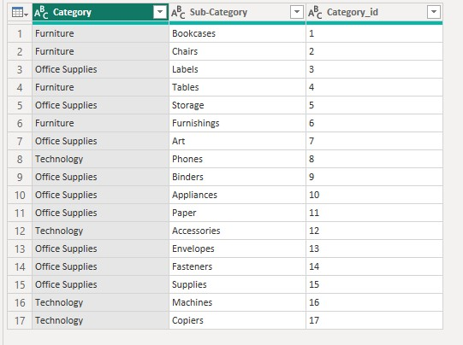

**Table2:** Bellow image showing relation between fact sales table and customer segment belong to segment (consumer, corporate and home office).

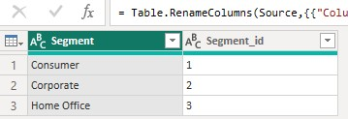

**Table3:** Bellow image showing relation between fact sales table and Order shipping details:

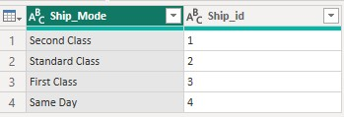

**Table4:** Bellow image showing ER diagram relationship between all tables: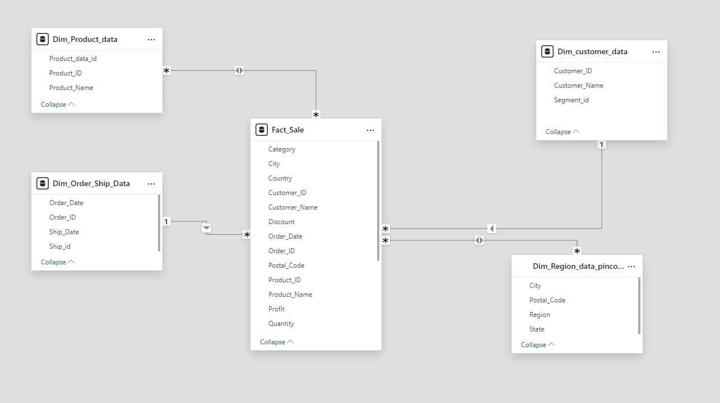

**Output chart:**

