WIZORA-AI MULTIMODAL KNOWLEDGE BASE • CURRICULUM SPECIFICATION
Gradient Descent and Its Optimization Variants
Theoretical Foundations, Comparative Regimes, Modern Adaptive Algorithms, and Implementation Dynamics
System Notice (Inter-Document Dependency): This document forms part of a multi-source educational package designed for Wizora-AI demonstration. It provides deep mathematical derivations and architectural trade-offs that directly complement the visual diagrams in SGD_Visual_Deep_Dive.pdf, the fast numerical lookups in Gradient_Descent_Quick_Reference.txt, and the lecture video Stochastic_Gradient_Descent_in_3_Minutes.mp4.

1. Mathematical Foundations of Gradient Optimization
Optimization lies at the epicenter of machine learning and parameter estimation. Given a parameterized model f(x; θ) and an objective empirical risk function J(θ), the goal is to discover an optimal parameter vector θ* that minimizes the global loss across the training distribution:
θ* = argmin_{θ} J(θ) = argmin_{θ} (1 / N) ∑_{i=1}^N L(f(x_i; θ), y_i)
Gradient Descent iteratively adjusts θ in the direction of steepest descent, defined as the negative gradient vector -∇J(θ). The step size is scaled by the learning rate hyperparameter η > 0:
θ_{t+1} = θ_t - η · ∇J(θ_t)

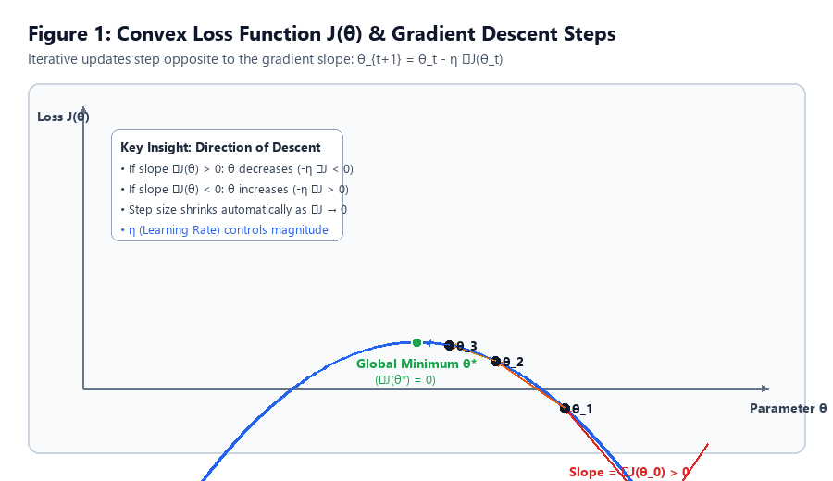
Figure 1.1: Geometric representation of gradient descent on a convex cost parabola.

2. Comparative Analysis: Batch vs. Stochastic vs. Mini-batch
Depending on the partition of training observations utilized to evaluate ∇J(θ) at each iteration t, gradient descent algorithms fall into three fundamental regimes:
1. Batch Gradient Descent (BGD): Evaluates the true gradient over all N training instances at every update step. Guarantees deterministic, monotonic loss reduction on convex surfaces. However, as N scales into millions of samples, computing ∇J(θ) becomes prohibitively slow and exhausts system RAM.
2. Stochastic Gradient Descent (SGD): Approximates the gradient using a single randomly selected sample (x_i, y_i) per iteration (Batch Size B = 1). The expectation of this single-sample gradient equals the full gradient (unbiased estimator). The high variance of SGD introduces significant noise, causing an erratic zigzag path that prevents the optimizer from stagnating in shallow local minima and flat saddle points.
3. Mini-batch Gradient Descent (MBGD): Partitions the dataset into small subsets of size B (typically powers of two, such as 32, 64, 128, or 256). This configuration represents the de facto standard in modern deep learning because it leverages SIMD vectorization on GPUs while maintaining sufficient stochasticity for regularization.
Criterion / Metric | Batch GD (BGD) | Stochastic GD (SGD) | Mini-batch GD (MBGD)
Batch Size (B) | N (Full Dataset) | 1 (Single Sample) | 32 to 256 (Small Batch)
Computational Cost | O(N · d) per update | O(d) per update | O(B · d) per update
Update Frequency | 1 update per epoch | N updates per epoch | N / B updates per epoch
Convergence Path | Smooth, monotonic, direct | Highly erratic, zigzag | Balanced, moderate variance
Hardware Parallelism | Requires huge memory | Poor GPU tensor utilization | Ideal GPU/TPU SIMD acceleration

3. Advanced Optimizers: Momentum, RMSprop, and Adam
Standard SGD struggles when traversing ill-conditioned loss surfaces, particularly ravines where the surface curves much more steeply in one dimension than in another. Modern deep learning employs adaptive learning rate algorithms to accelerate convergence and eliminate coordinate oscillations:
• SGD with Classical Momentum: Introduces a velocity vector v_t that accumulates an exponentially decaying moving average of past gradients with momentum factor β (typically 0.9). This accelerates progress along persistent directions while dampening orthogonal oscillations: v_{t+1} = β · v_t + η · ∇L(θ_t), θ_{t+1} = θ_t - v_{t+1}.
• RMSprop: Maintains an exponentially decaying average of squared gradients s_t = γ · s_{t-1} + (1 - γ) · (∇L_t)^2. Parameter updates are scaled inversely by √s_t + ε, effectively dampening updates along high-variance coordinates.
• Adam (Adaptive Moment Estimation): Combines the advantages of Momentum (first moment estimate m_t) and RMSprop (second uncentered moment estimate v_t) with bias-correction factors to compensate for initialization at zero:
m_t = β_1 · m_{t-1} + (1 - β_1) · g_t
v_t = β_2 · v_{t-1} + (1 - β_2) · g_t^2
m_hat_t = m_t / (1 - β_1^t), v_hat_t = v_t / (1 - β_2^t)
θ_{t+1} = θ_t - [ η / (√v_hat_t + ε) ] · m_hat_t

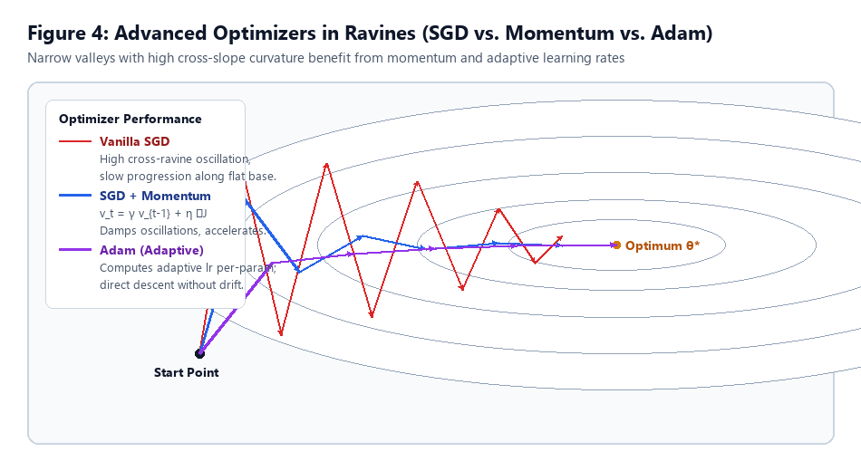
Figure 3.1: Optimizer behavior in an anisotropic ravine (Vanilla SGD vs Momentum vs Adam).

4. Practical Engineering Recipes & Learning Rate Scaling
When scaling deep learning workloads across distributed GPU clusters, the following empirical rules apply:
1. Linear Scaling Rule for Batch Size: When increasing the mini-batch size B by a factor of k, multiply the base learning rate η by k (η' = k · η). This keeps the expectation of weight updates proportional across epochs.
2. Warmup Schedules: Begin training with a small learning rate that gradually ramps up to the target η over the first 5 to 10 epochs. This prevents catastrophic weight divergence during early training when variance is high.
3. Cosine Annealing: Decays the learning rate following a cosine curve towards a small minimum value, delivering smooth late-stage convergence without abrupt step-drop artifacts.

5. Demonstration Cross-Reference Matrix
For Wizora-AI demonstration validation, test cases should query relationships across files:
• Visual Validation: Refer to Figure 1 in SGD_Visual_Deep_Dive.pdf for trajectory contour geometry.
• Numerical Verification: Refer to Section 3 of Gradient_Descent_Quick_Reference.txt for step-by-step weight update arithmetic (w_0 = 1.00 updating to 1.40).
• Audio/Video Grounding: Refer to timestamp 01:15 in Stochastic_Gradient_Descent_in_3_Minutes.mp4 for the concept of evaluating one sample at a time to reduce calculation time.

