Lab101
Student:Bekzat Erkeshuly
Group:CS-2440

Title: QRadar Log Analysis Investigation

1. Introduction
This report presents the analysis of security events using IBM QRadar SIEM. The investigation focuses on identifying suspicious activity, attacker behavior, and potential indicators of compromise within the network.

2. Objective
The objective of this lab is to analyze log data in QRadar, detect malicious activities, and reconstruct attacker actions using event correlation and filtering techniques.

3. Methodology
The investigation was conducted using QRadar tools such as:
Log Sources
Offenses tab
Event filtering
Payload analysis

4. Investigation Process

4.1 Log Sources Analysis
The analysis began in the Log Sources section, where 15 sources were identified. One of them contained data from an Intrusion Detection System (IDS), which is critical for detecting malicious activity.



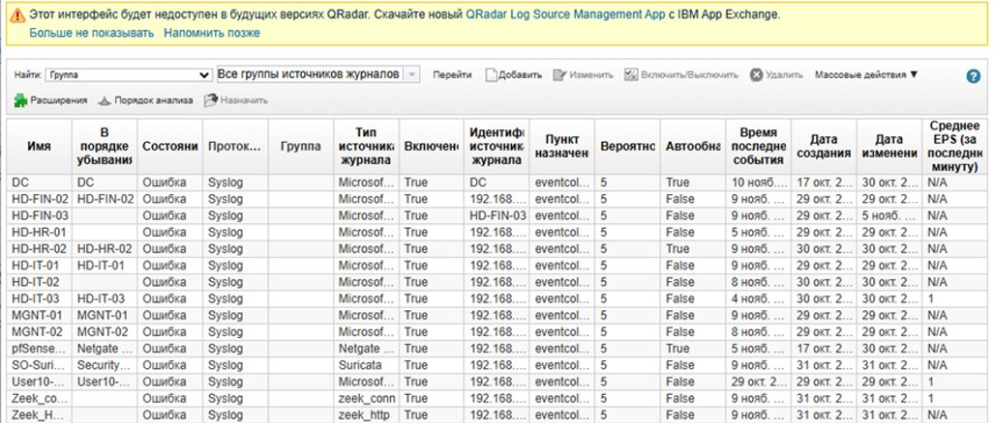

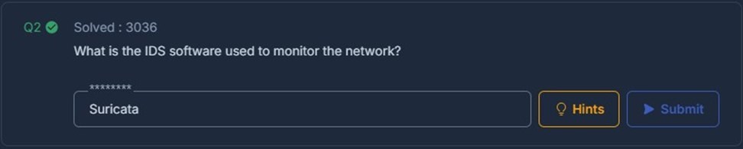

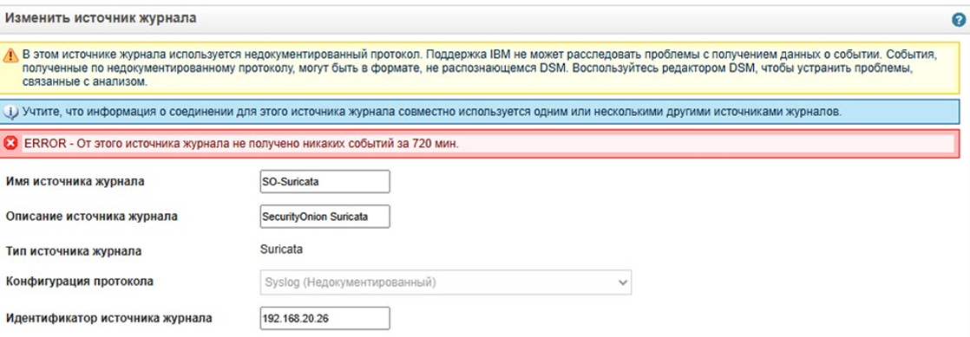4.2 Domain and Host Identification
By analyzing log events, the domain name hackdefend.local was identified. Additionally, the host HD-FIN-03.hackdefend.local was detected, confirming the internal network structure.
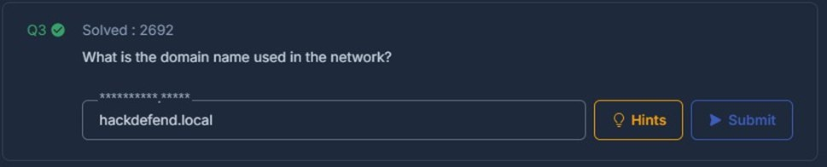
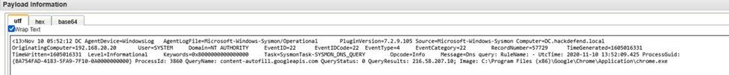

4.3 IP Address Analysis
Source and Destination IP fields were used to track communication between hosts. This allowed identification of internal and external interactions.
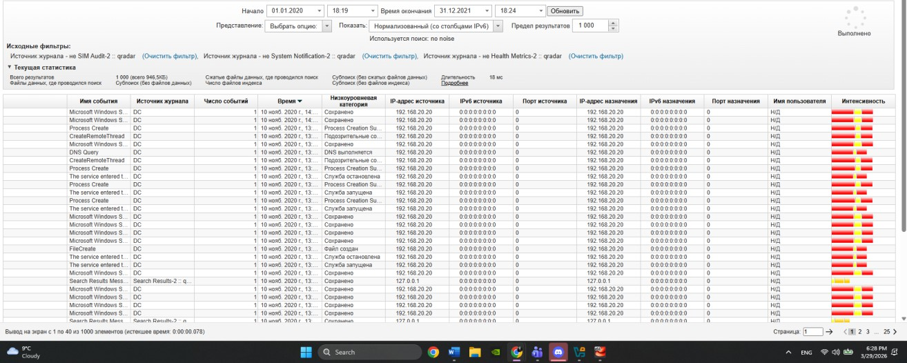
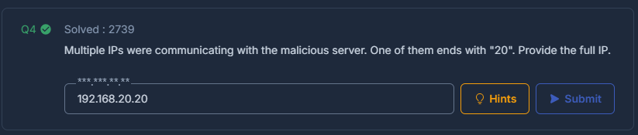
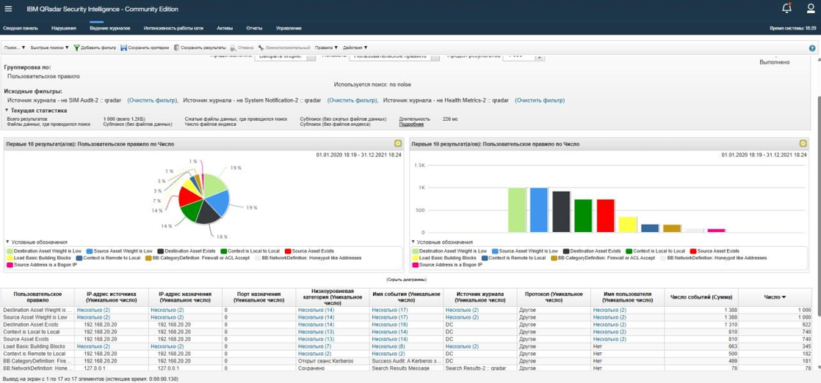

4.4 Identifying the Attacker
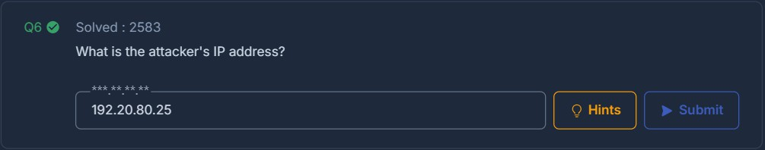
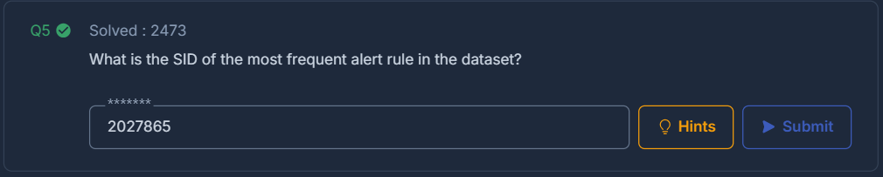
The attacker’s IP address was found in the Offenses tab. By disabling the “Exclude Closed Offenses” filter, additional suspicious activity became visible. The attacker IP stood out as external to the network.

To find the most frequent SID, events were grouped by RULE SID. This allowed all SIDs to be compared easily. The SID with the highest number of occurrences was selected as the answer

4.5 Event Filtering
Several filters were applied:
- payload contains "project" → narrowed search results
- payload contains "md5" → identified file hashes
- payload contains "cmd" → detected command execution
- payload contains "\Run\" → found persistence mechanisms
These filters improved efficiency and helped isolate malicious behavior.
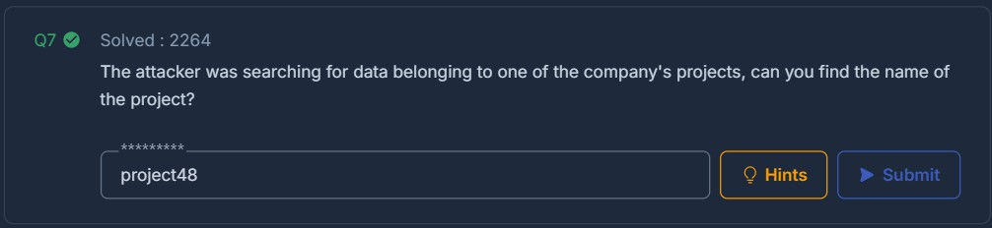
A filter using “payload contains ‘project’” was applied based on the task context. This helped narrow down the results to relevant logs. As a result, the necessary information was found more efficiently.
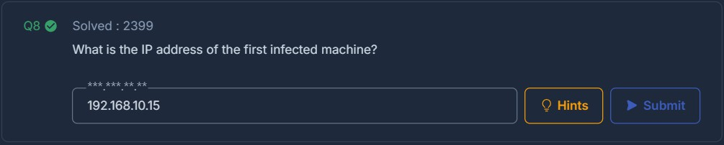

By selecting the attacker’s IP address in the Offenses tab, all related activity was displayed. This included communication with other systems. It allowed identification of all connected IP addresses.
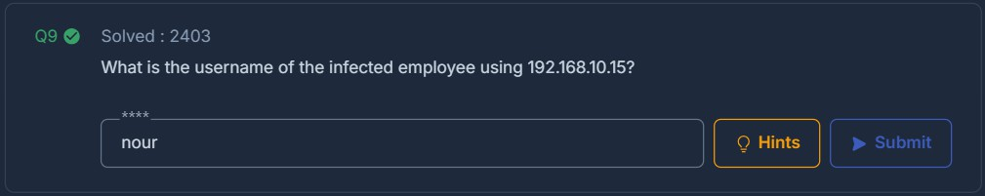
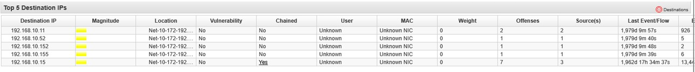

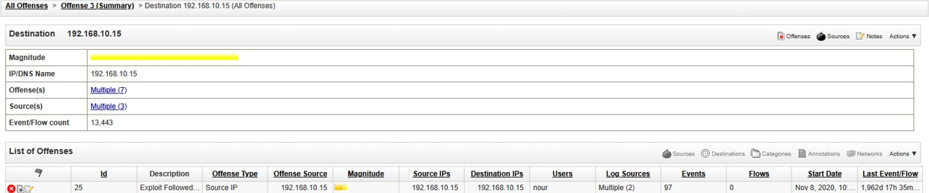
Logs related to destination IP 192.168.10.15 were analyzed. These logs contained user-related activity. The username was identified directly from the event details.
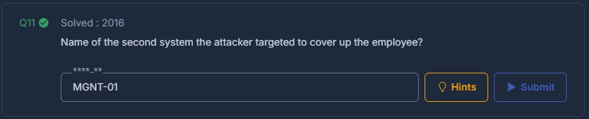

The logs showed that PowerShell commands were executed. This is often associated with command execution by an attacker. Therefore, this activity was considered suspicious.

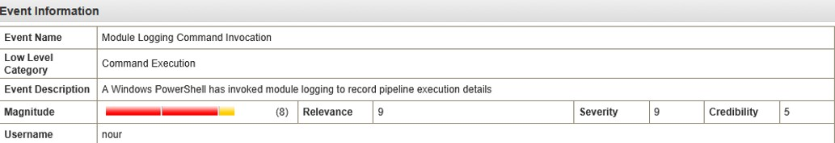

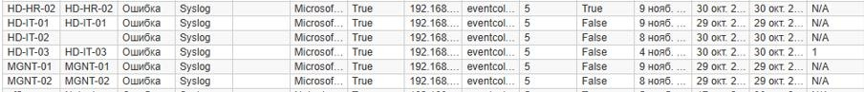
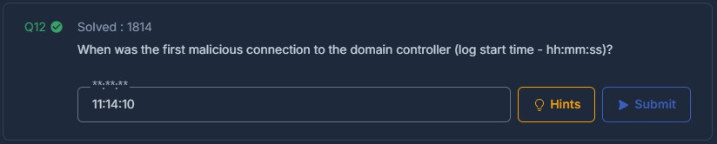
Logs were filtered for connections to 192.168.20.20. Among the results, unusual activity involving notepad was observed. This behavior seemed suspicious in the given context. Therefore, it was considered relevant to the investigation.
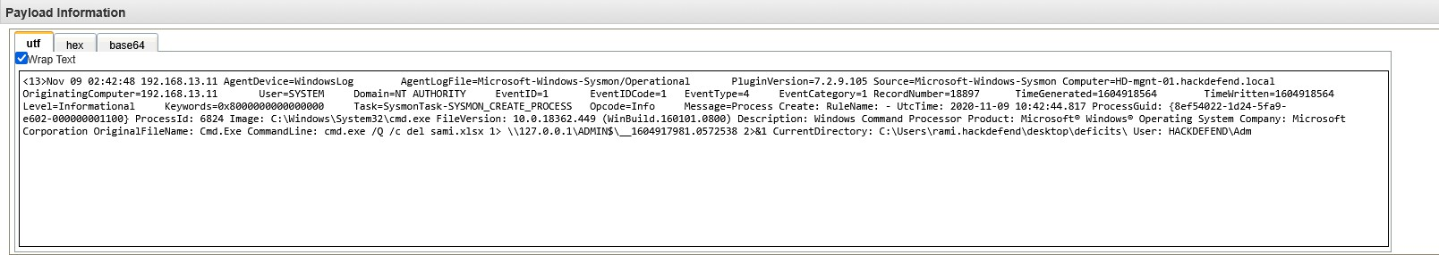

A filter “payload contains cmd” was applied to find command execution. A suspicious command was identified in the logs. Further analysis showed it was

4.6 Suspicious Activity Detection
PowerShell execution was detected, which is commonly used by attackers for remote control.
A suspicious command related to wmiexec.py was identified, indicating remote execution.
Use of curl suggested possible data exfiltration.
Notepad activity in logs appeared unusual and contextually suspicious.

Logs for the infected host 192.168.10.15 were analyzed. Focus was placed on process creation events. This made it possible to identify the Process ID (PID). The PID provided details about the running process.
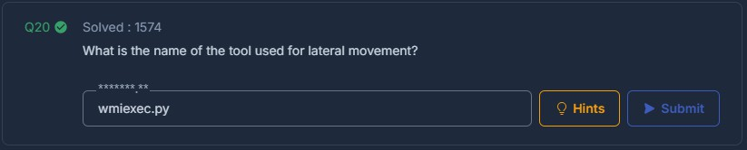
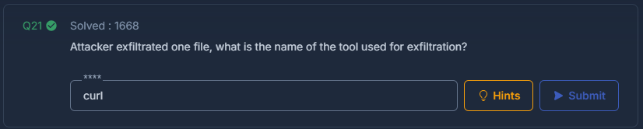
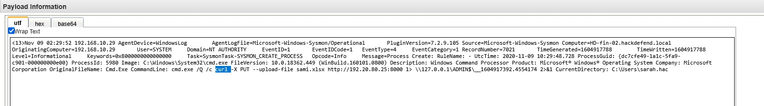
related to wmiexec.py. This tool is often used for remote command execution.

4.7 Malware Identification
By analyzing logs containing MD5 hashes, a malicious file was identified. The file name was extracted from the same logs, confirming its presence in the system.

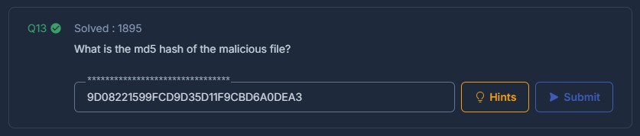

A filter “payload contains md5” was applied to search for file hashes. This helped to locate logs containing hash values. The MD5 hash of the suspicious file was identified in these logs. This information is useful for further analysis.
Logs were filtered using “\Run\” to detect persistence mechanisms. This helped to find registry-related entries. A suspicious entry was identified during the analysis.

4.8 Persistence Mechanism
Registry entries in the \Run\ path indicated that the attacker established persistence, allowing the malicious program to run automatically.
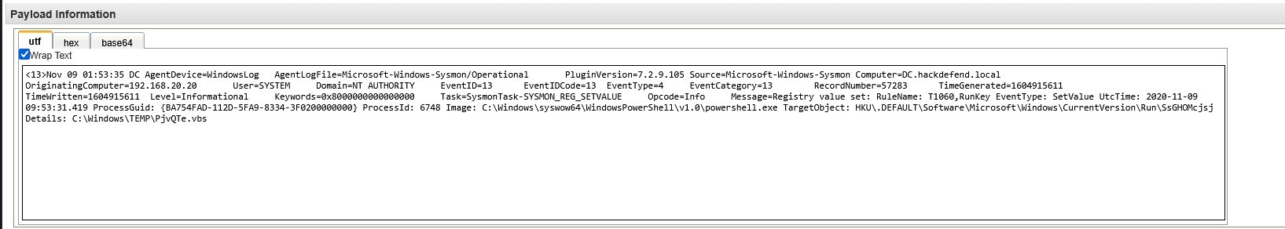
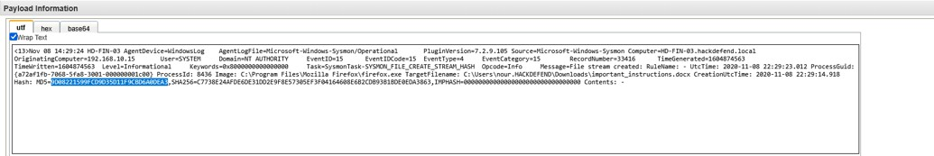

4.9 Network Activity Analysis
ICMP traffic indicated network scanning.
The infected host 192.168.10.15 scanned the 192.168.20.0 network.
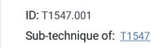
DNS over HTTPS traffic was analyzed and confirmed to be legitimate (Microsoft Office365).
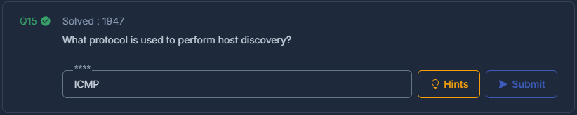

A filter “payload contains ICMP” was used to analyze network activity. ICMP traffic is commonly used for host discovery. The logs confirmed that such activity was present. This indicates possible network scanning.

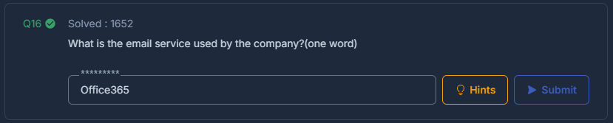

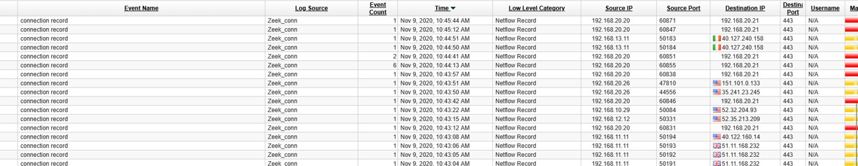

Common SMTP ports were checked first, but no useful results were found. Then DNS-related HTTPS traffic was analyzed. It showed that the IP address was linked to Microsoft Office365 services. This indicates that the traffic was legitimate.

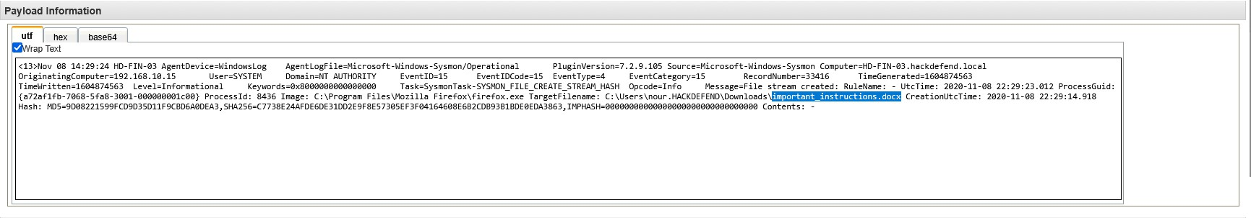
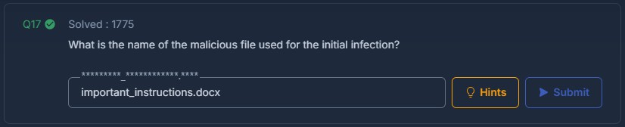

4.10 User Activity
- A suspicious account named rambo was identified.
- Another administrator account adam was detected.
- Logs grouped by user activity helped identify abnormal behavior.

The malicious file name was identified in the same logs as the MD5 hash. These logs usually contain both hash and filename. By analyzing them, the file name was clearly determined. This helped to confirm the suspicious file.

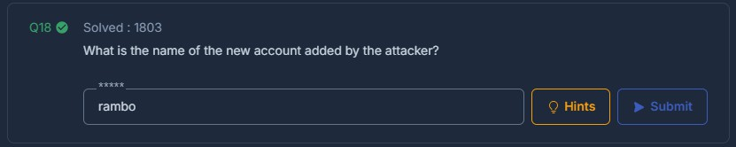

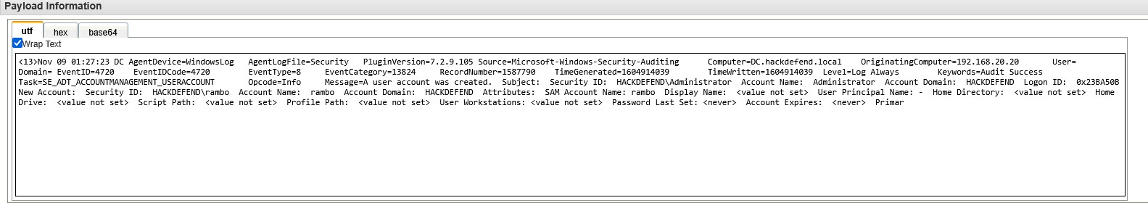

Events were grouped by “User Created” to find new accounts. This helped to identify recently created users. The username “rambo” was found in the logs. It appeared suspicious in the context of the investigation.

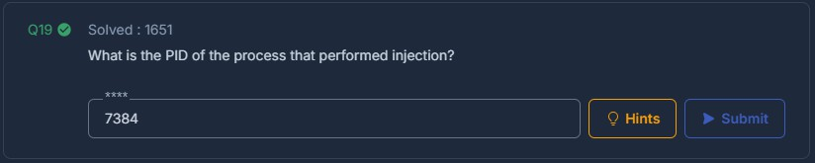

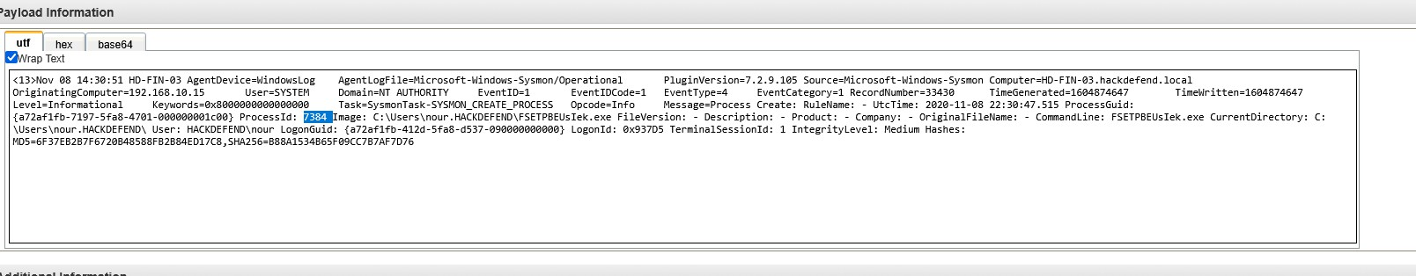

Another suspicious command was found during the analysis. It used curl, which is commonly used for data transfer. This may indicate data exfiltration. Therefore, the activity was considered potentially malicious.


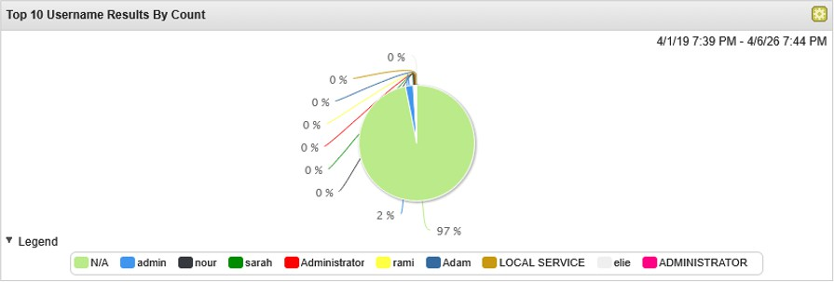
Logs were grouped by username to analyze user activity. Accounts with administrative privileges were reviewed. An additional admin user named “adam” was identified. This account was considered important for the investigation.

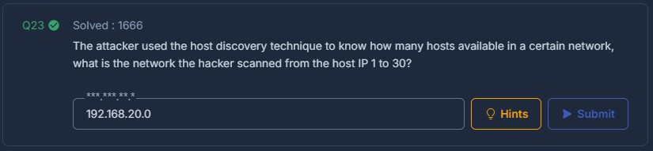
The infected host 192.168.10.15 was analyzed for network activity. It was observed scanning the 192.168.20.0 network. This behavior is typical for reconnaissance. It indicates that the attacker was exploring the network.
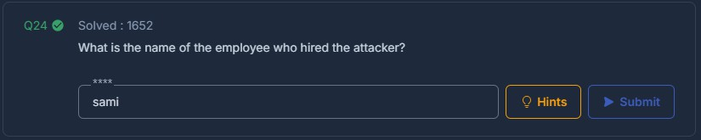
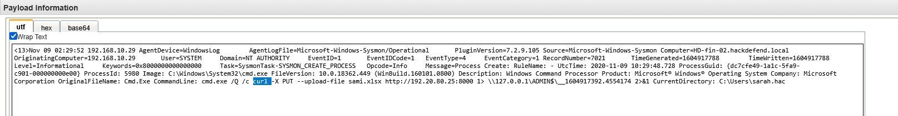
The required information was obtained from the provided Excel file. The file was reviewed and analyzed carefully. Relevant data was extracted from it. This helped to answer the question correctly.


Conclusion
The investigation confirmed that the system was compromised by an external attacker. The attacker used tools such as PowerShell and wmiexec for command execution, established persistence via registry modifications, and performed network scanning to explore the environment. The presence of suspicious accounts and potential data exfiltration indicates a serious security breach.

.

