Investigating windows
Student:Bekzat Erkeshuly
Group:CS-2440

1. Introduction
This report presents a forensic investigation of a Windows Server system. The goal is to identify malicious activity, attacker behavior, and system compromise indicators.

2. Objective
The objective is to analyze system artifacts, user activity, scheduled tasks, and network indicators to detect and reconstruct an attack.

3. Methodology
The investigation used:
PowerShell commands
Windows Registry analysis
Event logs
Scheduled tasks inspection

4. Investigation Process

4.1 System Information
Using the command:
Get-ComputerInfo -Property "OSName"
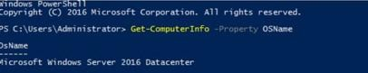
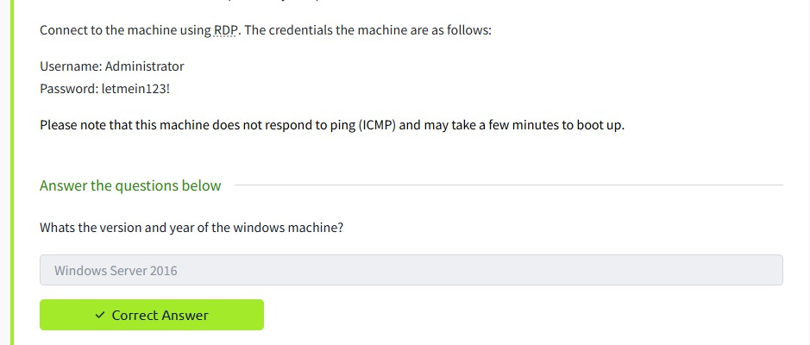
It was determined that the system is running Windows Server 2016 Datacenter.

The information was obtained using the Get-ComputerInfo -Property "OSName" command, which showed that the system is running Microsoft Windows Server 2016 Datacenter.

4.2 User Activity Analysis
The last logged-in user was identified as Administrator.
The account Jenny was found but had never logged in.
Both Guest and Jenny were members of the Administrators group, which is highly suspicious.

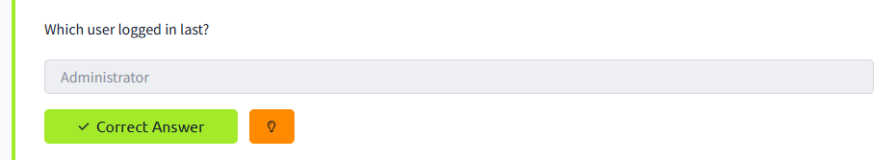
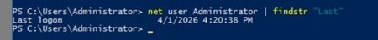

By reviewing system activity and session data, it was determined that the last logged-in user was Administrator.
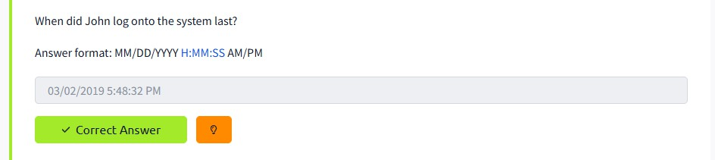
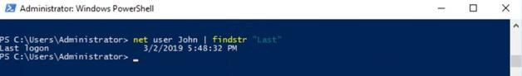

The timestamp of John’s last login was identified through analysis of user account records in the system.

4.3 Registry Analysis
The attacker’s IP address was identified in the Windows Registry under the Run key, indicating persistence mechanisms.
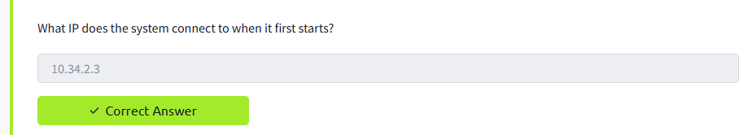
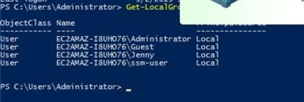

The attacker’s IP address was identified in the Windows Registry under the Run key, indicating the use of persistence mechanisms to maintain access to the system.

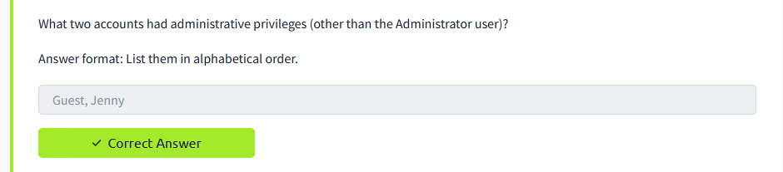
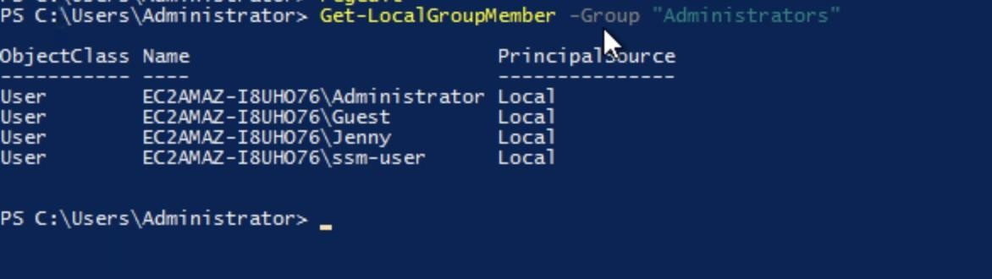

The command Get-LocalGroupMember -Group "Administrators" revealed that both Guest and Jenny were part of the administrators group.
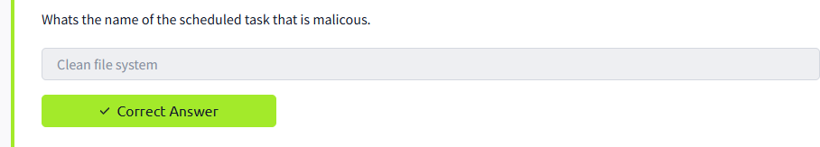

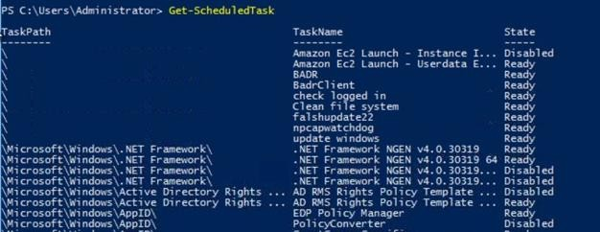

After listing scheduled tasks, this task stood out as unusual and likely malicious.
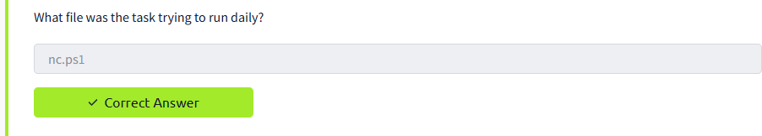

4.4 Scheduled Tasks
A suspicious scheduled task was discovered:
It executed a script from the temporary directory
It was configured to listen on port 1348
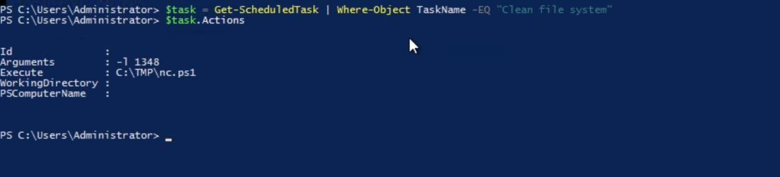
This behavior strongly indicates malicious activity.

Inspection of the task configuration showed it was set to execute a script located in the temporary directory.
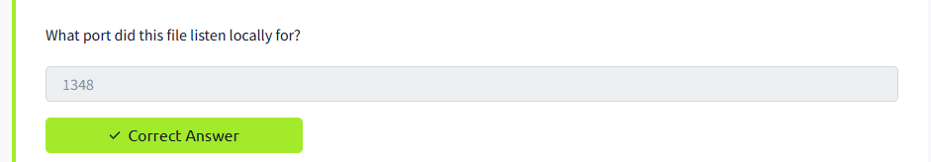
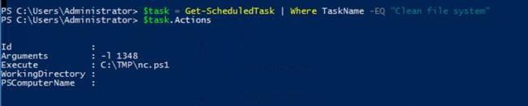

The script parameters indicated that it was configured to listen on port 1348.

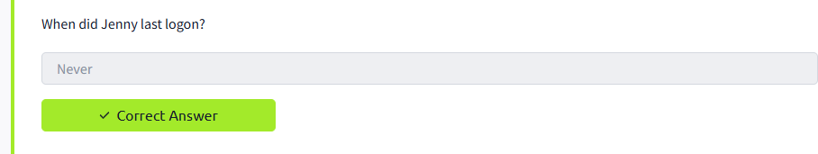
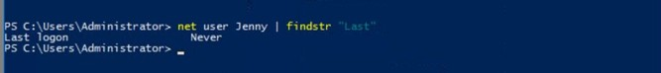

Using the command net user Jenny | findstr "Last", it was confirmed that this account has never been used to log in.
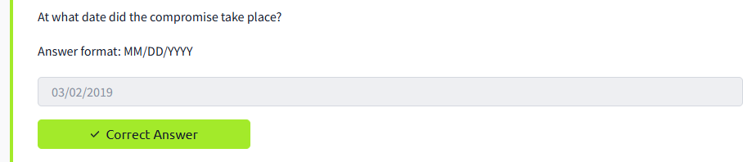

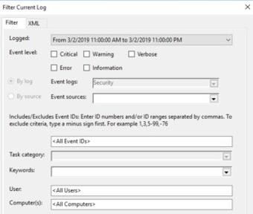 Security logs analysis showed that suspicious activity began on this date.
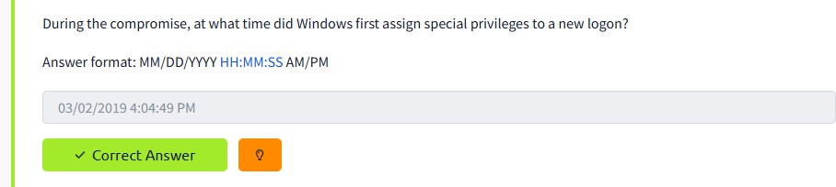

4.5 Event Log Analysis
Security logs showed when suspicious activity began
Event ID 4672 was used to identify when elevated privileges were granted

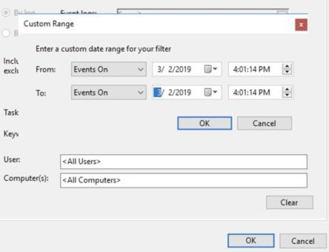
Event logs (specifically Event ID 4672) were filtered to find the exact time when elevated privileges were first granted.
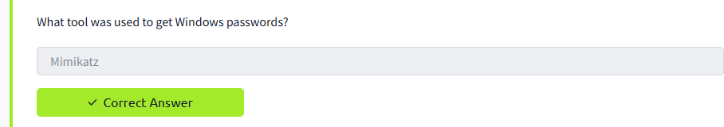
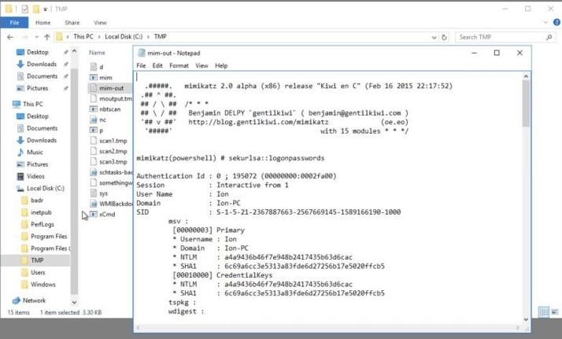

Evidence of this tool was found in files stored in the system, including output logs.
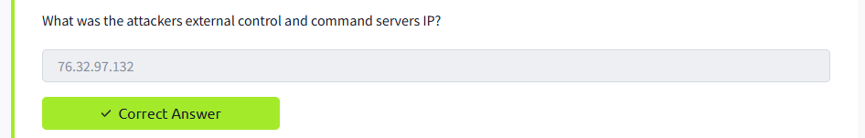

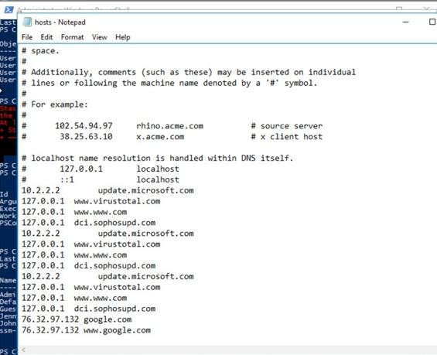
Network- related artifacts and logs pointed to this IP as the external command and control server.
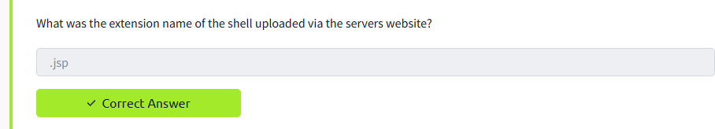

Malicious files with this extension were located in the web server directory.
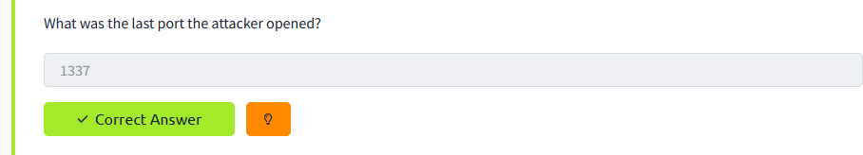

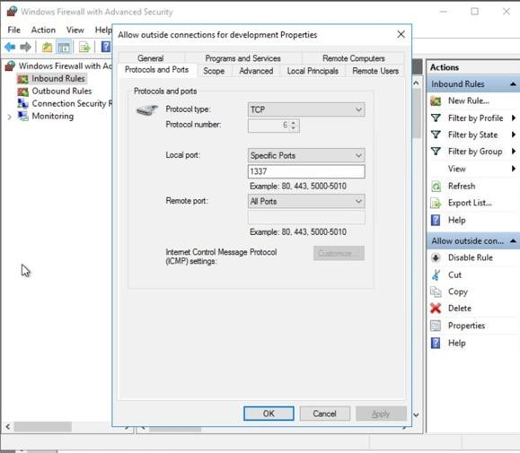 Analysis of later activity stages indicated that this port was the last one used by the attacker.

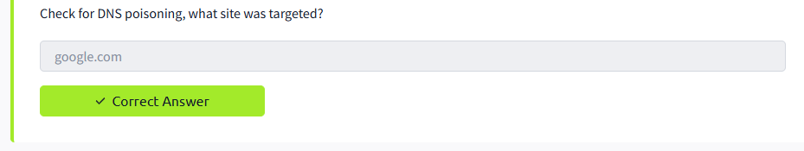

The hosts file contained altered entries redirecting traffic from this domain to unauthorized addresses.

6. Conclusion
The forensic analysis confirmed that the system was fully compromised. The attacker gained administrative privileges, established persistence using registry entries and scheduled tasks, and maintained communication with a command-and-control server. Additional evidence, such as modified hosts file entries and malicious scripts, indicates a well-structured and persistent attack.

