Part 1 Lab 1
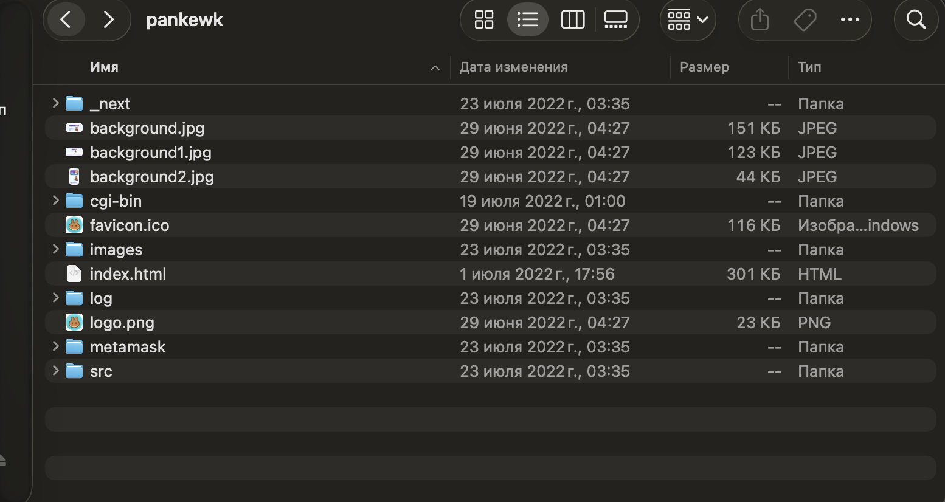
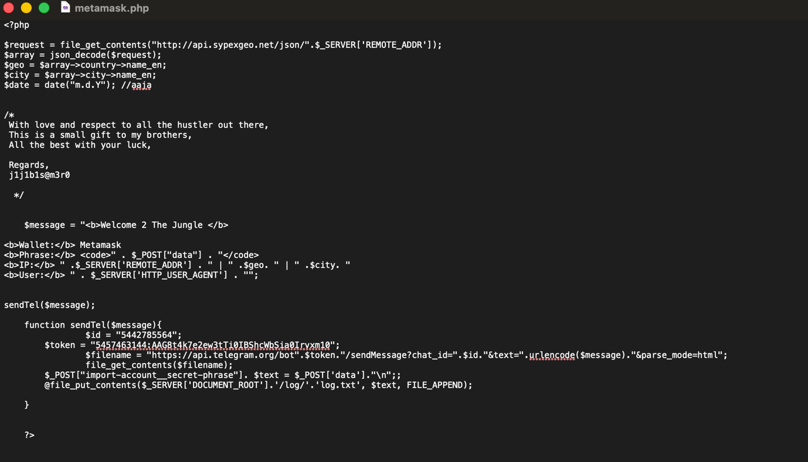
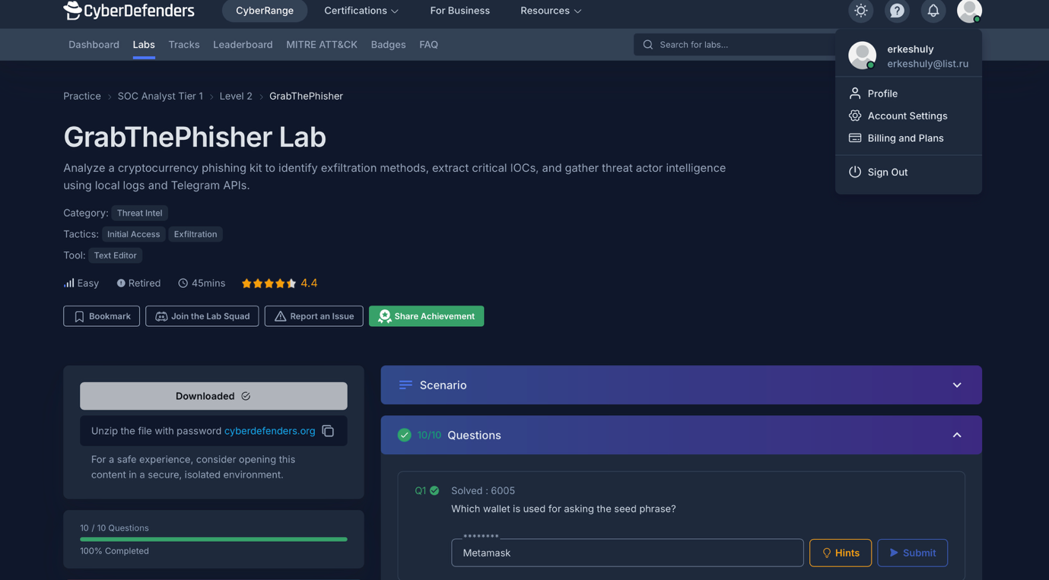
Part 1 Lab 2
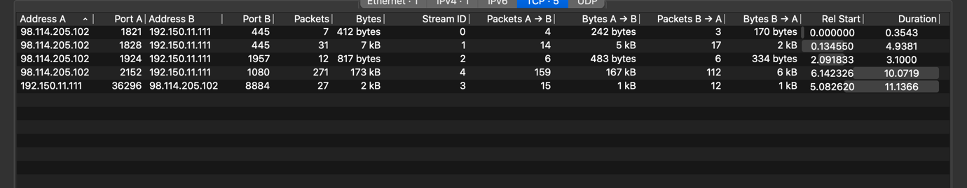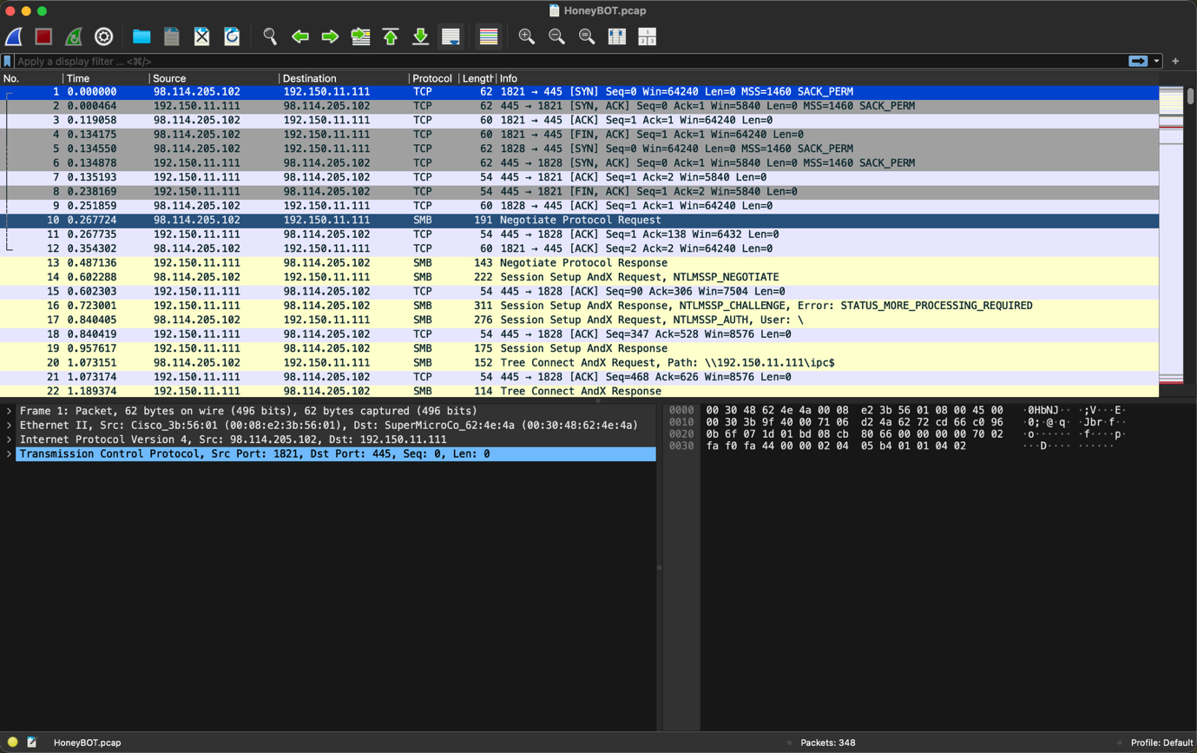

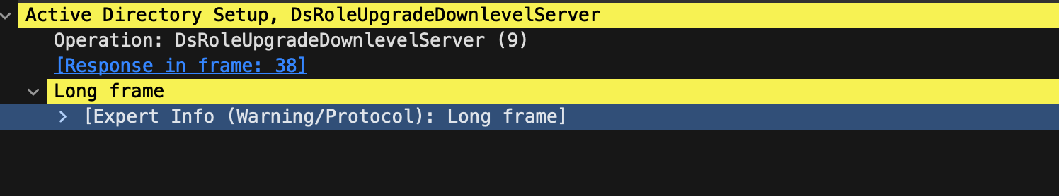
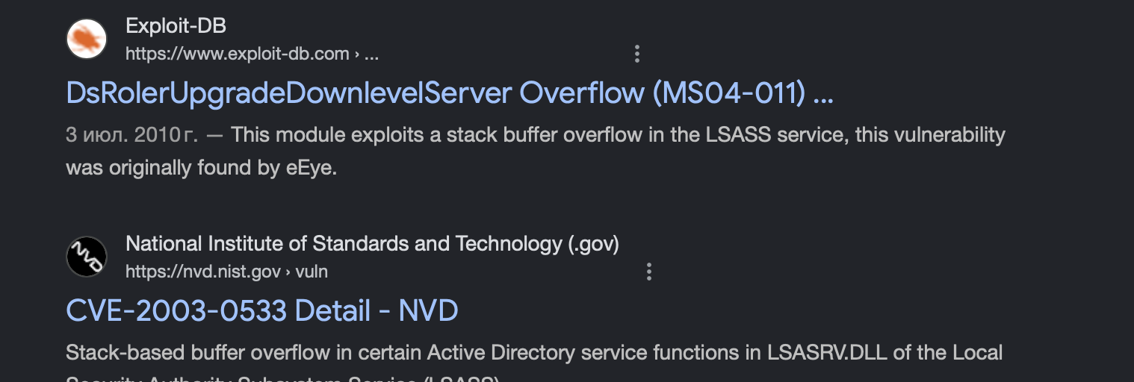
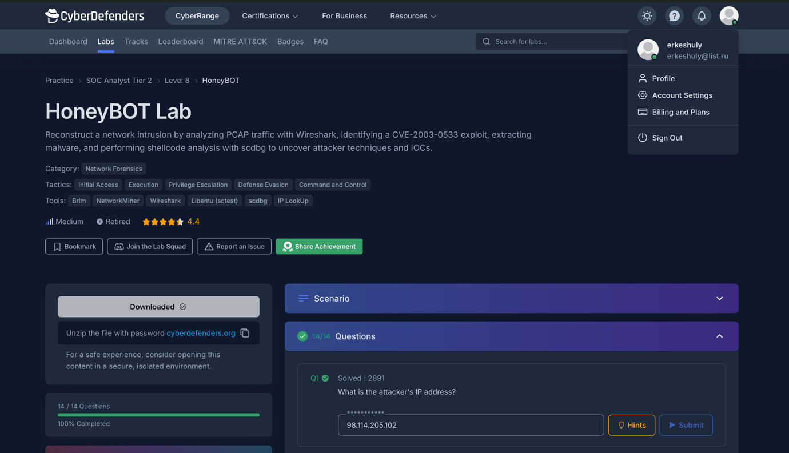
Part 2 Week 3
Question 1
What makes one alert more urgent than another?
Answer:
An alert becomes more urgent based on its potential impact and the criticality of the affected asset.
Explanation:
High-priority alerts typically involve:
critical systems (servers, databases)
possible account compromise
active attack behavior (e.g., code execution, lateral movement)
Other important factors include:
confidence level (true positive vs false positive)
presence of confirmed IOCs
The higher the potential damage and likelihood of a real attack, the higher the urgency.

Question 2
Which tasks should stay manual even in a highly automated SOC?
Answer:
Tasks that require judgment, analysis, and decision-making should remain manual.
Explanation:
These include:
final validation of incidents
investigation of complex attacks
response decision-making
threat hunting
Automation improves efficiency, but it cannot fully replace human reasoning, especially for sophisticated or novel threats.

Question 3
How do metrics help improve both analyst workflow and security outcomes?
Answer:
Metrics help evaluate SOC performance and identify inefficiencies in processes.
Explanation:
Common metrics include:
MTTD (Mean Time to Detect)
MTTR (Mean Time to Respond)
false positive rate
They help:
speed up incident response
improve workload distribution
enhance detection accuracy
As a result, both analyst efficiency and overall security posture improve.

Question 4
Why should a SOC avoid optimizing only for alert volume?
Answer:
Because a high volume of alerts does not necessarily indicate better security.
Explanation:
Focusing only on alert quantity can lead to:
excessive false positives
analyst overload (alert fatigue)
missed critical threats
A SOC should prioritize alert quality, accuracy, and relevance rather than volume.

Part 2 Week4
Question 1
Which phishing indicator do users miss most often?
Answer:
The most commonly missed phishing indicator is the URL or domain name.
Explanation:
Users often focus on the visual appearance of the email (logo, design, branding) and assume it is legitimate. However, attackers frequently use domains that look very similar to real ones (e.g., slight spelling changes or subdomains). Without carefully checking the actual URL, users may not notice that the link leads to a malicious website.

Question 2
Why can legitimate-looking emails still be malicious?
Answer:
Legitimate-looking emails can still be malicious because attackers can easily replicate the appearance of trusted organizations.
Explanation:
Phishing emails often include real logos, formatting, and language copied from official communications. In some cases, attackers may even spoof sender addresses or compromise legitimate accounts. As a result, the email appears trustworthy, but contains malicious links or attachments designed to steal credentials or sensitive information.

Question 3
Which control would reduce risk most in your environment?
Answer:
The most effective control would be user awareness training combined with email filtering.
Explanation:
User awareness training helps individuals recognize phishing attempts, such as suspicious links or requests for sensitive data. At the same time, advanced email filtering systems can automatically block known malicious emails and reduce exposure. Together, these controls significantly lower the likelihood of successful phishing attacks.
