Marqus Jaravata

N01472647

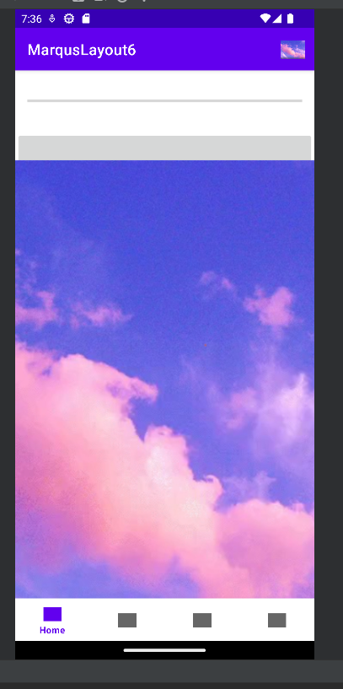HomeFragment

HomeFragment progress bar update after 2 clicks

progress bar disappears on 5th click and closes on 8th

MarqusFragment w/ functionality

PersonFragment

PersonFragment item selection

SettingsFragment demonstrating data passThru.

image in top right corner of app opens settings (taken after clicking).

