Best-first search VS Beam search

Heuristics – Case: Fruit fly

Authors: Mercylyn Wiemer (10749306), Shan Shan Huang (10768793) & Marwa Ahmed (10747141)

**Goal of experiment:**

The goal of the experiment is to compares the best-first search algorithm with the beam search algorithm. It compares the number of inversions needed to get to the solution. In addition, it will compare the breakpoints and distancepoints heuristics with each other.

**Methods:**

The best-first search algorithm constantly selects the best child based on breakpoints or distancepoints. This means that many children are pruned. In contrast to the beam search, that selects the 50 best children per layer. This way less children are pruned.

**Results:**

**Table1. Number of inversions needed to get to the solution with best-first search, beam search and different heuristics on Drosophila Melanogaster genome.**

|  |  |  |
| --- | --- | --- |
| **Heuristics** | **Best-first search** | **Beam search** |
| Breakpoints | 17 inversions | 13 inversions |
| Distance Points | 35 inversions | 21 inversions |

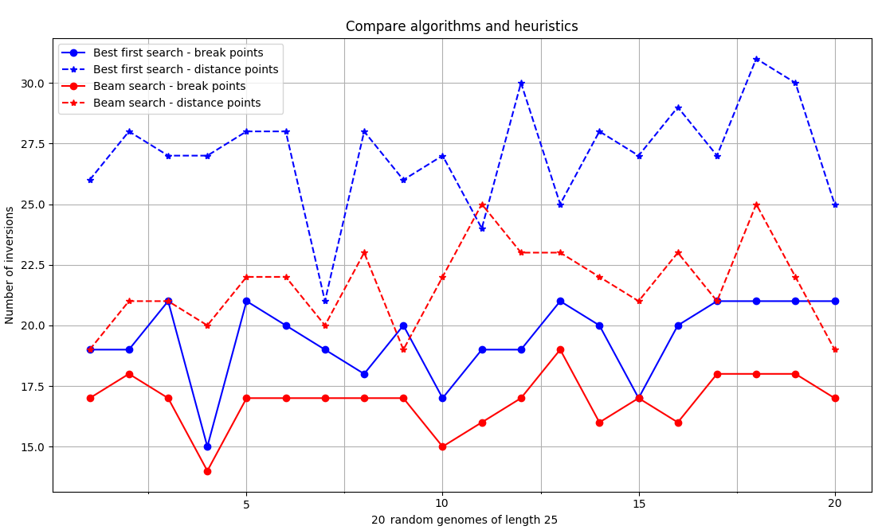

**Figure 1. Compares best-first search algorithm with the beam search algorithim and different heuristics on 20 random genome sequences of length 25.**

**Discussion:**

The beam search finds a solution in less steps than best-first search. This is expected, because the best-first search prunes more than the beam search does. The heuristics based on breakpoints seems to work better than the heuristics based on distancepoints. This might be caused because distancepoints does not pay attention to genes that are already in a sorted order.

**Conclusion:**

Beam search finds a better solution than best-first search. Breakpoints is a better heuristic than distancepoints.