Branch and bound – number of selected children

Heuristics – Case: Fruit fly

Authors: Mercylyn Wiemer (10749306), Shan Shan Huang (10768793) & Marwa Ahmed (10747141)

**Goal of experiment:**

In this experiment we change the number of selected children in the branch and bound (BnB): depth-first search which prunes using breakpoints. It will show what the influence of this constrain is on the run time and the numbers of inversions made to find the solution.

**Methods:**

The BnB depth-first search with breakpoints searches for a path from a given genome to a solution genome. The path consists of reversions of gene blocks in a genome. From the given root genome, every possible reversion is generated: the children. Depending on the number of selected children, one, two, or three children with the least breakpoints are explored first. The upper bound is updated, every time a solution is found.

**Results:**

**Table1. Branch and bound: Influence of the number of selected children on the runtime and number of inversions needed to get to the solution**

|  |  |  |
| --- | --- | --- |
| No of selected children  (fruit flies) | Number of inversions to solution | Runtime |
| 1 | 17 | 0.4 sec |
| 2 | 13 | 144 sec / 2.6 min. |
| 3 | - | > 10min |

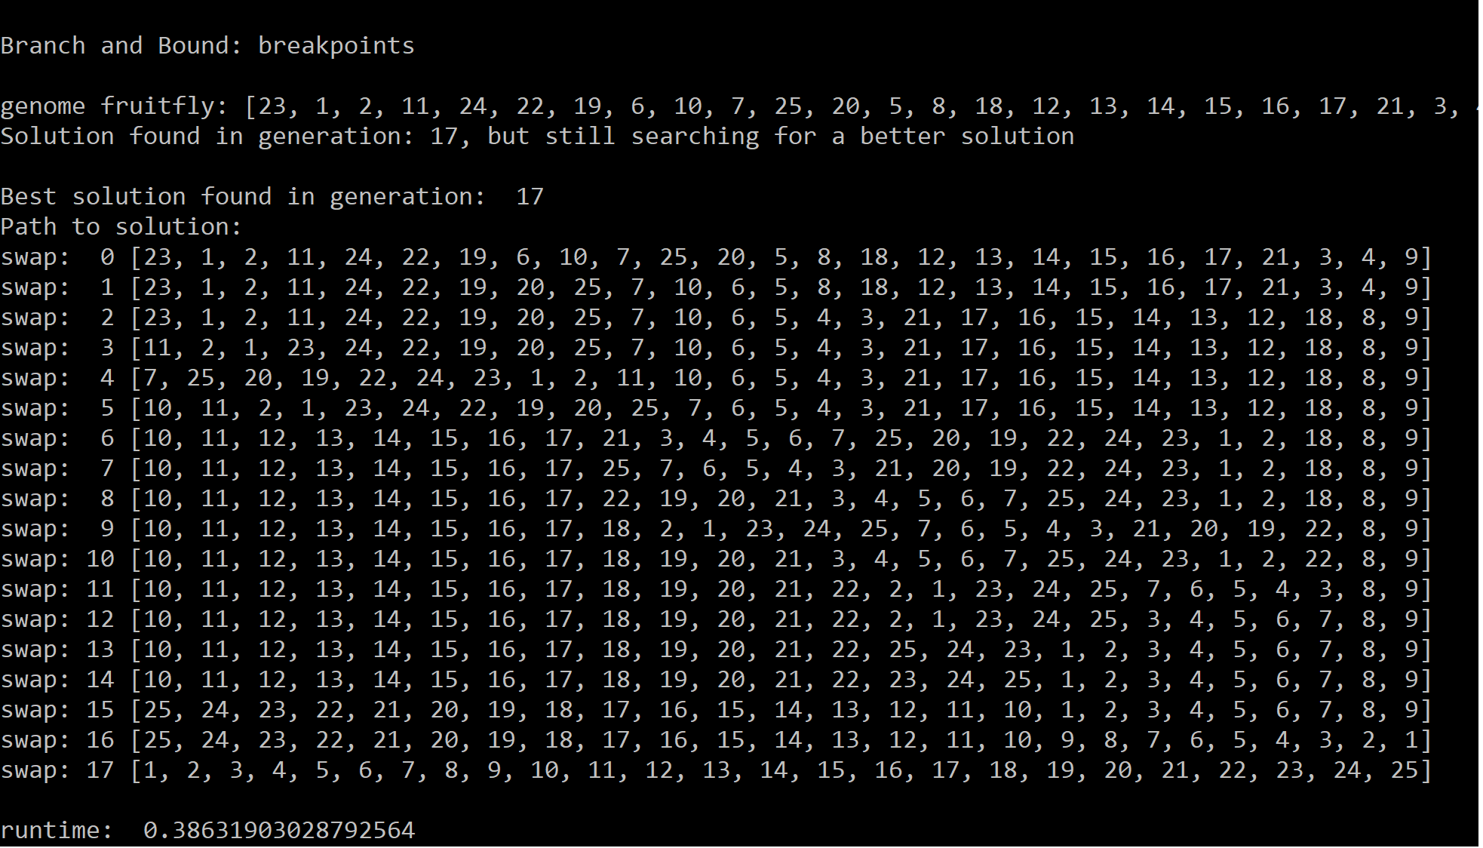

**Figure 1. Result of BnB depth-first search when selecting one child.**

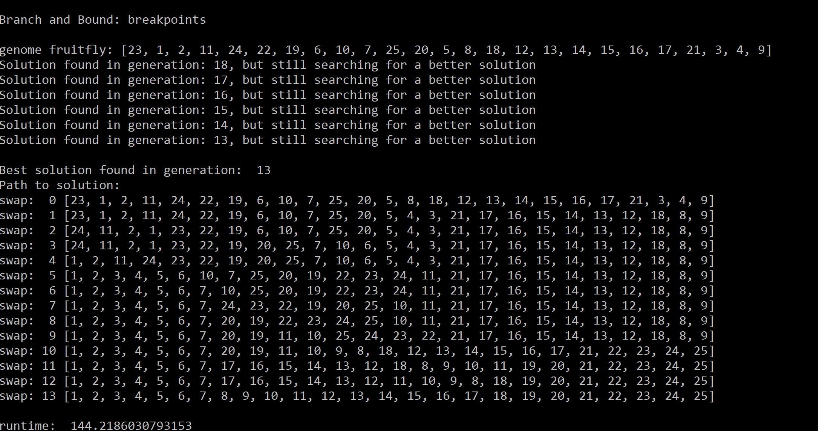

**Figure 2. Result of BnB depth-first search when selecting two children.**

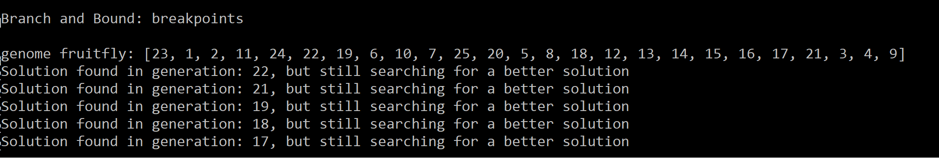

**Figure 3. Result of BnB depth-first search when selecting three children.**

**Discussion:**

Selecting one child has a fast runtime of less than one second and finds a solution in 17 inversions (Figure 1). While selecting two children has a slightly longer runtime, runtime of 2.6 minutes, but finds a solution in just 13 inversions (Figure 2). Selecting three children, increased the runtime up to more than 10 minutes, and after 10 minutes it does not find a better solution than 17 inversions (Figure 3).

**Conclusion:**

Selecting two children works better than selecting one or three, when taking in consideration the number of inversions and runtime.