Experiment 2

Heuristics – Case: Fruit fly

Authors: Mercylyn Wiemer (10749306), Shan Shan Huang (10768793), Marwa Ahmed (10747141)

**Goal of experiment:**

This experiment changes the beam size of the branch and bound (BnB): depth-first beam search with breakpoints. It will show what the influence if of the beam size on run time and the numbers of swaps made to find the solution.

**Methods:**

The BnB depth-first beam search with breakpoints searches for a path from a given genome to a solution genome. The path consists of reversions of gene blocks in a genome. From the given root genome, every possible reversion is generated: the children. Depending on the beam size one, two, or three children with the least breakpoints are explored first. The upper bound is updated, every time that it finds a solution.

**Results:**

**Table1. Influence of Bnb: depth-first beam size on solution found and runtime**

|  |  |  |
| --- | --- | --- |
| Beam size  (fruitfly) | Number of swaps to solution | Runtime |
| 1 | 17 | 0.4 sec |
| 2 | 13 | 144 sec / 2.6 min. |
| 3 | - | > 10min |

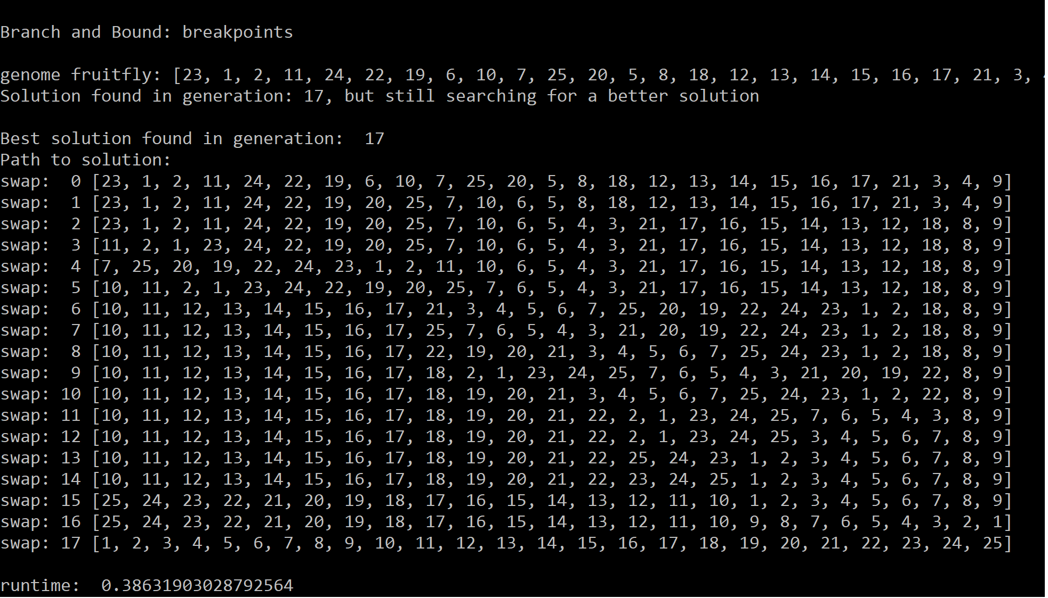

**Figure 1. Result of BnB depth-first beam search with beam size of one fruitfly.**

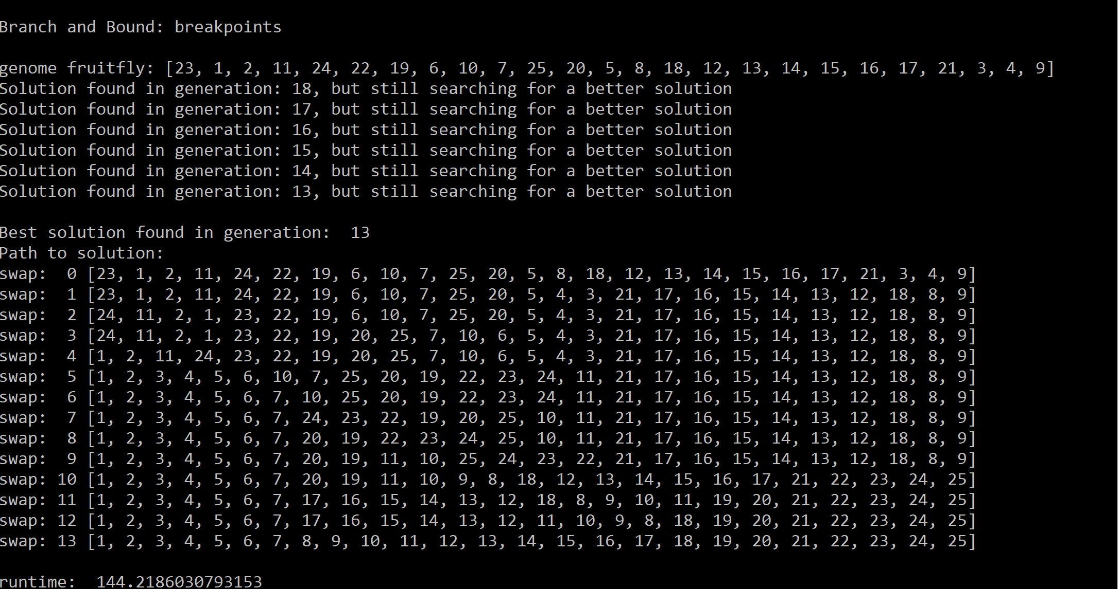

**Figure 2. Result of BnB depth-first beam search with beam size of two fruitflies**

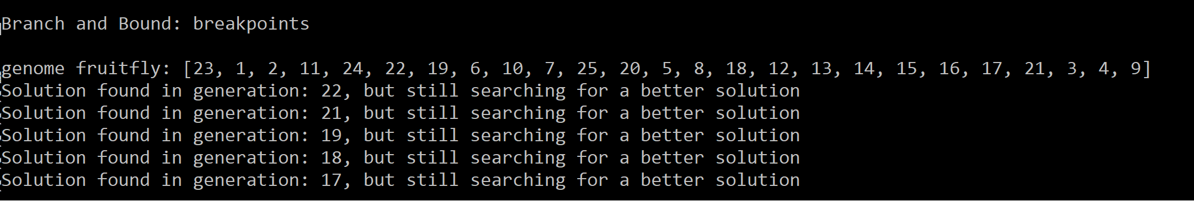

**Figure 3. Result of BnB depth-first beam search with beam size of three fruitflies.**

**Discussion:**

A beamsize of 1 fruitfly has a fast runtime of less than one second, and finds a solution in 17 swaps (Figure 1). A beamsize of 2 fruitflies has a relatively fast runtime of 2.6 minutes, but finds a solution in 13 swaps (Figure 2). A beamsize of 3 fruitflies has a long runtime of more than 10 minutes, and after 10 minutes it does not find a better solution than 17 swaps (Figure 3).

**Conclusion:**

It seems that a beamsize of two fruitflies works better than a beam size of 1 or 3, when taking in consideration the number of swaps and runtime.