Assignment 3.1 – Prompt Engineering – Improving Prompts and Context Management
M.Rohan || 2303A51545|| Batch-8

Question 1: Zero-Shot Prompting – Palindrome Number

Zero-Shot Prompt
“Write a Python function that checks whether a given number is a palindrome.”

AI-Generated Code
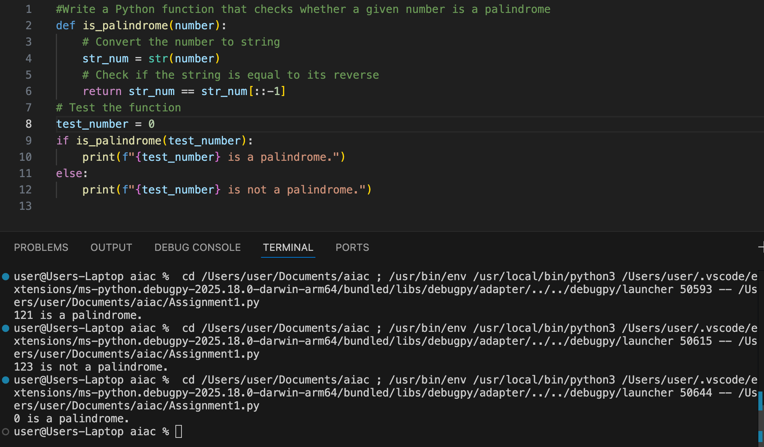

Question 2: One-Shot Prompting – Factorial Calculation

One-Shot Prompt
“Write a Python function to calculate factorial.
Example: Input: 5 → Output: 120”

AI-Generated Code
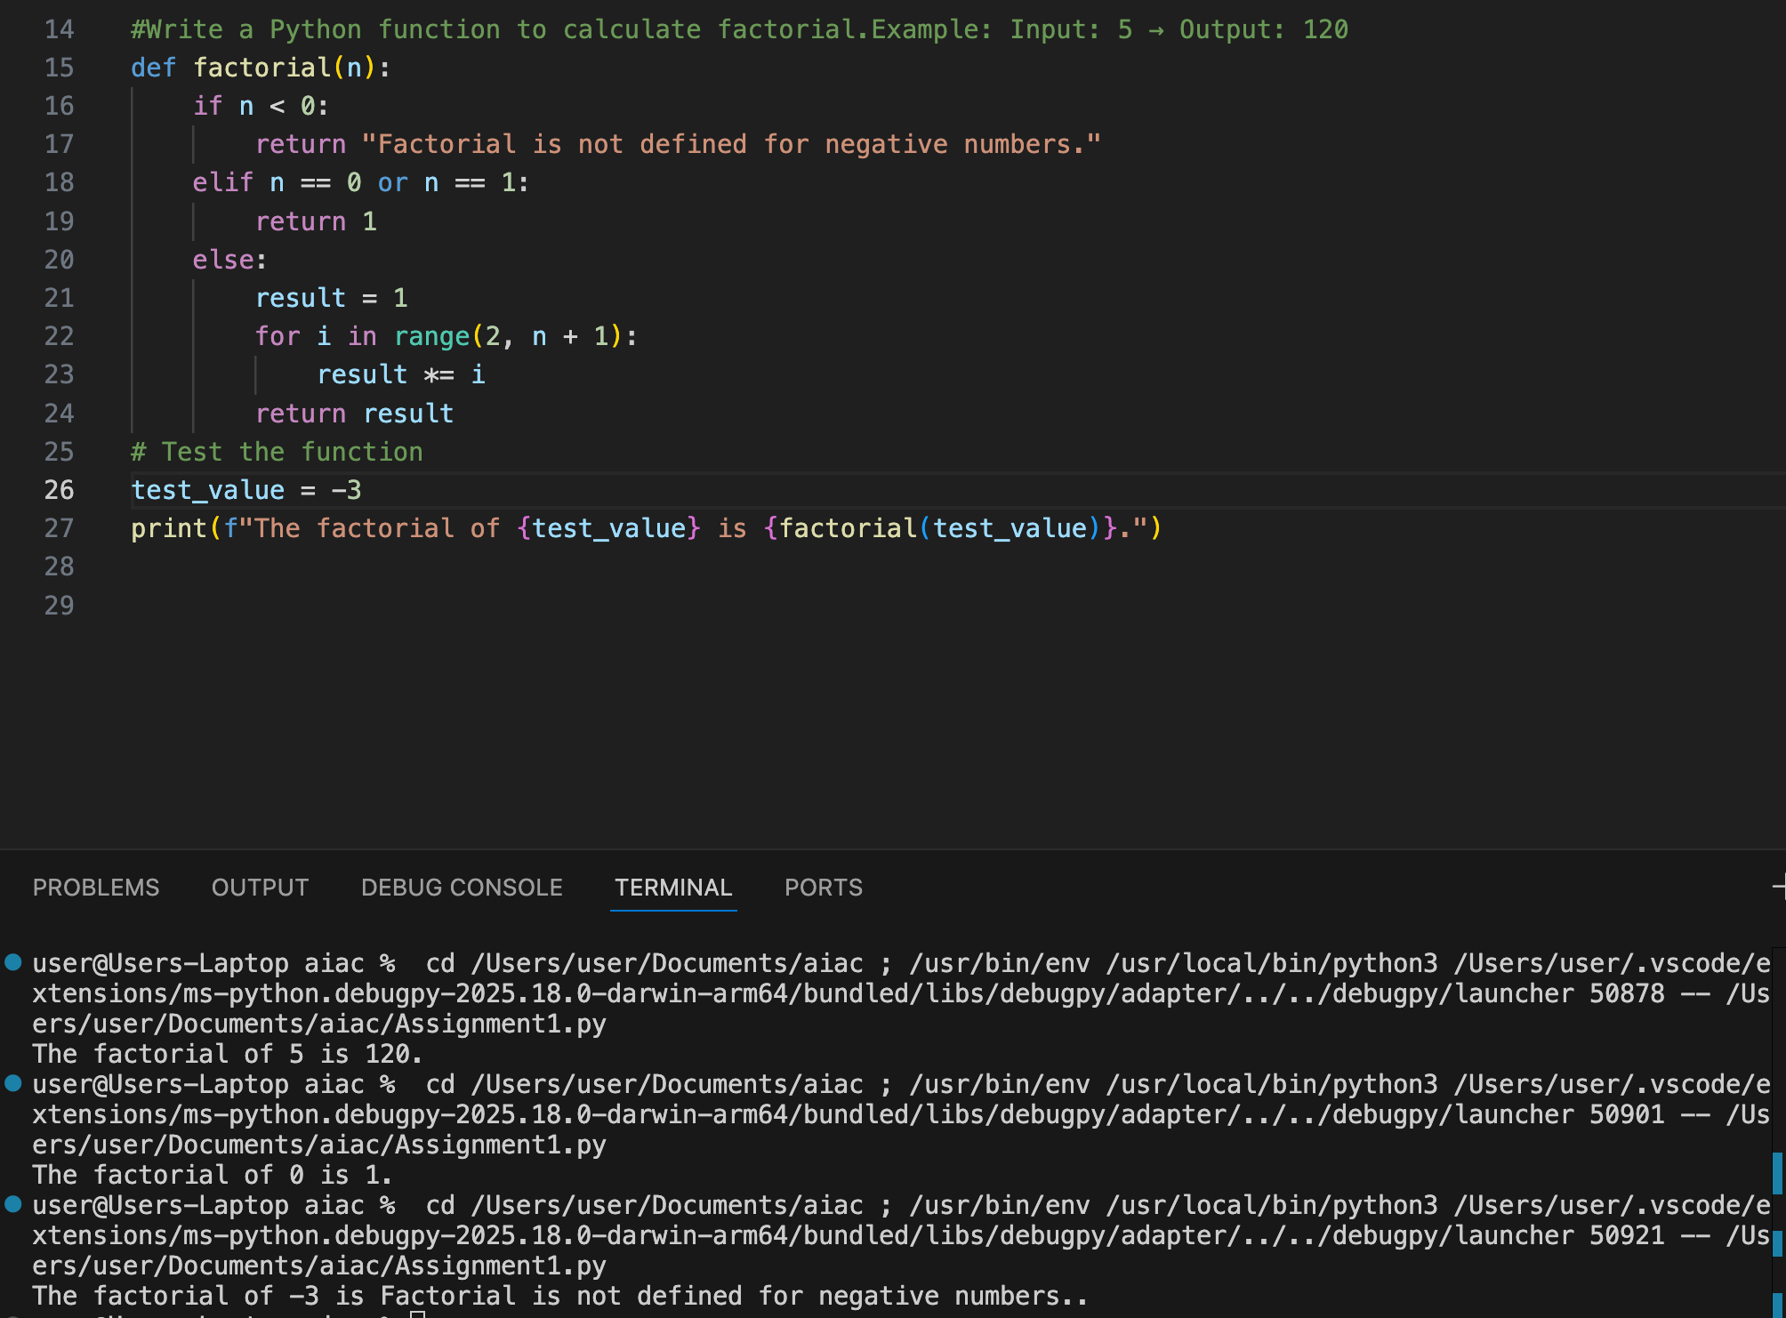

Question 3: Few-Shot Prompting – Armstrong Number

Few-Shot Prompt
“Write a Python function to check Armstrong numbers.
Examples:
153 → Armstrong Number
370 → Armstrong Number
123 → Not an Armstrong Number”

AI-Generated Code
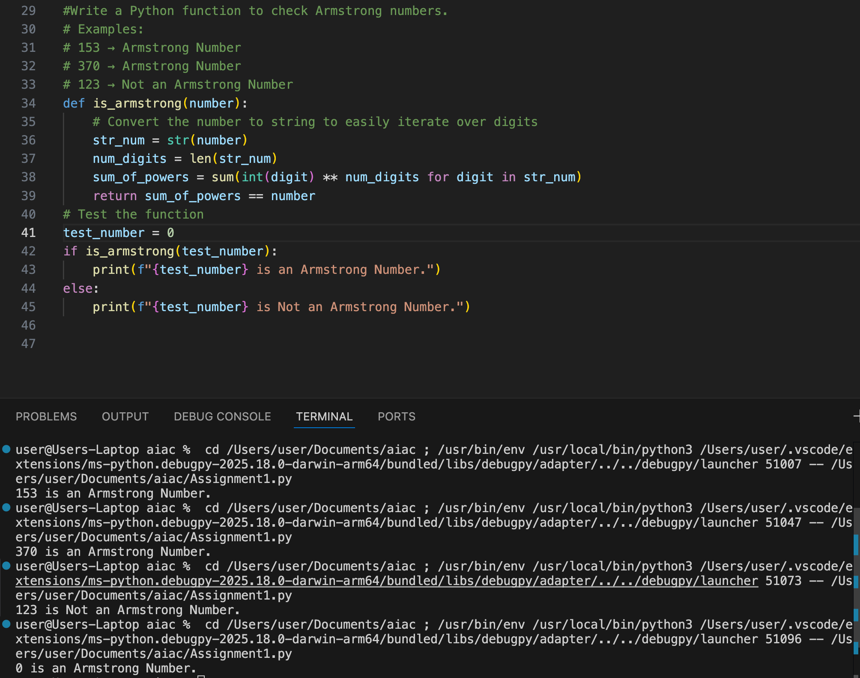

Question 4 : Context-Managed Prompting – Number Classification

Context-Managed Prompt
“Write an optimized Python program that classifies a number as Prime, Composite, or Neither.
Ensure input validation and efficiency.”
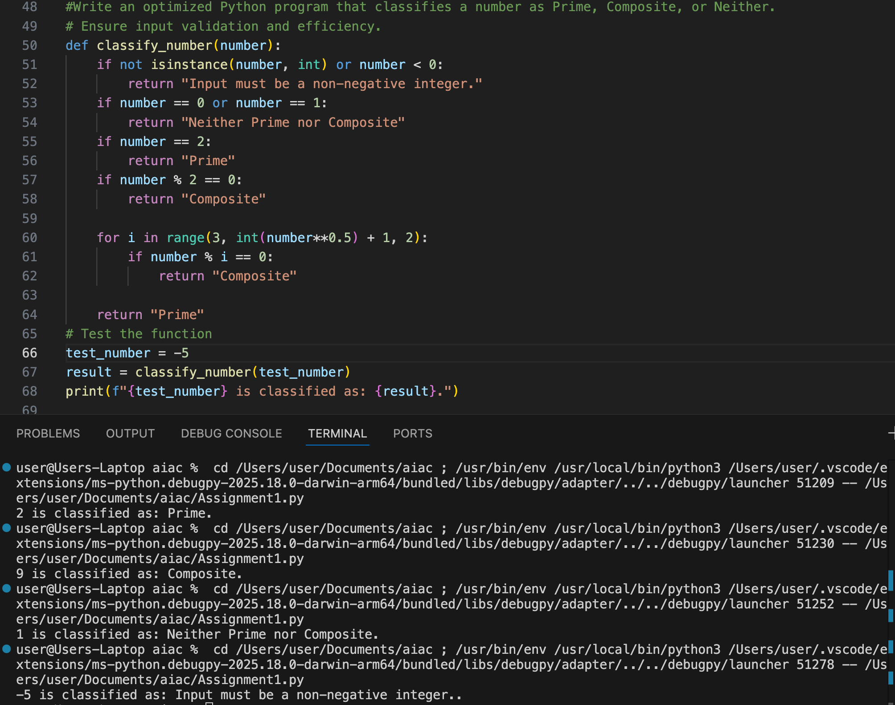

Question 5: Zero-Shot Prompting – Perfect Number

Zero-Shot Prompt
“Write a Python function to check whether a given number is a perfect number.”

AI-Generated Code
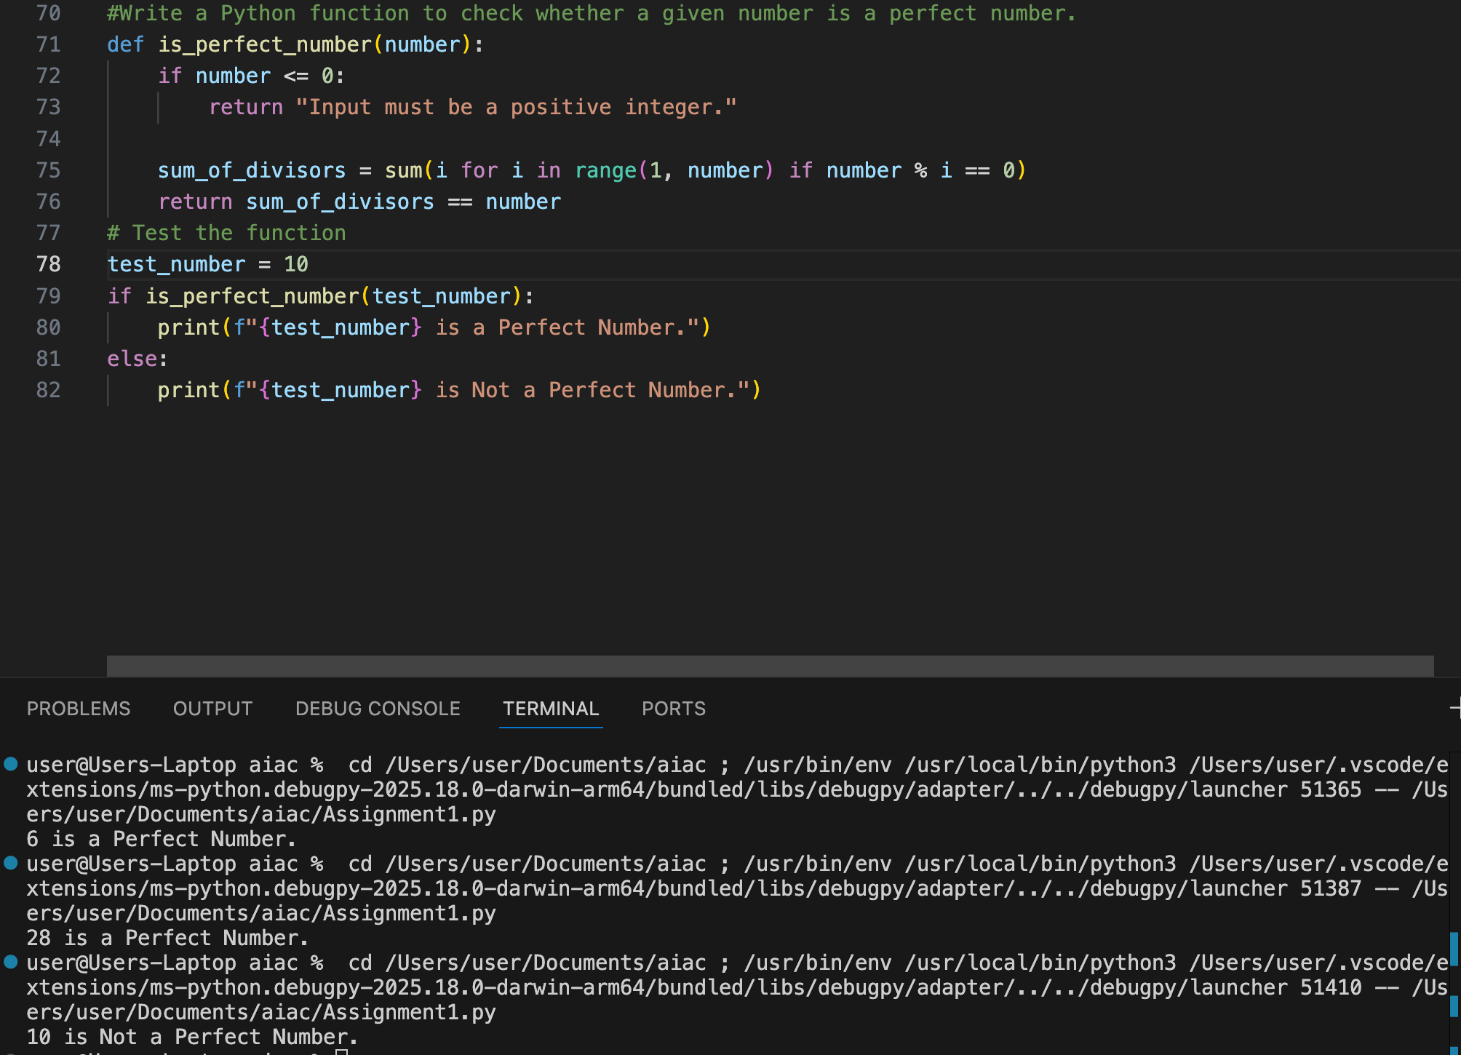

Question 6: Few-Shot Prompting – Even or Odd with Validation

Few-Shot Prompt
“Write a Python program to classify numbers.
Examples:
8 → Even
15 → Odd
0 → Even”

AI-Generated Code
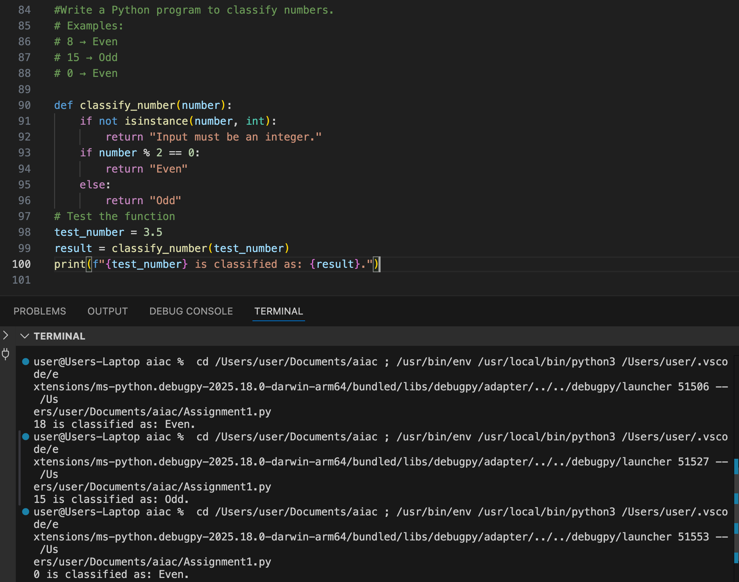

Conclusion
Zero-shot prompting works for simple logic but lacks validation.
One-shot prompting improves correctness.
Few-shot prompting produces the most structured and accurate code.
Context-managed prompts deliver optimized and production-ready solutions.

