ASSIGNMENT-9.3
Name: M.Rohan
HT. No: 2303A51545
Batch: 08
Lab 9: Documentation Generation – Automatic Documentation and Code Comments Task 1: Basic Docstring Generation
Scenario
You are developing a utility function that processes numerical lists and must be properly documented for future maintenance.
Requirements
- Write a Python function to return the sum of even numbers and sum of odd numbers in a given list
- Manually add a Google Style docstring to the function
- Use an AI-assisted tool (Copilot / Cursor AI) to generate a function-level docstring
- Compare the AI-generated docstring with the manually written docstring
- Analyze clarity, correctness, and completeness Expected Output
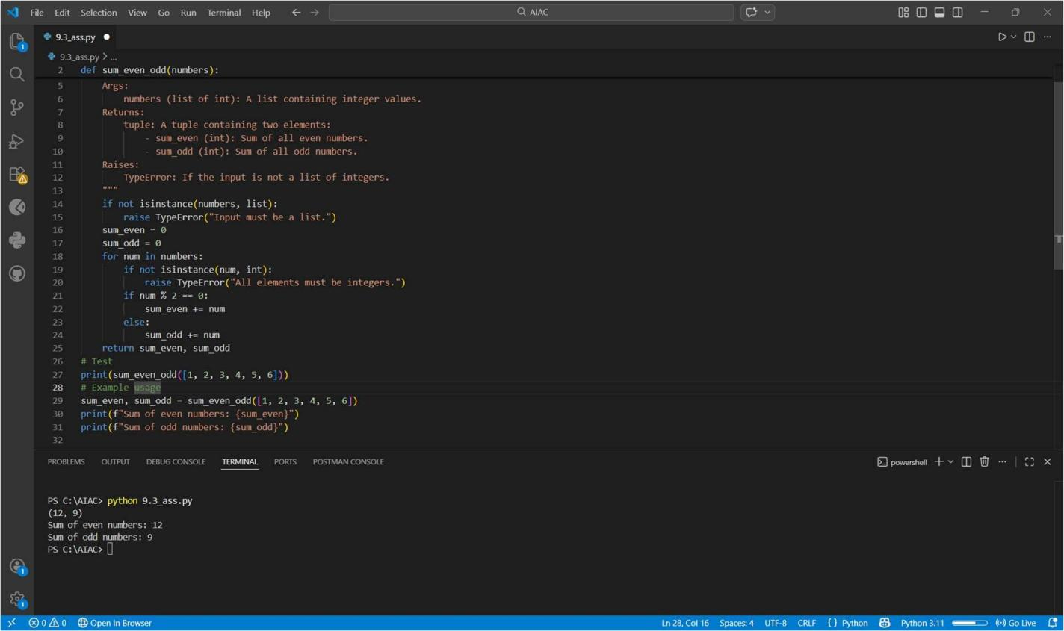
Task 2: Automatic Inline Comments Scenario
You are developing a student management module that must be easy to understand for new developers.
Requirements
- Write a Python program for an sru_student class with the following:
- Attributes: name, roll_no, hostel_status
- Methods: fee_update() and display_details()

- Manually write inline comments for each line or logical block
- Use an AI-assisted tool to automatically add inline comments
- Compare manual comments with AI-generated comments
- Identify missing, redundant, or incorrect AI comments Expected Output
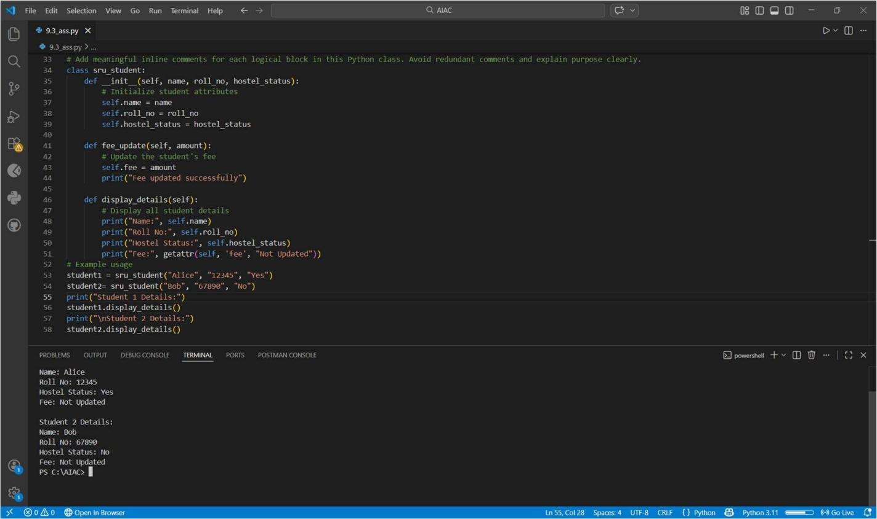
Task 3: Module-Level and Function-Level Documentation Scenario
You are building a small calculator module that will be shared across multiple projects and requires structured documentation.
Requirements
- Write a Python script containing 3–4 functions (e.g., add, subtract, multiply, divide)
- Manually write NumPy Style docstrings for each function
- Use AI assistance to generate:
- A module-level docstring
- Individual function-level docstrings
- Compare AI-generated docstrings with manually written ones
- Evaluate documentation structure, accuracy, and readability Expected Output

