


Faculty of Computers and Artificial Intelligence
Third Year – 2026
E-commerce Order & Supply Chain
Data Warehouse Project

Dr. Ali Zidane
TA: Nourhan Ihab
S3,4

Name | ID
Mariam Ehab | 20231160
Rahma Bahgat | 20231056
Rawda Raafat | 20231067

The Source we got the dataset from: Ecommerce Order & Supply Chain Dataset from Kaggle

1. Source System Physical Model

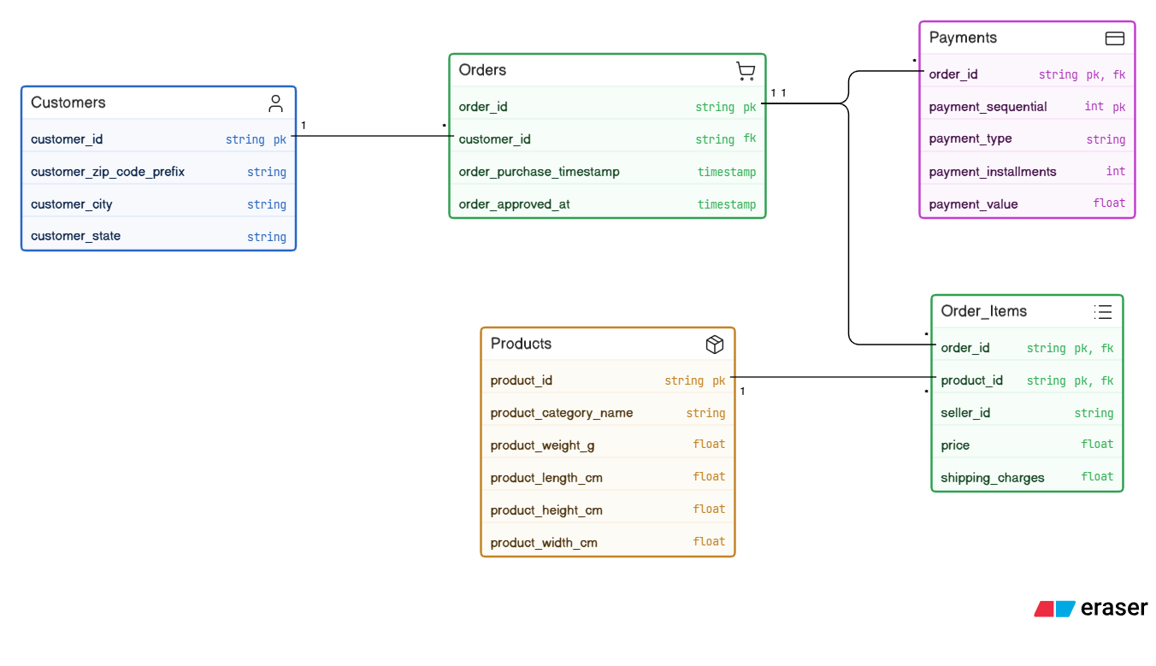

2. KPIs
- Average Order Value: This tells us how much money customers normally spend when they place an order.
  - payment_value in Fact_Payments (or the sum of price in Fact_OrderItems) grouped by order_id.
- Approval Lead Time: This shows us how long it takes for a seller to confirm an order after a customer buys something. It helps us see how good the seller is at getting orders ready to go.
  - Approval_Lead_Time_Hours measure in Fact_Order_Approvals (calculated from order_purchase_timestamp and order_approved_at).
- Freight Burden Ratio: This is what we get when we compare the cost of shipping to the cost of the product, and it helps us understand how much money we spend on shipping for each product.
  - shipping_charges and price measures in Fact_OrderItems.
- Payment Method Distribution: This shows us where our money is coming from like which types of payments people use.
  - payment_value in Fact_Payments joined with Dim_PaymentType.
- Installment Utilization Rate: This tells us what percentage of our sales are paid over time instead of all at once.
  - payment_installments measure in Fact_Payments.

3. Dimensional Model

a. Define the business processes that you will model:
The data warehouse examines the e-commerce platform's three primary business processes:
1) Product Sales: This involves monitoring the goods that are sold to clients as well as their prices and delivery expenses.

2) Financial Processing: This involves keeping track of and examining the payments that are made, the ways in which they are processed, and the plans that are utilized to pay for things.

3) Fulfillment Lifecycle: This refers to tracking an order's progress from the time a customer places it until it is accepted.

b. Declare the grain of each fact table:
- Fact_OrderItems: One row represents a single individual product (item) within a purchase order.
- Fact_Payments: One row represents a single, sequential payment transaction for an order.
- Fact_Order_Approvals: One row is inserted once the order approval event occurs, recording the lead time between purchase and approval for that specific order.

c. Define the type of each fact table:
- Fact_OrderItems: Transactional Fact Table.
- Fact_Payments: Transactional Fact Table.
- Fact_Order_Approvals: Transactional Fact Table.

d. Define the dimensions and the type of each one:

Dimension Name | Dimension Type | Description & Justification
Dim_Date | Conformed & Role-Playing Dimensions | A shared, standardized dimension utilized consistently across all three fact tables to ensure unified reporting.
Dim_Time | Role Playing Dimension | A single physical table that plays multiple logical roles (Purchase Time, Approval Time) within the order approvals fact table.
order_id & seller_id | Degenerate Dimension | Transactional identifiers stored directly within the Fact Tables without a separate dimension table, used for grouping and tracing.
Dim_PaymentType | Junk Dimension | Consolidates low-cardinality attributes (payment_type) and a derived flag (Is_Installment_Flag) into a single table
Dim_Geography | Static Dimension | A fixed reference table for geographic data (Zip Code, City, State) that rarely or never changes.
Dim_Customer | SCD Type 2 | To track historical changes in a customer's location over time using EffectiveDate, ExpirationDate, and IsCurrent flags.
Dim_Product | SCD Type 1 | To store physical product attributes. Any attribute updates will directly overwrite the existing data.

e. Define the measures that will appear in the fact tables and the type of each one:
- Fact_OrderItems:
  - price (Numeric, Fully Additive)
  - shipping_charges (Numeric, Fully Additive)
- Fact_Payments:
  - payment_value (Numeric, Fully Additive)
  - payment_installments (Numeric, Non-additive)
- Fact_Order_Approvals:
  - Approval_Lead_Time_Hours (Numeric, Semi-additive)

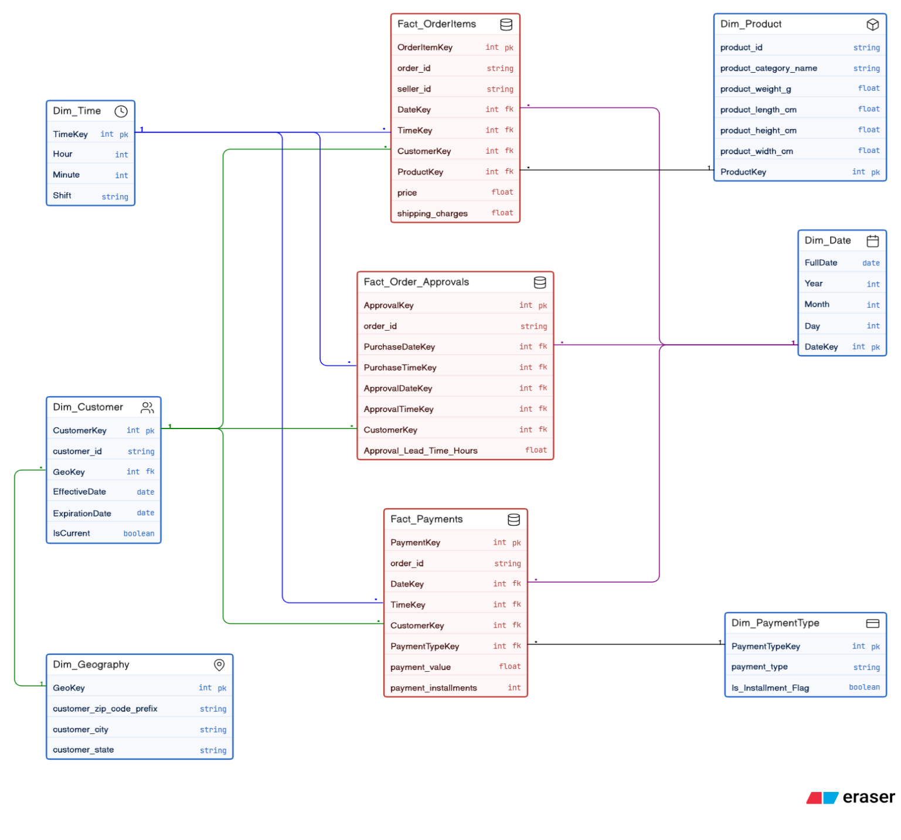
f. Physical model of your model (the final star/galaxy schema):

