**NERVOUS SYSTEM**

* The body’s command center
* It’s made up of your brain, spinal cord and nerves.
* Your nervous system works by sending messages, or electrical signals, between your brain and all the other parts of your body. These signals tell you to breathe, move, speak and see.

**Function**

1. Receiving sensory input
2. Integrating Information
3. Controlling muscles and glands
4. Maintaining homeostasis
5. Establishing and maintaining mental activity

**Two major divisions**

1. **Central Nervous System (CNS)**

* Consists of the brain and spinal cord

1. **Peripheral Nervous System (PNS)**

* Consists of the nerves and ganglia
* The communication link between the CNS and the various parts of the body
* It carries information about the different tissues of the body to the CNS and delivers commands from the CNS to other body tissues that alter body activities.

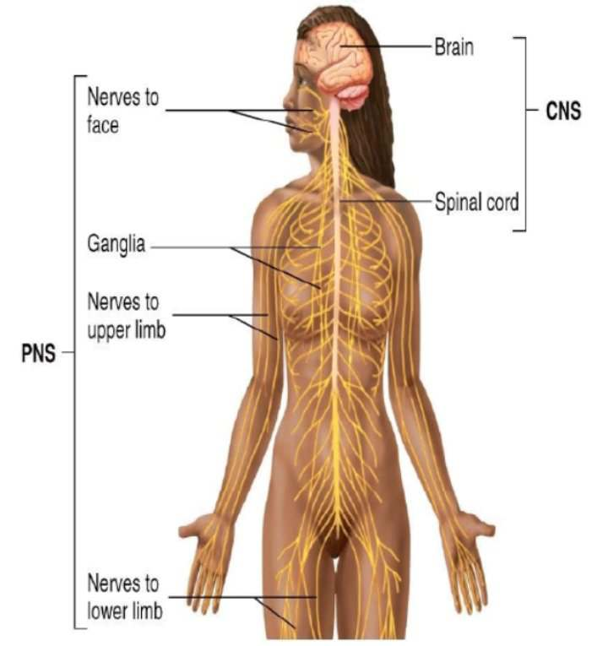

**The PNS can be divided into two parts:**

1. **Sensory division or Afferent division (toward)**

* Conducts action potentials from sensory receptors to the CNS

**Sensory neuron**

* Neurons that carry signals from the outer parts of your body (periphery) into the CNS
* (Periphery – CNS)

1. **Motor division or Efferent division (away)**

* Conducts action potentials from the CNS to effector organs, such as the muscles and glands

**Motor neuron**

* Neurons that transmit action potentials from the CNS toward the periphery
* (CNS – Periphery)

**The PNS can be further divided based on what it does:**

1. **Somatic Nervous System (SNS)**

* Transmits action potentials from the CNS to skeletal muscles
* Voluntary movement

1. **Autonomic Nervous System (ANS)**

* Transmit action potentials from the CNS to cardiac muscle, smooth muscle, and glands.
* Involuntary movement

**Autonomic division is divided into:**

1. Sympathetic division
2. Parasympathetic division

**Enteric Nervous System (ENS)**

* Unique subdivision of the peripheral nervous system
* Has both sensory and motor neurons contained wholly within the digestive tract
* It can function without input from the CNS or other parts of the PNS

**CELLS OF THE NERVOUS SYSTEM**

**Two types of cells that make up the nervous system**

* **Neurons**
* **Glial cells**

1. **Neurons or nerve cells**

* Receive stimuli, conduct action potentials, and transmit signals to other neurons or effector organs.

**Three parts of the neuron**

1. **Cell body or Soma**

* Contains a single nucleus. The nucleus of the neuron is the source of information for gene expression

1. **Dendrites**

* Short, often highly branching cytoplasmic extensions that are tapered from their bases at the neuron cell body to their tips.
* Usually receives information from other neurons or from sensory receptors and transmit the information toward the neuron cell body

1. **Axon**

* A single long cell process extending from the neuron cell body
* Sensory neurons that conduct action potentials toward the CNS, and axons of motor neurons conduct action potentials away from the CNS.
* Axon may remain branched or unbranched to form **Collateral Axons**

**Axon Hillock**

* The area where the axon leaves the neuron cell body

**Types of Neurons**

1. **Multipolar neurons**

* Have many dendrites and a single axon
* Most common neurons in the CNS
* All motor neurons are multipolar

1. **Bipolar neurons**

* Have two processes: one axon and one dendrite
* Located in some sensory organs, such as in the retina of the eye and in the nasal cavity

1. **Pseudo-unipolar neuron**

* Have a single process extending from the cell body
* This process divides into two process a short distance from the cell body. One process extends to the periphery, and the other extends to CNS

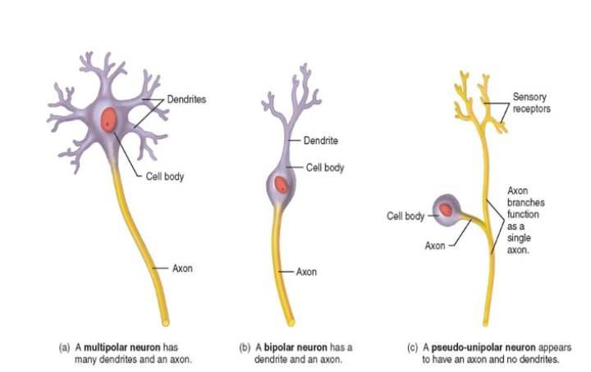

1. **Glial Cells or neuroglia nerve**

* Supportive cells of the CNS and PNS, these cells do not conduct action potentials
* Carries out different functions that enhance neuron functions and maintain normal conditions within nervous tissue

**Glial cells of the CNS**

1. **Astrocytes**

* Serve as the major supporting cells in the CNS
* They can stimulate or inhibit the signaling activity of nearby neurons
* It participates with the blood vessel endothelium to form a permeability barrier called **blood-brain barrier**

1. **Ependymal cell**

* Line the fluid-filled cavities (ventricles and canals) within the CNS
* Some produces cerebrospinal fluid, and others with cilia, help move the cerebrospinal fluid through the CNS

1. **Microglia**

* Act as immune cells of the CNS
* Help protect the brain by removing bacteria and cell debris

1. **Oligodendrocytes**

* Provide an insulating material that surrounds the axons

**Glial cells of the PNS**

1. **Schwann cells**

* Provide insulating material around axons

1. **Satellite cells**

* Found around the cell bodies of certain neurons of the PNS.
* These cell provide support and nutrition to the neurons and protect the neurons from heavy-metal poisons, such as leas and mercury

**Mylelin Sheaths**

* Specialized cell layers that wrap around the axons of some neurons
* Formed by the cell processes of oligodendrocytes in the CNS and Schwann cells in the PNS

**Myelinated axon**

* With two Schwann cells forming part of the myelin sheath around a single axon. Each Schwann cell surrounds part of one axon

**Unmyelinated axon**

* With two Schwann cells surrounding several axons in parallel formation. Each Schwann cell surrounds part of several axons

**Nodes of Ranvier**

* Gaps in the myelin sheath
* Occurs every millimeter between the myelinated areas.
* Ion movement can occur

**Organization of Nervous Tissue**

The nervous tissue varies in color due to the location and arrangement of the parts of neurons and glial cells. Nervous tissue exists as gray and white matter

**Gray matter**

* Consists of groups of neuron cell bodies and their dendrites, where there is very little myelin

**Cortex**

* In CNS
* The gray matter on the surface of the brain

**Nuclei**

* Clusters of gray matter located deeper within the brain

**Ganglion**

* In the PNS
* A cluster of neuron cell bodies

**White matter**

* Consists of bundles of parallel axons with their myelin sheaths, which are whitish color
* White matter of the PNS consists of bundles of axons and associated connective tissue that forms **nerves**

**Nerve tracts**

* Also called Conduction pathways
* Formed from the white matter of the CNS
* Propagate action potentials from one area of the CNS to another

**ELECTRICAL SIGNALS AND NEURAL PATHWAYS**

**Resting membrane potential**

* Results from the charge difference across the membrane of cells
* Is set by leak ion channels and the sodium-potassium pump

**Two basic type of Ion channels**

**Leak channels**

* Are always open
* Ions can leak across the membrane, down their concentration gradient

**Gated channels**

* Are closed until opened by specific signals

**Chemically gated channels**

* Are opened by specific chemicals

**Voltage-gated channels**

* Are opened by a change in the electrical property of the cell membrane

**Polarized**

* A  [lipid membrane](https://en.wikipedia.org/wiki/Lipid_bilayer) that has a positive [electrical charge](https://en.wikipedia.org/wiki/Electrical_charge) outside and a negative charge on the inside, which produces the [resting potential](https://en.wikipedia.org/wiki/Resting_potential) in living cells.
* Uneven charge distribution across the cell membrane means that the membrane is polarized

**CENTRAL AND PERIPHERAL NERVOUS SYSTEM**

**Spinal cord**

* Extends from the foramen magnum at the base of the skull to the second lumbar vertebra
* Spinal nerves communicate between the spinal cord and the body

**Cauda equina**

* The inferior end of the spinal cord and the spinal nerves exiting there resemble a horse’s tail

A cross section reveals that the spinal cord consists of a superficial white matter portion and a deep gray matter portion. The white matter consists of myelinated axons, and the gray matter is mainly a collection of neuron cell bodies.

The white matter in each half of the spinal cord is organized into three columns:

1. Dorsal column (posterior)
2. Ventral column (anterior)
3. Lateral column

**Ascending tracts**

* Consists of axons that conduct action potentials toward the brain

**Descending tracts**

* consists of axons that conduct action potentials away from the brain

The gray matter of the spinal cord is shaped like the letter H, with dorsal horns (posterior) and ventral horns (anterior).

Small **lateral horns**

* exists in levels of the spinal cord associated with autonomic nervous system

**Central canal**

* A fluid-filled space in the center of the spinal cord

Spinal nerves arise from numerous rootlets along the dorsal and ventral surfaces of the spinal cord. The ventral rootlets combine to form a ventral root on the ventral side of the spinal cord, and the dorsal rootlets combine to form a dorsal root on the dorsal side of the spinal cord. The ventral and dorsal roots unite just lateral to the spinal cord to form a spinal nerve.

**Dorsal root ganglion** (swelling or knot)

* A region in the dorsal root
* Contains the cell bodies of pseudo-unipolar sensory neurons

**Reflex**

* Is an involuntary reaction in response to a stimulus applied to the periphery and transmitted to the CNS
* Allow a person to react to stimuli more quickly than is possible if conscious thought is involved

**Reflex arc**

* The neuronal pathway by which a reflex occurs
* Basic functional unit of the nervous system because it is the smallest, simplest pathway capable of receiving a stimulus and yielding a response

**Five basic components of a reflex**

1. Sensory receptor
2. Sensory neuron
3. Interneurons
4. Motor neuron
5. Effector organ (muscles or glands)

Note: the simplest reflex arc does not involve interneurons. Most reflexes occur in the spinal cord or brainstem rather than in the higher brain centers.

**Stretch reflex**

* The simplest reflex
* Occurs when muscles contract in response to a stretching force applied to them

**Knee-jerk reflex or patellar reflex**

* A classic example of a reflex involving the spinal cord
* It is used by clinicians to determine if the higher CNS centers that normally influence this reflex are functional

**Withdrawal reflex**

* Also called as flexor reflex
* Function is to remove a limb or another body part from a painful stimulus

**Spinal nerves**

* Arise along the spinal cord from the union of the dorsal roots and ventral roots

**Mixed nerves**

* any nerve that contains both sensory (afferent) and motor (efferent nerve fibers). All 31 pairs of spinal nerves are **mixed nerves**

**Dermatome**

* the area of skin supplied with sensory innervation by a pair of spinal nerves
* each of the spinal nerves except C1 has a specific cutaneous sensory distribution

**Dermatomal**

* map for the sensory cutaneous distribution of the spinal nerves

**Plexuses**

* where neurons of several spinal nerves come together and intermingle

**Three major plexuses**

1. Cervical Plexus
2. Brachial Plexus
3. Lumbosacral Plexus

The major nerves of the neck and limbs are branches of these plexuses. Spinal nerves T2 through T11 do no join a plexus. Instead, these nerves extend around the thorax between the ribs, giving of branches to muscles and skin

**Coccygeal plexus**

* Supplies motor innervation to the muscles of the pelvic floor and sensory cutaneous innervation to the skin over the coccyx

**Cervical plexus**

* Originates from spinal nerves C1 to C4
* Branches from this plexus innervate several of the muscles attached to the hyoid bone, as well as the skin of the neck and posterior portion of the head
* Important branches of the cervical plexus are the **phrenic nerve**, which innervates the diaphragm. Contraction of the diaphragm is largely responsible for our ability to breathe

**Brachial plexus**

* Originates from spinal nerves C5 to T1
* Five major nerves emerge from the brachial plexus to supply the upper limb and shoulder

**Axillary nerve**

* Innervates two shoulder muscles and skin over part of the shoulder

**Radial nerve**

* Innervates all the muscles in the posterior arm and forearm as well as the skin over the posterior surface of the arm, forearm, and hand
* Lies very close to the medial side of the humerus in the proximal part of the arm and is susceptible to damage in that area

**Crutch paralysis**

* Occurs when a person uses crutches improperly
* Subsides once the patient starts using the crutches correctly

**Musculocutaneous nerve** (muscle + skin)

* Innervates the anterior muscles of the arm and the skin over the radial surface of the forearm

**Ulnar nerve**

* Innervates two anterior forearm muscles and most of the intrinsic hand muscles
* It also innervates the skin over the ulnar side of the hand
* The ulnar nerve can be easily damaged where it passes posterior to the medial side of the elbow
* The ulnar nerve at this location is called the “**funny bone**”

**Median nerve**

* Innervates most of the anterior forearm muscles and some of the intrinsic hand muscles
* It also innervates the skin over the radial side of the hand

**Lumbosacral plexus**

* Originates from spinal nerves L1 to S4
* Four major nerves exit the lumbosacral plexus to supply the lower limb

**Obturator nerve**

* Innervates the muscles of the medial thigh and the skin over the same region

**Femoral nerve**

* Innervates the anterior thigh muscles and the skin over the anterior thigh and medial side of the leg

**Tibial nerve**

* Innervates the posterior thigh muscles, the anterior and posterior leg muscles, and most of the intrinsic foot muscles
* It also innervates the skin over the sole of the foot

**Common fibular nerve**

* Innervates the muscles of the lateral thigh and leg and some intrinsic foot muscles
* It also innervates the skin over the anterior and lateral leg and the dorsal surface (top) of the foot

The tibial and common fibular nerves are bound together within a connective tissue sheath and together are called the **Sciatic nerve**