1. History:

m4 da tb3 el history?

y3ni homa (recent, upvoted, downvoted, and hidden) m4 bs upvoted.

1. Subreddit:
   1. The user can join or leave subreddit using subreddit name
   2. Get if the user joined the subreddit not, also if mod or not (when get subreddit), may be a new end point but also, using the name of subreddit. You may change get subreddit by name body to contain subreddit id, thus the end points can use subreddit id.

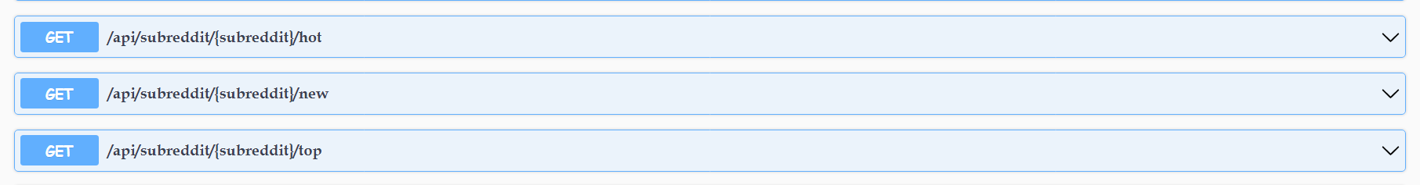 + rising + controversial



* 1. List of moderators
  2. Cake date (creation date)

1. For create post:
   1. Subreddits the user joined