- 伊钱卡拉古城 Ичан-Калы（Itchan Kala )
入选世界遗产时间：1990年

（简介）Itchan Kala is the inner town (protected by brick walls some 10 m high) of the old Khiva oasis, which was the last resting-place of caravans before crossing the desert to Iran. Although few very old monuments still remain, it is a coherent and well-preserved example of the Muslim architecture of Central Asia. There are several outstanding structures such as the Djuma Mosque, the mausoleums and the madrasas and the two magnificent palaces built at the beginning of the 19th century by Alla-Kulli-Khan.

伊钱卡拉（Itchan Kala）是古代希瓦绿洲的内城（由约10米高的砖墙环绕保护），曾是商队穿越沙漠前往伊朗前的最终休整地。尽管留存至今的古老遗迹有限，但它完整统一且保存完好，堪称中亚伊斯兰建筑的典范。城内有多座杰出建筑，包括朱玛清真寺（Djuma Mosque）、陵墓群、经学院，以及19世纪初由阿拉-库里汗（Alla-Kulli-Khan）主持修建的两座宏伟宫殿。///

（详细）Itchan Kala, the inner fortress of Khiva, is located to the South of the Amu Darya River (known as the Oxus in ancient times) in the Khorezm region of Uzbekistan and it was the last resting-place of caravans before crossing the desert to Persia.

Itchan Kala has a history that spans over two millennia. The inner town has 26 hectares and was built according to the ancient traditions of Central Asian town building, as a regular rectangle (650 by 400 meters) elongated from south to north and closed by brick fortification walls that are up to ten meters high.

The property is the site of 51 ancient monumental structures and 250 dwellings and displays remarkable types of architectural ensembles such as Djuma Mosque, Oq Mosque, madrasahs of Alla-Kulli-Khan, Muhammad Aminkhon, Muhammad Rakhimkhon, Mausoleums of Pahlavon Mahmoud, Sayid Allavuddin, Shergozikhon as well as caravanserais and markets. The attributes are outstanding examples of Islamic architecture of Central Asia. Djuma Mosque, a mosque with a covered courtyard designed for the rugged climate of Central Asia, is unique in its proportions and the structure of its inner dimensions (55m x 46m), faintly lit by two octagonal lanterns and adorned with 212 columns. The madrasahs, which make up the social areas, have majestic proportions with a simple decoration, and they form another type of Islamic architecture specific to Central Asia.

The place of the architectural heritage of Itchan Kala in the history of Central Asian architecture is determined not only by the abundance of surviving architectural monuments, but also by the unique contribution of Khorezmian master builders to Central Asian architecture and preservation of its classical traditions. The domestic architecture of Khiva, with its enclosed houses with their courtyard, reception room with portico or avian supported by delicately sculptured wooden posts, and private apartments, is also an important attribute of the property that can be studied in its 18th- and 20th-century morphological variants.

伊钱卡拉是希瓦古城的内城要塞，位于乌兹别克斯坦花剌子模地区的阿姆河（古代称乌浒水，Oxus）以南，曾是商队穿越沙漠前往波斯前的最终休整地。
伊钱卡拉拥有跨越两千多年的历史。内城占地26公顷，依照中亚古城建设的古老传统建造，呈南北延伸的规则矩形（650米×400米），四周由高达10米的砖砌防御城墙封闭。

该遗产地包含51座古代纪念性建筑和250处民居，展现了多种杰出的建筑群类型，例如朱玛清真寺（Djuma Mosque）、奥克清真寺（Oq Mosque）、阿拉-库里汗经学院（Alla-Kulli-Khan Madrasah）、穆罕默德·阿明汗经学院（Muhammad Aminkhon Madrasah）、穆罕默德·拉希姆汗经学院（Muhammad Rakhimkhon Madrasah）、帕赫拉万·马赫穆德陵墓（Pahlavon Mahmoud Mausoleum）、赛义德·阿拉乌丁陵墓（Sayid Allavuddin Mausoleum）、谢尔戈兹汗建筑群（Shergozikhon Complex），以及商队旅馆和市场。这些建筑是中亚伊斯兰建筑的杰出典范。

朱玛清真寺是一座为适应中亚严酷气候设计的带顶庭院的清真寺，其比例和内部空间结构（55米×46米）独具特色，由两座八角形灯笼微弱照明，并装饰有212根立柱。构成社交区域的经学院则具有宏伟的比例和简约的装饰，代表了中亚特有的另一类伊斯兰建筑形式。

伊钱卡拉建筑遗产在中亚建筑史中的地位不仅源于其丰富的现存建筑遗迹，更因花剌子模匠人对中亚建筑的独特贡献及其对古典传统的保护而确立。希瓦的民居建筑——包括带庭院的封闭式住宅、由精雕木柱支撑的门廊或柱廊的接待厅，以及私人居所——也是该遗产地的重要特征。

However, the outstanding qualities of Itchan Kala derive not so much from the individual monuments but also from the incomparable urban composition of the city, and from the harmony with which the major constructions of the 19thand 20th centuries were integrated into a traditional structure.

然而，伊钱卡拉的杰出价值不仅源于其单体建筑遗迹，更在于其无与伦比的城市肌理，以及19至20世纪新建重要建筑与传统结构的有机融合所达成的和谐统一。

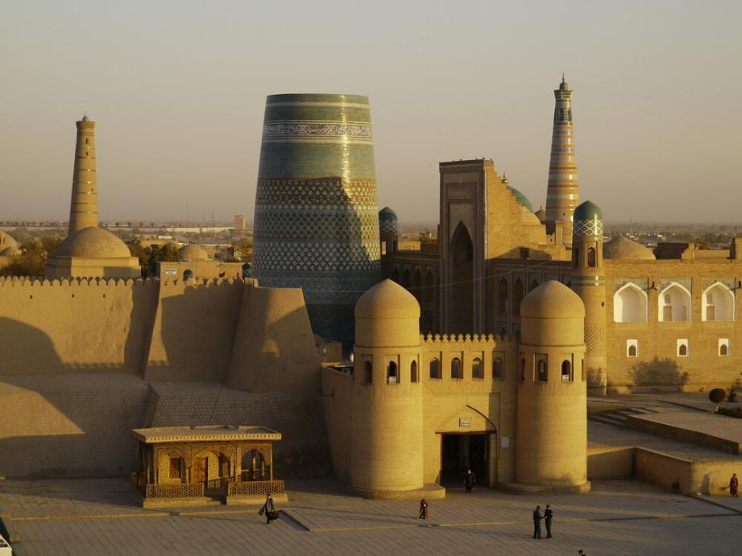
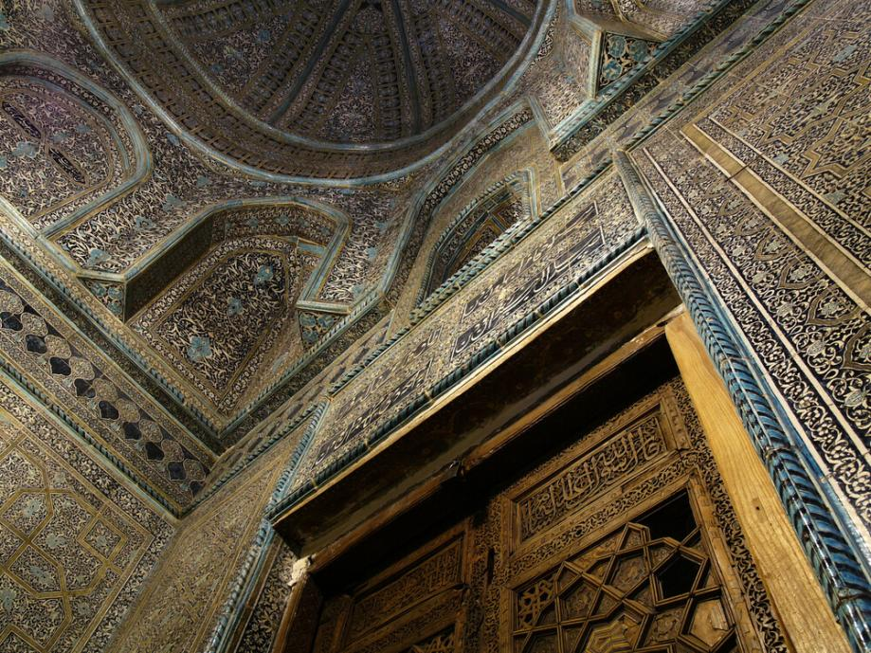
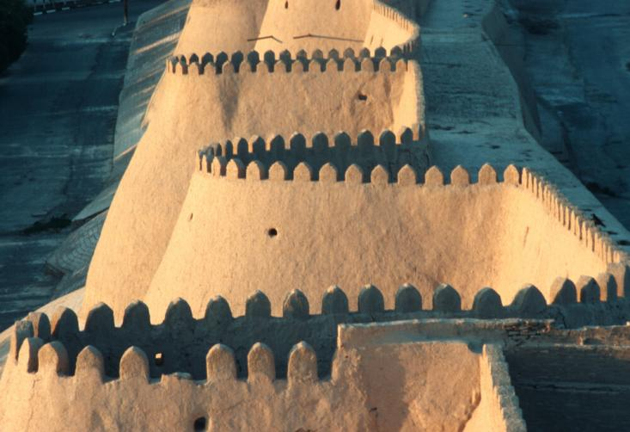

- 布哈拉历史中心 исторический центр Бухары（Historic Centre of Bukhara）
入选世界遗产：1993年

（简介）Bukhara, which is situated on the Silk Route, is more than 2,000 years old. It is the most complete example of a medieval city in Central Asia, with an urban fabric that has remained largely intact. Monuments of particular interest include the famous tomb of Ismail Samani, a masterpiece of 10th-century Muslim architecture, and a large number of 17th-century madrasas.
布哈拉坐落于丝绸之路上，拥有逾两千年的历史。它是中亚中世纪城市最完整的典范，其城市肌理基本保存完好。其中极具历史价值的建筑包括伊斯梅尔·萨曼尼陵墓（Ismail Samani Tomb）——10世纪伊斯兰建筑的杰作，以及大量17世纪经学院建筑群。

（详细）The Historic Centre of Bukhara, situated on the Silk Roads, is more than two thousand years old. It is one of the best examples of well preserved Islamic cities of Central Asia of the 10th to 17th centuries, with an urban fabric that has remained largely intact.

Bukhara was long an important economic and cultural center in Central Asia. The ancient Persian city served as a major center of Islamic culture for many centuries and became a major cultural center of the Caliphate in the 8th century.

With the exception of a few important vestiges from before the Mongol invasions of Genghis Khan in 1220 and Temur in 1370, the old town bears witness to the urbanism and architecture of the Sheibani period of Uzbek rule, from the early 16th century onwards. The citadel, rebuilt in the 16th century, has marked the civic center of the town since its earliest days to the present,

Important monuments that survive from early times include the famous Ismail Samanai tomb, impressive in its sober elegance and the best surviving example of 10th century architecture in the whole Muslim world. From the 11th century Karakhanid period comes the outstanding Poi-Kalyan minaret, a masterpiece of decoration in brick, along with most of the Magoki Attori mosque and the Chashma Ayub shrine. The Ulugbek medresseh is a surviving contribution from Temurid. With the advent of the Sheibanids came some of the most celebrated buildings of Bukhara: the Poi-Kalyan group, the Lyabi-Khauz ensemble, the Kosh Medresseh and the Gaukushon medresseh in the Hodja-Kalon ensemble. Later buildings from this phase of Bukhara´s history include monumental medressehs at important crossroads: Taki Sarafon (Dome of the Moneychangers), Taki-Tilpak-Furushan (Dome of the Headguard Sellers), Tim-Bazzazan, and Tiro-Abdullah-Khan. In the early 17th century fine buildings were added, including a new great mosque, Magoki Kurns (1637), and the imposing Abdullaziz-Khan medresseh (1652).

However, the real importance of Bukhara lies not in its individual buildings but rather in its overall townscape, demonstrating the high and consistent level of urban planning and architecture that began with the Sheibanid dynasty.

布哈拉历史中心（Historic Centre of Bukhara）坐落于丝绸之路上，拥有两千多年的历史。作为10至17世纪中亚伊斯兰城市中保存最完好的典范之一，其城市肌理基本完整存续。

布哈拉长期作为中亚重要的经济与文化中心。这座古老的波斯城市在多个世纪里一直是伊斯兰文化的核心地标，并于8世纪成为哈里发国的主要文化枢纽。

除1220年成吉思汗西征与1370年帖木儿入侵前遗留的少数重要遗迹外，老城区主要见证了16世纪乌兹别克昔班尼王朝时期的城市规划与建筑风貌。自16世纪重建的城堡（Citadel）至今仍是城市的核心公共空间。

早期存世的重要遗迹包括著名的伊斯梅尔·萨曼尼陵墓（Ismail Samanai Tomb）——以其庄重优雅的风格著称，是整个伊斯兰世界10世纪建筑的最佳遗存。11世纪喀喇汗王朝时期则留下了杰出的波伊·卡扬宣礼塔（Poi-Kalyan Minaret），以及马戈基·阿托里清真寺（Magoki Attori Mosque）主体部分和查什玛·阿尤布圣殿（Chashma Ayub Shrine）。兀鲁伯经学院（Ulugbek Medresseh）是帖木儿王朝的遗存杰作。昔班尼王朝时期诞生了布哈拉最负盛名的建筑群：波伊·卡扬建筑群、拉比·豪兹广场（Lyabi-Khauz Ensemble）、双经学院（Kosh Medresseh）以及霍加·卡隆建筑群（Hodja-Kalon Ensemble）中的高库尚经学院（Gaukushon Medresseh）。此后还涌现出位于重要路口的纪念性经学院：钱商穹顶市集（Taki Sarafon）、头巾商穹顶市集（Taki-Tilpak-Furushan）、提姆·巴扎赞（Tim-Bazzazan）与提罗·阿卜杜拉汗经学院（Tiro-Abdullah-Khan Medresseh）。17世纪初新增的精美建筑包括马戈基·库尔纳清真寺（Magoki Kurns Mosque，1637年）与宏伟的阿卜杜拉齐兹汗经学院（Abdullaziz-Khan Medresseh，1652年）。

然而，布哈拉的真正价值不在于单体建筑，而在于其整体城市景观——它展现了自昔班尼王朝起城市规划与建筑艺术高度统一且持续发展的非凡成就。

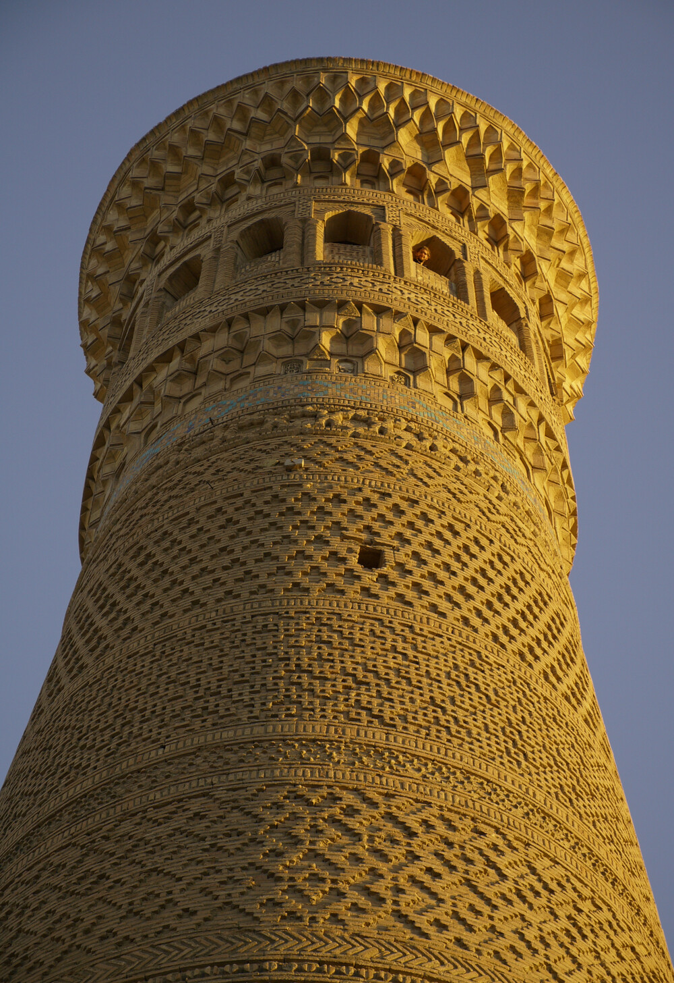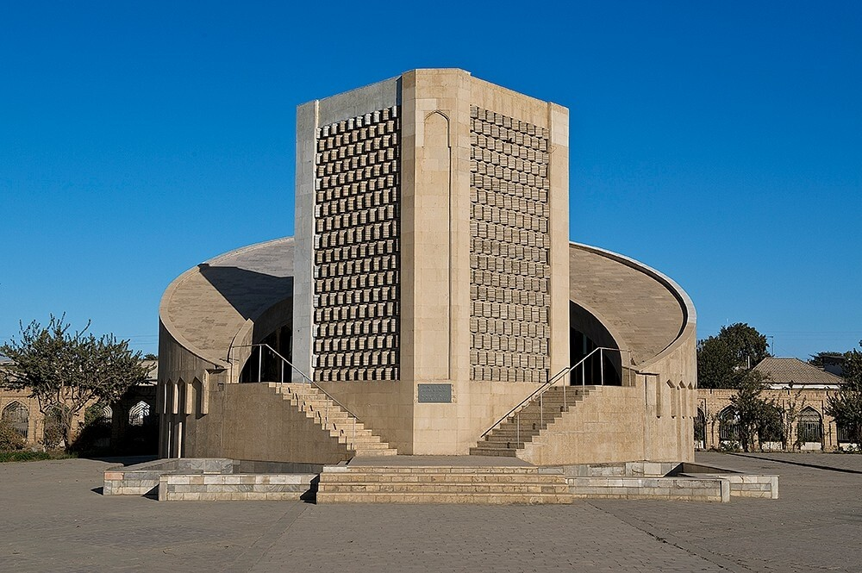

3、沙赫里萨布兹历史中心 Исторический центр Шахрисабза
（Historic Centre of Shakhrisyabz）
入选世界遗产：2000年

（简介）The historic centre of Shakhrisyabz contains a collection of exceptional monuments and ancient quarters which bear witness to the city's secular development, and particularly to the period of its apogee, under the rule of Amir Temur and the Temurids, in the 15th-16th century.

沙赫里萨布兹历史中心（Historic Centre of Shakhrisyabz）汇集了一系列非凡的建筑遗迹与古老街区，见证了这座城市的世俗化发展进程，尤其凸显了15-16世纪在埃米尔·帖木儿（Amir Temur）及其帖木儿王朝（Temurids）统治下达到鼎盛时期的辉煌成就。

（详细）The Historic Centre of Shakhrisyabz, located on the Silk Roads in southern Uzbekistan, is over 2000 years old and was the cultural and political centre of the Kesh region in the 14th and 15th century.

A collection of exceptional monuments and ancient quarters can be found within the medieval walls, parts of which still remain. The Historic Centre of Shakhrisabz bears witness to the city’s secular development and to centuries of its history, and particularly to the period of its apogee, under the empire of Temur, in the 15th century. Construction of elements continued in Shakhrisyabz throughout different time periods, lending a unique character to the place by the succession of different architectural styles. Despite the inroads of time, the remaining vestiges are still impressive in the harmony and strength of styles, an enriching addition to the architectural heritage of Central Asia and the Islamic world.

The Ak-Sarai Palace construction began in 1380, the year following Temur's conquest of Khorezm, whose artisans were deported to work on the palace and provide its rich decoration. Although Samarkand may boast a great many Temurid monuments, not one can rival the Ak-Sarai Palace in Shakhrisyabz. The foundations of its immense gate have been preserved: this architectural masterpiece is outstanding in its dimensions and bold design.

The Dorus Saodat is a vast complex which was destined as a place of burial for the ruling family and contained, in addition to the tombs themselves, a prayer hall, a mosque, and accommodation for the religious community and pilgrims. The main façade was faced with white marble. The tomb of Temur, also of white marble, is a masterpiece of the architecture of this period and it is also one of the finest memorials to be found in Central Asia.

The covered Chor-su bazaar was built at the cross-roads of two main streets, in the form of an octagon with a central cupola, with no particular decoration but with an eye to the exterior effect of bold architecture. The baths, rebuilt on the site of the 15th century baths and still in use today, are heated by an elaborate network of underground conduits.

Shakhrisyabz contains not only outstanding monuments dating from the period of the Temurids, but also mosques, mausoleums, and entire quarters of ancient houses.

In addition to these monuments, the town also offers a variety of interesting constructions of a more modern period, including the Mirhamid, Chubin, Kunduzar, and Kunchibar mosques. Period houses reflect a more popular architectural style, with rooms typically laid out around a courtyard with veranda.

沙赫里萨布兹历史中心（Historic Centre of Shakhrisyabz）位于乌兹别克斯坦南部的丝绸之路上，拥有逾两千年的历史，曾是14至15世纪克什地区（Kesh）的文化与政治中心。

中世纪的城墙（部分仍存）内汇集了众多非凡的建筑遗迹与古老街区。沙赫里萨布兹历史中心见证了这座城市的世俗化发展及其数百年历史进程，尤其是15世纪帖木儿帝国（Empire of Temur）统治下达到鼎盛时期的辉煌。不同时期的持续营建使此地因建筑风格的代际叠加而形成独特风貌。尽管岁月侵蚀，现存遗迹仍以风格之和谐与力量令人惊叹，为中亚及伊斯兰世界的建筑遗产增添了浓墨重彩的一笔。

阿克萨莱宫（Ak-Sarai Palace）始建于1380年，即帖木儿征服花剌子模次年，其工匠被迁至此参与宫殿建造并提供繁复装饰。尽管撒马尔罕拥有众多帖木儿王朝遗迹，但无一能与沙赫里萨布兹的阿克萨莱宫媲美。其巨门基址保存至今，这一建筑杰作以恢弘尺度与大胆设计独树一帜。

多鲁斯·萨奥达特陵寝群（Dorus Saodat）是专为统治家族修建的墓葬建筑群，除墓室本身外，还包含祈祷厅、清真寺以及宗教团体与朝圣者的居所。主立面以白色大理石装饰，帖木儿的白色大理石陵墓（亦位于此）是该时期建筑艺术的巅峰之作，亦是中亚最精美的纪念性建筑之一。

乔尔苏穹顶巴扎（Chor-su Bazaar）建于两条主街交汇处，呈八边形布局，中央穹顶无繁复装饰，但外立面以粗犷建筑效果夺人眼目。浴场重建于15世纪原址之上，至今仍在使用，其供暖系统依托精密的地下管道网络。

沙赫里萨布兹不仅保存着帖木儿王朝时期的杰出建筑，还留存着清真寺、陵墓及成片古老民居街区。

除上述遗迹外，城中亦包含更晚近时期的有趣建筑，如米尔哈米德清真寺（Mirhamid Mosque）、楚宾清真寺（Chubin Mosque）、昆杜扎尔清真寺（Kunduzar Mosque）与昆奇巴尔清真寺（Kunchibar Mosque）。传统民居则体现民间建筑风格，典型布局为带柱廊庭院的环绕式房间。

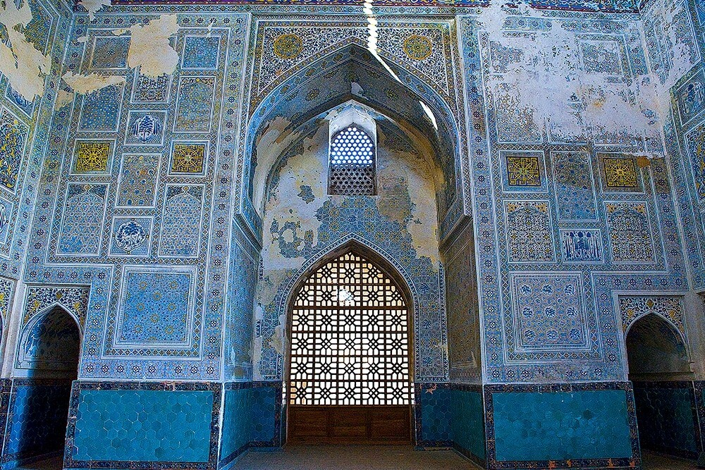
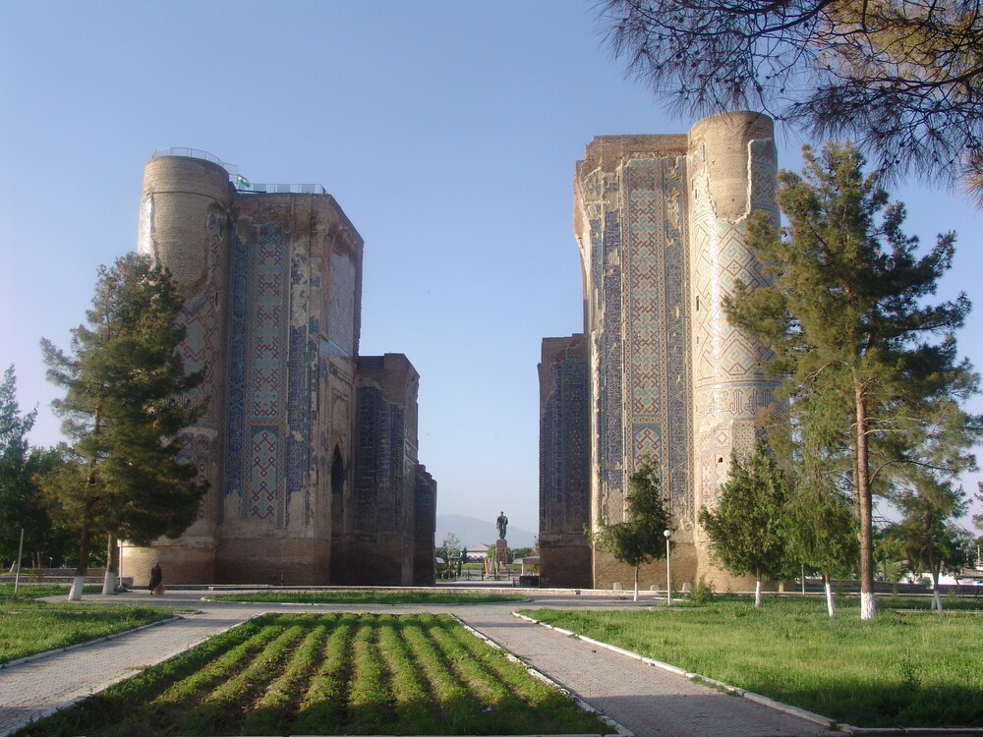

- 撒马尔罕-文化交汇之地Самарканд - перекресток культур（Samarkand – Crossroad of Cultures）
列入世界遗产：2001

（简介）The historic town of Samarkand is a crossroad and melting pot of the world's cultures. Founded in the 7th century B.C. as ancient Afrasiab, Samarkand had its most significant development in the Timurid period from the 14th to the 15th centuries. The major monuments include the Registan Mosque and madrasas, Bibi-Khanum Mosque, the Shakhi-Zinda compound and the Gur-Emir ensemble, as well as Ulugh-Beg's Observatory.

撒马尔罕古城是世界文化的十字路口与熔炉。该城始建于公元前7世纪（古称阿夫拉西阿卜），并于14至15世纪帖木儿王朝时期达到鼎盛发展阶段。主要遗迹包括：
雷吉斯坦广场建筑群（Registan Complex）：含清真寺与经学院群落；
比比-哈努姆清真寺（Bibi-Khanum Mosque）；
沙希-辛达陵墓群（Shakhi-Zinda Compound）；
古尔-埃米尔陵墓群（Gur-Emir Ensemble）；
兀鲁伯天文台（Ulugh-Beg's Observatory）。

（详细）The historic town of Samarkand, located in a large oasis in the valley of the Zerafshan River, in the north-eastern region of Uzbekistan, is considered the crossroads of world cultures with a history of over two and a half millennia. Evidence of settlements in the region goes back to 1500 BC, with Samarkand having its most significant development in the Temurid period, from the 14th to the 15th centuries, when it was capital of the powerful Temurid realm.

The historical part of Samarkand consists of three main sections. In the north-east there is the site of the ancient city of Afrosiab, founded in the 7th century BC and destroyed by Genghis Khan in the 13th century, which is preserved as an archaeological reserve. Archaeological excavations have revealed the ancient citadel and fortifications, the palace of the ruler (built in the 7th century displays important wall paintings), and residential and craft quarters. There are also remains of a large ancient mosque built from the 8th to 12th centuries.

To the south, there are architectural ensembles and the medieval city of the Temurid epoch of the 14th and 15th centuries, which played a seminal role in the development of town planning, architecture, and arts in the region. The old town still contains substantial areas of historic fabric with typical narrow lanes, articulated into districts with social centres, mosques, madrassahs, and residential housing. The traditional Uzbek houses have one or two floors and the spaces are grouped around central courtyards with gardens; built in mud brick, the houses have painted wooden ceilings and wall decorations. The contribution of the Temurid masters to the design and construction of the Islamic ensembles were crucial for the development of Islamic architecture and arts and exercised an important influence in the entire region, leading to the achievements of the Safavids in Persia, the Moghuls in India, and even the Ottomans in Turkey.

To the west there is the area that corresponds to the 19th and 20th centuries expansions, built by the Russians, in European style. The modern city extends around this historical zone. This area represents traditional continuity and qualities that are reflected in the neighbourhood structure, the small centres, mosques, and houses. Many houses retain painted and decorated interiors, grouped around courtyards and gardens.

The major monuments include the Registan mosque and madrasahs, originally built in mud brick and covered with decorated ceramic tiles, the Bibi-Khanum Mosque and Mausoleum, the Shakhi-Zinda compound, which contains a series of mosques, madrasahs and mausoleum, and the ensembles of Gur-Emir and Rukhabad, as well as the remains of Ulugh-Bek’s Observatory.

撒马尔罕古城（Samarkand）位于乌兹别克斯坦东北部泽拉夫尚河流域的广阔绿洲中，被视为世界文化的十字路口，拥有超过两千五百年的历史。该地区的定居点证据可追溯至公元前1500年，而撒马尔罕最重要的发展阶段是14至15世纪的帖木儿王朝时期（Temurid period）——当时它作为强大的帖木儿帝国的都城。

撒马尔罕的历史城区由三个主要部分组成。东北部是阿夫拉西阿卜古城（Afrosiab）遗址，该城建于公元前7世纪，13世纪被成吉思汗摧毁，现作为考古保护区保存。考古发掘揭示了古代城堡与防御工事、统治者宫殿（7世纪建造，存有重要壁画）、居住区与手工业区，以及8至12世纪建造的大型古清真寺遗迹。

南部是14至15世纪帖木儿王朝时期的建筑群和中世纪城区，它们对本地区的城市规划、建筑与艺术发展具有开创性意义。老城区仍保留大量历史肌理，包括典型的狭窄街巷、以清真寺、经学院和社区中心为核心划分的街区，以及传统乌兹别克住宅。这些传统住宅多为1-2层土坯砖建筑，围绕带花园的中央庭院布局，室内装饰彩绘木天花板与墙面图案。帖木儿建筑师对伊斯兰建筑群的设计与建造贡献卓著，深刻影响了波斯萨法维王朝、印度莫卧儿帝国乃至土耳其奥斯曼帝国的建筑与艺术发展。

西部是19至20世纪俄罗斯人建造的欧式风格扩建区，现代城市围绕这一历史区域扩展。该区域体现了传统延续性，体现在社区结构、小型中心、清真寺和住宅中。许多住宅仍保留彩绘内饰，围绕庭院与花园布局。
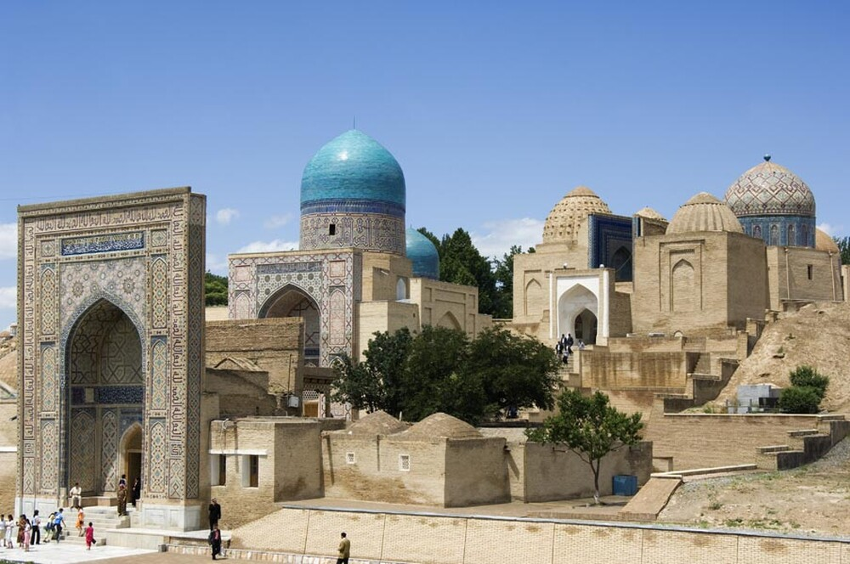
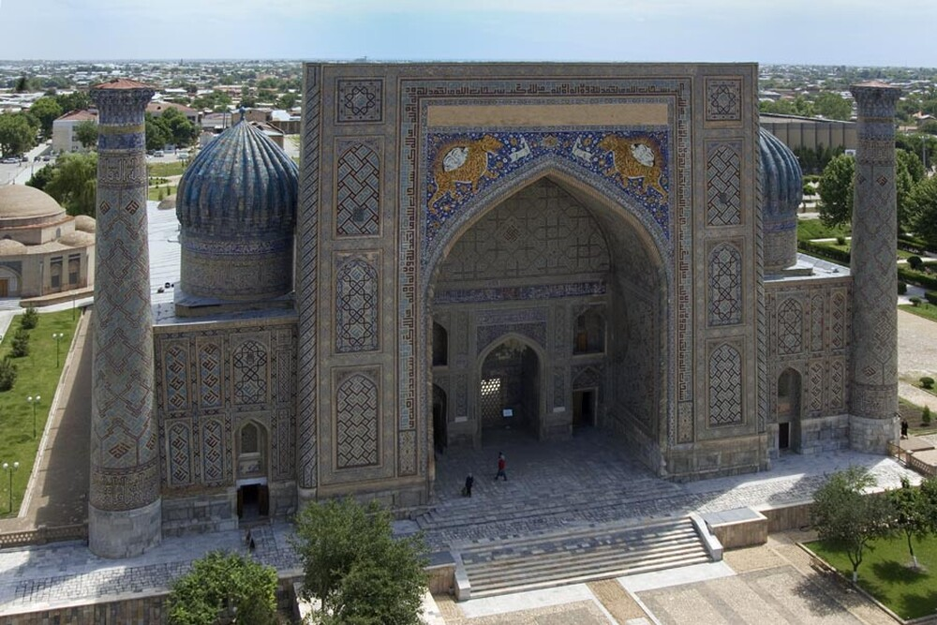

- 西部天山山脉 Западный Тянь-Шань（Western Tien-Shan）
列入世界遗产：2016

（简介）The transnational property is located in the Tien-Shan mountain system, one of the largest mountain ranges in the world. Western Tien-Shan ranges in altitude from 700 to 4,503 m. It features diverse landscapes, which are home to exceptionally rich biodiversity. It is of global importance as a centre of origin for a number of cultivated fruit crops and is home to a great diversity of forest types and unique plant community associations.

这项跨国遗产位于世界最大山系之一的天山山脉（Tien-Shan）中。西部天山（Western Tien-Shan）海拔跨度从700米至4,503米，拥有多样化的地貌景观，孕育着异常丰富的生物多样性。其全球重要性体现在：作为多种栽培水果作物的起源中心；拥有高度多样化的森林类型与独特的植物群落组合。

（详细）暂无

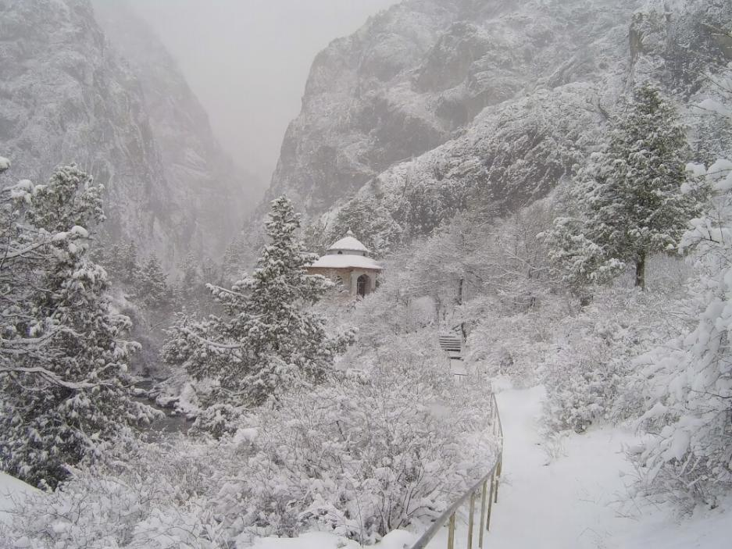
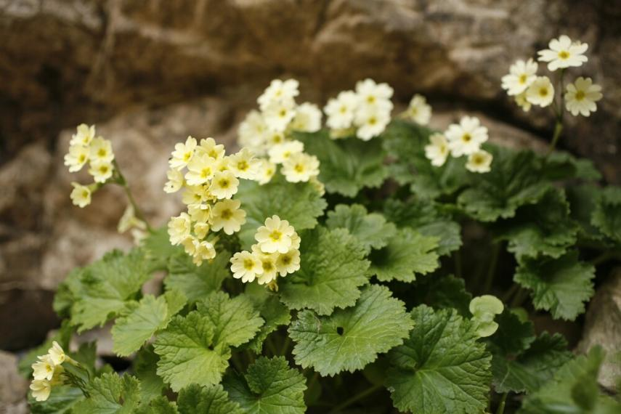
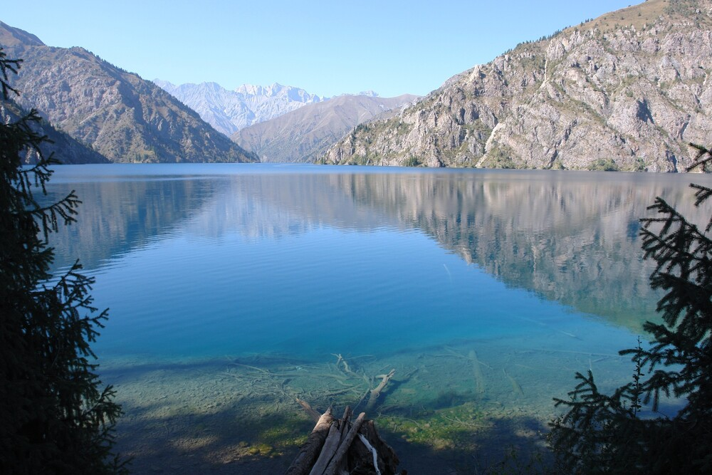

- 丝绸之路：长安-天山廊道Великий шелковый путь：Коридор Зарафшан-Каракумы
（Silk Roads: Zarafshan-Karakum Corridor）
列入世界遗产：2023

（简介）The Zarafshan-Karakum Corridor is a key section of the Silk Roads in Central Asia that connects other corridors from all directions. Located in rugged mountains, fertile river valleys, and uninhabitable desert, the 866-kilometre corridor runs from east to west along the Zarafshan River and further southwest following the ancient caravan roads crossing the Karakum Desert to the Merv Oasis. Channelling much of the east-west exchange along the Silk Roads from the 2nd century BCE to the 16th century CE, a large quantity of goods was traded along the corridor. People travelled, settled, conquered, or were defeated here, making it a melting pot of ethnicities, cultures, religions, sciences, and technologies.

泽拉夫尚-卡拉库姆廊道（Zarafshan-Karakum Corridor）是中亚丝绸之路的核心路段，承担着连接四方路网的枢纽作用。这条全长866公里的廊道横跨崎岖山脉、肥沃河谷与无人荒漠，自东向西沿泽拉夫尚河（Zarafshan River）延伸，继而向西南循古商道穿越**卡拉库姆沙漠（Karakum Desert），直抵梅尔夫绿洲（Merv Oasis）。

从公元前2世纪至公元16世纪，该廊道长期作为丝路东西交流的主通道，大量货物经此贸易流通。人们在此迁徙、定居、征战或败退，使其成为民族、文化、宗教、科学与技术的熔炉。

（详细）The Zarafshan-Karakum Corridor is one of the key sections of the Silk Roads in Central Asia that connects other corridors from all directions. Comprising thirty-four component parts located in rugged mountains, fertile river valleys, and uninhabited desert, the 866-kilometre corridor runs from east to west along the Zarafshan River and further southwest following the ancient caravan roads crossing the Karakum Desert to the Merv Oasis.

Dotted along the corridor passing through varied geographical areas such as highland, piedmont, dry steppe, oases, fertile valleys, and arid-desert zones, the selected component parts reflect the complexity of landscapes and the adaption of societies to the control of the Silk Roads movement and trade. The variation in human responses between the fertile valleys and deltas, and the desert and river crossings, are clearly reflected in the selection of small towns, forts, and way stations; while the outcomes of the political and social capital generated by trading contacts are reflected in the range of commercial, elite, and religious buildings included in the nomination. It was the place where the Sogdians, some of the most international merchants in the world history, flourished. The control of these corridors was of vital significance to many of the great Silk Roads empires, such as the Sogdian, the Parthian, the Sassanian, the Timurid and the Seljuk, as they were fundamental to long-distance exchange along the Silk Roads.

Along the corridor, a large quantity of goods and some high-value commodities from the East and the West were moved and traded, and many famous local products were brought out of there to feed the desires of the populations afar. People travelled, settled, conquered, or were defeated there, making it a melting pot of ethnicities, cultures, religions, sciences, and technologies. During the historic period of the Silk Roads between the 2nd century BCE and the 16th century CE, the Corridor had experienced three prosperous periods: the rise of Sogdians merchants between the 5th and 8th centuries CE; the thriving trade with the Muslim world and beyond between the 10th and 12th centuries CE, and significant development of science, culture, urban planning and economics under the Mongols' rule from the 13th century to the 17th century CE.

泽拉夫尚-卡拉库姆廊道（Zarafshan-Karakum Corridor）是中亚丝绸之路的关键路段之一，连接着来自四面八方的其他通道。这条全长866公里的廊道包含34个组成部分，分布于崎岖山脉、肥沃河谷与无人荒漠之间，自东向西沿泽拉夫尚河（Zarafshan River）延伸，继而向西南沿古商道穿越卡拉库姆沙漠（Karakum Desert），最终抵达梅尔夫绿洲（Merv Oasis）。

分布于廊道沿线的组成部分横跨高原、山麓、干草原、绿洲、肥沃河谷及干旱荒漠等多样地理区域，反映了地貌的复杂性以及人类社会对丝绸之路交通与贸易管控的适应性。在肥沃河谷与三角洲地带，人类选择建造小型城镇、堡垒和驿站；而在沙漠与河流渡口区域，应对方式则截然不同——这些差异清晰体现在遗址类型的选择中。提名遗产中的商业建筑、精英居所与宗教场所，则映射出贸易往来催生的政治资本与社会资本的成果。此地曾是粟特人（Sogdians）——世界历史上最具国际性的商人群体——繁荣发展的舞台。控制这些廊道对粟特、帕提亚（Parthian）、萨珊（Sassanian）、帖木儿（Timurid）和塞尔柱（Seljuk）等丝路帝国至关重要，因它们是丝绸之路上远距离交流的基础。

沿廊道流通和交易的不仅有大量东西方货物与高价值商品，还有许多当地特产被输送至远方以满足需求。人们在此迁徙、定居、征战或败退，使其成为民族、文化、宗教、科学与技术的熔炉。在公元前2世纪至公元16世纪的丝绸之路历史时期内，该廊道经历了三次繁荣期：公元5至8世纪粟特商人的崛起；公元10至12世纪与穆斯林世界及其他地区的贸易兴盛；以及公元13至17世纪蒙古统治下科学、文化、城市规划与经济的重要发展。

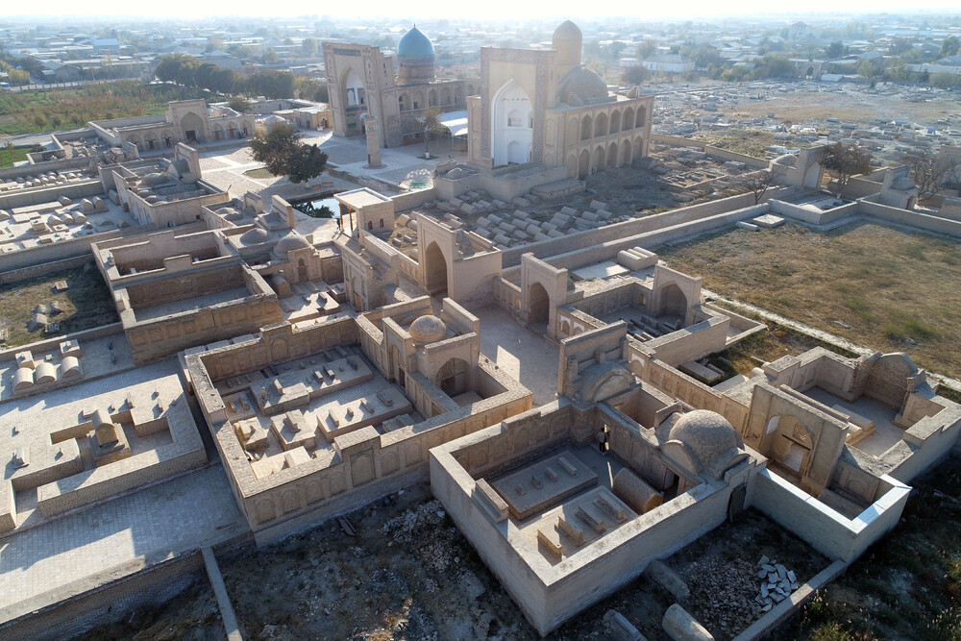
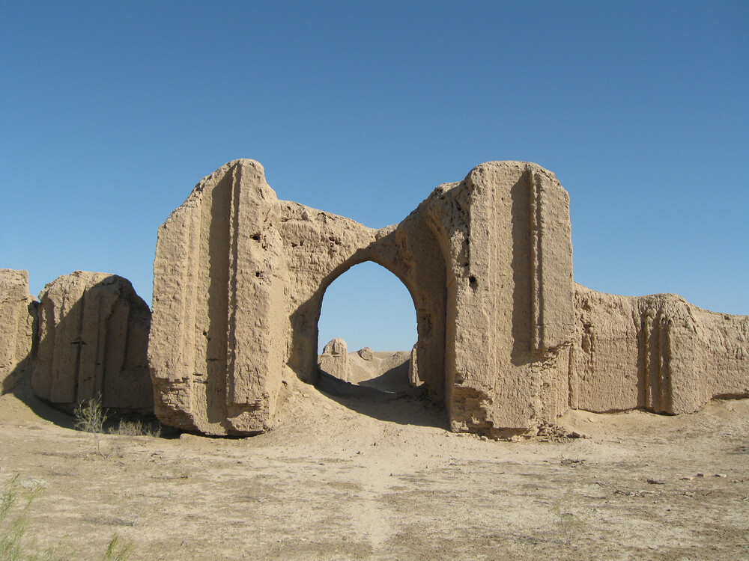
7、费尔干纳峡谷的沙漠城堡群
列入世界遗产：2023

（简介）This transnational property comprises fourteen component parts found across arid areas of Central Asia’s temperate zone between the Caspian Sea and the Turanian high mountains. The area is subject to extreme climatic conditions with very cold winters and hot summers, and boasts an exceptionally diverse flora and fauna that has adapted to the harsh conditions. The property also represents a considerable diversity of desert ecosystems, spanning a distance of more than 1,500 kilometres from East to West. Each of the component parts complements the others in terms of biodiversity, desert types, and ongoing ecological processes.

这项跨国遗产包含分布于中亚温带干旱区的14个组成部分，其范围西起里海（Caspian Sea），东至图兰高山（Turanian high mountains）。该区域气候条件极端，冬季严寒，夏季酷热，却孕育出异常丰富的适应严酷环境的动植物群。遗产地还展现出沙漠生态系统的显著多样性，东西跨度超过1500公里。各组成部分在生物多样性、沙漠类型及持续生态过程方面互为补充。

