INFORMATION SYSTEMS | INFO3002A

Improving Municipal Service Delivery and Accountability in Gauteng
Vision Document: VMOSA and Key Performance Indicators
Based on the Gauteng City-Region Observatory (GCRO) Quality of Life III Survey

MODULE  INFO3002A | GROUP  Data Lens | SUBMISSION DATE  22 October 2026
GROUP MEMBERS
Name | Student number | Role
Zarmeen Ismail | 2837202 | Research, VMOSA and KPIs & Final Report Compilation
Klaas Maseogane | 2653953 | Database Development and Data Preparation
Mavuyisi Chabane | 2586216 | Database design & implementation (Access), ERD, and Power BI dashboard development
Mosa Lichaba | 2673277 | Data Cleaning and data Preparation

CONTENTS
Table of Contents
1. Introduction 1
2. Vision 1
3. Mission 1
4. Objectives 1
4.1 Objective 1: Improve Municipal Infrastructure and Maintenance 1
4.2 Objective 2: Strengthen Municipal Accountability and Responsiveness 1
4.3 Objective 3: Reduce Inequalities in Basic Municipal Services 1
5. Strategies 1
5.1 Strategy 1: Prioritised Infrastructure Maintenance 1
5.2 Strategy 2: Improved Municipal Communication and Accountability 1
5.3 Strategy 3: Equitable Access to Basic Municipal Services 1
6. Action Plans 1
6.1 Action Plan 1: Infrastructure Improvement Programme 1
6.2 Action Plan 2: Municipal Accountability and Communication Programme 1
6.3 Action Plan 3: Basic Service Equality Programme 1
7. Key Performance Indicators 1
8. KPI Definitions and Alignment Table 1
9. ERD and Data Model Justification 1
10. Power BI Dashboard and Visual Justification 1
11. References 1

1. Introduction
Municipal service delivery is critical to enhancing the quality of life for the residents of Gauteng. Major services that are directly impacting the lives of the residents are supposed to be provided and maintained by municipalities, like water, sanitation, electricity, roads, street lighting, and stormwater drainage. The quality and reliability of those services impact directly on their lives, safety, and general satisfaction with their communities. This project will focus on improving service delivery and accountability in municipalities within the Gauteng region, based on the data from the Gauteng City-Region Observatory (GCRO) Quality of Life III Survey. It is a survey that would provide information related to residents’ experiences with municipal services, including levels of satisfaction and access to basic infrastructure.
Preliminary analysis of survey data identified major areas of dissatisfaction with local municipal performance, street lighting, roads, stormwater drainage, and municipal billing. Informal or formal dwelling also showed differences in the satisfaction of basic services. The following example is the project proposal to the government based on the above findings, which would suggest government action focused on three main areas: improving municipal infrastructure, strengthening government accountability, and reducing inequality in access to basic services. The motive behind it is to identify areas of intervention and measurable indicators for gauging government progress in improving delivery at the local level.

2. Vision
OUR VISION
To create a Gauteng where all communities have access to reliable, equitable and responsive municipal services that improve residents’ quality of life and promote sustainable development.

3. Mission
OUR MISSION
To improve the quality and reliability of municipal services across Gauteng through targeted infrastructure maintenance, improved municipal accountability and more equitable service delivery.

The initiative tries to answer to areas where citizens are highly unsatisfied, improve communication between municipalities and their residents, and prioritize communities that receive inadequate delivery of basic services. The data collected by the survey will be used for the purposes of identifying challenges in delivering services and guiding government interventions, as well as setting indicators for these performances that can be monitored in the future.

4. Objectives
The initiative proposes three measurable objectives focusing on infrastructure, accountability and service equality.

4.1 Objective 1: Improve Municipal Infrastructure and Maintenance
OBJECTIVE 1
To reduce the percentage of residents dissatisfied with street lighting, road conditions and stormwater drainage by 10 percentage points within five years of implementing the initiative.

This objective focuses on improving the condition and reliability of municipal infrastructure. By addressing maintenance problems and prioritising areas with high dissatisfaction, municipalities can improve service quality and residents’ experiences of their local environments.

4.2 Objective 2: Strengthen Municipal Accountability and Responsiveness
OBJECTIVE 2
To increase the percentage of residents satisfied with municipal billing and overall local municipal performance, while increasing the proportion of government enquiries receiving responses, within five years of implementation.

The objective is to enhance the historical relationship between municipalities and residents by more open billing practices, better communication, and effective reverts to service-related enquiries. One way to build public trust in local government would be to make the municipal authorities more accountable, therefore residents’ concerns could be dealt with more efficiently.

4.3 Objective 3: Reduce Inequalities in Basic Municipal Services
OBJECTIVE 3
To reduce dissatisfaction with water and sanitation services among residents living in informal dwellings within five years of implementing the initiative.

The goal is to address differences in service delivery among different communities. For instance, informal-sect dwellers are likely to face more challenges in accessing reliable basic services; thus, improvements made in this case will not be felt by other communities for more equitable living conditions. This will be achieved by ensuring that all variables outside the underserved communities are kept constant.

5. Strategies

5.1 Strategy 1: Prioritised Infrastructure Maintenance
Local authorities should introduce maintenance to a data-driven approach by pinpointing the zones with the highest levels of public dissatisfaction with roads, streetlights, and stormwater drainage. The government’s resources and maintenance activities should be prioritized according to the extreme service delivery problems and needs of the affected communities. The strategy is aimed at the improvement of efficiency in municipal maintenance programs through the directing of attention and resources to areas where the need for intervention is greatest.

5.2 Strategy 2: Improved Municipal Communication and Accountability
Municipalities could also articulate and follow transparent methods in their communication and complaint handling to make the systems responsive. One of the thrust areas of this strategy would be increasing the clarity of the bills received from the municipality, opening more accessible channels for reporting of problems in service delivery and the introduction of systems for tracking and responding to residents’ inquiries. Through improved communication and accountability, confidence is instilled in residents that any issues raised are being taken into consideration and acted upon by the municipalities.

5.3 Strategy 3: Equitable Access to Basic Municipal Services
The government’s priority should be to focus on communities that still lack access to proper water and sanitation, with much of that focus on informal settlement residents. This will entail the pinpointing of those areas, provision of resources for basic infrastructure improvements, and partnership with local municipalities in bridging service-delivery gaps. The objective of the strategy is to narrow the gaps in municipal service quality and make certain that developments are focused on communities in most need.

6. Action Plans
The following action plans outline the practical steps required to implement the proposed strategies.

6.1 Action Plan 1: Infrastructure Improvement Programme
Linked to Objective 1 and Strategy 1
1 | Analyse survey data on greatest dissatisfaction levels in roads, street lighting, and stormwater drainage in the districts.
2 | Infrastructure inspections in critical areas would lead to the identification of maintenance requirements.
3 | The maintenance schedule to have prioritization of urgent repairs and areas with the most service delivery problems.
4 | Allocate budgets and resources from the municipality towards the previously identified infrastructure improvements.
5 | Execute repair and maintenance programmes such as streetlight repairs, road maintenance, and storm-water drainage improvement.
6 | Follow-up assessments and resident satisfaction surveys will then be conducted to check if infrastructure conditions and service delivery satisfaction has improved.

6.2 Action Plan 2: Municipal Accountability and Communication Programme
Linked to Objective 2 and Strategy 2
1 | Identify municipalities that are most afflicted in terms of both the billing system and the overall performance of the local authority.
2 | Check over the existing municipal billing and complaints systems for weaknesses.
3 | Introduce clearer billing statements and easy points of contact for residents to make enquiries.
4 | A complaint-tracking mechanism will be established to write, monitor, and follow up on resident grievances.
5 | Set response-time standards for municipal queries and complaints.
6 | Monitor historical rates of response, billing satisfaction, and overall municipal satisfaction through previous surveys and records.

6.3 Action Plan 3: Basic Service Equality Programme
Linked to Objective 3 and Strategy 3
1 | Use the information reviewed from questionnaires to clarify differences in satisfaction levels with water and sanitation among formal and informal settlers.
2 | Identifying municipalities or communities with the greatest dissatisfaction with basic services.
3 | Conduct delivery servicing assessment to identify key infrastructure and maintenance challenges in priority communities.
4 | The provision of more funding will go a long way in assisting the improvement of the sanitation and water facilities in the most neglected areas.
5 | Work in tandem with local authorities on productive service improvement initiatives.
6 | Conduct some follow-up studies to find out if the initial dissatisfaction of informal residents has been reduced with water and sanitation services.

7. Key Performance Indicators
It will evaluate the proposed initiative using Eight Key Performance Indicators. This indicator focuses on Infrastructure satisfaction, Municipal accountability, and the Inequalities in basic service delivery. The KPIs shall be calculated using relevant questions from the GCRO Quality of Life III Survey, whereby a historical survey will provide baseline information for any future surveys measuring progress toward the proposed objectives. Each of the KPIs will be tied to a specific objective, strategy, and action plan so that the corresponding dashboard provides the relevant information for the interventions proposed by the government.

How the framework fits together
OBJECTIVE 1  Improve Municipal Infrastructure and Maintenance | → | STRATEGY 1  Prioritised Infrastructure Maintenance | → | ACTION PLAN 1  Infrastructure Improvement Programme
OBJECTIVE 2  Strengthen Municipal Accountability and Responsiveness | → | STRATEGY 2  Improved Municipal Communication and Accountability | → | ACTION PLAN 2  Municipal Accountability and Communication Programme
OBJECTIVE 3  Reduce Inequalities in Basic Municipal Services | → | STRATEGY 3  Equitable Access to Basic Municipal Services | → | ACTION PLAN 3  Basic Service Equality Programme

8. KPI Definitions and Alignment Table
No. | KPI | Survey question(s) used | What it measures / calculation | Justification | Objective | Strategy | Action plan
1 | Street Lighting Dissatisfaction | Q1.29 | Percentage of residents dissatisfied or very dissatisfied with street lighting in their area. | Identifies areas where street lighting needs improvement and helps monitor the effectiveness of maintenance programmes. | O1 Infrastructure | S1 Prioritised maintenance | AP1 Infrastructure improvement
2 | Road Dissatisfaction | Q1.28 | Percentage of residents dissatisfied or very dissatisfied with local road conditions. | Highlights road infrastructure problems and helps municipalities prioritise repairs and maintenance. | O1 Infrastructure | S1 Prioritised maintenance | AP1 Infrastructure improvement
3 | Stormwater Drainage Dissatisfaction | Q1.31 | Percentage of residents dissatisfied or very dissatisfied with stormwater drainage. | Identifies drainage-related service concerns and helps evaluate whether infrastructure improvements are effective. | O1 Infrastructure | S1 Prioritised maintenance | AP1 Infrastructure improvement
4 | Municipal Billing Satisfaction | Q1.27 | Percentage of residents satisfied or very satisfied with municipal billing services. | Helps assess billing transparency and whether improvements to billing processes increase residents’ satisfaction. | O2 Accountability | S2 Communication and accountability | AP2 Accountability programme
5 | Government Enquiry Response Rate | Q6.9, Q6.10 | Percentage of residents who contacted government and received a response. | Measures government responsiveness and helps evaluate improvements in communication and complaint handling. | O2 Accountability | S2 Communication and accountability | AP2 Accountability programme
6 | Informal-Dwelling Sanitation Dissatisfaction | Q1.23, H.3 | Percentage of residents living in informal dwellings who are dissatisfied or very dissatisfied with sanitation services. | Highlights inequalities in sanitation services and helps government prioritise underserved communities. | O3 Service equality | S3 Equitable basic services | AP3 Basic service equality
7 | Informal-Dwelling Water Dissatisfaction | Q1.22, H.3 | Percentage of residents living in informal dwellings who are dissatisfied or very dissatisfied with water services. | Identifies water-service challenges in informal communities and helps evaluate targeted service improvements. | O3 Service equality | S3 Equitable basic services | AP3 Basic service equality
8 | Overall Municipal Performance Satisfaction | Q6.7 | Percentage of residents satisfied or very satisfied with their local municipality’s overall performance. | Provides an overall indication of residents’ satisfaction with municipal performance and helps assess broader improvements in service delivery. | O2 Accountability | S2 Communication and accountability | AP2 Accountability programme

KPI Calculations and Historical Baselines
The eight selected KPIs will be calculated using data from the GCRO Quality of Life III Survey. The survey provides information on residents’ satisfaction with municipal services and their experiences with local government.

KPI Calculations
For satisfaction KPIs, anyone who chose either Satisfied or Very Satisfied is considered a numerator responder. For dissatisfaction KPIs, anyone who chose Dissatisfied or Very Dissatisfied will be considered a responder.
The percent is calculated using this formula:
KPI (%) = (Weighted number of qualifying responses ÷ Weighted number of valid responses) × 100

Survey weights will then be applied to the variables to correct the discrepancies in the relative representation of respondents within the dataset. Missing, invalid, and non-responsive records will be excluded from these calculations. The calculation for the Government Enquiry Response Rate is based on respondents who had contacted the government and then provided a valid response in terms of whether they had replied. For the water and sanitation KPIs, the calculations will be restricted to respondents living in informal dwellings.

Historical Baselines
The GCRO Quality of Life III Survey offers historical baseline data to pinpoint provisions of service delivery at a municipal level. Indications of particularly high dissatisfaction in terms of the preliminary analysis of the group were related to street lighting, roads, and stormwater drainage. Further differences in satisfaction concerning water and sanitation services were identified between people living in formal and informal housing. These are the historical results that will be taken into consideration as a reference point for the proposed government initiative. Unfortunately, the dataset pertains to only one survey period and therefore is not in any position to show independently whether there have been improvements in service delivery over the years. For that reason, future similar surveys would be needed to assess progress towards the initiative’s five-year objectives.

9. ERD and Data Model Justification
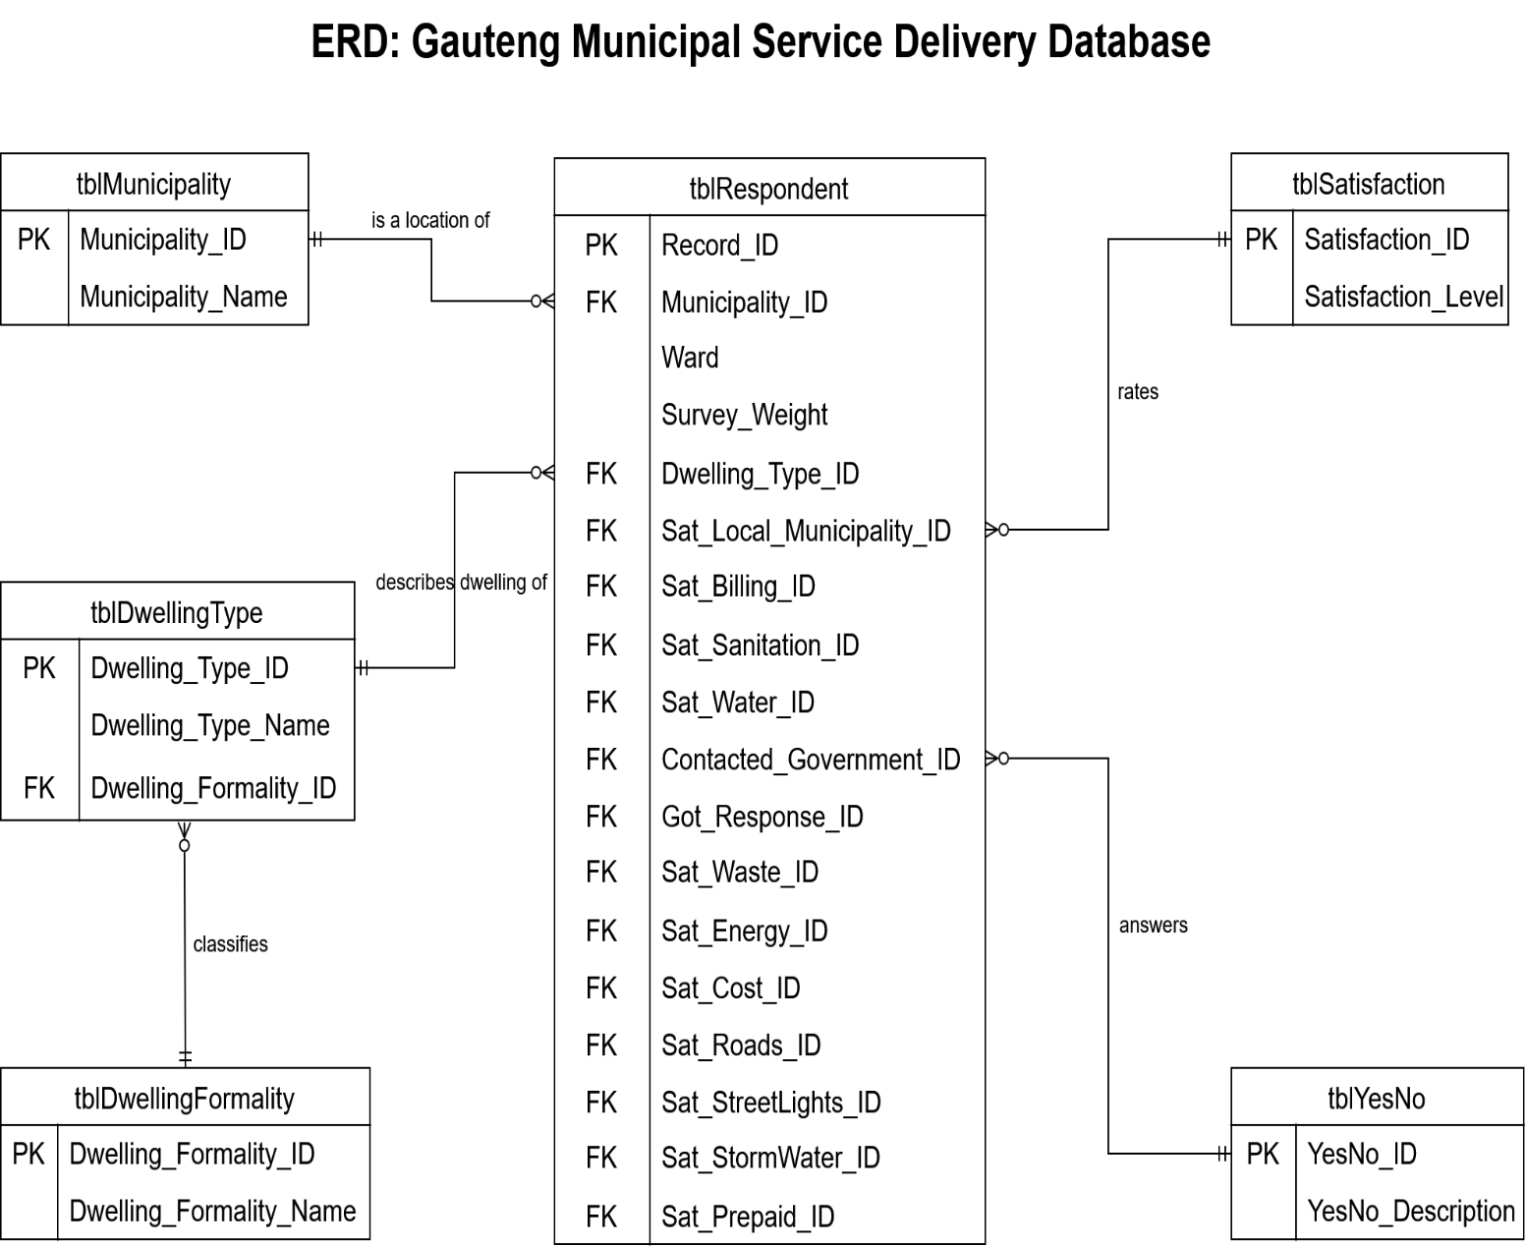
The database organises the survey data to calculate the eight selected KPIs. Its structure consists of a central respondent table and five lookup tables containing information about municipalities, dwelling types, dwelling formality, satisfaction levels and yes/no responses. Figure 1 illustrates how these tables are connected. This structure allows the survey responses to be interpreted consistently and analysed according to the initiative’s priorities: infrastructure, accountability and service equality.

9.1 Database structure

Central respondent table

The central table, tblRespondent, stores the individual survey records. Each record is identified by Record_ID, which serves as the primary key. The table includes municipality and dwelling identifiers, ward information, the survey weight and separate fields for respondents’ answers to the selected survey questions.

Keeping these responses in the same record allows each respondent’s service experiences to be analysed alongside their municipality and dwelling classification.

Municipality and dwelling table

tblMunicipality stores municipality identifiers and names. Its relationship with the respondent table allows KPI results to be grouped and compared across municipalities. tblDwellingType stores dwelling-type identifiers and names. It also connects to tblDwellingFormality, which classifies dwelling types according to formality. Together, these tables allow the analysis to identify respondents living in informal dwellings, as required for the water and sanitation KPIs.

Satisfaction and yes/no lookup tables
tblSatisfaction stores satisfaction identifiers and their levels. These levels allow coded responses to be interpreted as categories such as satisfied, very satisfied, dissatisfied and very dissatisfied. tblYesNo provides the identifiers and descriptions for yes/no responses, including whether respondents contacted government and whether they received a response. Separating these descriptions from the respondent records reduces repeated text and supports consistent interpretation of the survey codes.

9.2 Relationships and Data Quality
The database uses one-to-many relationships. One municipality can be associated with many respondents, and one dwelling type can describe many respondents. Similarly, one dwelling-formality category can classify several dwelling types.
Primary keys uniquely identify records within the tables, while foreign keys provide the connections between related records.
Although the satisfaction questions share a response scale, respondents can give different answers to each question. Each satisfaction field therefore requires its own relationship to tblSatisfaction. Similarly, Contacted_Government_ID and Got_Response_ID require separate relationships to tblYesNo.
When referential integrity is enforced, these relationships can prevent non-null foreign-key values from referring to codes that do not exist in the lookup tables. Missing and inapplicable responses must still be handled correctly when calculating the KPIs.

9.3 KPI Data Fields

The database contains the following fields needed to calculate the eight indicators.

Table 1: Database fields used to calculate each KPI
KPI | Relevant database field(s) | Use in the calculation
1. Street Lighting Dissatisfaction | Sat_StreetLights_ID | Identify dissatisfied and very dissatisfied responses to Q1.29.
2. Road Dissatisfaction | Sat_Roads_ID | Identify dissatisfied and very dissatisfied responses to Q1.28.
3. Stormwater Drainage Dissatisfaction | Sat_StormWater_ID | Identify dissatisfied and very dissatisfied responses to Q1.31.
4. Municipal Billing Satisfaction | Sat_Billing_ID | Identify satisfied and very satisfied responses to Q1.27.
5. Government Enquiry Response Rate | Contacted_Government_ID  Got_Response_ID | Among respondents who contacted government and gave a valid response answer, identify those who received a reply (Q6.9 and Q6.10).
6. Informal-Dwelling Sanitation Dissatisfaction | Sat_Sanitation_ID  Dwelling_Type_ID  Dwelling_Formality_ID* | Use the dwelling lookups to select informal-dwelling respondents, then identify dissatisfaction with sanitation (Q1.23 and H.3).
7. Informal-Dwelling Water Dissatisfaction | Sat_Water_ID  Dwelling_Type_ID  Dwelling_Formality_ID* | Use the dwelling lookups to select informal-dwelling respondents, then identify dissatisfaction with water (Q1.22 and H.3).
8. Overall Municipal Performance Satisfaction | Sat_Local_Municipality_ID | Identify satisfied and very satisfied responses to Q6.7.

9.4 Calculation Notes and Limitations

The Survey_Weight field enables weighted KPI percentages to be calculated. This involves dividing the sum of weights for qualifying responses by the sum of weights for valid, eligible responses and multiplying the result by 100.

For the water and sanitation indicators, both the numerator and denominator must be restricted to informal-dwelling respondents. These indicators measure dissatisfaction within that group; measuring an inequality gap would require an additional comparison with formal-dwelling respondents.

The Government Enquiry Response Rate measures responses from government departments generally, rather than only municipal enquiries. It indicates whether a reply was received, not the response time or whether the issue was resolved.

Overall, the model provides the data structure needed to connect the survey evidence to the selected KPIs and Power BI dashboard. It supports analysis of the historical baseline, while comparable future data would be required to evaluate progress towards the proposed objectives.

10. Power BI Dashboard and Visual Justification

The Power BI dashboard presents the eight selected KPIs on a single screen (Figure 2). It brings together information about municipal infrastructure, government accountability and inequalities in basic services. The dashboard compares historical survey results with the proposed improvement targets, helping decisionmakers identify areas requiring attention and understand the improvements the initiative aims to achieve.

Figure 2: Power BI dashboard showing the eight selected KPIs

10.1 Dashboard Layout and organization
The dashboard is organised around the initiative’s three objectives. The top row presents dissatisfaction with street lighting, roads and stormwater drainage across municipalities, supporting Objective 1: Improve Municipal Infrastructure and Maintenance. The middle row presents municipal billing satisfaction, government enquiry responses and overall municipal satisfaction. These indicators support Objective 2: Strengthen Municipal Accountability and Responsiveness. The bottom row compares water and sanitation dissatisfaction between residents of informal and formal dwellings, supporting Objective 3: Reduce Inequalities in Basic Municipal Services. The formal-dwelling results provide a comparison for interpreting the two informal-dwelling KPIs. Each visual represents one selected KPI. This arrangement keeps related measures together and connects the dashboard to the objectives, strategies and action plans discussed in the report.

KPI | Visual Used | Justification
1. Street Lighting Dissatisfaction | Horizontal bar chart comparing municipalities, with a target line. | The chart allows dissatisfaction rates to be compared across municipalities. Arranging the bars from highest to lowest makes areas reporting greater dissatisfaction easy to identify. Horizontal labels accommodate municipality names clearly. The orange line shows the proposed 24.8% target, allowing each municipality’s result to be compared with the benchmark.
2. Road Dissatisfaction | Horizontal bar chart comparing municipalities, with a target line. | This visual highlights differences in residents’ dissatisfaction with roads across municipalities. The ranked bars help identify where further investigation and maintenance planning should be prioritised. The 24.7% target line shows the intended benchmark. Using the same chart type as street lighting also provides consistency across the infrastructure indicators.
3. Stormwater Drainage Dissatisfaction | Horizontal bar chart comparing municipalities, with a target line. | The chart shows which municipalities report higher dissatisfaction with stormwater drainage. Comparing bar lengths helps decisionmakers identify differences between areas, while the 22.6% target line indicates the proposed improvement level. The visual supports the identification of priority areas for drainage inspections and maintenance assessments.
4. Municipal Billing Satisfaction | Gauge chart with a target marker. | The gauge presents one headline satisfaction percentage in relation to its target. The displayed result of 44.23% can be compared directly with the proposed 54.2% target. The large central value makes the result easy to locate, while the marker shows the improvement required to reach the benchmark.
5. Government Enquiry Response Rate | Gauge chart with a target marker. | The gauge shows the displayed response rate of 55.11% against the proposed 70.1% target. This is suitable for presenting a single response-rate indicator rather than a ranking of municipalities. It provides a clear summary of whether eligible respondents who contacted government received a reply. It does not measure how quickly a reply was received or whether the issue was resolved.
6. Informal-Dwelling Sanitation Dissatisfaction | Horizontal bar chart comparing informal and formal dwellings, with a target line. | Showing both dwelling groups makes the difference in sanitation dissatisfaction visible. The dashboard displays 56.84% for informal dwellings and 10.12% for formal dwellings. This gives context to the informal-dwelling KPI and supports the justification for targeted service improvements. The 41.8% target applies to the informal-dwelling group.
7. Informal-Dwelling Water Dissatisfaction | Horizontal bar chart comparing informal and formal dwellings, with a target line. | The chart compares water dissatisfaction of 41.67% among informal-dwelling respondents with 7.84% among formal-dwelling respondents. Placing the groups together makes the disparity easier to interpret than displaying the informal rate alone. The 26.7% target applies to informal dwellings and provides a benchmark for the proposed improvements.
8. Overall Municipal Performance Satisfaction | Gauge chart with a target marker. | The gauge presents the displayed overall satisfaction rate of 37.03% against the proposed 47.0% target. It provides a broad summary of residents’ perceptions of municipal performance alongside the more specific service indicators. Its format is consistent with the other accountability indicators, making the middle row easier to interpret.

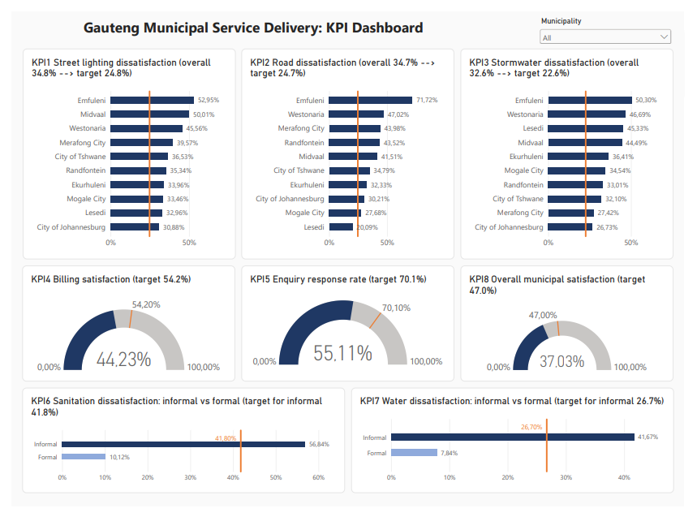
figure 2: Gauteng Municipal Service Delivery KPI Dashboard

10.3 Color, Labelling and filtering
The dashboard uses a consistent colour scheme. Dark blue represents the main survey results, while light blue distinguishes formal-dwelling respondents in the water and sanitation comparisons. Orange lines and markers distinguish the proposed targets from the observed survey results. Percentage labels provide the values directly, reducing the need to estimate results from bar lengths or gauge positions. Chart titles identify the KPI and its target so that each visual can be interpreted within the wider programme. The titles of the infrastructure charts state both the overall survey result and the proposed target (for example, 34.8% to 24.8% for street lighting), reflecting the 10-percentage-point reduction set out in Objective 1. The same target line is applied to every municipality within each chart. The municipality selector allows users to focus the dashboard on a selected municipality. This supports movement between an overall view and a more specific geographic view without requiring additional dashboard pages.

10.4 Key Observations
The baseline results show that every municipality currently sits above the target line for street lighting and stormwater drainage dissatisfaction, while Lesedi is the only municipality below the road dissatisfaction target (20.09% compared with 24.7%). Emfuleni records the highest dissatisfaction on all three infrastructure indicators (52.95% for street lighting, 71.72% for roads and 50.30% for stormwater drainage), which suggests it could be a priority area for the infrastructure improvement programme. The water and sanitation comparisons show a substantial gap between dwelling types: sanitation dissatisfaction is 56.84% in informal dwellings compared with 10.12% in formal dwellings, and water dissatisfaction is 41.67% compared with 7.84%. These differences support the focus of Objective 3 on underserved communities.

10.5 Interpretation and Limitations

The direction of improvement differs between the indicators. For street lighting, roads, stormwater drainage, water and sanitation, lower dissatisfaction is the desired outcome. For billing satisfaction, government enquiry responses and overall municipal satisfaction, higher percentages are the desired outcome.
The bar charts compare categories rather than changes over time. A line chart was therefore not used, as it would imply a time trend from a single survey period. Pie charts were also not selected because the municipality-specific rates are separate percentages, not portions of one overall total.
The dashboard presents historical baseline results and proposed targets. The distance between a baseline and its target represents the intended improvement, not progress already achieved by the initiative. Comparable future data would be needed to assess whether the objectives have been met.
Finally, the satisfaction indicators describe residents’ reported experiences rather than directly measuring infrastructure conditions. They can guide the identification of priority areas, but inspections and other operational information would be needed to determine the specific causes of dissatisfaction and the appropriate interventions.

