# Melbourne Gaol Escapists

Ke Yu: s3686930 Biao Li: s3675917 Tanzim Shahriar: s3642965 YiGong Wang: s3585378

Game Guide:

Press arrow keys to select facing direction or move your character.

(If your input does not match your character’s current facing, it will change its facing based on your input)

Press corresponding ability keys to cast abilities.

(make your character face toward where you like to cast the ability, then press ability key)

As a prisoner, your goal is to escape the prison (find the red tile)

As a Law enforcer, your target is to arrest all prisoners before they could escape

Faction (Team):

Prisoner: Havoc, Jager, A57, LockSmith

Law enforcement: Warden, Guard

Characters & Abilities:

|  |  |  |  |  |
| --- | --- | --- | --- | --- |
| Image | Name | Ability | Ability Key | Ability description |
|  | Havoc | Break through wall | Q | Break a wall tile |
|  | Jager | Place a trap | W | Place a trap on floor tile |
|  | A47 | Disguise | R | Create a bait to distract enemies |
|  | LockSmith | Pick lock | E | Unlock a door tile |
|  | Warden | FOV * = 5 (passive),  Arrest another player | F | Has greater FOV by default,  score points by arresting enemies. |
|  | Guard | Arrest another player | F | score points by arresting enemies. |
| N/A | Common | Super Charge! | A | Skip current turn and move 3 tiles at next turn. |

*FOV: field of view

A demonstration of FOV:

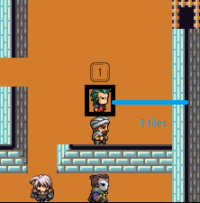 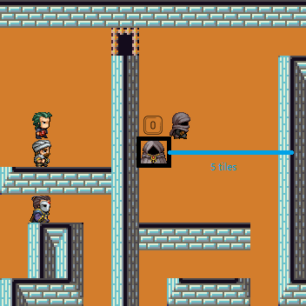

Status:

|  |  |  |
| --- | --- | --- |
| Image | Name | Description |
|  | SuperCharged | Indicates that you are super charged, can move 3 times this turn |
|  | arrested | Indicates that you are arrested and eliminated |
|  | trapped | Indicates that you are trapped, can not move in this turn. |
|  | normal | Normal state, the number indicates your stamina |

Tiles:

|  |  |  |
| --- | --- | --- |
| Image | Name | Description |
|  | Floor | Basic tile |
|  | Wall | Normally, players can not walk on it, but can be broke by ability |
|  | Door | Locked by default, can be unlocked by ability. (unfortunately, there is no open/close animation) |
| (same a floor because trap is invisible) | Trap | Immobilize the player who steps on it for 3 turns |
|  | Goal | Prisoners’ ultimate goal is to find and step on this tile |

Other Game Function:

|  |  |  |
| --- | --- | --- |
| Name | Key | Description |
| Saving game | Y | Save game session to file |
| Undo | T | / |
| Loading game | T | Load a game session from file |
| Pausing game | Escape | Pause the game |

Undo:

After pressing T, a window (see Figure 1) will pop up and ask haw many turns would like to undo.

Choose 1,2 or 3 from the drop-down menu (see Figure 2) to undo or choose “load another universe” to load game.

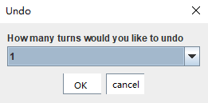

Figure 1

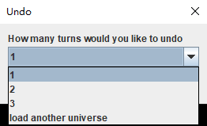

Figure 2

Pausing game:

When escape key pressed, the game will ignore all input until you press escape again

Design Pattern:

Please refer to other pdf files in submission folder for class diagram or click on the link

Creational Pattern:

* [Singleton](https://www.lucidchart.com/invitations/accept/a69e7077-5f9f-4fb6-b0f9-b297a8af4bdc): keep one and only one instance of an object
* [Abstract Factory](https://www.lucidchart.com/invitations/accept/6707237f-e38b-4803-80a4-fe790e695803): hide object instanciation behind the scene,

only exposing a simple interface

Structural Pattern:

* [Decorator](https://www.lucidchart.com/invitations/accept/d068f694-8204-413d-a408-0db445de47b3): modify tiles’ responsibility and image at runtime
* [Proxy](https://www.lucidchart.com/invitations/accept/66751813-6045-4b9c-99e9-5724001bb8ee): a ProxyPlayer that forward move requests to

real player and keep other requests to itself

Behavioural Pattern:

* [Observer & State](https://www.lucidchart.com/invitations/accept/4a696903-636e-4973-be9f-3d943291e25f)*: change the the key layout accroding to game states
* [Command](https://www.lucidchart.com/invitations/accept/ac5d6982-c251-4eae-9f29-b11e07241a85): undo and load game
* [Visitor](https://www.lucidchart.com/invitations/accept/7798e545-1440-4de1-a74b-c9a312b36016): decouple players and skills, easy to add more skills in ther future.

* a simple [sequence diagram](https://www.lucidchart.com/invitations/accept/52db9056-66d5-4772-8199-d6b5644b4518) is included to demostrate the implmentation of observer & state patten

Individual Contribution:

Ke Yu: 25%

game mechanics, Controller & Model classes, design pattern implementation.

Biao Li: 25%

UI implementation, View classes, design pattern implementation.

Tanzim Shahriar: 25%

game board design, design pattern implementation.

YiGong Wang: 25%

documentation and diagrams, design pattern implementation.