**Project Summary Report**

System name： Poetry Tracing System

System version：1.0

Team members：Yu LI（201830310210）

Tu Xiaozhao（201830310209）

Che Jingang（201830310245）

Wang Ziyue（201830310208）

**Directory**

1 Introduction 1

1.1 Document purpose 1

1.2 Project brief 1

1.3 Project context 1

2 System goal and modules design 2

2.1 System goal 2

2.2 Use case diagram 2

2.3 Modules design 2

3 Organization and implementation 4

3.1 Personnel organization 4

3.2 Work assignment 4

4 Project execution 5

4.1 Project plan（Milestones） 5

4.2 Actual execution 7

5 Project risk and testing 7

5.1 Risk control 7

5.1.1 Risk plan 7

5.1.2 Actual risk and handling 8

5.2 Project test summary 9

5.2.1 Test plan 9

5.2.2 Test results 11

6 Lessons learnt 12

7 Conclusion 13

8 Future plan 13

# Introduction

## Document purpose

This project summary report documents the preparation and completion of the project, covering the various stages and aspects of the project. The document summarizes and looks forward to the beginning and end of the poetry traceability system, which is used to evaluate the project completion and summarize experience for future project management.

## Project brief

With the increasing power of data, people are more and more enthusiastic in the pursuit of technology. However, they gradually forget the traditional Chinese culture and the foundation of the Chinese nation -- Chinese language, especially ancient poetry. However, ancient poetry is very large and has different sentence patterns. Learning only from paper books is extremely inefficient and limited in ability, which requires an intelligent and efficient system with a huge amount of data to retrieve ancient poetry. In addition, there will be some scattered and incomplete poems and sentences, and even some rare words, which causes great difficulties in the search of poems and essays. The intelligent ancient poetry source tracing system can find out the source of this sentence and a series of information based on the pictures of poems uploaded by users, which greatly reduces the threshold for learning and popularizing ancient poetry and improves the learning efficiency.

The intelligent poetry tracing system adopts advanced image and text recognition technology and crawler technology. Pycharm is used as a development tool, and the background database management system is MySql community version. Finally, the website is used as a carrier for users to use.

## Project context

The intelligent poetry source tracing system comes into being as required by the software project management course. The main function of the system is to find the original text of the poem and picture uploaded by users through text recognition, and present the author, background, translation and appreciation, etc. The project cycle is 10 weeks.

# System goal and modules design

## System goal

The first iteration cycle: according to the pictures of a certain poem provided by the user, the corresponding whole poem and relevant data are given.

Second iteration cycle: expected to complete the function of retrieval according to author, poem name and dynasty.

## Use case diagram

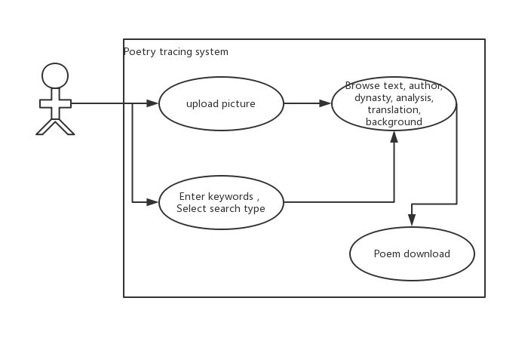

## Modules design

The first round of iteration: users upload pictures, and identify the poems and texts in the pictures through the picture recognition function of the system. The system sends the poems and texts to the background, and the background returns the complete information of poems and texts to the users.

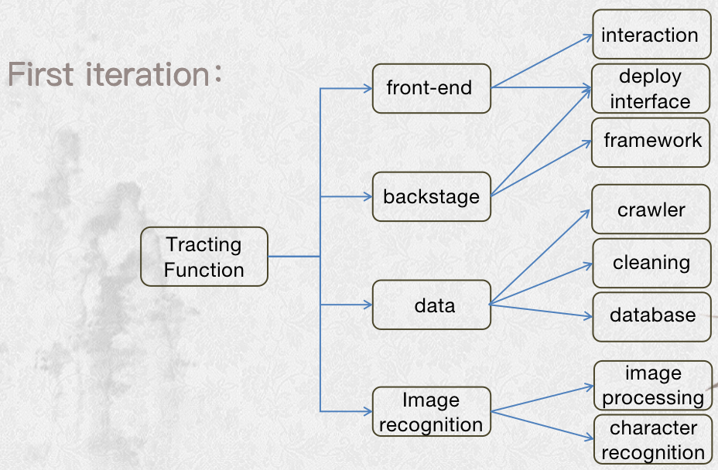The first iteration of the system use case diagram

The second iteration: it is roughly divided into three modules -- poetry and prose retrieval module (users can search according to author/dynasty/category), poetry and prose information download module and website sharing module.

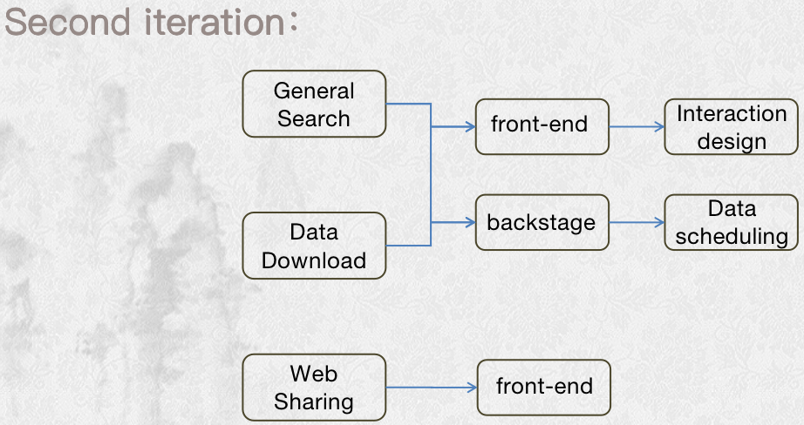The second iteration of the system use case diagram

# Organization and implementation

## Personnel organization

Project manager: Yu Li

Project developers: Tu Xiaozhao,Che Jingang,Wang Ziyue

Testers: Tu Xiaozhao,Che Jingang,Wang Ziyue,Yu Li

## Work assignment

* Data module: collect data, build database and provide query interface.

Involving technology：crawler

Workload：14 hours(days)

Director:Tu

Inspector:Yu

* Verse recognition module: convert the image into text after processing, and provide conversion interface.

Involving technology：Tesseract_OCR

Workload：14 hours(days)

Director:Yu

Inspector:King

* Website architecture module: Django architecture website is used to call interfaces.

Involving technology：Django

Workload：14+7 hours(days)

Director:King

Inspector:Tu

* Website front-end module: design and implement the website front-end, provide data reception and display interface.

Workload：14+7hours(days)

Director:Wang

Inspector:Yu

# Project execution

## Project plan（Milestones）

The total cycle of the project is 10 weeks. The first stage is the first 5 weeks (March 12, solstice, April 9), and the second stage is the last 5 weeks (April 9, solstice, May 14).Delivery standard are detailed in system design.

**First iteration:**

March 12→ submit：overall design*1

submitter：yu

Inspector：yu/tu/king/wang

March 19→ submit：detailed design*1

submitter：yu

Inspector：yu/tu/king/wang

submit：technical study result*4

submitter：yu/tu/king/wang

Inspector：yu

March 26→ submit：the early code*4

submitter and inspector：yu <-- tu

tu <-- yu

king <-- wang

wang <-- king

April 2→ submit： the middle code*4

submitter and inspector：yu <-- tu

tu <-- yu

king <-- wang

wang <-- king

April 9→ submit：the post code*4

submitter and inspector：yu <-- tu

tu <-- yu

king <-- wang

wang <-- king

April 16→ submit：the initial system*1

submitter：yu

inspector:yu/tu/king/wang

submit：improvement plan*1

submitter:yu

inspector:yu/tu/king/wang

**Second iteration:**

April 23→ submit the early code*2

submitter：king/wang

inspector:yu

April 30→ submit the post code*2

submitter：king/wang

inspector:yu

submit system test result*1

submitter：yu/tu/king/wang

May 1→ submit final product

submitter：yu

## Actual execution

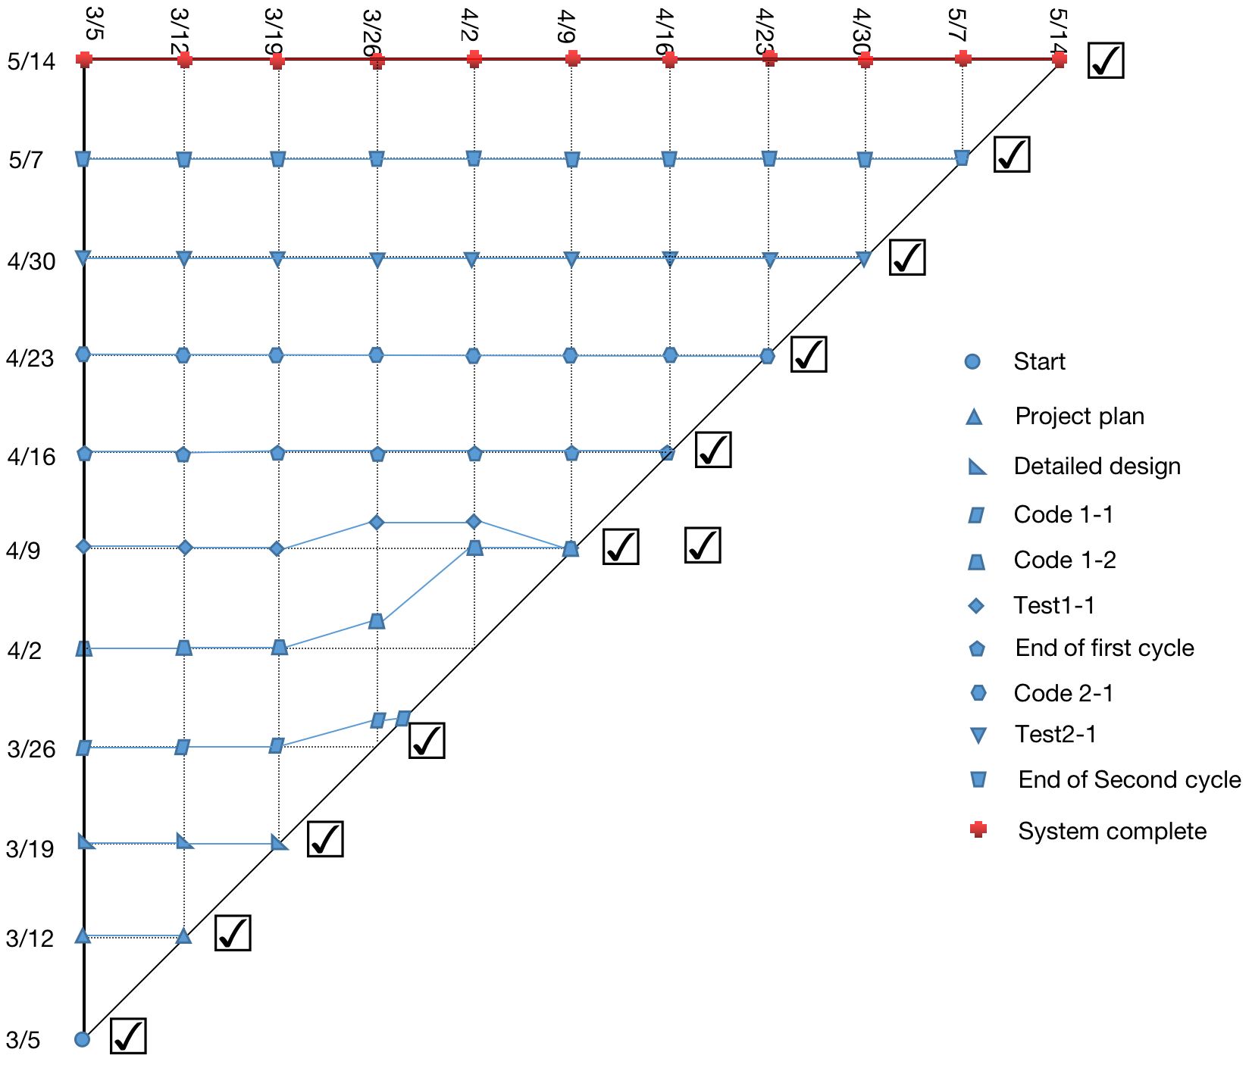

Milestone Trend Chart

# Project risk and testing

## Risk control

### 5.1.1 Risk plan

|  |  |  |  |
| --- | --- | --- | --- |
| Risk description | Planning strategy | processing difficulty | workload |
| The late data processing is too slow (more than 5 seconds). | Temporary database design has an impact on the efficiency of data retrieval. The database table will be split, making the query from fuzzy search to accurate search, thus improving the efficiency of search. | Medium | High |
| The leader of module can't finish the work because of the emergency (sick leave or high-priority task). | If the risk happens in the first or second round of iterative development stage, the development task will back up to 7 days, and the testing task of the last week will be assigned to the other three people.If the risk happens in the first or second round of iterative testing stage,the testing task will be directly assigned to the three. | Medium | Low |
| The two of the team can’t get well with each other,even lead to the miss of task. | The project manager will be the intermediator,transmitting the document. | Low | Low |
| The image processing can’t improve the accuracy rate. | Skip this step and use the package directly.This will make the accuracy rate over 60%. | Low | Low |

### 5.1.2 Actual risk and handling

|  |  |  |  |  |
| --- | --- | --- | --- | --- |
| Risk description | Strategy | Technological | Cost/Workload | Schedule |
| The front-end framework has difficulty invoking page data. | Change the page component type and rearrange the layout. | Medium | High | High |
| The front-end frame cannot properly call the picture channeling interface. | Because it takes more time to change the image acceptance mode and the improvement is small, skip this image processing step to avoid project delays. | Low | Low | Low |
| The person in charge of the front-end page module failed to submit the code of the development stage on time. | The two-day delay in submission did not affect the progress of the project. | Low | Low | Medium |
| The document did not meet the requirements and was rewritten, almost missing task. | Spend the night revising the document and submitting it before the deadline. | Low | Medium | Low |

## Project test summary

### 5.2.1 Test plan

Data and database integrity testing:

|  |  |
| --- | --- |
| Test objectives: | Ensure that the database access methods and processes are running without data corruption. |
| Test scope: | The "poems" table in the database |
| Technology: | Invoke the various database access methods and populate them with queries against the data.  Check the database to ensure that the data has been output as expected and that all database events have occurred normally. |
| Starting criteria: | The database was established and the project data was imported completely. |
| Completion criteria: | All of the database access methods and processes are running as designed, and the data is not corrupted. |
| Test priorities and priorities: | High: whether the data is completed as expected. |
| Special considerations: | Data migration may not be successful. |

The interface test:

|  |  |
| --- | --- |
| Test objectives: | Ensure that the interface calls are correct. |
| Test scope: | All software interfaces record input and output data. |
| Technology: | Operate each interface separately and input data for testing one by one. |
| Starting criteria: | All interface functions are completed and running normally. |
| Completion criteria: | All interfaces have gone through the I/o process. |
| Test priorities and priorities: | High: whether the output of each interface meets the requirements. |
| Special considerations: | Interface constraints, environment configuration. |

Integration test:

|  |  |
| --- | --- |
| Test objectives: | Test the correctness of business process and data flow in requirements. |
| Test scope: | A business process defined in a requirement, or a combination of different functional modules to form a large function. |
| Technology: | Use valid and invalid data to execute each use case, use case flow, or function to verify the following:  When the required picture is passed in, the retrieved poem corresponds to the picture.  An error message or warning message is displayed when a nonconforming image is passed in.  When the required fields are entered, the retrieved poems correspond to the fields and the selected labels.  Displays an error message or warning message when entering fields that do not meet the requirements. |
| Starting criteria: | The front-end frame is completed, the internal data flow is normal, and the interfaces are connected normally. |
| Completion criteria: | All planned tests have been executed. |
| Test priorities and priorities: | Low: whether the incoming error data can correctly prompt the user.  High: whether the correct data passed in can be output as required. |
| Special considerations: | None |

Functional test:

|  |  |
| --- | --- |
| Test objectives: | Ensure that the two main modules tested are functional, including image retrieval and normal retrieval. |
| Test scope: | Integrated complete system. |
| Technology: | Use valid and invalid data to execute each use case, use case flow, or function to verify the following:  When the required picture is passed in, the retrieved poem corresponds to the picture.  An error message or warning message is displayed when a nonconforming image is passed in.  When the required fields are entered, the retrieved poems correspond to the fields and the selected labels.  Displays an error message or warning message when entering fields that do not meet the requirements. |
| Starting criteria: | The front-end frame is completed, the internal data flow is normal, and the interfaces are connected normally. |
| Completion criteria: | All planned tests have been executed. |
| Test priorities and priorities: | Low: whether the incoming error data can correctly prompt the user.  High: whether the correct data passed in can be output as required. |
| Special considerations: | None |

### 5.2.2 Test results

See test report for specific test results.

Database test:

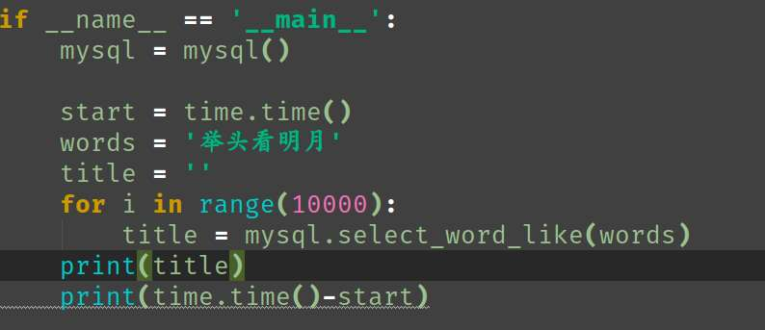

Database test result：



Character recognition test and result：

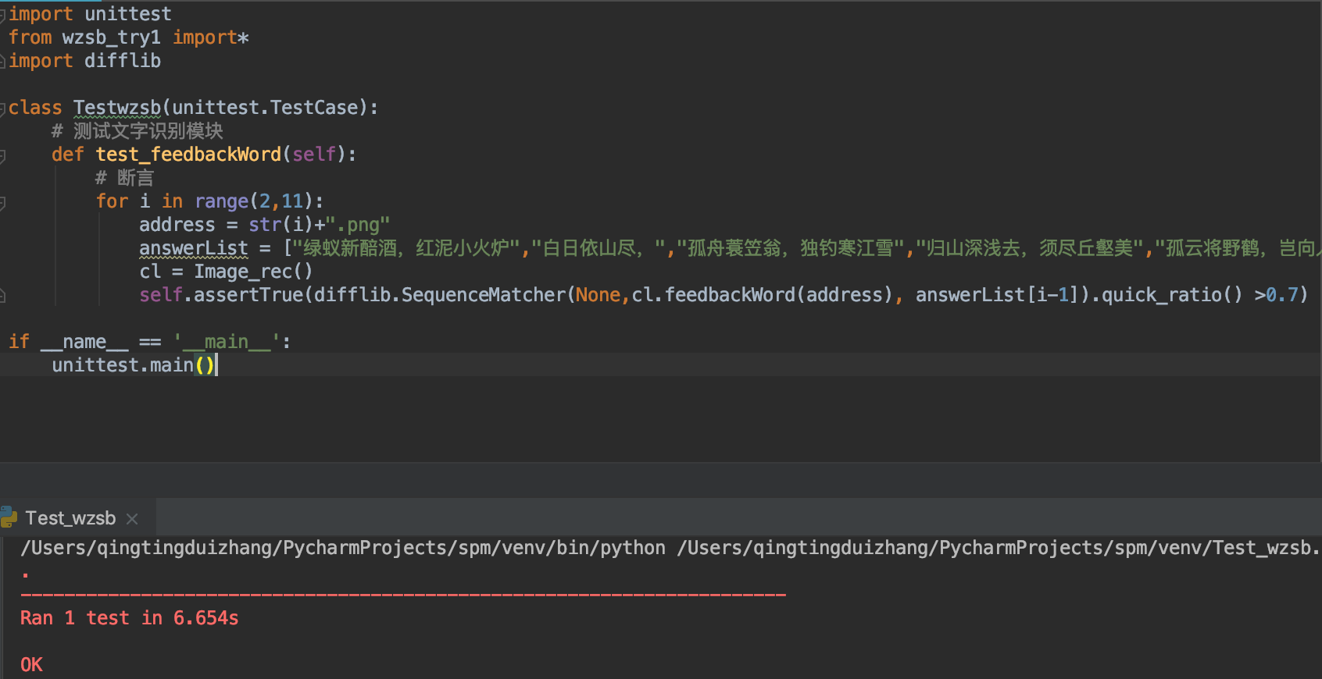

# Lessons learnt

1. The technical coupling between modules should not be too high, otherwise it will easily lead to the integration of modules due to technical differences. This requires that when making project plans, the task boundaries should be delimited, the highly coupled tasks should be assigned to the same person, and when the task load is large, the technical characteristics and compatibility should be understood in advance, and the detailed task design should be determined.
2. There should not be too long time interval between the two iterations of the project, and the task gap should be controlled within two days as far as possible. Otherwise, it will be difficult to concentrate, subjective initiative is poor and efficiency is low when re-entering the project.
3. The amount of tasks should be consistent with the development time, that is, the working pressure of developers in two iterations should be similar; otherwise, task postponement is more likely to occur in the phase with low pressure, because the developer has low psychological pressure and poor subjective initiative.

# Conclusion

The "poetry traceability system" project lasted 70 days and two development cycles. There are 4 people in the project team, who are respectively responsible for 4 modules and other test tasks. The task parallel mechanism is adopted, and the work results are submitted every 7 days. The project has realized two main functions of image retrieval and keyword retrieval. The retrieval time and website stability are in line with the project requirements, and the project goal has been basically completed. There are some small defects in the project. For example, the text recognition module cannot recognize certain fonts, which makes it impossible to retrieve poems, and it also has certain requirements on the shooting Angle and environment of pictures.

During the project, all team members cooperated with each other, learned together, and achieved the goal according to the plan. They not only gained some professional skills, but also had an in-depth understanding of various processes and technical methods of software project management, which well cultivated their personal ability and enriched their project experience.

# Future plan

In the next version of the project, it is planned to optimize the text recognition module and page logic arrangement, and add voice description, account management, advertising booth and other functions. The optimization of the text recognition module is specific to the manual training sample, which supports the recognition of handwriting, cursive script, round font and other fonts, increases the image processing procedures, and expands the scope of image recognition. Page logical arrangement specifically refers to reducing the user's difficulty in using various functions, the complexity of page operation, making the system more humane.