# Intelligent Poetry Tracing System Detailed Plan

**directory**

**1. modules design** **2**

**2. Interface design 3**

**3. Database design 4**

**4. Mailestones** **4**

**5. Deliverables** **5**

**6. WBS 8**

**7. Gantt chart 10**

**8. Web page design 14**

1. modules design

The first round of iteration: users upload pictures, and identify the poems and texts in the pictures through the picture recognition function of the system. The system sends the poems and texts to the background, and the background returns the complete information of poems and texts to the users.

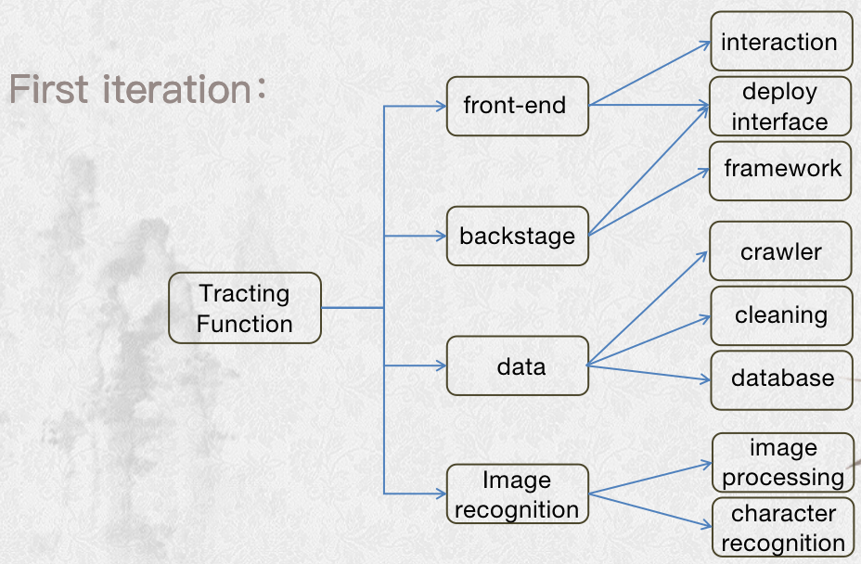The first iteration of the system use case diagram

The second iteration: it is roughly divided into three modules -- poetry and prose retrieval module (users can search according to author/dynasty/category), poetry and prose information download module and website sharing module.

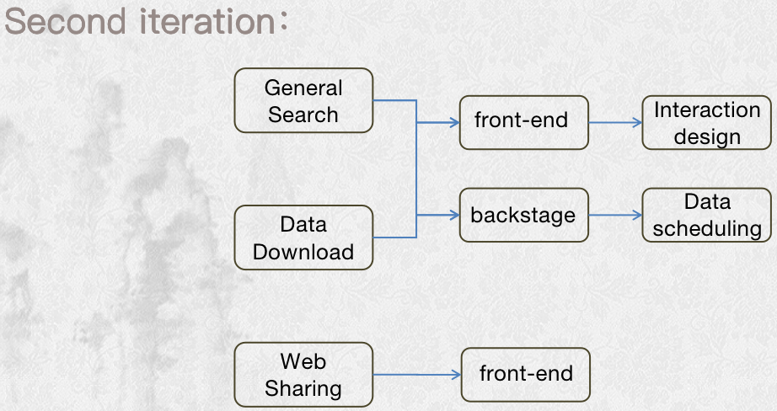The second iteration of the system use case diagram

2. Interface design

First iteration：

front-end

f

a

backstage

b

c

d

e

data base

Image recognition

**a** my_upload(address) ——output picture address

**b、c** feedbackWord(address) ——input image location

return verse ——output verse

**d、e** select_for_args(sql) ——input database operation command

return list ——output data

**f** get_mess_title(title_name) ——output title

get_mess_author(author_name) ——output author

get_mess_dynasty(dynasty_name) ——output dynasty

get_mess_poem(poem) ——output poem_body

get_mess_tac(tac) ——output tac

get_mess_background(background) ——output background

get_mess_self_intro(self_intro) ——output self_intro

get_mess_appreciation(appreciation) ——output appreciation

Second iteration：

front-end

j

g

backstage

i

h

Image recognition

data base

**g** my_search(input,checkbox) ——input search_type and text

**h、i** select_for_args(sql) ——input database operation command return list ——output data

**j**  get_mess_title(title_name) ——output title

get_mess_author(author_name) ——output author

get_mess_dynasty(dynasty_name) ——output dynasty

get_mess_poem(poem) ——output poem_body

get_mess_tac(tac) ——output tac

get_mess_background(background) ——output background

get_mess_self_intro(self_intro) ——output self_intro

get_mess_appreciation(appreciation) ——output appreciation

3. Database design

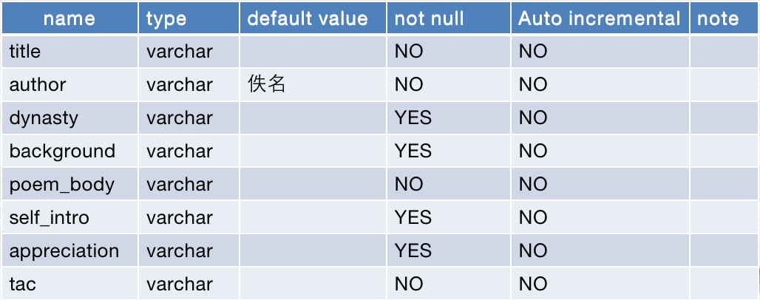

4. Milestones

The total cycle of the project is 10 weeks. The first stage is the first 5 weeks (March 12, solstice, April 9), and the second stage is the last 5 weeks (April 9, solstice, May 14). The specific milestones are as follows:

First iteration:

March 12→ submit the overall design

submitter：yu

March 19→ submit detailed design

submitter：yu

submit technical study result

submitter：yu\tu\king\wang

March 26→ submit the early code

submitter：yu\tu\king\wang

April 2→ submit the middle code

submitter：yu\tu\king\wang

April 9→ submit the post code

submitter：yu\tu\king\wang

April 16→ deliver the initial system, make improvement plan

submitter：yu

Second iteration:

April 23→ submit the early code

submitter：king\wang

April 30→ submit the post code,system test result

submitter：yu

May 1→ submit final product

submitter：yu

## Deliverables

|  |  |  |  |  |  |  |
| --- | --- | --- | --- | --- | --- | --- |
|  | weeks | 1 | | | | |
|  |  | deliverables | Effort | deadline | beginTime | Delivery standards |
| Wang(王子越) |  |  |  |  |  |  |
| King(车金刚) |  |  |  |  |  |  |
| Yu(俞立) |  |  |  |  |  |  |
| Mars(涂晓招) |  |  |  |  |  |  |
| all numbers |  | Project plan | 7h | 3/12 | 3/05 | Have general design and requirements analysis |

|  |  |  |  |  |
| --- | --- | --- | --- | --- |
| 2 | | | | |
| deliverables | Effort | deadline | beginTime | Delivery standards |
| Learning document | 10h | 3/19 | 3/05 | Technical report |
| Learning document | 10h | 3/19 | 3/05 | Technical report |
| Learning document | 10h | 3/19 | 3/05 | Technical report |
| Learning document | 10h | 3/19 | 3/05 | Technical report |
| detailed design | 7h | 3/19 | 3/13 | Interface design, database field design and Detailed design of the project |

|  |  |  |  |
| --- | --- | --- | --- |
| 3 | | | |
| deliverables | Effort | deadline | beginTime |
| The code Page prototype of web | 7h | 3/26 | 3/19 |
| Website framework construction progress document | 7h | 3/26 | 3/19 |
| the code of Image processing | 7h | 3/26 | 3/19 |
| Data capture document | 7h | 3/26 | 3/19 |
|  |  |  |  |

|  |  |  |  |  |
| --- | --- | --- | --- | --- |
| 4 | | | | |
| deliverables | Effort | deadline | beginTime | Delivery standards |
| the code of the first version of the site page | 7h | 4/02 | 3/26 | Image upload |
| the code of Website background framework and interface | 7h | 4/02 | 3/26 | Ability to manipulate data in a database |
| the code of Word recognition processing | 7h | 4/02 | 3/26 | The ratio of Character recognition is up to 70% |
| 7h | 4/02 | 3/26 |
|  |  |  |  |  |

|  |  |  |  |  |
| --- | --- | --- | --- | --- |
| 5 | | | | |
| deliverables | Effort | deadline | beginTime | Delivery standards |
| the documentation of Web framework interface test | 7h | 4/09 | 4/02 | At least 2 bugs |
| the documentation of site page test | 7h | 4/09 | 4/02 | At least 3 bugs |
| the documentation of Database interface test | 7h | 4/09 | 4/02 | At least 2 bugs |
| the documentation of Word recognition interface test | 7h | 4/09 | 4/02 | At least 2 bugs |
|  |  |  |  |  |

|  |  |  |  |  |
| --- | --- | --- | --- | --- |
| 6 | | | | |
| deliverables | Effort | deadline | beginTime | Delivery standards |
| The instructions of bug repaired | 4h | 4/16 | 4/10 | The test bug has been fixed |
| The instructions of bug repaired | 4h | 4/16 | 4/10 | The test bug has been fixed |
| The instructions of bug repaired | 4h | 4/16 | 4/10 | The test bug has been fixed |
| The instructions of bug repaired | 4h | 4/16 | 4/10 | The test bug has been fixed |
| all of the code and the plans of the next | 3h | 4/16 | 4/10 | detail plans |

|  |  |  |  |
| --- | --- | --- | --- |
| 7 | | | |
| deliverables | Effort | deadline | beginTime |
| the code of the second version of the site page | 7h | 4/23 | 4/17 |
| the code of Website interface | 7h | 4/23 | 4/17 |
| the code of Optimizing text recognition | 7h | 4/23 | 4/17 |
| 7h | 4/23 | 4/17 |
|  |  |  |  |

|  |  |  |  |  |
| --- | --- | --- | --- | --- |
| 8 | | | | |
| deliverables | Effort | deadline | beginTime | Delivery standards |
| the document of Test and optimize | 7h | 4/30 | 4/24 |  |
| the document of Test and optimize | 7h | 4/30 | 4/24 |  |
| the document of Test and optimize | 7h | 4/30 | 4/24 |  |
| the document of Test and optimize | 7h | 4/30 | 4/24 |  |

|  |  |  |  |
| --- | --- | --- | --- |
| 9 | | | |
| deliverables | Effort | deadline | beginTime |
|  |  |  |  |
|  |  |  |  |
|  |  |  |  |
|  |  |  |  |
| all documents and all code | 1 | 5/1 | 5月1日 |

## 6. WBS

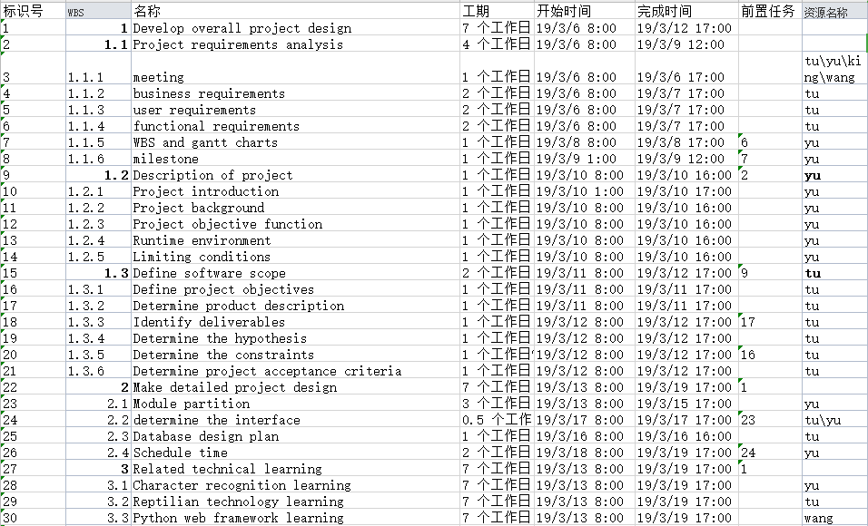

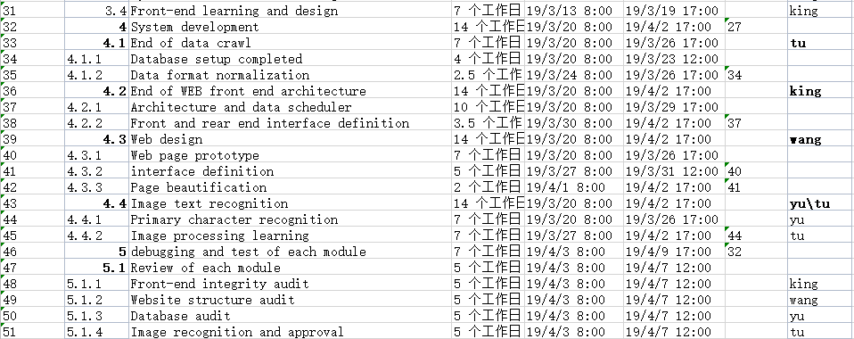

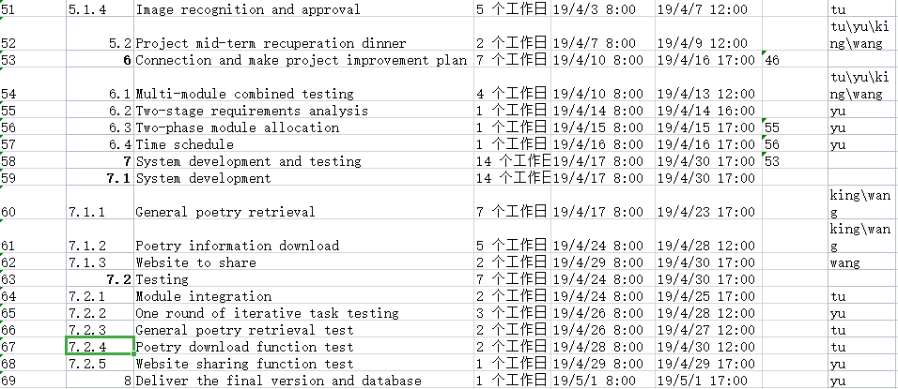

## 7. Gantt chart

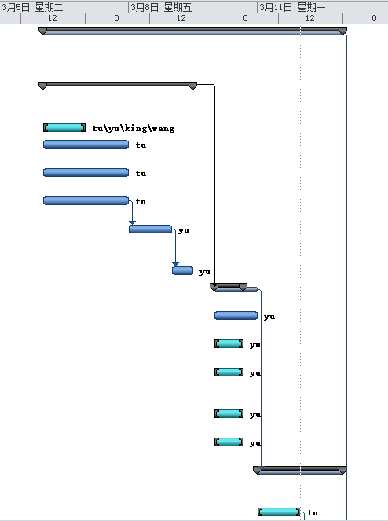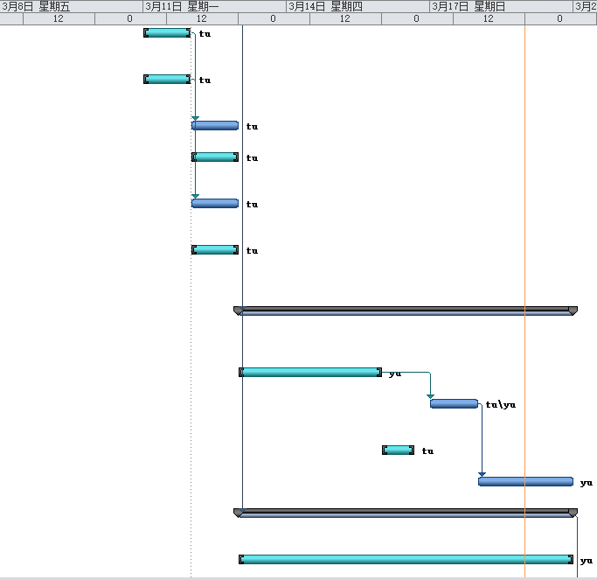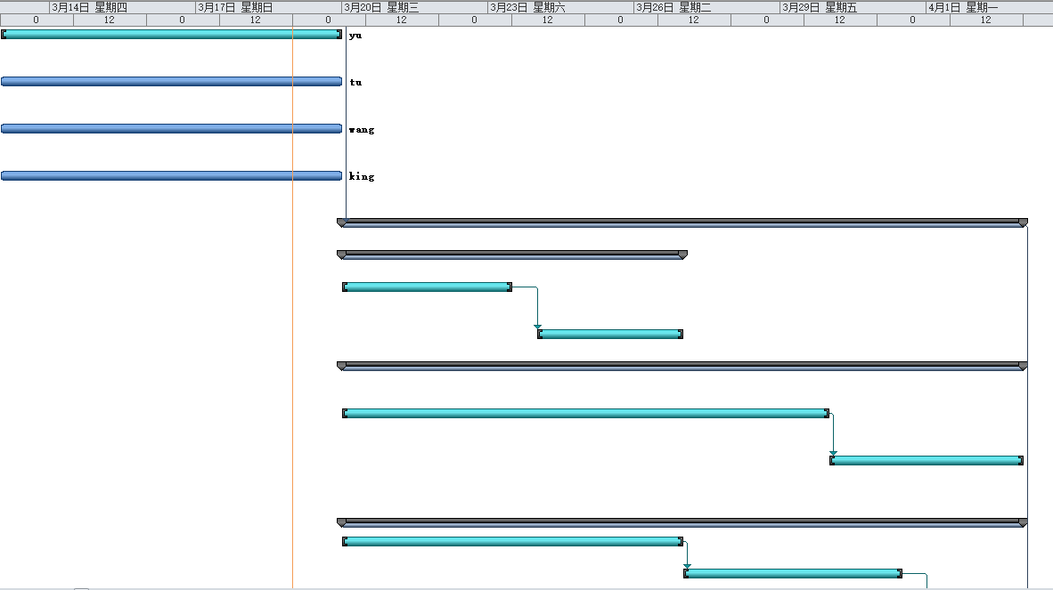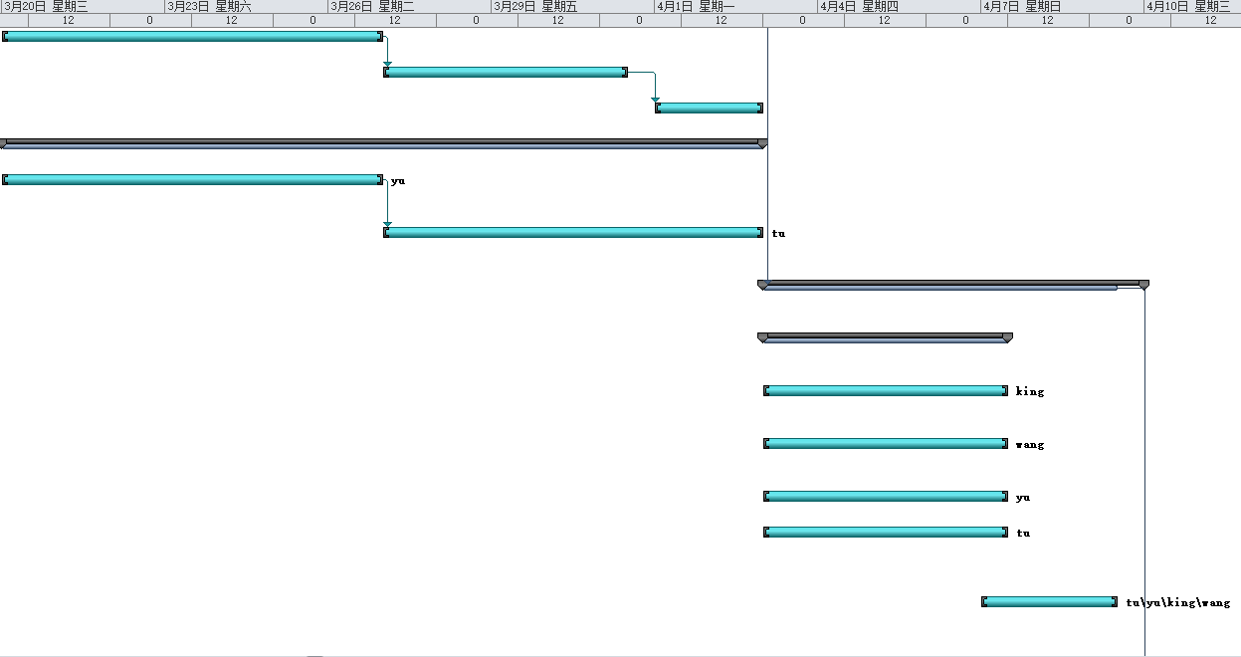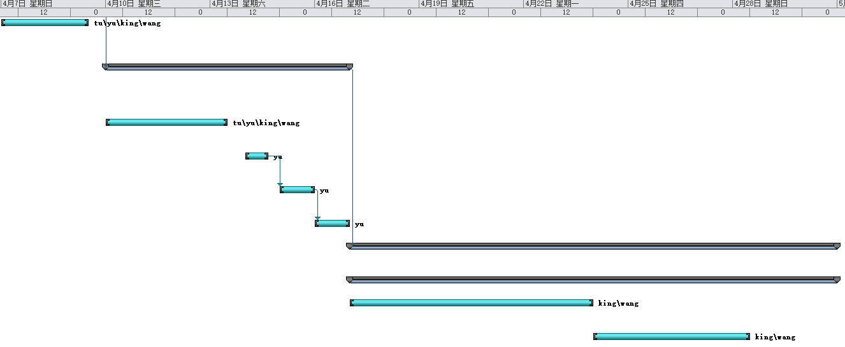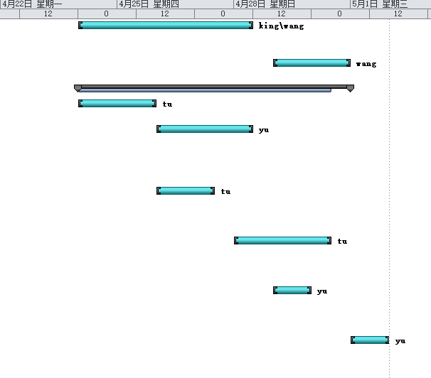

## 8. Web page design

## 屏幕快照 2019-03-19 下午10.21.57

