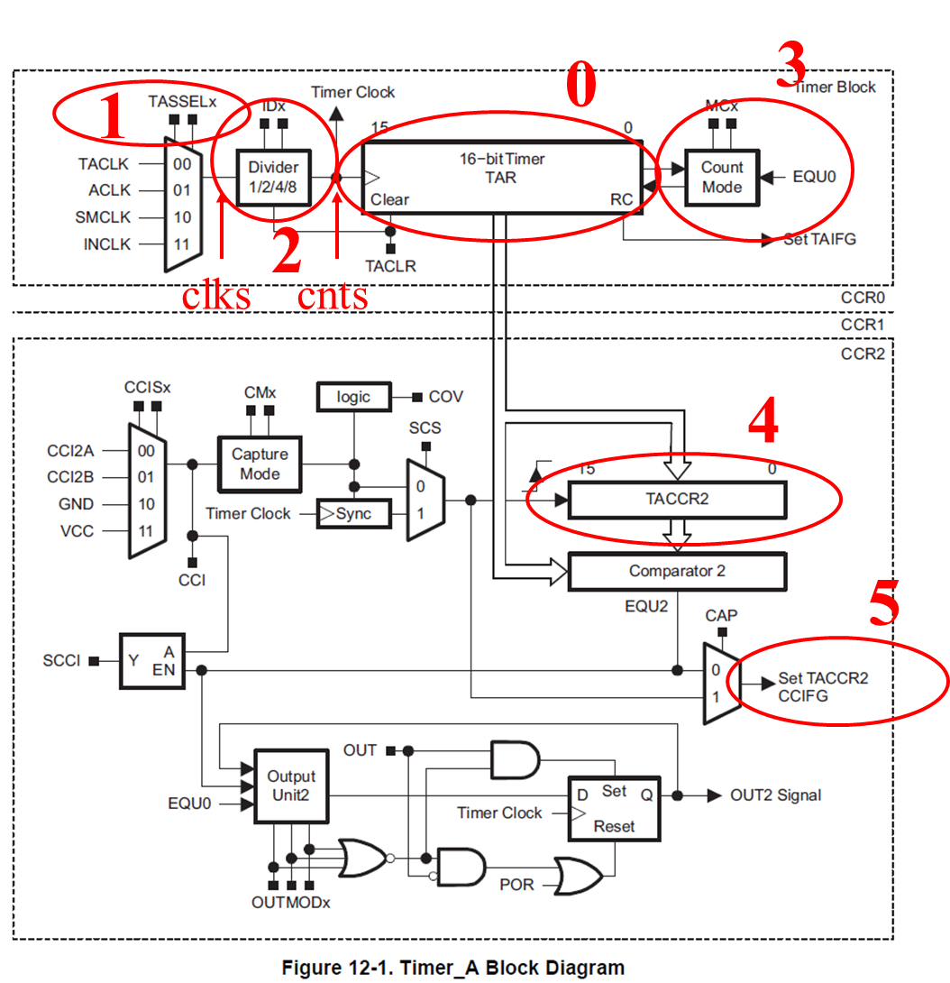

Given: SMCLK = 8 MHz, TASSEL=2, ID=2, MC=1, TACCR0=0xECE, and TAR starts at 0

Find: How long will it take to roll over TAR? {Fill in the blanks)

$$\frac{1 µs}{__8__ clks}×\frac{__4__ clks}{1 cnt}×\frac{__3790___ cnts}{1 TAR roll over}=1.895 ms=1.9 ms$$

Given : SMCLK = 8 MHz, TASSEL= 2, ID= 2, MC= 1, and TAR starts at 0

Find: The TACCRO values that will roll over TAR in 84 μs?

$$\frac{__8__ clks}{1 µs}×\frac{1 cnt}{__4__ clks}×\frac{84 µs}{1 TAR roll over}=168 cnt$$

To help with the calculations, call the output of the mux associated with the TASSELx signal **clks**. Call the signal coming out of the IDx clock divider **cnts**.

1. Given TAR=0, an 8 MHz clock, TASSEL_2, ID_2, MC_1, and TACCR0=255, how long will it take to roll over TAR?

2. Given TAR=0, an 8 MHz clock, TASSEL_2, ID_0, MC_1, and TACCR0=2^16-1, how long will it take to roll over TAR?

3. Do the previous problem, except with ID_1.

4. Do the previous problem, except with ID_2.

5. Do the previous problem, except with ID_3.

6. Given a TAR=0, an 8 MHz clock, TASSEL_2, ID_1, and MC_1, how many counts would it take to roll over

TAR in 84 μs?

7. Complete the following table assuming SMCLK = 8 MHz, TASSEL= 2, MC= 1, TACCR0=0x2006, and TAR starts at 0. How long will it take to roll over TAR?

|  |  |  |
| --- | --- | --- |
| **ID** | **Prescalar** | **MaxDelay (milliseconds)** |
| 0 | 1:1 | $\frac{1 µs}{8 clks}×\frac{1 clks}{1 cnt}×\frac{8198 cnts}{1 TAR roll over}=1.025 ms$ |
| 1 | 1:2 | $\frac{1 µs}{8 clks}×\frac{2 clks}{1 cnt}×\frac{8198 cnts}{1 TAR roll over}=2.05 ms$ |
| 2 | 1:4 |  |
| 3 | 1:8 |  |

8. Given SMCLK = 8 MHz, TASSEL= 2, MC_1, ID_2, provide a nice round number for TACCR0 that will cause TAR to roll over in 40 ms.

9. Given these settings, how many counts will it take to create a delay of 550 μs? 1.65 ms? 4.5 ms? 90 ms?

$\frac{8 clks}{1 µs}×\frac{1 cnt}{4 clks}×\frac{550 µs}{1 TAR roll over}=1,100 cnts$

$\frac{8 clks}{1 µs}×\frac{1 cnt}{4 clks}×\frac{1.65 ms}{1 TAR roll over}=3,300 cnts$

$\frac{8 clks}{1 µs}×\frac{1 cnt}{4 clks}×\frac{4.5 ms}{1 TAR roll over}=9,000 cnts=9×{10}^{3} cnts$

$\frac{8 clks}{1 µs}×\frac{1 cnt}{4 clks}×\frac{90 ms}{1 TAR roll over}=180,000 cnts=180×{10}^{3} cnts$