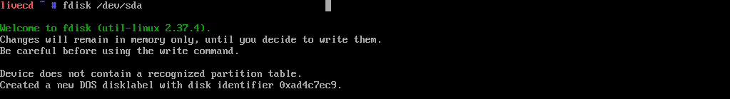

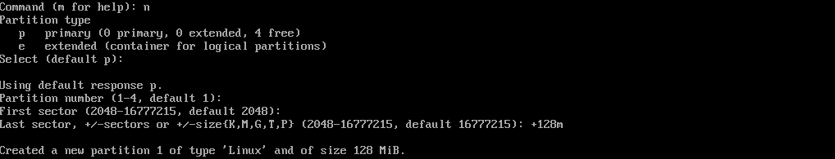

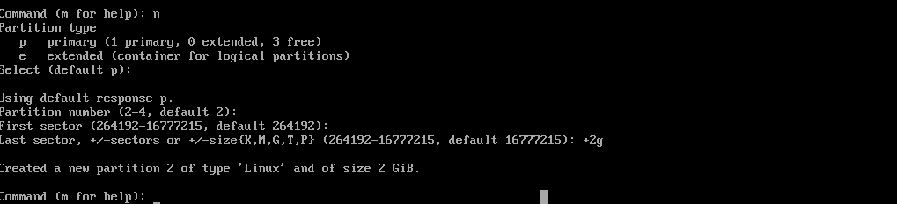

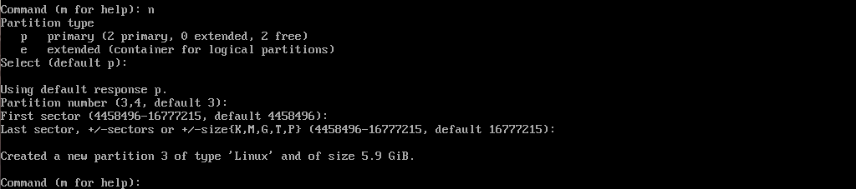

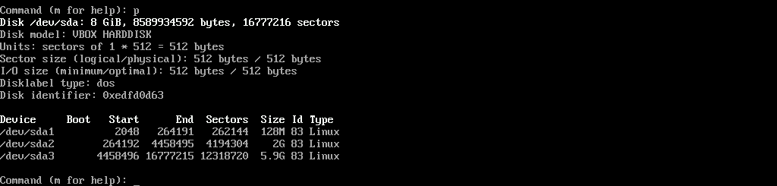

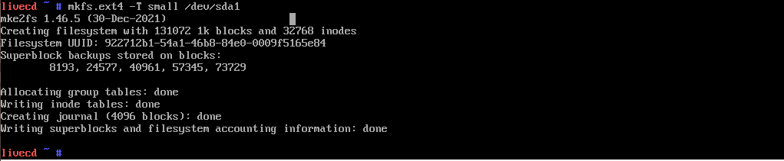

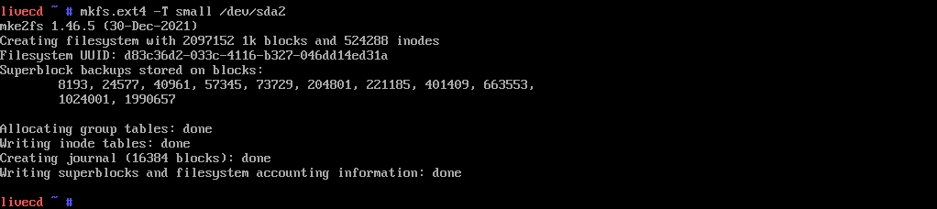

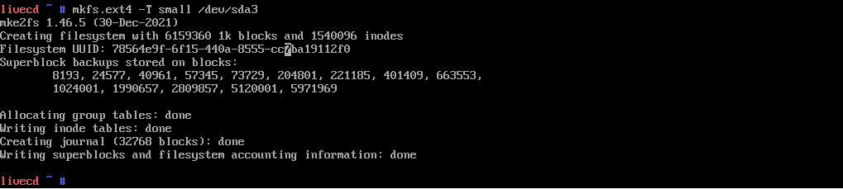

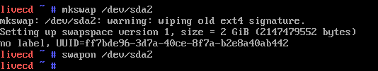

C:\Users\User\Desktop\Gentoo amd64\Screenshot_10.png

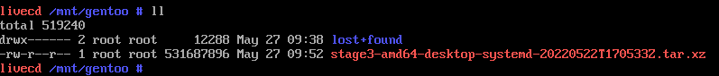

C:\Users\User\AppData\Local\Microsoft\Windows\INetCache\Content.Word\7. Распакуем архив stage.png

C:\Users\User\Desktop\Gentoo amd64\Screenshot_12.png

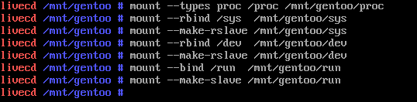

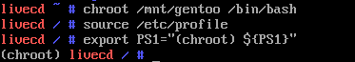

C:\Users\User\Desktop\Gentoo amd64\Screenshot_15.png

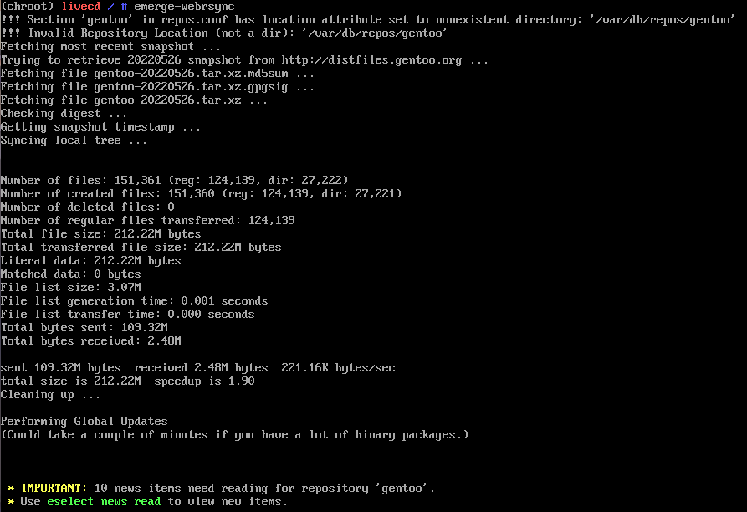

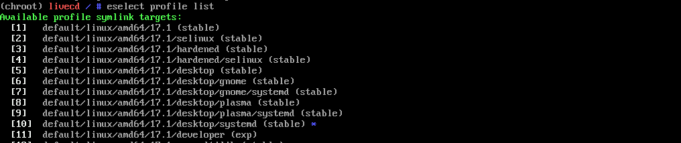

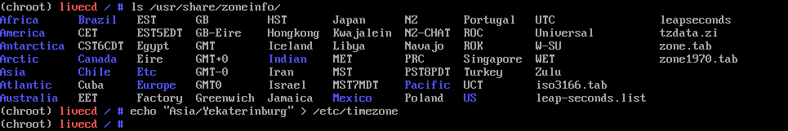

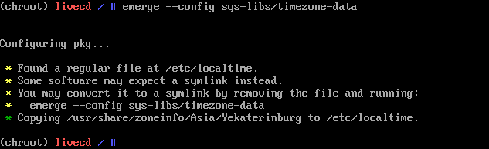

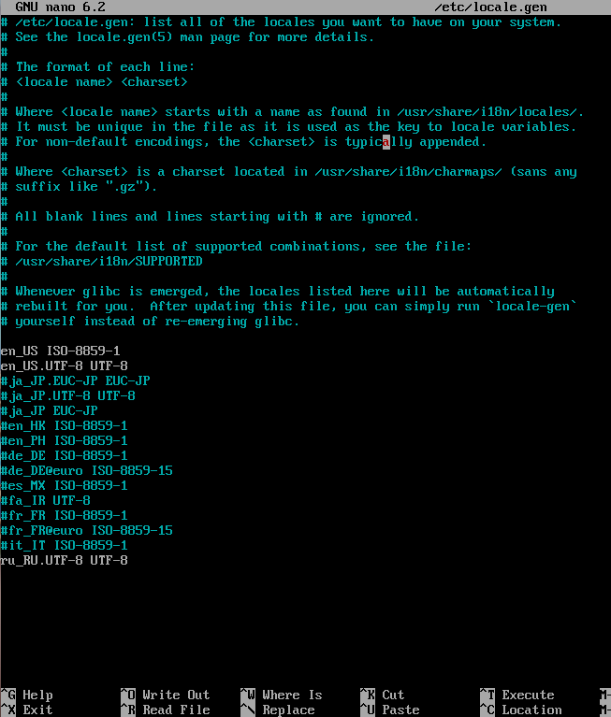

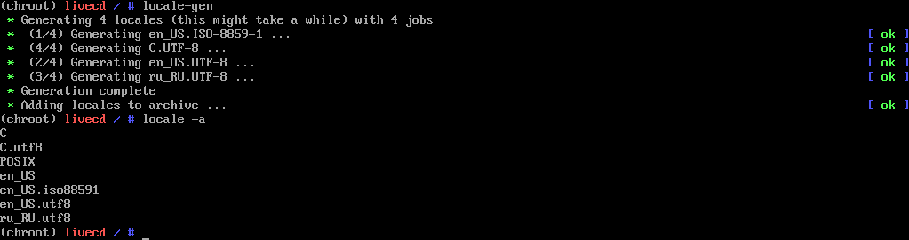

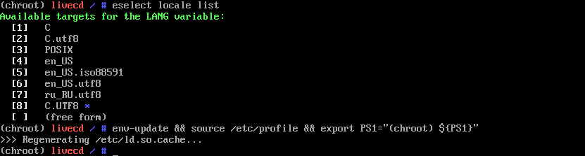

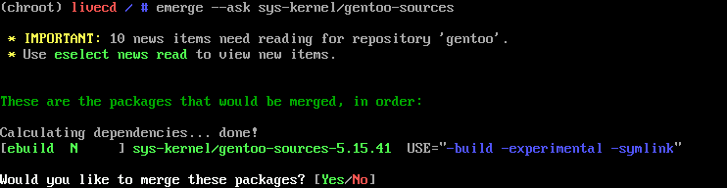

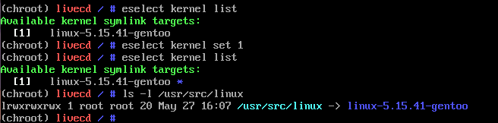

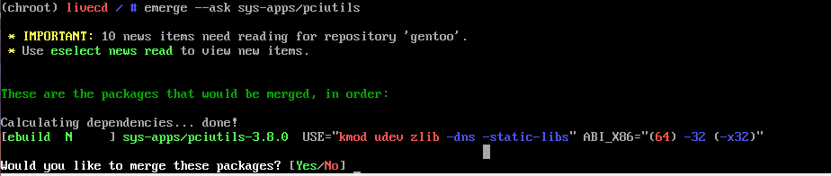

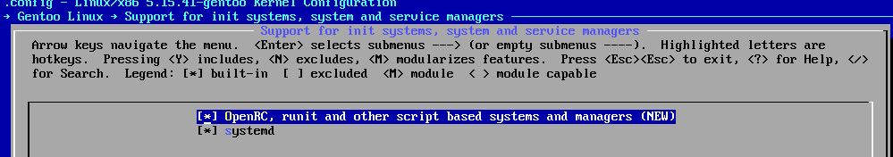

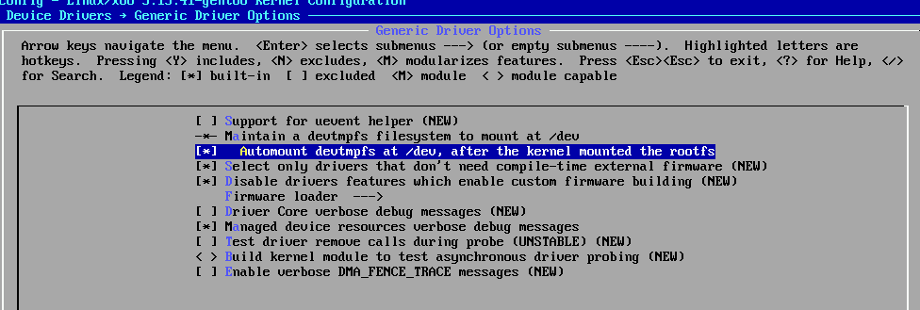

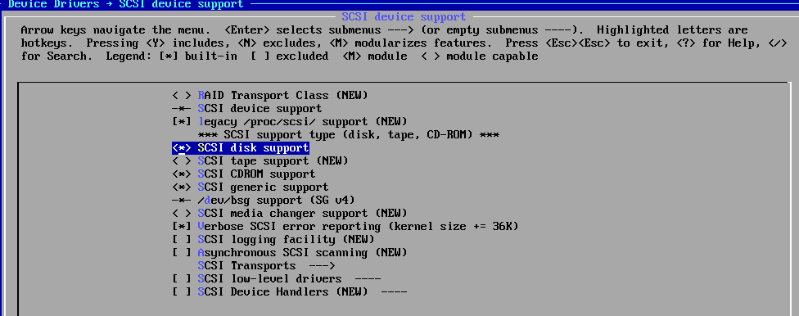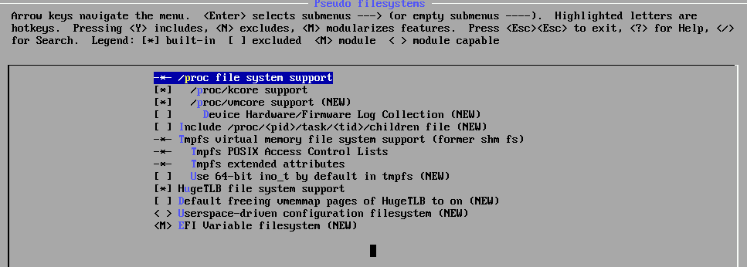

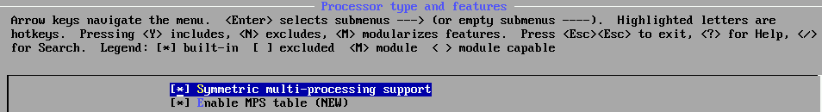

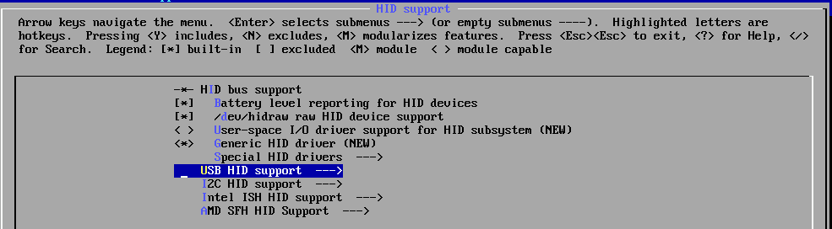

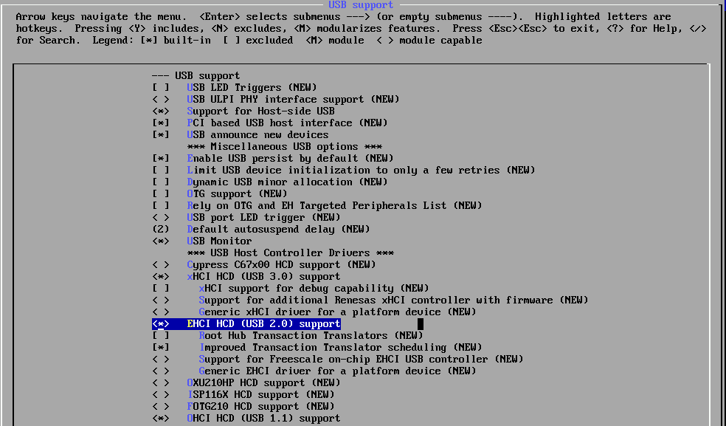

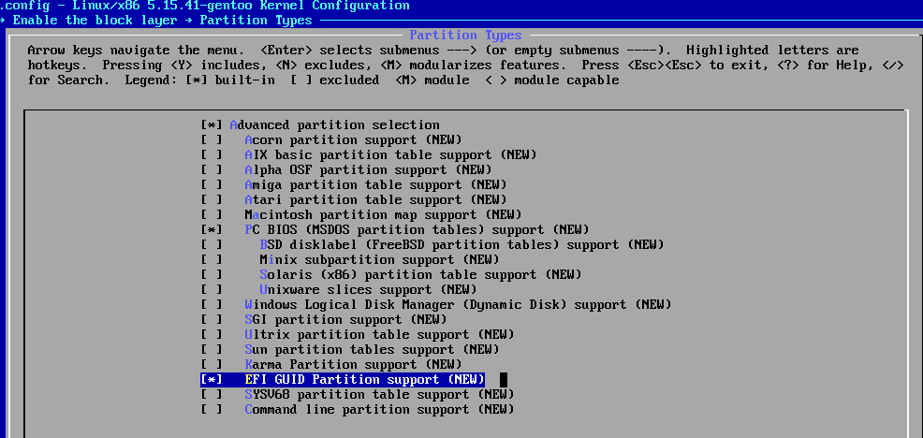

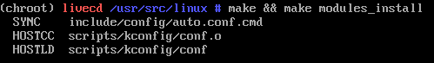

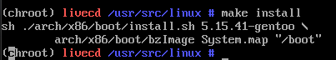

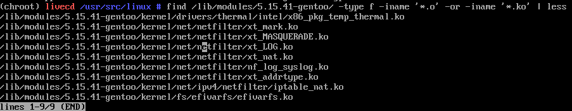

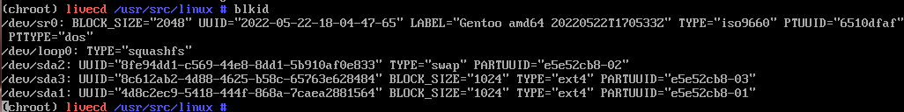

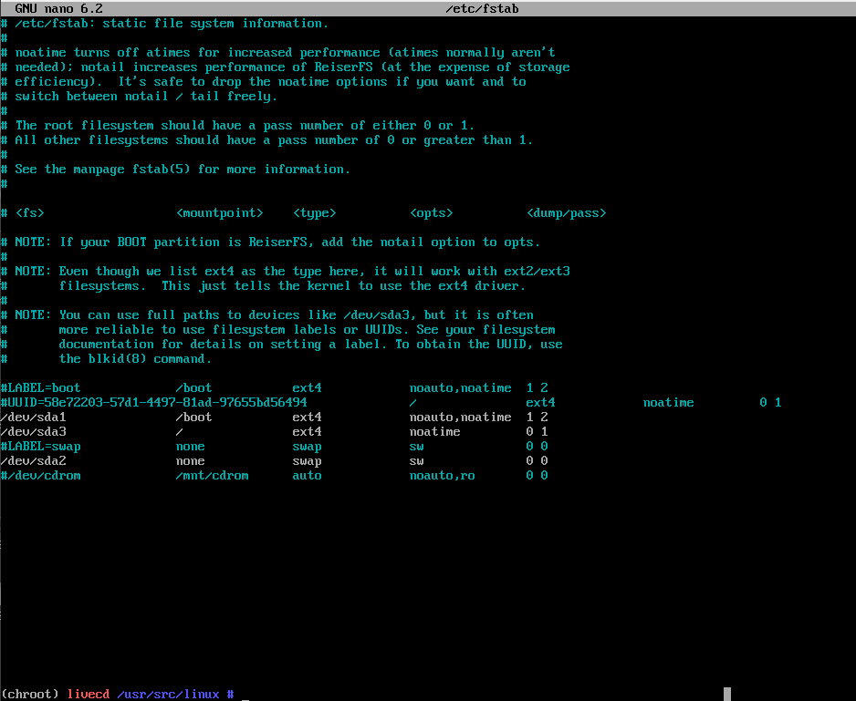

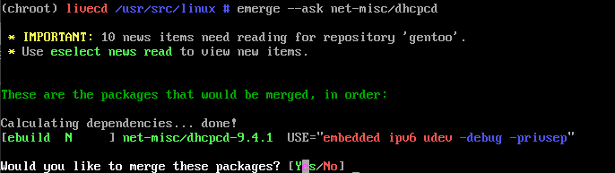



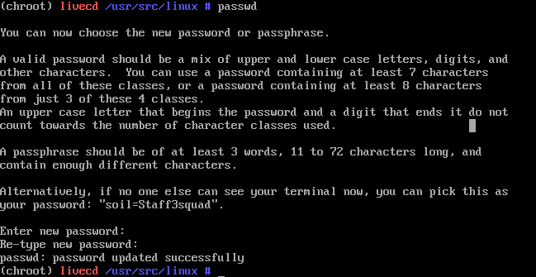

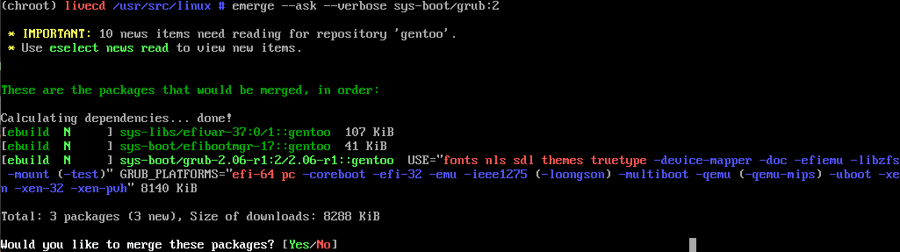

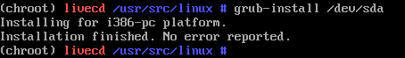

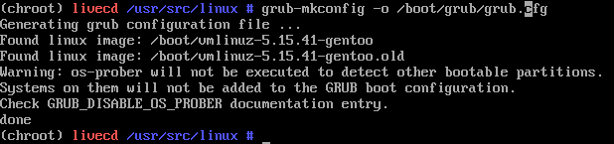

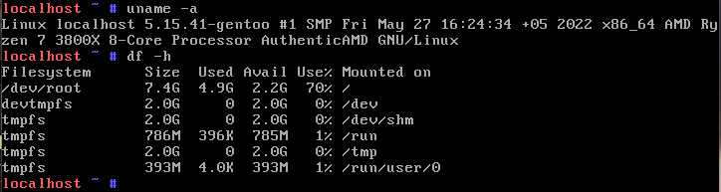

C:\Users\User\Desktop\Gentoo amd64\Screenshot_45.png

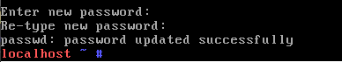

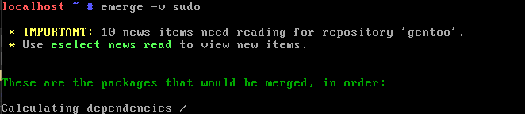

C:\Users\User\Desktop\Gentoo amd64\Screenshot_48.png