Assignment 1 : Command To change UserName & email in Git bash
1. Set your username and email in Git.
2. Verify the configuration.

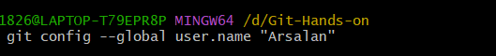

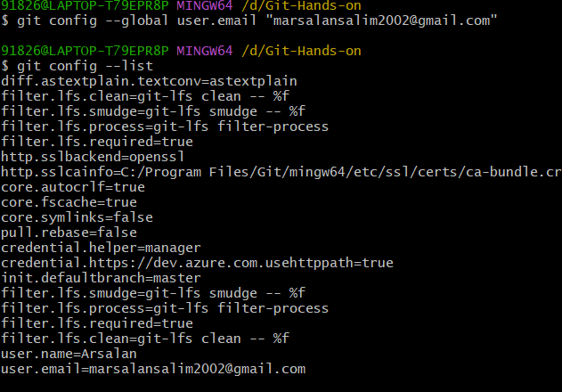

Assignment 2: Initialize a Local Repository
1. Create a new folder named git-hands-on.
2. Initialize it as a Git repository.
3. Check the repository status.
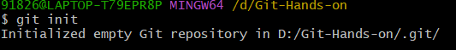

Assignment 3: Create and Track Files
1. Create a file named documentation.txt.
2. Add a short project description inside it.
3. Check file status.
4. Stage the file.
5. Commit the changes with an appropriate message

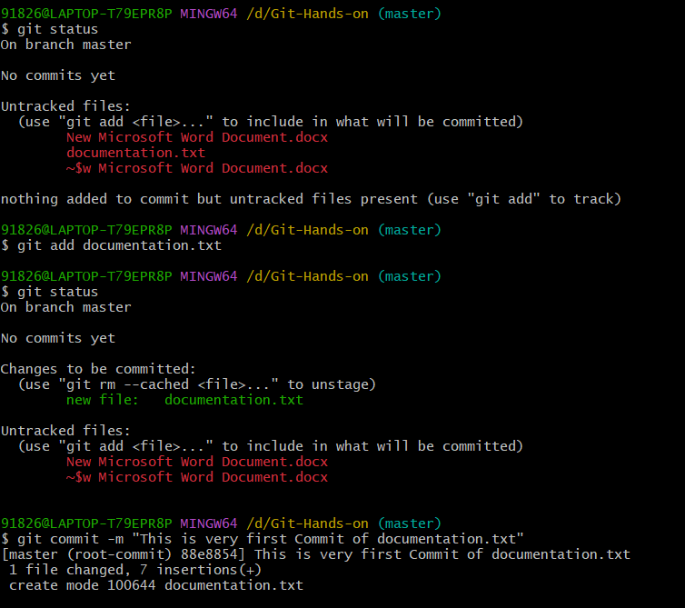

Assignment 4: Modify and Commit Changes
1. Edit documentation.txt and add one more line.
2. View the differences between working directory and staging area.
3. Stage and commit the changes.
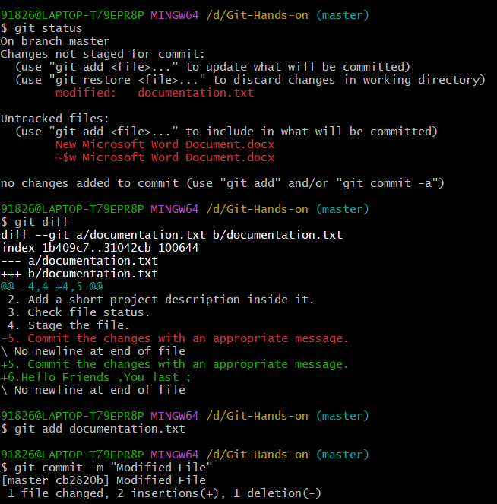

Assignment 5: View Commit History
1. View the complete commit history.
2. View commit history in one-line format.
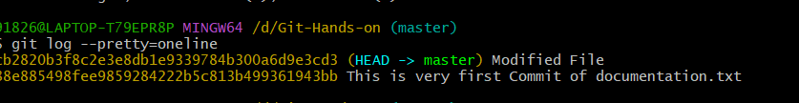

Assignment 6: Create and Work with Branches
1. Create a new branch named feature-1.
2. Switch to the new branch.
3. Create a new file feature.txt.
4. Commit the changes.
5. Switch back to the main branch.
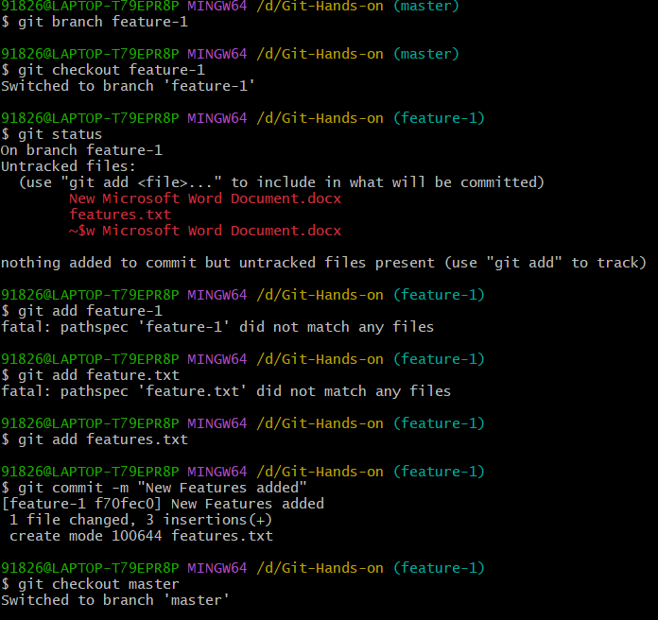

Assignment 7: Merge Branches
1. Merge feature-1 branch into main.
2. Verify the merge using commit history.
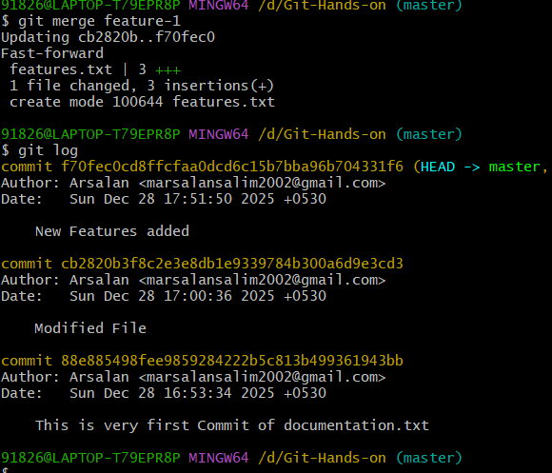

Assignment 8: Connect to a Remote Repository
1. Create a new repository on GitHub.
2. Add the remote repository URL to your local repo.
3. Verify the remote connection.
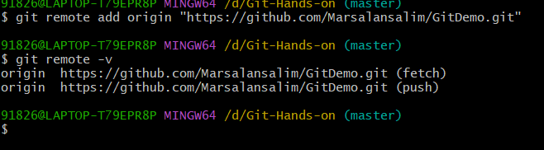

Assignment 9: Push Code to GitHub
1. Push the main branch to GitHub.
2. Verify files on GitHub.
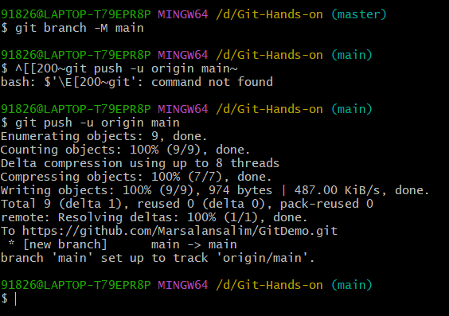

Assignment 10: Clone a Repository
1. Clone the same GitHub repository into a different folder.
2. Verify the cloned content.
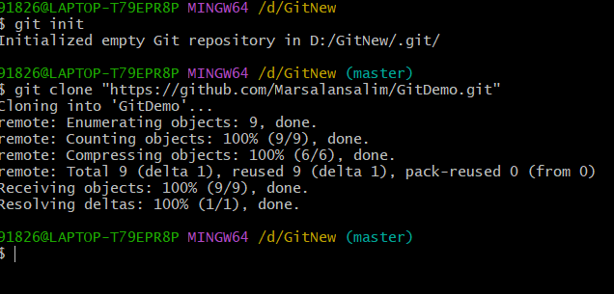
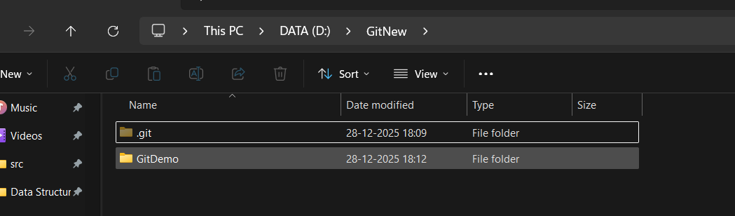

Assignment 11: Undo Changes
1. Make a change in documentation.txt but do not commit.
2. Discard the changes.
3. Verify the file status.
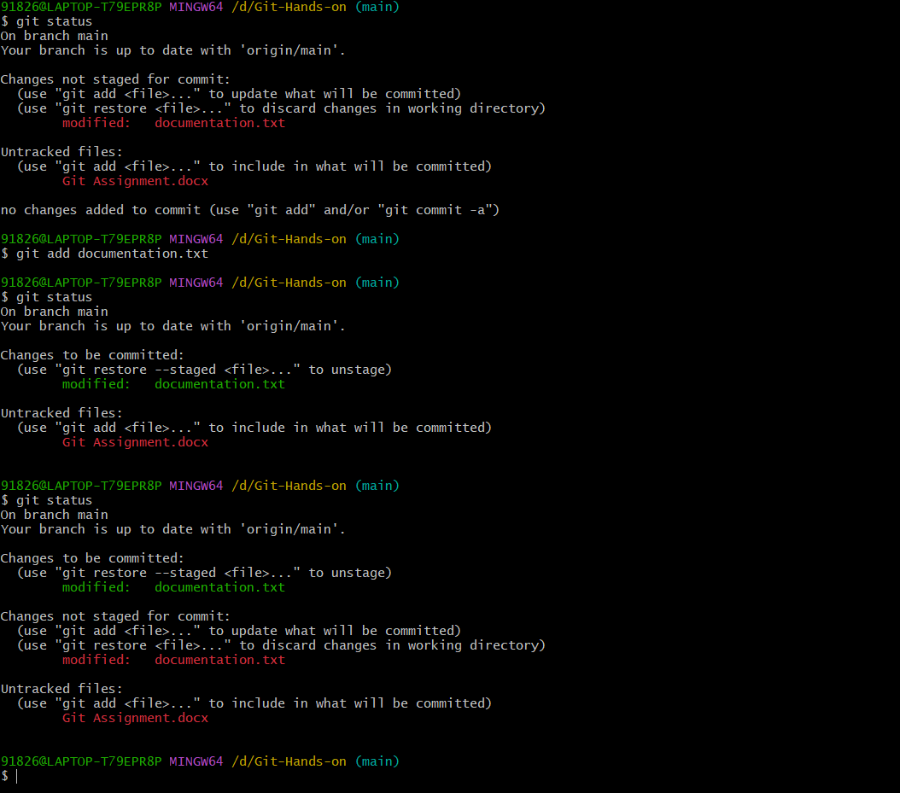

Assignment 12: Remove Files
1. Delete feature.txt using Git.
2. Commit the deletion.
