This information product has been peer reviewed and approved for publication as a preprint by the U.S. Geological Survey.

Article Type: Letter

Title: Higher methanotroph abundance and bottom-water methane in ponds with floating photovoltaic arrays

Running head: Floating solar and methane in ponds

Author Names: Nicholas E. Ray¹, Sophia Aredas², Steven M. Grodsky³, Ash Canino⁴, Simone J. Cardoso⁵, Meredith A. Holgerson⁶, Meredith Theus⁶, Marian L. Schmidt²

Author Affiliations:
¹ School of Marine Science & Policy, University of Delaware, USA
² Department of Microbiology, Cornell University, USA
³ U.S. Geological Survey, New York Cooperative Fish and Wildlife Research Unit, Department of Natural Resources and the Environment, Cornell University, USA
⁴ Department of Natural Resources and Environment, Cornell University, USA
⁵ Department of Zoology, Institute of Biological Sciences, Universidade Federal de Juiz de Fora, Brazil
⁶ Department of Ecology and Evolutionary Biology, Cornell University, USA

Corresponding Author: Nicholas E. Ray; nickray@udel.edu

Author Contribution Statement:
NER designed the study, provided supplies, performed field sampling, laboratory analyses, and data analysis, and wrote the first draft of the manuscript. SA performed field sampling, laboratory analyses, data analysis, and edited the manuscript. SMG secured funding, constructed the floating solar arrays, performed field sampling, and edited the manuscript. AC, SJC, and MT performed field sampling and edited the manuscript. MAH secured funding, performed field sampling, and edited the manuscript. MLS designed the study, provided supplies, data analysis, secured funding, and edited the manuscript.

Scientific Significance Statement
Producing energy using floating photovoltaic (FPV) powerplants offers an opportunity to produce renewable energy, spare land, and reduce evaporation from ponds, lakes, and reservoirs. However, FPV deployment in these ecosystems is associated with colder temperatures, less oxygen availability, and changes in carbon cycling processes. Specifically, experimental evidence demonstrates an increase in concentrations of methane – a potent greenhouse gas – in ponds following FPV deployment. In this study, we investigate how microbial communities associated with aquatic methane cycling differ between ponds with and without FPV. We show that FPV deployment increases bottom-water methane concentrations and triggers dense blooms of methane-oxidizing bacteria. These results provide the first evidence that microbial communities respond strongly to engineered shading and may help buffer greenhouse gas emissions in solar-covered waters.

Data and Code Availability
All raw and processed data for this project are publicly available. The code used for statistical comparisons, generating figures, and processing microbial community data are available on GitHub at https://github.com/MarschmiLab/Ray_LO_Letters_FPV_Methane. Biogeochemical data and summaries of methane cycling microbe abundances is available for download via the Figshare Repository (https://doi.org/10.6084/m9.figshare.29614025.v1). The raw, compressed 16S rRNA gene sequencing fastq files are available in the NCBI Sequence Read Archive (SRA) under the BioProject accession number PRJNA1417770 (https://www.ncbi.nlm.nih.gov/bioproject/1417770). All flow cytometry data are available from Zenodo (https://zenodo.org/records/18462017).

Abstract (150 words max)
Floating photovoltaic (FPV) arrays alter the methane (CH₄) cycling dynamics of waterbodies on which they are deployed. Here, we investigated dissolved CH₄ dynamics and associated CH₄ cycling microbial communities (methanogens and methanotrophs) in the second year of FPV deployment (70% aerial coverage) in experimental ponds. We found that bottom-water CH₄ concentrations were twice as high in ponds with FPV compared to those without, while surface water CH₄ concentrations were orders of magnitude lower than bottom-waters, but did not differ between treatments. There was no change in the relative abundances of putative sediment methanogens or methanotrophs, but FPV restructured methanogen communities. FPV promoted late-summer methanotroph blooms in the water column, with abundances surpassing 1,000,000 cells mL⁻¹. We conclude that prolonged periods of CH₄ production in low oxygen FPV ponds favored blooms of methanotrophs, that may mitigate diffusive CH₄ emissions to the atmosphere by consuming dissolved CH₄.

Keywords: pond, methane, floating solar, greenhouse gas, methanogen, methanotroph
Introduction
Methane (CH₄) emissions from aquatic ecosystems have increased because of human activity (Jackson et al. 2024). Floating photovoltaic arrays (FPV), first deployed in 2007, are a rapidly expanding renewable energy technology that can alter aquatic CH₄ dynamics and emissions (Cazzaniga and Rosa-Clot 2021; Ray et al. 2024). By 2023, over 643 FPV power plants had been installed on lakes, ponds, and reservoirs worldwide (Nobre et al. 2024; Ramanan et al. 2024). There is substantial interest and potential in expanding FPV use on reservoirs and lakes to meet demands for renewable energy (Jin et al. 2023; Woolway et al. 2024), but the ecological and biogeochemical tradeoffs – particularly effects on CH₄ cycling – must be evaluated before broader deployment (Almeida et al. 2022; Gallaher et al. 2025).

FPV deployment is associated with lower water temperatures (Dörenkämper et al. 2021; Andini et al. 2022), reduced oxygen availability (Wang et al. 2022; Ray et al. 2024), and changes in stratification (Ilgen et al. 2023). These factors influence CH₄ dynamics in small, shallow systems where FPV has most commonly been deployed (Bastviken et al. 2004; Aben et al. 2017; Ray and Holgerson 2023; Nobre et al. 2024). Indeed, in the first year of FPV deployment, experimental ponds with FPV showed twice the dissolved CH₄ concentrations and CH₄ ebullition compared to control ponds, but diffusive CH₄ emissions were lower (Ray et al. 2024). Whether these observed patterns persist over time or might be similar in other ecosystems is unclear.

Understanding how FPV affects methanogens (CH₄ producers) and methanotrophs (CH₄ consumers) is essential for predicting CH₄ emissions. Methanogenic archaea and methanotrophic archaea and bacteria jointly regulate CH₄ dynamics, yet it remains unresolved how FPV-induced changes in temperature, light, oxygen, and primary production influences their abundance, composition, and activity. Evidence from non-FPV settings suggests changes in such limnological conditions can re-structure CH4-cycling communities and alter metabolic rates (Wang et al. 2021; Bertolet et al. 2022). Clarifying microbial responses to FPV is critical for determining whether this technology amplifies or dampens CH₄ emissions and, more broadly, for understanding how pond microbial communities respond to reduced light and oxygen.

Here, we investigate how FPV affects CH₄ dynamics in temperate experimental ponds during the second year of FPV deployment, with a focus on identifying microbial and biogeochemical mechanisms underlying dissolved CH₄ concentrations. We pair observations of temperature, dissolved oxygen, and dissolved CH₄ with measurements of methanogen and methanotroph community structure and CH₄ process rates during an intensive mid-summer sampling campaign in ponds with and without FPV. To capture microbial mechanisms relevant to dissolved CH₄ concentrations, we focus on well-characterized methanotrophs and integrate community data with functional rate measurements to capture both composition and activity.

Methods
Location and Sampling Scheme
In 2023, FPV arrays (70% aerial coverage) were deployed on three ponds at the Cornell Experimental Ponds Facility in Ithaca, New York, USA (42.5049 N, 76.4666 W). Observational sampling of six ponds starting in 2022 prior to FPV deployment in 2023, providing three replicate control and three replicate FPV ponds (Ray et al. 2024). Each pond is a 30 x 30 m inverted, truncated pyramid, 1.75 m deep, unlined, and with sediment accumulation since construction in 1958-1959. Rooted, submerged macrophytes dominate primary production.

We returned in summer 2024 to continue measurements of dissolved CH₄ (surface and bottom), temperature, and dissolved oxygen (4 depths; 0.1, 0.75, 1, and 1.25 m from the water surface). We sampled methanogens and methanotrophs four times in 2024 from surface water, bottom water, and sediments. On July 11, 2024, we measured diffusive CH₄ exchange and net CH₄ production or consumption in surface waters, bottom waters, and sediments. For each date, we calculated density gradients of pond water columns using temperature profile data to compare mixing and stratification dynamics between ponds with and without FPV (Supplemental Methods).

Observational CH₄ Concentration Measurements
We collected samples to determine dissolved CH₄ concentrations in the surface and bottom water of each pond six times between June 20 and September 5. Samples were collected in triplicate from the pond center using a headspace equilibration approach, with surface samples collected by hand at 10 cm depth and bottom water collected using a Van-Dorn bottle ~10 cm from the sediment-water interface (Ray et al. 2024). Samples were stored in 12 mL pre-evacuated borosilicate exetainer vials until analysis using a gas chromatograph equipped with a flame ionization detector (Shimadzu GC-2014).

Microbial Sample Collection and Preservation
Water samples for microbial analysis were collected as for CH₄ measurements and sequentially filtered through 200 µm and 20 µm NYTEX mesh into 2 L Nalgene bottles and kept on ice until return to the laboratory the same day. Surface sediments (top 2 cm) were collected using a PVC pole corer and stored in WhirlPak bags in the cooler. Water was filtered onto 0.22 µm polyethersulfone filters using a peristaltic pump (190-2020 mL per sample). Sediments were homogenized using a stainless-steel coffee grinder (three 1 second pulses per sample). Filters (halved) and homogenized sediment were stored in 2 mL cryovials at -80 °C. Samples for flow cytometry were fixed with 1 μL 25% glutaraldehyde, diluted 15–20×, stained with SYBR Green I, and run in triplicate on an Attune NxT (see supplemental methods).

Microbial DNA Extraction, Sequencing and Bioinformatics
DNA was extracted from half filters using the DNeasy PowerWater Kit and from sediments using the DNeasy PowerSoil Pro Kit (Qiagen), eluted in 50 μL elution buffer, quantified with a Qubit fluorometer (Thermo-Fisher) and stored at −20 °C. The V4 region of the 16S rRNA gene was amplified following the Earth Microbiome Project protocols (Caporaso et al. 2011; Apprill et al. 2015; Parada et al. 2016) using triplicate 25 µL PCRs with KAPA HiFi 2X Mastermix (Roche), 0.2 μM 515F (5’-GTGYCAGCMGCCGCGGTAA) and 806R (5’-GGACTACNVGGGTWTCTAAT) primers with Illumina Nextera overhangs, and 5 ng template DNA. Zymo-BIOMICS Microbial Community DNA Standard (Zymo) was included to assess error rates. Samples, including PCR and indexing blanks, were pooled, indexed, and sequenced (2 x 250 bp) on an Illumina MiSeq sequencer at the Cornell Biotechnology Resources Center.

Raw sequences were processed into amplicon sequence variants (ASVs) using the DADA2 workflow (Callahan et al. 2016) in R. Reads were trimmed to 253-254 base pairs (max error = 1), merged, denoised, and chimera-checked. Taxonomy was assigned with GreenGenes2 (McDonald et al. 2024). Data were imported into phyloseq (McMurdie and Holmes 2013); mitochondrial, chloroplast, and ASVs with a higher relative abundance in blanks were removed. The mock community revealed 24 spurious ASVs (error rate of 0.087%). Samples with low read counts were excluded, resulting in 8,188-171,275 reads per sample. Water column ASV relative abundances were multiplied by cell counts to obtain absolute ASV counts per mL whereas the ASV relative abundances in sediments were multiplied by the minimum library size (20,826 sequences) for relative abundance.

Microbial metabolic profiles were predicted using custom code Functional Annotation of Prokaryotic Taxa version 2 (FAPROTAX v2) based on cultured prokaryotes (Louca et al. 2016). Using default parameters, ASVs were putatively identified through phylogenetic placement onto the FAPROTAX v2 reference tree. Methanogens and methanotrophs were identified at the family and genus level and verified through scientific literature and public databases (NCBI; Table S1).

Diffusive CH₄ Flux Measurements and Estimation of k600
We measured diffusive fluxes at the center and edge of each pond using floating chambers (18.93 L volume; 0.071 m² cross sectional area) attached to a portable analyzer that determines CH₄ concentrations in air using off-axis integrated cavity output spectroscopy (GLA132-GGA, ABB Measurement and Analytics; Ray et al. 2024). At the same time, we collected headspace samples for determination of dissolved CH₄ concentrations. Using diffusive CH₄ flux measurements and dissolved CH₄ concentrations, we calculated gas transfer velocities (i.e., k₆₀₀ values as:

$k_{600}= \frac{{CH}_{4} Flux}{[{CH}_{4}]_{water}-[{CH}_{4}]_{equilibrium}} ×(\frac{600}{S_{c}})^{-n}$

Where S_{c} and n are the Schmidt number for CH₄ and the Schmidt number exponent, respectively.

Water Column CH₄ Bottle Incubations
We used light and dark bottle incubations to determine rates of CH₄ production and consumption in surface and bottom waters of each pond. Immediately following the collection of dissolved CH₄ samples, we filled 125 mL glass incubation bottles (one clear and one darkened with electrical tape, representative of ambient and low light conditions) and sealed them with gas tight rubber septa. These bottles were then suspended either 10 cm from the surface or 10 cm from the sediment-water interface. The following day, bottles were collected, de-capped, and sampled for temperature, dissolved oxygen, and dissolved CH₄ concentrations as described previously. Rates of CH₄ production or consumption were then calculated as the change in dissolved CH₄ concentration over time, assuming starting conditions in each bottle matched the conditions in the pond when the bottles were filled.

Potential Sediment CH₄ Production
We collected sediments alongside microbial samples and stored them in acid-washed polyethylene bottles at −20 °C for later determination of potential sediment CH₄ production using bench-top bottle incubations. Briefly, we added ~ 5 g wet weight of thawed sediment to 125 mL glass incubation bottles equipped with optical O₂ sensor spots (FireSting -GO2, PyroScience GMBH), added 70 mL of tap water that had been left out for > 24 hrs to allow for dissipation of any chlorine that might be present and to achieve atmospheric equilibrium, sealed the vials with gas tight rubber septa, and then over-pressured each vial with 15 mL of laboratory air. Two replicate bottles were used per pond. Headspace CH₄ samples were collected on day 0, 2, 5, 6, and 14. Incubations were performed in the dark with room temperature ~22 °C. To compare sediment CH₄ production potential, we calculated rates of sediment CH₄ production over time relative to the dry mass of sediment in each bottle. We note that this approach allows for comparison between ponds with and without FPV, but estimated CH₄ production rates are unlikely to represent in situ conditions.

Statistical Comparisons
All statistical analyses were performed using R statistical software and figures were made using the ggplot2 package (Wickham 2016). We considered the results of statistical tests to be significant when p < 0.05.

We fit linear mixed-effects models (fixed: treatment, day of year; random: pond) to compare environmental and microbial metrics in FPV compared to Open ponds using lme4 (Bates et al. 2015; Table S2). Rates of water column CH₄ production or consumption in surface and bottom waters were compared using a mixed effects model of light or dark bottle and FPV presence with pond as a random effect (Table S3). Contrasts between treatments were made using least square means tests via emmeans (Lenth 2018) (Table S4).

Water temperature and oxygen were depth-averaged by pond and day. Diffusive CH₄ fluxes, k600, and potential sediment CH₄ production were compared using two-tailed t-tests (Tables S5&6).

Bray–Curtis dissimilarities were visualized with principal coordinates analysis (PCoA) and tested using PERMANOVA (adonis2), β-dispersion (betadisper), Mantel tests, and Procrustes analysis in vegan (Oksanen et al. 2018). Water column ASVs were analyzed as absolute abundances by scaling relative sequence abundances to total microbial cell counts (cells mL⁻¹), whereas sediment ASVs were analyzed as relative abundances following rarefaction. Differentially abundant ASVs were identified with ANCOMBC-II (tax_level = “ASV”; prevalence >5%, fdr-adjusted q < 0.05, global test by FPV; Lin and Peddada 2024).

Results
FPV Ponds had Higher CH₄ Concentrations at Depth
Dissolved CH₄ concentrations were relatively stable over time (Fig. 1A & 1C). Surface CH₄ did not differ between FPV (1.79 ± 4.01 µmol CH₄ L⁻¹) and control ponds (2.07 ± 3.19 µmol CH₄ L⁻¹; p = 0.208; Fig. 1B). However, bottom water CH₄ was two orders of magnitude higher than in surface waters, and more than twice as high in FPV ponds (306.2 ± 419.0 µmol CH₄ L⁻¹) than controls (129.7 ± 45.60 µmol CH₄ L⁻¹; p = 0.003; Fig. 1D).

FPV Ponds were Colder and Less Oxygenated
Ponds with FPV were on average almost 4 °C colder across the water column (18.87 ± 1.69 °C; mean ± SD) than control ponds (22.78 ± 2.29 °C) during summer (p < 0.001; Fig. S1). On average, ponds could be considered stratified (i.e., density gradient > 0.29 kg m⁻³ m⁻¹; Holgerson et al 2022), but we found no evidence that FPV changed pond mixing and stratification patterns, as mean density gradients in FPV ponds (0.76 ± 0.63 kg m⁻³ m⁻¹) were similar to control ponds (0.62 ± 0.42 kg m⁻³ m⁻¹; p = 0.180). While all ponds were generally undersaturated in DO, surface waters in control ponds were occasionally oversaturated, unlike FPV ponds, which remained undersaturated throughout the sampling period (Fig. S2; Table S7). Mean DO in FPV ponds (2.70 ± 0.98 mg L¹) was half that of control ponds (5.42 ± 2.20 mg L⁻¹; p < 0.001; Fig. 1 E-H & Fig. S3).

FPV Ponds had Higher Water Column Methanotroph Abundance
Water column methanotroph abundance showed increasing divergence between FPV and Open ponds as the season progressed. In surface waters, methanotroph abundance was 3.7 times higher in FPV ponds (4.4 ± 3.7 x 10⁵ cells mL⁻¹) than control ponds (1.2 ± 1.0 x 10⁵ cells mL⁻¹; p = 0.021; Fig. 2A-B). Bottom waters displayed similar trends, with 2.8. times more methanotrophs in FPV ponds (Fig. 2E-H). Abundance of methanogens in the water column was orders of magnitude lower and there were no differences between treatments (Fig. 2C & D). Methanogens averaged ~20% of the sediment community and were more abundant than methanotrophs (~6%), but neither group differed between treatments (Fig. 2I-L).

FPV Altered Methanotroph and Methanogen Community Structure
FPV altered methanotroph and methanogen community composition in both water and sediment (Fig. S4; Table S8), with FPV presence producing stronger between-group separation than pond identity (Table 1). Community composition varied with day of year (DOY), with significant FPV x DOY and pond x DOY interactions in both habitats. Spatial structuring by FPV presence and pond identity was more pronounced in sediments than in the water column. Water column community structure was tightly coupled with methanotroph composition rather than methanogens, indicated by strong correlations between water column community structure and methanotroph composition, supported by Mantel (r = 0.996, p < 0.001) and Procrustes (correlation = 0.999, m12 = 0.002, p < 0.001) analyses.

FPV altered seasonal trajectories in sediment methanogen communities, but not methanotroph communities. For both methanogens and methanotrophs, community composition was structured primarily by pond identity, with additional contributions from FPV and DOY, and for methanogens, a significant FPV x DOY interaction indicating FPV-specific seasonal shifts (Fig. S3A & B; Table S9).

FPV-associated shifts in water column methanotrophs were driven by a small number of Type 1 (hereafter gammaproteobacterial) methanotrophic ASVs identified by ANCOM-BC2. Four gammaproteobacterial methanotrophic ASVs within the order Methylococcales were 3-12x enriched in FPV ponds compared to controls. The strongest enrichment was observed for ASV_32 (Methyloparacoccus, family Methylococcaceae), which increased almost 12x under FPV. Additional enriched ASVs belonged to the family Methylomonadaceae, including ASV_13 (genus unresolved) and ASV_141 (Methylobacter_C), and ASV_44 (Methylomonas), which each increased ~3-4x. Collectively, these individual taxa reached absolute abundances exceeding 300,000 cells mL⁻¹ in FPV ponds. Four gammaproteobacterial methanotroph ASVs within the family Methylococcaceae decreased under FPV (~3x lower abundance), including multiple ASVs classified as Methyloterricola (Fig. S4 & S5). These taxa occurred at much lower absolute abundances (Fig. S4 & S5), remaining one to two orders of magnitude less abundant than the FPV enriched methanotrophs (Fig. 4).

In sediments, FPV effects were not differentially abundant. However, there were treatment-specific seasonal trajectories across many of the most abundant sediment methanogen ASVs (Fig. S6), consistent with FPV x DOY interaction effects. These temporal shifts occurred across multiple ASVs within the genera Methanothrix, Methanoregula, Methanosarcina, Methanobacterium (Fig S6). Only a single ASV was enriched in the sediments, Methanoperedens_A (ASV_4603; an archaeal methanotroph), but its relative abundance was negligible.

No Apparent Differences in CH₄ Cycling Processes
We found no differences in diffusive water-air CH₄ exchange or gas transfer velocities between ponds with and without FPV or between the center and edge of ponds (Table S5&10). On average, all ponds emitted CH₄ to the atmosphere at a rate of 404.1 ± 896.6 µmol CH₄ m⁻² h⁻¹. We also found no difference in rates of water column CH₄ net-production or consumption between ponds with and without FPV (Table S3). Sediments from both Open and FPV ponds produced CH₄, but we found no difference in potential CH₄ production rates by sediments in ponds with FPV (5.43 ± 4.81 ppm CH₄ g dry sediment⁻¹ d⁻¹) compared to those without (14.13 ± 10.92 ppm CH₄ g dry sediment⁻¹ d⁻¹; p = 0.303; Table S6).

Discussion
Following FPV deployment, bottom waters sustained elevated dissolved CH₄ concentrations for a second year along with enhanced water column methanotroph abundances (Fig. 1D; Fig. 2). Surface water CH₄ – and diffusive CH₄ emissions – were similar between FPV and Open ponds. Together, these patterns suggest FPV-induced changes in redox conditions promote CH₄ accumulation in bottom-waters, while microbially mediated CH₄ oxidation dynamically constrains diffusive CH₄ fluxes to the atmosphere, positioning water column methanotrophs as a potentially critical biofilter.

Specifically, we hypothesize that prolonged low-oxygen conditions in FPV ponds facilitate longer periods of CH₄ accumulation in bottom waters overlying sediments. In response to this accumulation, water column methanotrophs reached bloom-like densities in late summer, exceeding 1,000,000 cells mL⁻¹ and reaching abundances higher in FPV than Open ponds (Fig 2A). The coexistence of a persistently large CH₄ pool and low, but not inhibitory, oxygen concentrations created conditions that selectively favored gammaproteobacterial methanotrophs later in the season, supporting elevated CH₄ oxidation throughout the water column. By oxidizing CH₄, methanotrophs serve as a fundamental biological sink that likely buffers diffusive CH₄ emissions.

Beyond CH₄ availability, FPV-driven hypoxia also restructured microbial composition in a lineage- and time-dependent manner. At the ASV level, closely related gammaproteobacterial methanotrophs within the order Methylococcales exhibited divergent responses to FPV across the season, with some lineages strongly enriched (Fig. 4 & S5) and others declining in FPV conditions (Fig S4 & S5). These taxa are adapted to low-oxygen environments and high CH₄ availability (Li et al. 2024). Gammaproteobacterial methanotrophs utilize the ribulose monophosphate (RuMP) pathway for carbon assimilation, which is more energy efficient than the serine pathway used by alphaproteobacterial (Type II) methanotrophs and supports rapid growth under high CH₄ availability (Knief, 2015). Therefore, FPV does not uniformly enhance water column methanotrophs, but instead acts as a selective filter that reshapes methanotroph community composition over time, promoting the growth of distinct Methylococcales genera at unique times of the season.

A similar FPV x DOY signal emerged within sediment methanogen communities. Although only relative abundance data were available for sediments and did not differ by FPV presence (Fig 2K-L), ASV-level time series revealed clear treatment-specific seasonal trajectories across many of the most abundant methanogen ASVs (Fig S6). These shifts included ASV-level changes in the timing and magnitude of mid-season peaks, often followed by earlier or steeper late-season declines relative to Open ponds (Fig S6). These same ASVs were not identified as differential abundance analysis, consistent with FPV effects operating primarily through time-dependent changes rather than a constant treatment effect as tested here. Because responses were distributed across many abundant ASVs rather than driven by a single taxon, sediment methanogen relative abundances did not differ between treatments (Fig. 2) despite strong compositional divergence (Fig 3 & Table S1&8).

In late summer, methanotrophs surpassed 1,000,000 cells mL⁻¹ in FPV surface and bottom waters, a density rarely reported in any aquatic system. This bloom may reflect the metabolic advantage of gammaproteobacterial methanotrophs under CH₄ -rich, low-O₂ conditions, as observed in freshwater lakes where gammaproteobacterial methanotrophs proliferate under hypoxia and anoxia (Reis et al. 2020; Reis et al. 2024). And while we did not measure light availability, shading from FPV floats and panels may also have enhanced methanotrophic activity (Murase & Sugimoto 2005; Thottathil et al. 2018).

Our results also demonstrate that the effect of FPV on pond biogeochemistry and CH₄ cycling varies over time. Immediately following FPV deployment in 2023, FPV ponds had lower oxygen concentrations and increased surface and bottom water CH₄ concentrations (Ray et al. 2024). By contrast, in the second year (2024), surface CH₄ concentrations no longer differed between treatments, and methanotroph abundance was substantially higher in FPV surface waters. These patterns suggest a time-lagged ecological response, where sustained hypoxia promotes bottom-water CH₄ accumulation, followed by methanotroph enrichment that buffers CH₄ flux near the surface. Quantifying how CH₄ ebullition responds to FPV deployment across seasons and years remains a key open question for understanding total emission dynamics.

Identifying strategies for low emission energy production is critical for combating climate change. As FPV expansion accelerates, understanding how this technology interacts with aquatic CH₄ dynamics is important for ensuring sustainability. Our study provides mechanistic evidence that FPV deployment can restructure microbial communities in ways that influence carbon cycling, offering a foundation for evaluating the long-term ecosystem-level impacts of continued FPV proliferation.

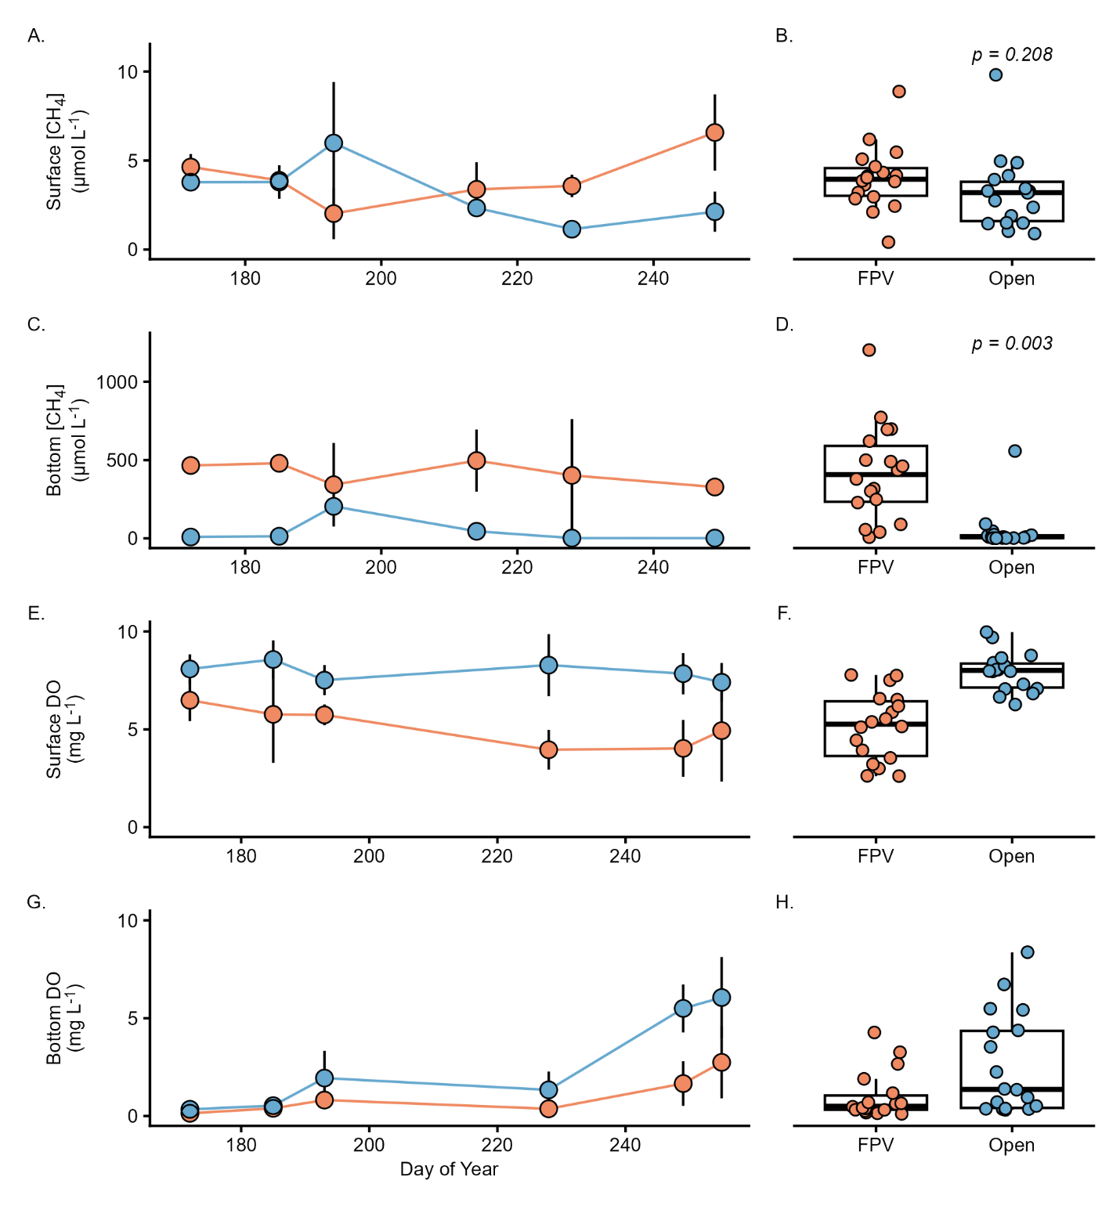
Fig. 1: Dissolved methane concentrations (A-D) and dissolved oxygen (DO) concentrations (E-H) in the surface (A, B, E, F) and bottom water (C, D, G, H) of ponds with and without floating photovoltaic (FPV) arrays in summer 2024. In (A, C, E, G) points indicate the mean CH₄ concentration from pond centers on a given date by treatment group and error bars indicate standard deviation. Colored lines connect the means. In panels (B, D, F, H) each point on the boxplot indicates a measured CH₄ concentration in an individual pond based on whether FPV is present (FPV) or not (Open) and p-values indicate the result of a least-squares mean test of the treatment effect of the mixed model (Table S3).

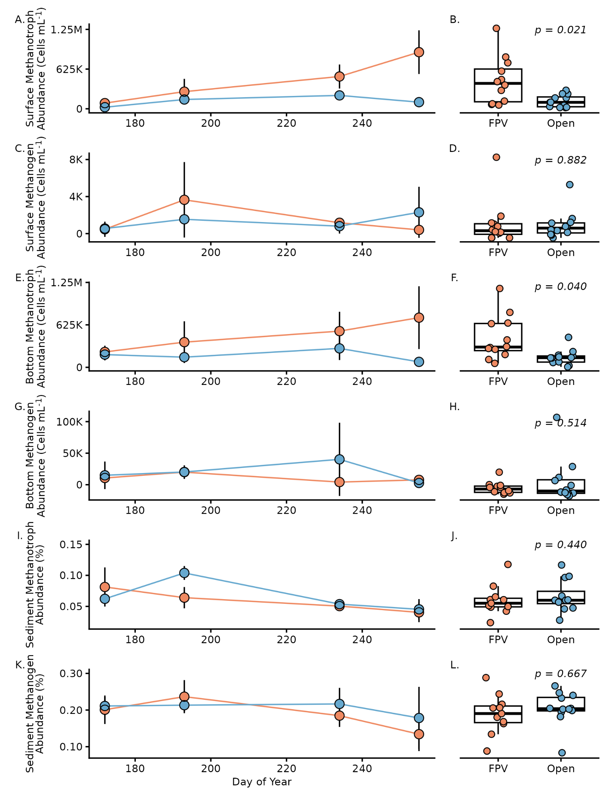
Fig. 2: Total abundance (A-H) of methanotrophs and methanogens in surface waters and bottom waters and relative abundance (I-L) of methanotrophs and methanogens in sediments of FPV and Open ponds in summer 2024. Information as for Fig. 1. P-values reflect least-square means test result of the mixed model (Table S3).

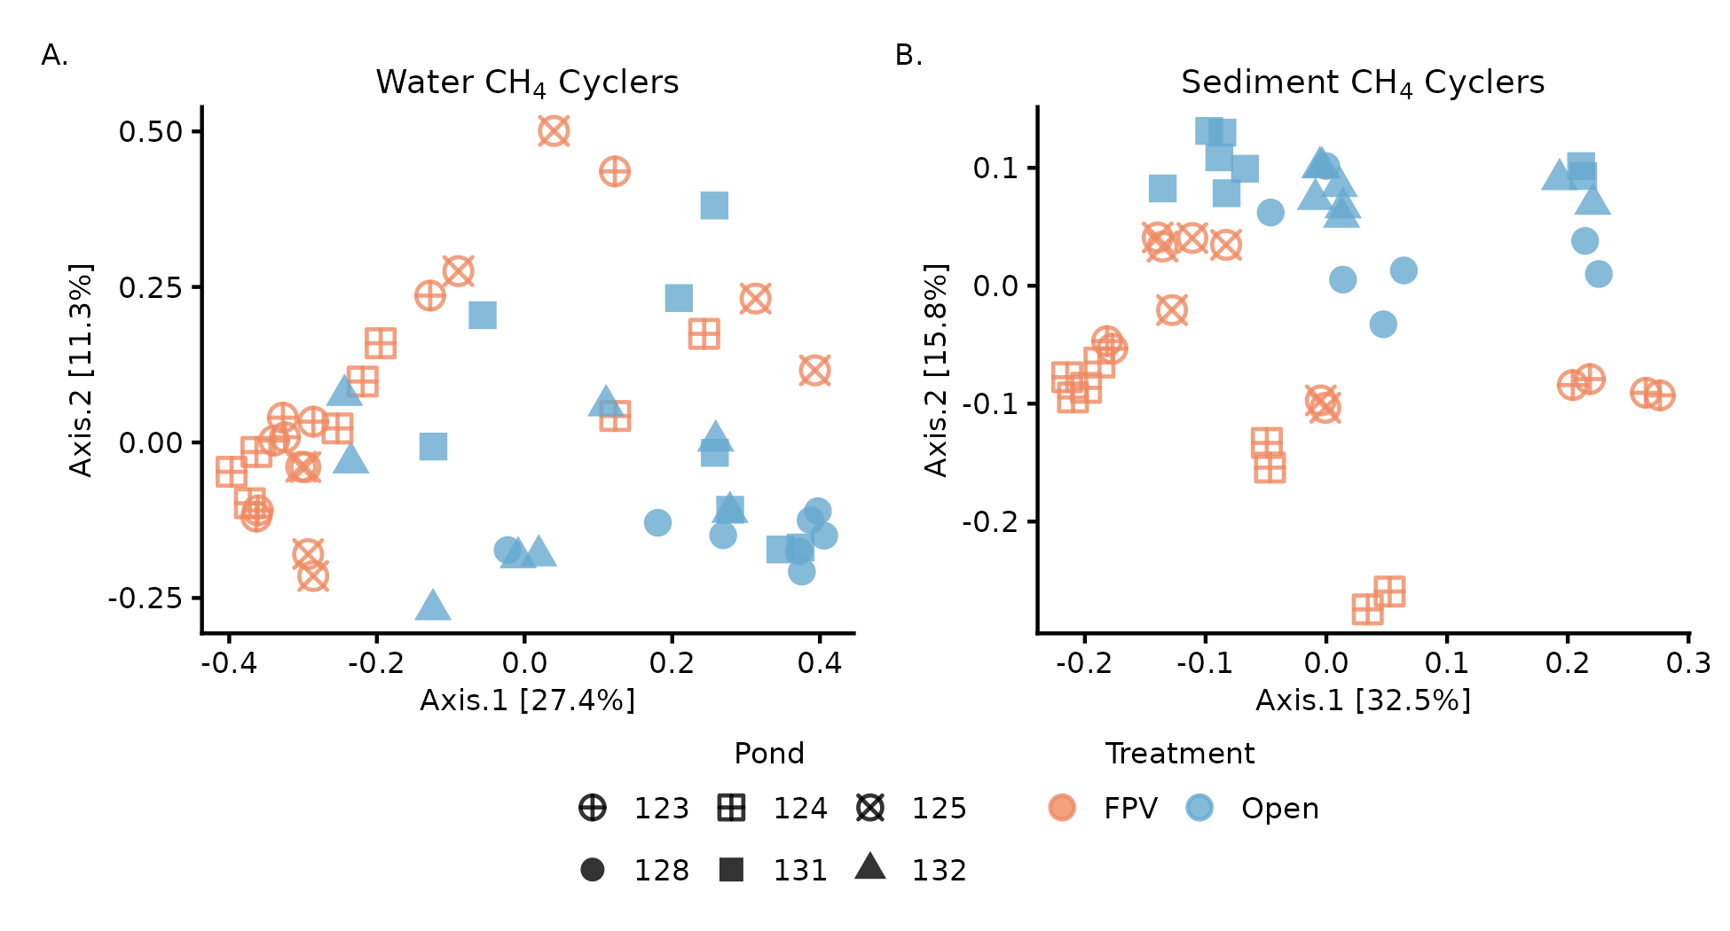

Fig. 3: Bray–Curtis PCoA of combined methanogen and methanotroph communities in FPV and Open ponds. (A) Dissimilarity among water column samples was calculated using absolute cell abundances. (B) Sediment samples were rarefied to 20,826 reads to calculate dissimilarity based on relative abundance; replicates are shown separately. Shapes denote ponds.

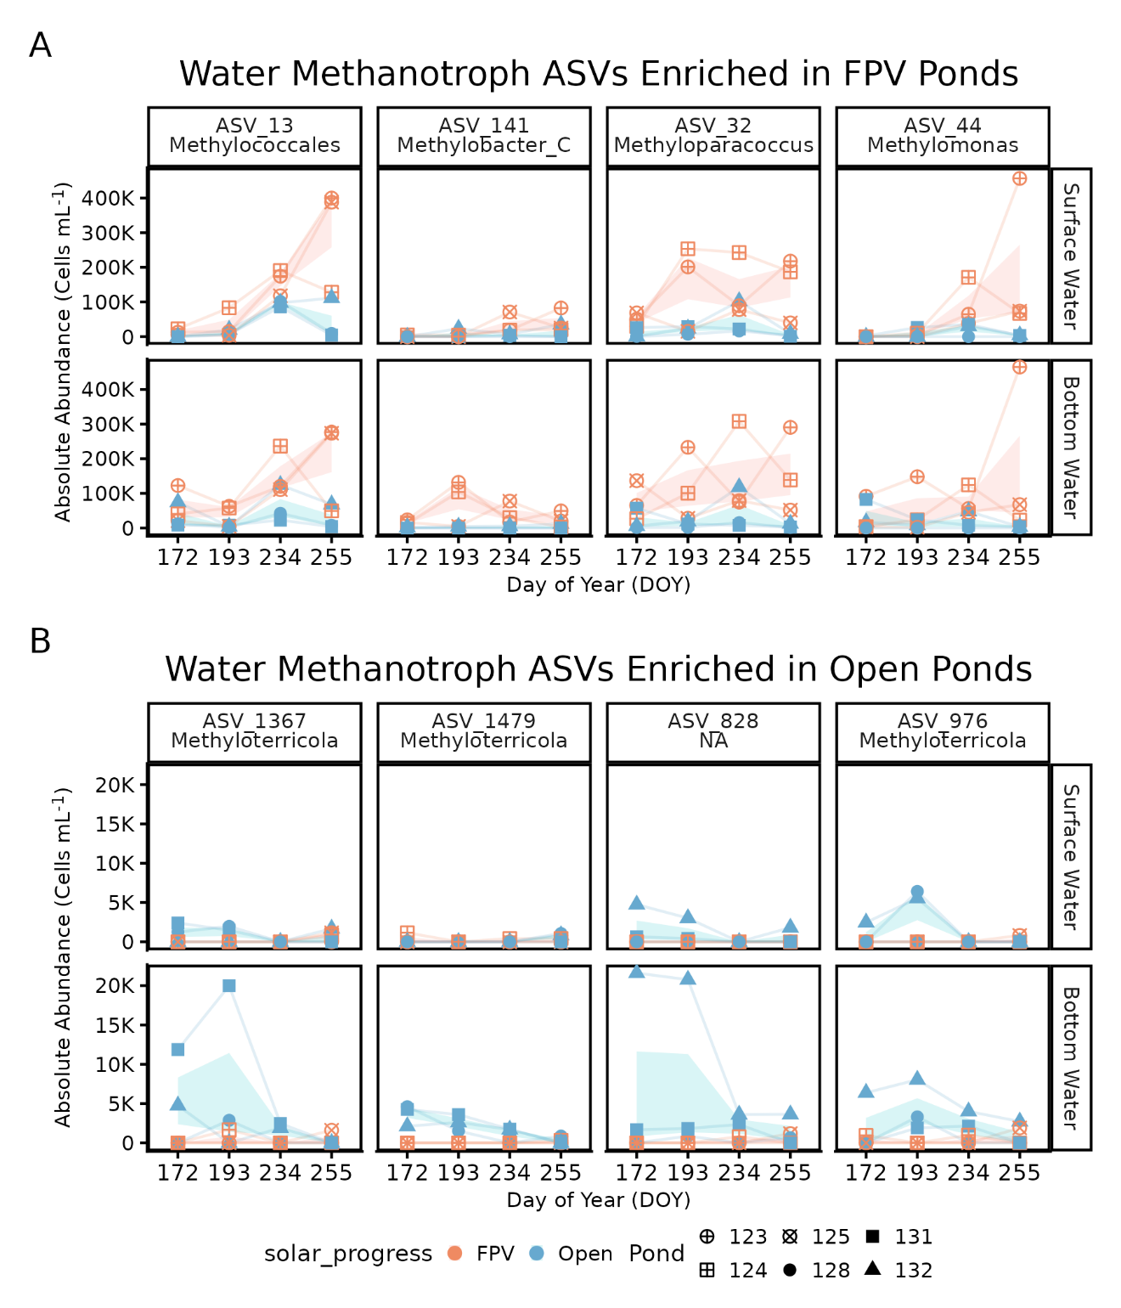
Fig. 4: Methanotroph ASVs identified as differentially abundant between FPV and open ponds using ANCOM-BC2 are shown as absolute abundance (cells mL⁻¹) across the sampling season. (A) Methanotroph ASVs that bloom under FPV infrastructure and (B) methanotroph ASVs enriched in open ponds. Panels are faceted by ASV and water-column depth (surface vs bottom). Points represent individual pond observations, lines connect repeated measurements through time within each pond–depth combination, and thick lines and shaded ribbons indicate treatment medians and interquartile ranges (25th–75th percentiles) at each date. FPV-enriched ASVs are dominated by members of the family Methylomonadaceae, with a single FPV-enriched Methylococcaceae ASV (Methyloparacoccus, ASV_32), whereas ASVs enriched in open ponds belong exclusively to Methylococcaceae. Taxonomic assignments are shown at the genus and species level, except ASV_13, which is classified within Methylomonadaceae, and ASV_828, which is classified within Methylococcaceae. For visualization, two low-abundance FPV-enriched ASVs (ASV_2028, ASV_346) and one open-pond ASV with minimal separation in absolute abundance (ASV_1019) were excluded.

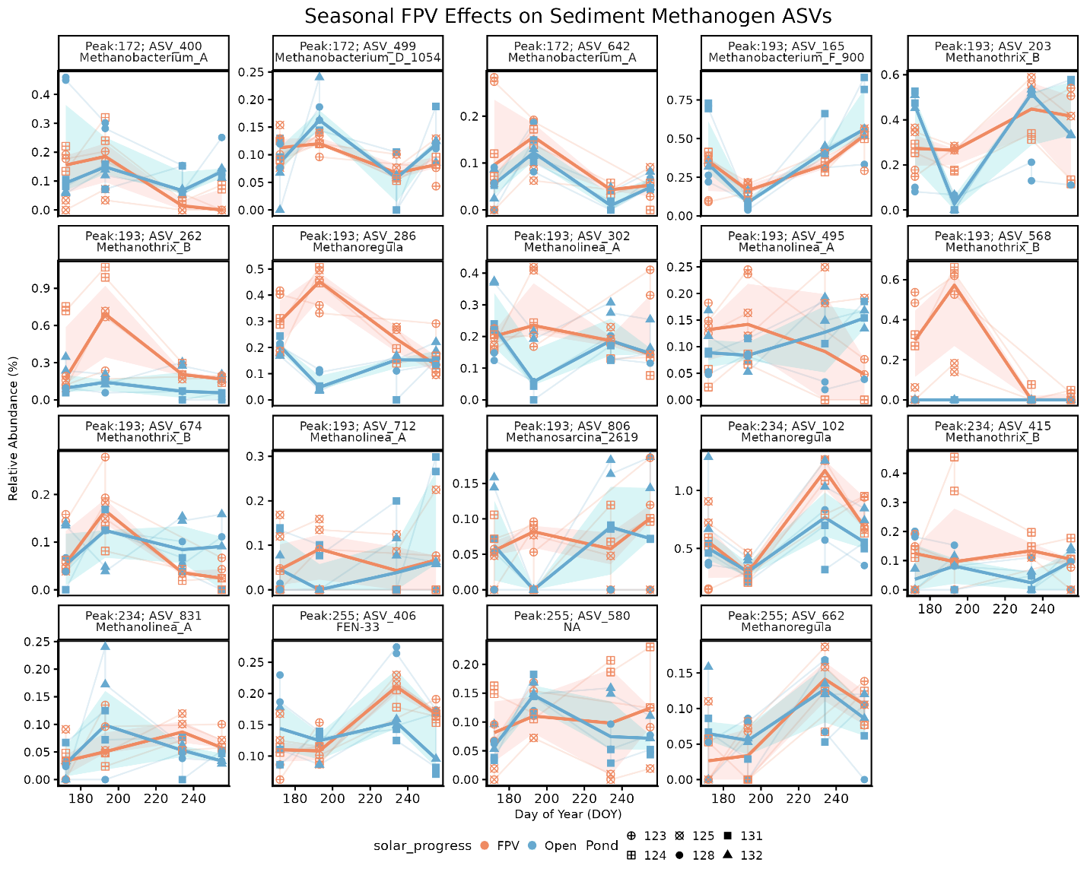
Fig. 5: Sediment methanogen ASVs showing strong, time-dependent divergence between FPV and open ponds are shown as relative abundance (%) across the sampling season. To identify FPV-associated seasonal patterns not captured by a constant treatment effect, methanogen ASVs were screened using a manual, seasonally explicit approach focused on abundant taxa (mean relative abundance > 0.05%). FPV–Open separation was quantified at each sampling date using median abundances, and ASVs were retained if peak FPV enrichment was supported across multiple sampling dates and/or multiple FPV ponds (see Supplemental Methods). Panels are faceted by ASV and annotated with the day of year (DOY) at which maximum FPV enrichment occurred. Points represent individual pond observations, thin lines connect repeated measurements within ponds, and thick lines and shaded ribbons indicate treatment medians and interquartile ranges (25th–75th percentiles) at each date. ASVs span multiple methanogenic phyla and classes, including genera within hydrogenotrophic (Methanobacterium), acetoclastic (Methanothrix), and methylotrophic (Methanoregula, Methanosarcina) groups.

Acknowledgements
This work was supported by an Atkinson Academic Venture Fund to SMG, MAH, MLS, awards 441993/2023-0 and 200781/2024-3 from National Council for Scientific and Technological Development (CNPq) to SJC, and startup funds from the University of Delaware made available to NER. We thank Benj Sterrett for helping to maintain access to the ponds, Autumn Newman, Augustus Pendleton, Sophia Richter and Kailyn Hanke for assistance with field and laboratory work, and Jera Jansen, Caitlin Davis, Mônica Antunes-Ulyssea, Sheena Dwyer-McNulty, Trifosa Simamora, Tim Boycott, and Dave Grodsky for helping construct the floating solar arrays. Any use of trade, firm, or product names is for descriptive purposes only and does not imply endorsement by the U.S. Government.

References
Aben, R. C. H. and others. 2017. Cross continental increase in methane ebullition under climate change. Nat Commun 8: 1682. doi:10.1038/s41467-017-01535-y
Almeida, R. and others. 2022. Floating solar power: evaluate trade-offs. Nature 606: 246–249.
Andini, S., N. Suwartha, E. A. Setiawan, and S. Ma’arif. 2022. Analysis of biological, chemical, and physical parameters to evaluate the effect of floating solar PV in Mahoni Lake, Depok, Indonesia: Mesocosm experiment study. Journal of Ecological Engineering 23: 201–207. doi:10.12911/22998993/146385
Apprill, A., S. Mcnally, R. Parsons, and L. Weber. 2015. Minor revision to V4 region SSU rRNA 806R gene primer greatly increases detection of SAR11 bacterioplankton. Aquatic Microbial Ecology 75: 129–137. doi:10.3354/ame01753
Bastviken, D., J. Cole, M. Pace, and L. Tranvik. 2004. Methane emissions from lakes: Dependence of lake characteristics, two regional assessments, and a global estimate. Global Biogeochem Cycles 18: 1–12. doi:10.1029/2004GB002238
Bates, D., M. Maechler, B. Bolker, and S. Walker. 2015. Fitting linear mixed-effects models using lme4. J Stat Softw 67: 1–48. doi:10.1126/science.1176170
Bertolet, B. L., C. Koepfli, and S. E. Jones. 2022. Lake Sediment Methane Responses to Organic Matter are Related to Microbial Community Composition in Experimental Microcosms. Front Environ Sci 10. doi:10.3389/fenvs.2022.834829
Callahan, B. J., P. J. McMurdie, M. J. Rosen, A. W. Han, A. J. A. Johnson, and S. P. Holmes. 2016. DADA2: High-resolution sample inference from Illumina amplicon data. Nat Methods 13: 581–583. doi:10.1038/nmeth.3869
Caporaso, J. G., C. L. Lauber, W. A. Walters, D. Berg-Lyons, C. A. Lozupone, P. J. Turnbaugh, N. Fierer, and R. Knight. 2011. Global patterns of 16S rRNA diversity at a depth of millions of sequences per sample. Proc Natl Acad Sci U S A 108: 4516–4522. doi:10.1073/pnas.1000080107
Cazzaniga, R., and M. Rosa-Clot. 2021. The booming of floating PV. Solar Energy 219: 3–10. doi:10.1016/j.solener.2020.09.057
Dörenkämper, M., A. Wahed, A. Kumar, M. de Jong, J. Kroon, and T. Reindl. 2021. The cooling effect of floating PV in two different climate zones: A comparison of field test data from the Netherlands and Singapore. Solar Energy 219: 15–23. doi:10.1016/j.solener.2021.03.051
Gallaher, A., E. L. Kalies, and S. M. Grodsky. 2025. Sustainability trade-offs across modeled floating solar waterscapes of the Northeastern United States. Cell Reports Sustainability. doi:10.1016/j.crsus.2025.100423
Holgerson, M. A., Richardson, D. C., Roith, J., Bortolotti, L. E., Finlay, K., Hornbach, D. J., Gurung, K., Ness, A., Andersen, M. R., Bansal, S., Finlay, J. C., Cianci-Gaskill, J. A., Hahn, S., Janke, B. D., McDonald, C., Mesman, J. P., North, R. L., Roberts, C. O., Sweetman, J. N., & Webb, J. R. (2022). Classifying mixing regimes in ponds and shallow lakes. Water Resources Research, 58(7), e2022WR032522.
Ilgen, K., D. Schindler, S. Wieland, and J. Lange. 2023. The impact of floating photovoltaic power plants on lake water temperature and stratification. Sci Rep 13. doi:10.1038/s41598-023-34751-2
Jackson, R. B. and others. 2024. Human activities now fuel two-thirds of global methane emissions. Environmental Research Letters 19: 101002. doi:10.1088/1748-9326/ad6463
Jin, Y. and others. 2023. Energy production and water savings from floating solar photovoltaics on global reservoirs. Nat Sustain 6: 865–874. doi:10.1038/s41893-023-01089-6
Knief, C. 2015. Diversity and habitat preferences of cultivated and uncultivated aerobic methanotrophic bacteria evaluated based on pmoA as molecular marker. Frontiers in Microbiology 6: 1346.
Lenth, R. 2018. emmeans: Estimated marginal means, aka least-squares means. R package version 1.2.3.
Li, B., Z. Mao, J. Xue, P. Xing, and Q. L. Wu. 2024. Metabolic versatility of aerobic methane-oxidizing bacteria under anoxia in aquatic ecosystems. Environmental Microbiology Reports 16. doi:10.1111/1758-2229.70002
Lin, H., and S. Das Peddada. 2024. Multigroup analysis of compositions of microbiomes with covariate adjustments and repeated measures. Nat Methods 21: 83–91. doi:10.1038/s41592-023-02092-7
Louca, S., L. Parfrey, and M. Doebeli. 2016. Decoupling function and taxonomy in the global ocean microbiome. Science (1979) 353: 1272–1277. doi:10.1126/science.aad8279
McDonald, D. and others. 2024. Greengenes2 unifies microbial data in a single reference tree. Nat Biotechnol 42: 715–718. doi:10.1038/s41587-023-01845-1
McMurdie, P. J., and S. Holmes. 2013. Phyloseq: An R Package for Reproducible Interactive Analysis and Graphics of Microbiome Census Data. PLoS One 8: e61217. doi:10.1371/journal.pone.0061217
Murase, J., & Sugimoto, A. (2005). Inhibitory effect of light on methane oxidation in the pelagic water column of a mesotrophic lake (Lake Biwa, Japan). Limnology and Oceanography, 50, 1339-1343.
Nobre, R., S. M. Rocha, S. Healing, Q. Ji, S. Boulêtreau, A. Armstrong, and J. Cucherousset. 2024. A global study of freshwater coverage by floating photovoltaics. Solar Energy 267. doi:10.1016/j.solener.2023.112244
Oksanen, J. and others. 2018. vegan: Community Ecology Package. R package version 2.5.
Parada, A. E., D. M. Needham, and J. A. Fuhrman. 2016. Every base matters: Assessing small subunit rRNA primers for marine microbiomes with mock communities, time series and global field samples. Environ Microbiol 18: 1403–1414. doi:10.1111/1462-2920.13023
R Core Team. 2014. R: A language and environment for statistical computing.
Ramanan, C. J., K. H. Lim, J. C. Kurnia, S. Roy, B. J. Bora, and B. J. Medhi. 2024. Towards sustainable power generation: Recent advancements in floating photovoltaic technologies. Renewable and Sustainable Energy Reviews 194: 114322. doi:10.1016/j.rser.2024.114322
Ray, N. E., and M. A. Holgerson. 2023. High intra-seasonal variability in greenhouse gas emissions from temperate constructed ponds. Geophys Res Lett 50: e2023GL104235. doi:10.1029/2023GL104235
Ray, N. E., M. A. Holgerson, and S. M. Grodsky. 2024. Immediate Effect of floating solar energy deployment on greenhouse gas dynamics in ponds. Environ Sci Technol 58: 22104–22113. doi:10.1021/acs.est.4c06363
Reis, P. C. J. and others. 2020. Niche separation within aerobic methanotrophic bacteria across lakes and its link to methane oxidation rates. Environ Microbiol 22: 738–751.
Reis, P. C. J. and others. 2024. Enigmatic persistence of aerobic methanotrophs in oxygen-limiting freshwater habitats. ISME J 18: wrae041.
Thottathil, S. D., Reis, P. C., del Giorgio, P. A., & Prairie, Y. T. (2018). The extent and regulation of summer methane oxidation in northern lakes. Journal of Geophysical Research: Biogeosciences, 123(10), 3216-3230.
Wang, B., E. Stirling, Z. He, B. Ma, H. Zhang, X. Zheng, F. Xiao, and Q. Yan. 2021. Pollution alters methanogenic and methanotrophic communities and increases dissolved methane in small ponds. Science of the Total Environment 801. doi:10.1016/j.scitotenv.2021.149723
Wang, T. W. and others. 2022. Effects of floating photovoltaic systems on water quality of aquaculture ponds. Aquac Res 53: 1304–1315. doi:10.1111/are.15665
Wickham, H. 2016. ggplot2: Elegant Graphics for Data Analysis, Springer-Verlag.
Woolway, R. I., G. Zhao, S. M. G. Rocha, S. J. Thackeray, and A. Armstrong. 2024. Decarbonization potential of floating solar photovoltaics on lakes worldwide. Nature Water 2: 566–576. doi:10.1038/s44221-024-00251-4
This information product has been peer reviewed and approved for publication as a preprint by the U.S. Geological Survey.

Supplementary Material

Higher methanotroph abundance and bottom-water methane in ponds with floating photovoltaic arrays

Any use of trade, firm, or product names is for descriptive purposes only and does not imply endorsement by the U.S. Government.

Nicholas E. Ray¹, Sophia Aredas², Steven M. Grodsky³, Ash Canino⁴, Simone J. Cardoso⁵, Meredith A. Holgerson⁶, Meredith Theus⁶, Marian L. Schmidt²

¹ School of Marine Science & Policy, University of Delaware, USA
² Department of Microbiology, Cornell University, USA
³ U.S. Geological Survey, New York Cooperative Fish and Wildlife Research Unit, Department of Natural Resources and the Environment, Cornell University, USA
⁴ Department of Natural Resources and Environment, Cornell University, USA
⁵ Department of Zoology, Institute of Biological Sciences, Universidade Federal de Juiz de Fora, Brazil
⁶ Department of Ecology and Evolutionary Biology, Cornell University, US

Supplemental Methods

Water Column Microbial Cell Abundances
Water samples were preserved for flow cytometry by adding 1 μL of 25% glutaraldehyde to 1 mL of 20 µm pre-filtered pond water, shaking, incubating for 10 minutes in the dark at room temperature, and freezing at -80 °C. Fixed samples were diluted to 15-20X, stained with SYBR Green I, and run in triplicate on an Attune NxT Flow Cytometer. DNA-positive cell counts were analyzed using the flowCore (Ellis et al. 2025) and ggcyto (Van et al. 2018) packages in R (R Core Team 2014).

Testing for Water Column Stratification
We tested if the water column was stratified for each pond on each sampling date by comparing calculated density gradients between ponds with and without FPV. We used temperature measurements in the surface and bottom waters, corrected for the distance between those samples. Water density at a given temperature was calculated as:

$$ρ\left(T\right)= \frac{ρ_{H2O}}{1+ β(T- T_{0})} × \frac{1000 kg m^{-3}}{1 kg L^{-1}}$$

Where ρ(T) is the density of water at a given temperature (kg m⁻³), ρ_{H2O} is the nominal density of water (assuming 1 kg L⁻¹ for freshwater), β is the volumetric temperature expansion coefficient (0.0002 °C⁻¹), T is the temperature of the water (C), and T₀ is standard temperature (20 °C).

We then calculated the density gradient between the surface and bottom water temperature (kg m⁻³ m⁻¹) for each pond on each sampling day, and compared density gradients between ponds with and without FPV by constructing a mixed effect model with FPV presence and day of year as fixed effects and pond as a random effect, using least square means to compare density gradients between ponds with and without FPV.

References
Ellis, B., P. Haaland, Hahne F, N. Le Meur, N. Gopalakrishnan, J. Spidlen, M. Jiang, and G. Finak. 2025. flowCore: flowCore: Basic structures for flow cytometry data. R package version 2.2.0.
Van, P., W. Jiang, R. Gottardo, and G. Finak. 2018. ggcyto: Next-generation open-source visualization software for cytometry. Bioinformatics 34: 3951–3953.
R Core Team. 2014. R: A language and environment for statistical computing.

Table S1: Methanogen and Methanotroph Taxonomic Classification
Order | Family | Genus | Methane Cycler
Methanocellales | Methanocellaceae | Methanocella_A | Methanogen
Methanomicrobiales | Methanomicrobiaceae |  | Methanogen
Methanomicrobiales | Methanospirillaceae_2121 | Methanolinea_A  Methanolinea_B  Methanoregula  UBA467  UBA288 | Methanogen
Methanomicrobiales | Methanospirillaceae_2125 | Methanospirillum | Methanogen
Methanosarcinales_A_2632 | Methanosarcinaceae | Methanosarcina_2619  Methanomethylovorans | Methanogen
Methanotrichales | Methanotrichaceae | Methanothrix_B | Methanogen
Methanobacteriales | Methanobacteriaceae | Methanobacterium_A  Methanobacterium_B_963  Methanobacterium_C  Methanobacterium_D_1054  Methanobacterium_F_896  Methanobacterium_F_900  Methanobrevibacter_A  Methanobrevibacter_D  Methanosphaera | Methanogen
Methanofastidiosales | Methanofastidiosaceae | Methanofastidiosum | Methanogen
Methanomassiliicoccales | Methanomassiliicoccaceae | Methanomassiliicoccus_A_1624 | Methanogen
Methanomassiliicoccales | Methanomethylophilaceae |  | Methanogen
Methanomassiliicoccales | UBA472 | FEN-33 | Methanogen
Methanomethylicales | Methanomethylicaceae | Methanomethylicus | Methanogen
Methanosarcinales_A_2632 | Methanoperedenaceae | Methanoperedens_A | Methanotroph
Methylomirabilales | 2-02-FULL-66-22 | 2-02-FULL-66-22 | Methanotroph
Rhizobiales_505101 | Beijerinckiaceae | Methylocystis  Methylosinus | Methanotroph
Methylococcales | Methylococcaceae | Methylocaldum  Methylococcus  Methylomagnum  Methyloparacoccus  Methyloterricola  Methylotetracoccus  UBA6136 | Methanotroph
Methylococcales | Methylomonadaceae | Crenothrix  Methylobacter_C_601048  Methylobacter_C_601751  Methyloglobulus  Methylomonas  Methylosoma  Methylovulum  UBA4132 | Methanotroph

Table S2: Summary of model information for mixed models to describe temperature, dissolved oxygen, surface and bottom water dissolved methane (CH₄) concentration, methanotroph abundance, and methanogen abundance, relative abundance of sediment methanogens and methanotrophs, and density gradients in ponds with and without floating photovoltaics (FPV). All models include FPV presence or absence and day of year as fixed effects and the pond ID as a random effect. For each fixed effect, the estimated effect size is listed ± standard error of the effect, with the associated t-value below in parentheses.

Response | Observations (n) | Intercept | FPV Presence | Day of Year
Temperature | 36 | 24.9 ± 2.06  (12.1) | 3.91 ± 0.60  (6.46) | -0.03 ± 0.01  (-3.00)
Dissolved Oxygen  (% Saturation) | 36 | -19.2 ± 18.5  (-1.03) | 32.2 ± 5.43  (5.92) | 0.23 ± 0.08  (2.72)
Dissolved Oxygen  (mg L⁻¹) | 36 | -3.45 ± 1.61  (-2.14) | 2.72 ± 0.53  (5.13) | 0.03 ± 0.01  (3.93)
Surface Water [CH₄] | 36 | 5.61 ± 2.60  (2.16) | -0.82 ± 0.65  (-1.26) | -0.01 ± 0.01  (-0.62)
Bottom Water [CH₄] | 36 | 631 ± 289  (2.18) | -373 ± 126  (-2.96) | -1.02 ± 1.33  (-0.77)
Surface water methanotroph abundance | 24 | -626754 ± 287292  (-2.18) | -318325 ± 86085  (-3.70) | 4997 ± 1316  (3.80)
Surface water methanogen abundance | 24 | -1332 ± 2632  (0.51) | -125 ± 789  (-0.16) | 0.44 ± 12.05  (0.04)
Bottom water methanotroph abundance | 24 | -94652 ± 324453  (-0.29) | -291441 ± 97220  (-3.00) | 2623 ± 1485  (1.77)
Bottom water methanogen abundance | 24 | 24108 ± 28147  (0.40) | 8895 ± 12441  (0.51) | -63.13 ± 125  (-0.62)
Sediment methanotroph abundance | 23 | 0.15 ± 0.03  (5.51) | 0.007 ± 0.008  (0.86) | -0.000 ± 0.000  (-3.42)
Sediment methanogen abundance | 23 | 0.32 ± 0.05  (5.83) | 0.014 ± 0.030  (0.46) | -0.001 ± 0.000  (-2.47)
Density Gradient  (kg m⁻³ m⁻¹) | 36 | 3.53 ± 0.37  (9.54) | -0.145 ± 0.108  (-1.34) | -0.013 ± (0.002)  (-7.65)

Table S3: Summary of model information for mixed models to describe bottle incubations to determine rates of water column dissolved methane (CH₄) production or consumption in ponds with and without floating photovoltaics (FPV). All models include FPV presence or absence and if the bottle was light or dark as fixed effects and the pond ID as a random effect. For each fixed effect, the estimated effect size is listed ± standard error of the effect, with the associated t-value below in parentheses.
Response | Observations (n) | Intercept | FPV Presence/Absence | Light/Dark Bottle
Surface CH₄ Flux | 12 | -0.09 ± 0.07  (-1.27) | -0.08 ± 0.10  (-0.82) | 0.08 ± 0.03  (3.01)
Bottom CH₄ Flux | 12 | -1.69 ± 4.14  (-0.41) | 2.11 ± 5.83  (0.36) | -0.66 ± 0.88  (-0.75)

Table S4: Results of least-square means comparisons between ponds with and without floating photovoltaics. Models for which comparisons are made are described in Tables S1 and S2. For bottle incubations to assess water column methane transformations, a positive value indicates net methane production, while a negative value indicates net methane consumption.
Comparison | Estimate ± SE | z-ratio | p-value
Temperature (°C) | -3.91 ± 0.60 | -6.46 | < 0.001
Dissolved Oxygen  (% Saturation) | -32.3 ± 5.43 | -5.92 | < 0.001
Dissolved Oxygen  (mg L⁻¹) | -2.72 ± 0.53 | -5.13 | < 0.001
Surface Water [CH₄] | 0.82 ± 0.65 | 1.26 | 0.208
Bottom Water [CH₄] | 373 ± 126 | 2.96 | 0.003
Surface Water CH₄ Production/Consumption | 0.08 ± 0.10 | 0.82 | 0.413
Bottom CH₄ Production/Consumption | -2.11 ± 5.83 | -0.36 | 0.718
Surface water methanotroph abundance | 318325 ± 86100 | 3.70 | 0.021
Surface water methanogen abundance | 125 ± 789 | 0.158 | 0.882
Bottom water methanotroph abundance | 291441 ± 97200 | 3.00 | 0.040
Bottom water methanogen abundance | -8895 ± 12400 | -0.72 | 0.514
Sediment methanotroph abundance | -0.007 ± 0.008 | -0.858 | 0.440
Sediment methanogen abundance | -0.014 ± 0.030 | -0.46 | 0.667
Density Gradient | 0.145 ± 0.108 | 1.40 | 0.180

Table S5: Results of Welch two-sample t-tests comparing diffusive methane fluxes and gas exchange velocities (k600) between the center and edges of ponds with and without floating photovoltaic arrays (FPV). We first compared pond locations across treatments, and then between locations and within treatments.
Comparisons Between Ponds with and Without FPV
Measurement | Pond Location | df | t-value | p-value
Diffusive CH₄ Flux | Center | 2.00 | -1.03 | 0.413
Diffusive CH₄ Flux | Edge | 2.00 | -0.97 | 0.436
k600 | Center | 2.18 | -0.75 | 0.525
k600 | Edge | 2.00 | -1.03 | 0.412
Comparisons between pond Center and Edge within the same pond type
Measurement | FPV Present/Absent | df | t-value | p-value
Diffusive CH₄ Flux | Present | 2.28 | -1.67 | 0.221
Diffusive CH₄ Flux | Absent | 3.34 | 0.34 | 0.751
k600 | Present | 2.03 | 1.17 | 0.362
k600 | Absent | 3.42 | -0.31 | 0.774

Table S6: Results of Welch two-sample t-test comparing potential rates of sediment CH₄ production between ponds with and without floating photovoltaic arrays.
Measurement | df | t-value | p-value
Sediment CH₄ Flux | 2.75 | -1.26 | 0.302

Table S7: Summary of mean ± standard deviation of measured concentrations and rates in ponds with FPV and control ponds without FPV. For potential sediment CH₄ production and water column CH₄ “flux”, positive values indicate net-CH₄ production while negative values indicated net-consumption.
Measurement | Control Ponds | FPV Ponds
Temperature (°) | 22.78 ± 2.29 | 18.87 ± 1.69
Dissolved Oxygen  (% Saturation) | 62.34 ± 22.79 | 30.18 ± 10.56
Dissolved Oxygen  (mg L⁻¹) | 5.42 ± 2.19 | 2.70 ± 0.98
Surface Water [CH₄]  (µmol L⁻¹) | 3.19 ± 2.07 | 4.01 ± 1.79
Bottom Water [CH₄]  (µmol L⁻¹) | 45.6 ± 129.7 | 419 ± 306
Surface water methanotroph abundance
Surface water methanogen abundance
Bottom water methanotroph abundance
Bottom water methanogen abundance
Sediment methanotroph abundance
Sediment methanogen abundance
Density Gradient  (kg m⁻³ m⁻¹) | 0.62 ± 0.42 | 0.76 ± 0.63
Potential Sediment CH₄ Production (ppm CH₄ g dry sediment⁻¹ d⁻¹) | 14.1 ± 10.9 | 5.43 ± 4.81
Surface Water Column CH₄ “Flux”  (µmol CH₄ L⁻¹ hr⁻¹) | -0.14 ± 0.15 | -0.05 ± 0.08
Bottom Water Column CH₄ “Flux”  (µmol CH₄ L⁻¹ hr⁻¹) | 0.09 ± 1.58 | -2.02 ± 9.03

Table S8: FPV treatment, pond, and day of year (DOY) significantly influence the combined methanogen and methanotroph community composition in the water column and sediments. Bray-Curtis dissimilarities were calculated using absolute abundances for water (Fig. 3A) and scaled relative abundances for sediment (Fig. 3B). PERMANOVA tested effects of FPV, pond, and DOY and their interactions on community composition, with the pseudo-F and R² representing group separation variance explained, respectively. β-dispersion tested group variance. Residual R² shown for each habitat.
Habitat Type | Variable | PERMANOVA |  |  |  | β-Dispersion |  | Figure
 |  | R² | Pseudo-F | p-value | Residuals | F | p-value
Water | FPV | 0.128 | 9.42 | 0.001 | 0.489 | 10.23 | 0.002 | 3A
Water | Pond | 0.155 | 2.85 | 0.001 |  | 1.20 | 0.305 | 3A
Water | DOY | 0.086 | 6.35 | 0.001 |  | 5.26 | 0.005 | 3A
Water | FPV:DOY | 0.059 | 4.34 | 0.001 |  |  |  | 3A
Water | Pond:DOY | 0.083 | 1.52 | 0.041 |  |  |  | 3A
Sediment | FPV | 0.135 | 12.02 | 0.001 | 0.361 | 1.51 | 0.216 | 3B
Sediment | Pond | 0.285 | 6.32 | 0.001 |  | 0.66 | 0.68 | 3B
Sediment | DOY | 0.107 | 9.48 | 0.001 |  | 1.73 | 0.172 | 3B
Sediment | FPV:DOY | 0.030 | 2.67 | 0.018 |  |  |  | 3B
Sediment | Pond:DOY | 0.082 | 1.81 | 0.011 |  |  |  | 3B

Table S9: FPV, pond, and day of year (DOY) structure sediment methanogen and methanotroph communities with distinct drivers and effect strengths. PERMANOVA and β-dispersion results for sediment methanogen and methanotroph communities. Bray-Curtis dissimilarities were calculated from rarefied relative abundances. FPV, pond, and DOY were modeled as main effects and interactions. R² indicates the proportion of variance explained; pseudo-F and p-values assess compositional differences. β-dispersion statistics test group variability. Residual R² is reported for each CH₄ group. Figures S3A and S3B show corresponding ordinations.

Habitat Type | CH₄ Group | Variable | PERMANOVA |  |  |  | β-Dispersion |  | Figure
 |  |  | R² | Pseudo-F | p-value | Residuals | F | p-value
Sediment | Methanogens | FPV | 0.135 | 12.4 | 0.001 | 0.349 | 2.92 | 0.105 | S3A
Sediment | Methanogens | Pond | 0.305 | 7.01 | 0.001 |  | 0.809 | 0.557 | S3A
Sediment | Methanogens | DOY | 0.098 | 9.01 | 0.001 |  | 1.03 | 0.411 | S3A
Sediment | Methanogens | FPV:DOY | 0.033 | 3.06 | 0.012 |  |  |  | S3A
Sediment | Methanogens | Pond:DOY | 0.079 | 1.82 | 0.016 |  |  |  | S3A
Sediment | Methanotrophs | FPV | 0.131 | 10.5 | 0.001 | 0.398 | 0.004 | 0.937 | S3B
Sediment | Methanotrophs | Pond | 0.231 | 4.63 | 0.001 |  | 0.723 | 0.604 | S3B
Sediment | Methanotrophs | DOY | 0.133 | 10.7 | 0.001 |  | 4.13 | 0.009 | S3B
Sediment | Methanotrophs | FPV:DOY | 0.020 | 1.59 | NS |  |  |  | S3B
Sediment | Methanotrophs | Pond:DOY | 0.088 | 1.76 | 0.018 |  |  |  | S3B

Table S10: Summary of diffusive CH4 fluxes, dissolved CH4 concentrations, and calculated k₆₀₀ values for the edges and centers of ponds with and without FPV. Values reported as mean ± standard deviation.
Measurement | Location | Control | FPV
Diffusive CH₄ Flux  (µmol m⁻² hr⁻¹) | Center | 954 ± 1565 | 26.7 ± 5.6
Diffusive CH₄ Flux  (µmol m⁻² hr⁻¹) | Edge | 588 ± 969 | 47.8 ± 21.1
Dissolved CH₄ Concentration  (µmol L⁻¹) | Center | 5.99 ± 3.43 | 2.02 ± 1.44
Dissolved CH₄ Concentration  (µmol L⁻¹) | Edge | 3.08 ± 1.03 | 6.18 ± 2.47
k600 (cm h⁻¹) | Center | 0.40 ± 0.62 | 0.12 ± 0.13
k600 (cm h⁻¹) | Edge | 0.60 ± 0.96 | 0.03 ± 0.01

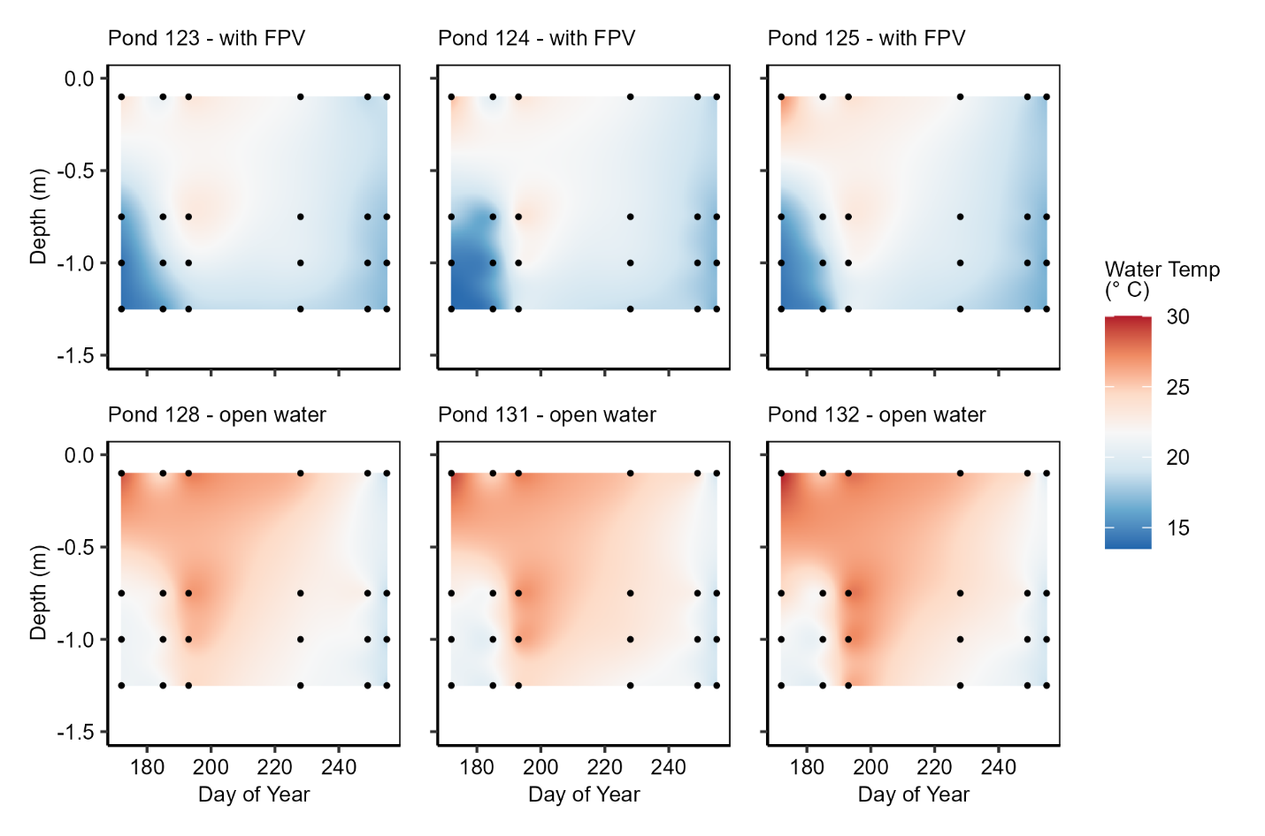
Fig. S1: Temperature profiles throughout summer 2024 in ponds with floating photovoltaic (FPV) arrays (top row) and ponds without FPV arrays (bottom row). Points indicate measurements and colors are interpolated based on those measurements.
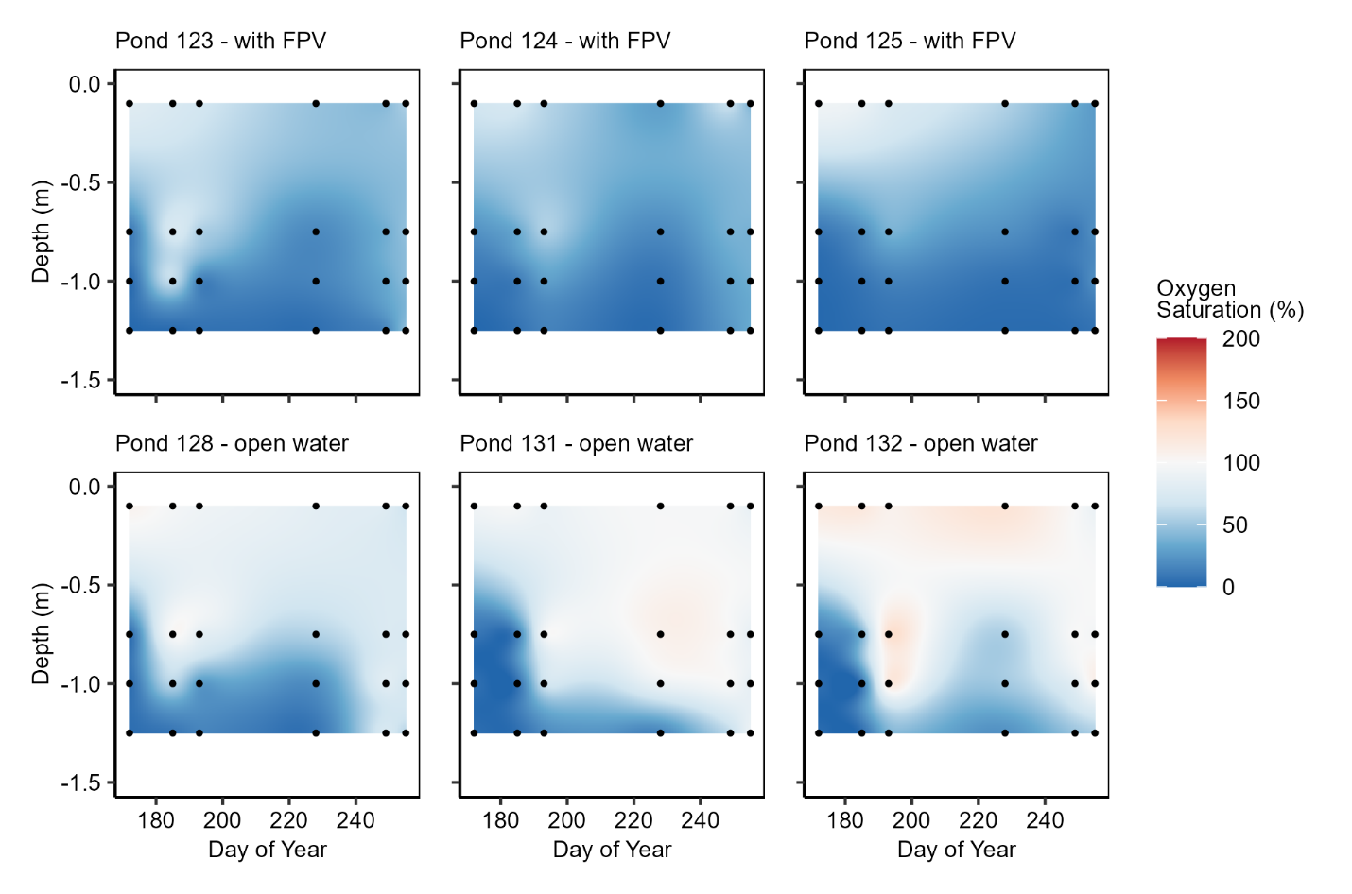
Fig. S2: Dissolved oxygen (percent saturation) profiles throughout summer 2024 in ponds with floating photovoltaic (FPV) arrays (top row) and ponds without FPV arrays (bottom row). Points indicate measurements and colors are interpolated based on those measurements.
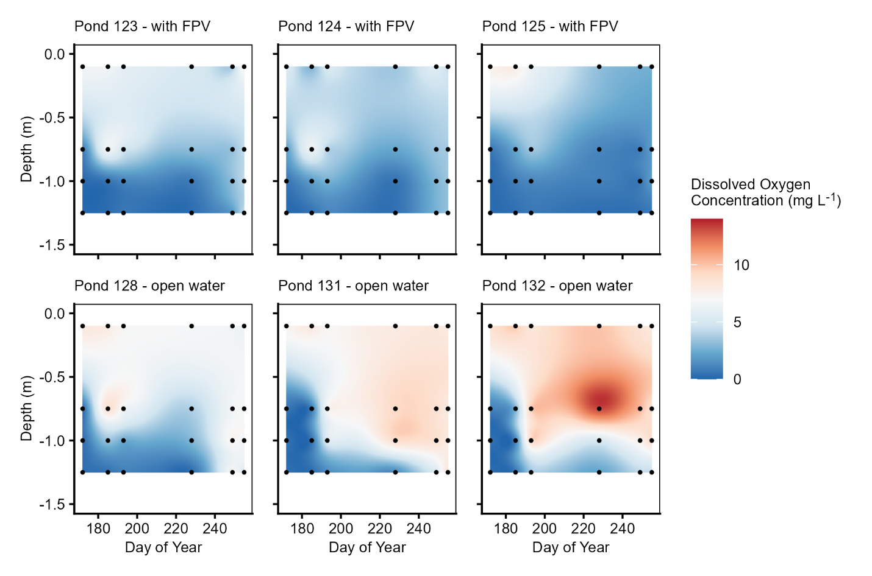
Fig. S3: Dissolved oxygen (mg L⁻¹) profiles throughout summer 2024 in ponds with floating photovoltaic (FPV) arrays (top row) and ponds without FPV arrays (bottom row). Points indicate measurements and colors are interpolated based on those measurements.

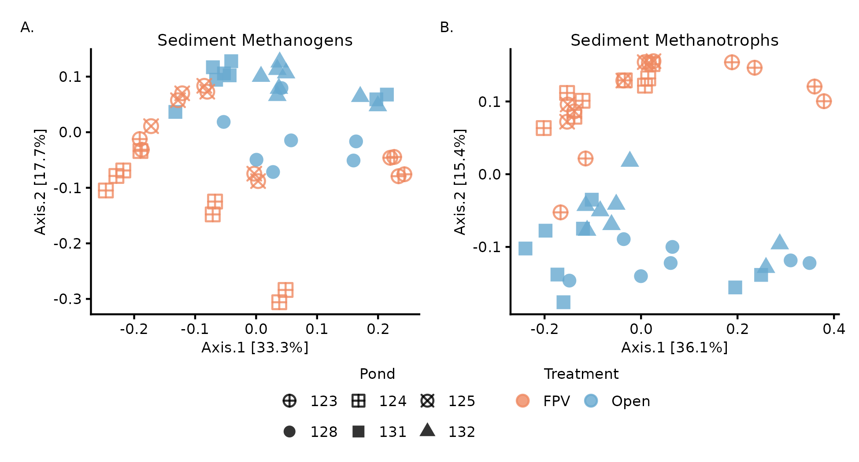

Fig. S4: Bray-Curtis PCoA of sediment (A) methanogenic and (B) methanotrophic communities within FPV and Open ponds; Sediment replicates and are shown separately.

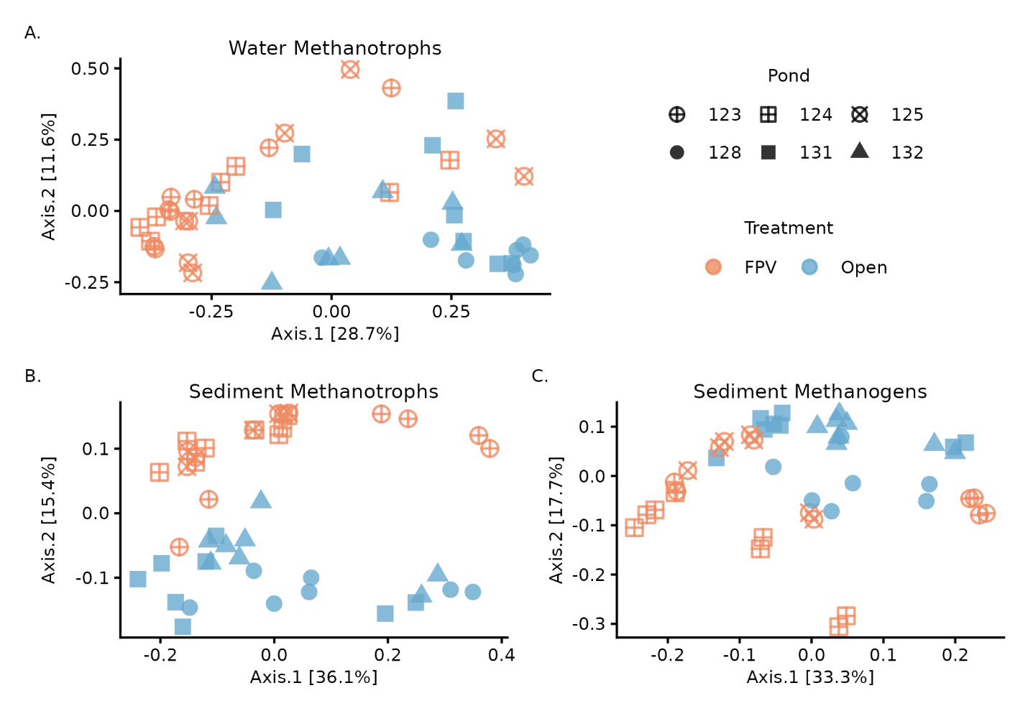
Fig. S5: Bray-Curtis PCoA of (A) water methanotrophs, sediment (B) methanotrophs and (C) methanogen communities within ponds with FPV (“FPV”) and ponds without FPV (“Open”); Sediment replicates and are shown separately.

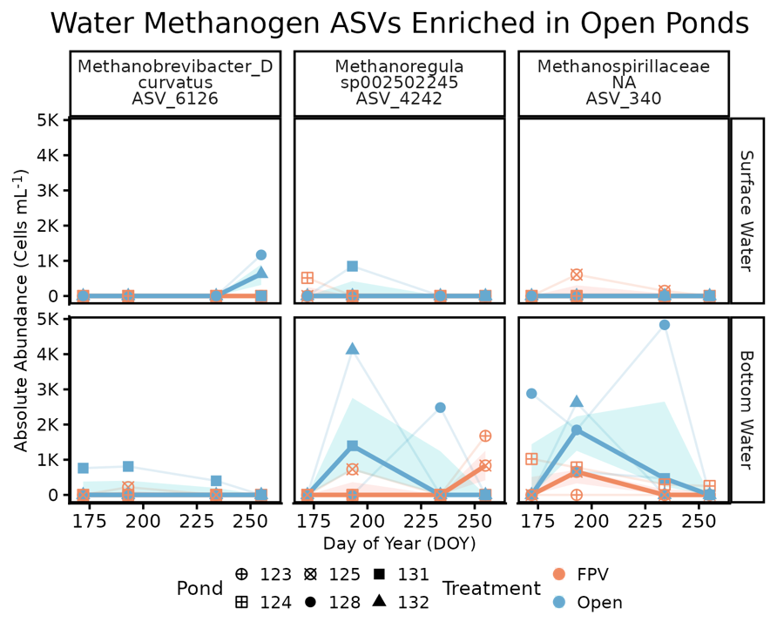
Fig. S6. Time-averaged differential abundance of water-column methanogen ASVs under non-FPV pond conditions. Absolute abundances (cells mL⁻¹) of water-column methanogen ASVs identified as enriched in open ponds using time-averaged ANCOM-BC2 analyses are shown across the sampling season.

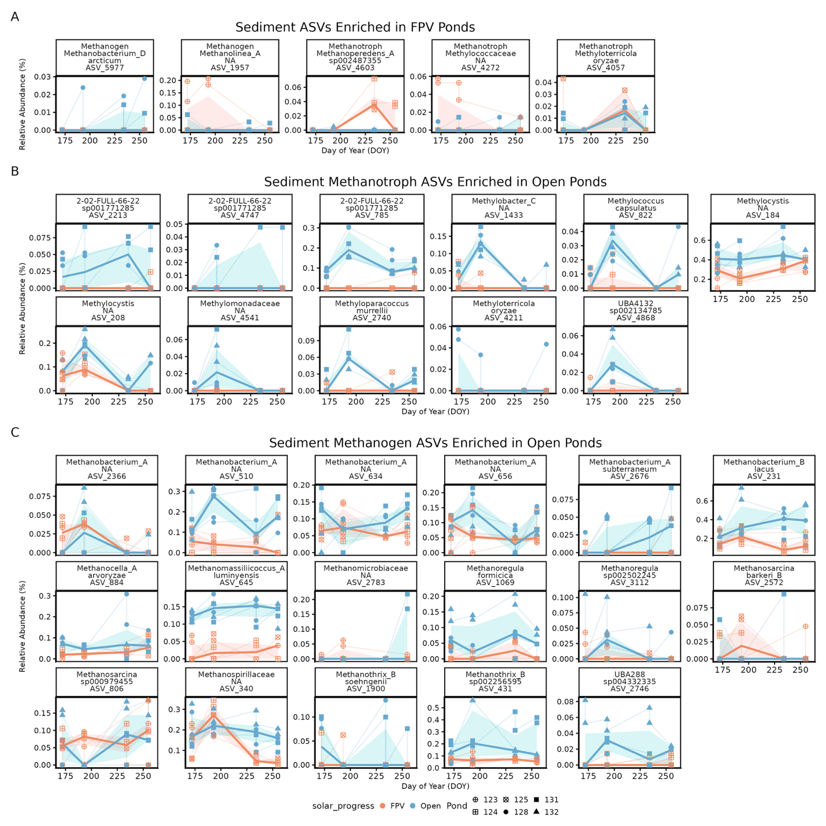

Fig. S7. Time-averaged differential abundance of sediment methane-cycling ASVs under FPV and non-FPV pond (“Open”) conditions. Sediment methane-cycling ASVs identified as differentially abundant using time-averaged ANCOM-BC2 analyses. (A) ASVs enriched in FPV ponds, (B) methanotroph ASVs enriched in open ponds, and (C) methanogen ASVs enriched in open ponds. Relative abundance (%) of each ASV is shown across day of year (DOY). ASVs lacking genus-level taxonomic resolution are labeled at the family level in facet titles (ASV_340, ASV_2783, ASV_4541, ASV_2366, ASV_634).

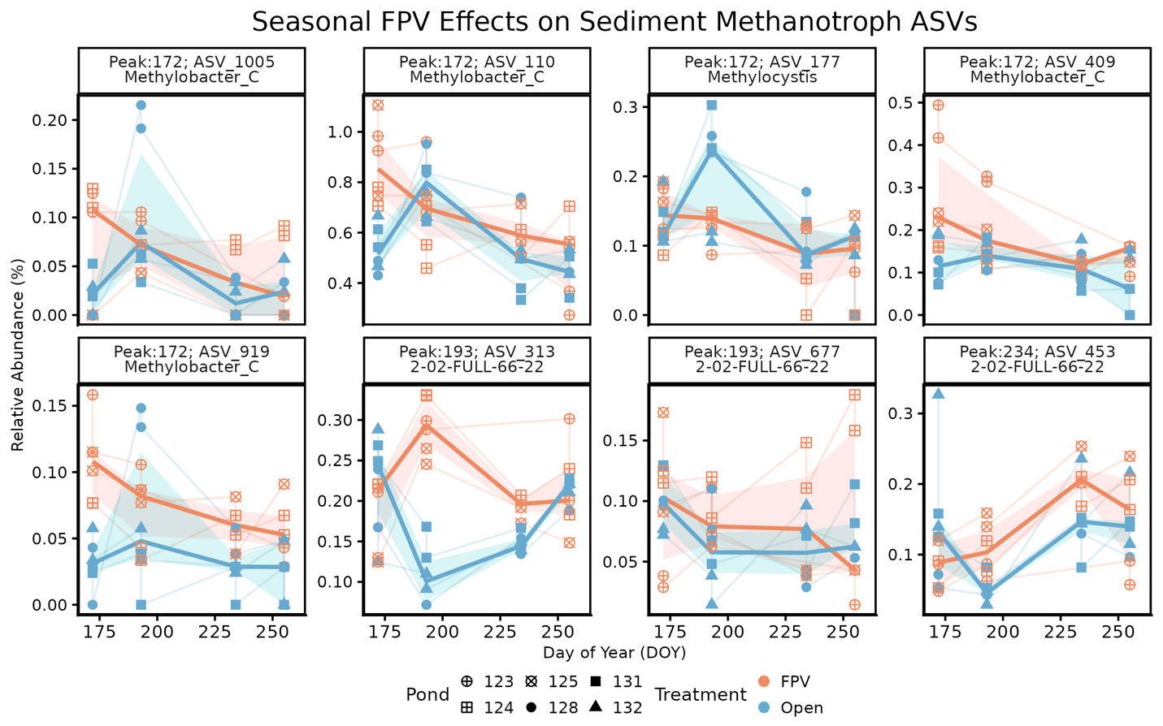
Fig. S8. Seasonally explicit enrichment of sediment methanotroph ASVs under FPV conditions. Relative abundance (%) of selected sediment methanotroph ASVs across the sampling season, highlighting ASVs with peak FPV-associated enrichment identified using a seasonally explicit (time-resolved) screening approach rather than time-averaged differential abundance testing. Taxa include Gammaproteobacteria (Type I; Methylobacter_C), Alphaproteobacteria (Type II; Methylocystis), and anaerobic nitrite-dependent methanotrophs (Type III; Methylomirabilales, 2-02-FULL-66-22). Community-level analyses did not detect a significant FPV × time effect for sediment methanotrophs.

