ILO - Project Markdown

Milo Skovfoged

27/4/2021

# Analysis of Fatalities

## Import, clean, and merged data

First we download the Fatility data. We download the normalized data per 100.000 worker (SDG_F881_SEX_MIG_RT_A)

## ref_area TotalFatilitiesNormP100K time classif1   
## Length:957 Min. : 0.000 Min. :2000 Length:957   
## Class :character 1st Qu.: 2.200 1st Qu.:2003 Class :character   
## Mode :character Median : 4.100 Median :2008 Mode :character   
## Mean : 6.096 Mean :2008   
## 3rd Qu.: 7.000 3rd Qu.:2013   
## Max. :133.400 Max. :2019   
## ref_area.label   
## Length:957   
## Class :character   
## Mode :character   
##   
##   
##

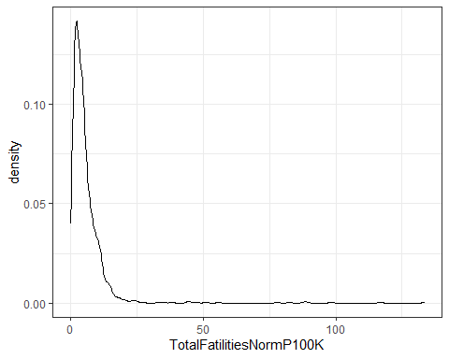

Then we download the labor inspection data. Here we download the different datasets:

1. Number of labor inspectors per 10.000 worker (LAI_INDE_NOC_RT_A)

## ref_area LaborInspectorsNormP10K time ref_area.label   
## Length:454 Min. : 0.0300 Min. :2008 Length:454   
## Class :character 1st Qu.: 0.3400 1st Qu.:2011 Class :character   
## Mode :character Median : 0.6300 Median :2013 Mode :character   
## Mean : 0.9368 Mean :2014   
## 3rd Qu.: 1.0425 3rd Qu.:2017   
## Max. :31.5600 Max. :2019

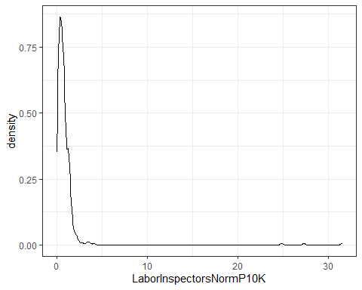

1. Number of inspections per inspector (LAI_VDIN_NOC_RT_A)

## ref_area InspectionsPerInspector time ref_area.label   
## Length:472 Min. : 0.12 Min. :2008 Length:472   
## Class :character 1st Qu.: 37.40 1st Qu.:2011 Class :character   
## Mode :character Median : 88.67 Median :2013 Mode :character   
## Mean :116.41 Mean :2014   
## 3rd Qu.:161.70 3rd Qu.:2017   
## Max. :829.98 Max. :2019

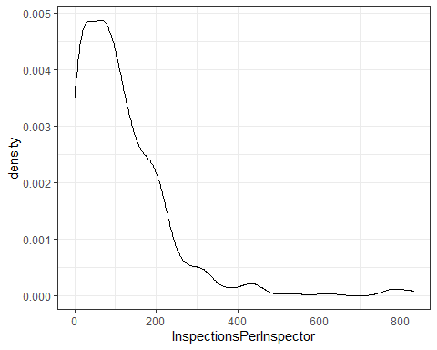

1. Total number of inspections (LAI_VIST_NOC_NB_A)

## ref_area TotalLaborInspections time ref_area.label   
## Length:523 Min. : 0 Min. :1996 Length:523   
## Class :character 1st Qu.: 2158 1st Qu.:2010 Class :character   
## Mode :character Median : 17572 Median :2013 Mode :character   
## Mean : 51529 Mean :2013   
## 3rd Qu.: 56350 3rd Qu.:2016   
## Max. :963443 Max. :2019

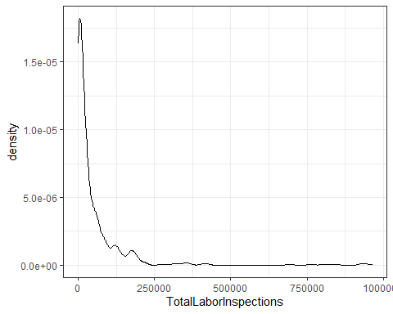

Them we combine and clean the data.

An initial linear regission analysis explains Fatilities very little (R-squared: 0.04)

It indicates a very small statical significants. The number of inspections per inspector increases the number of Fatilities

However, the

##   
## Call:  
## lm(formula = TotalFatilitiesNormP100K ~ LaborInspectorsNormP10K *   
## InspectionsPerInspector, data = CombinedFatilityDataNoNA)  
##   
## Residuals:  
## Min 1Q Median 3Q Max   
## -5.090 -2.233 -0.894 1.046 33.706   
##   
## Coefficients:  
## Estimate Std. Error t value  
## (Intercept) 4.718197 0.413298 11.416  
## LaborInspectorsNormP10K 0.044176 0.126423 0.349  
## InspectionsPerInspector 0.008084 0.003827 2.112  
## LaborInspectorsNormP10K:InspectionsPerInspector -0.016202 0.004346 -3.728  
## Pr(>|t|)   
## (Intercept) < 2e-16 ***  
## LaborInspectorsNormP10K 0.72707   
## InspectionsPerInspector 0.03568 *   
## LaborInspectorsNormP10K:InspectionsPerInspector 0.00024 ***  
## ---  
## Signif. codes: 0 '***' 0.001 '**' 0.01 '*' 0.05 '.' 0.1 ' ' 1  
##   
## Residual standard error: 3.865 on 245 degrees of freedom  
## Multiple R-squared: 0.05597, Adjusted R-squared: 0.04441   
## F-statistic: 4.842 on 3 and 245 DF, p-value: 0.00272

## `geom_smooth()` using formula 'y ~ x'

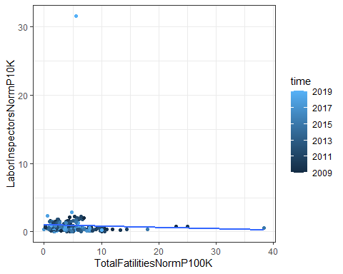

## `geom_smooth()` using formula 'y ~ x'

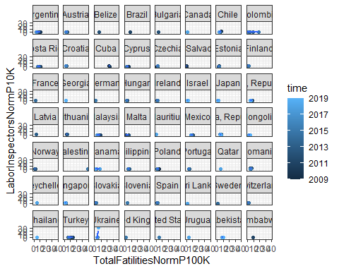

## `geom_smooth()` using formula 'y ~ x'

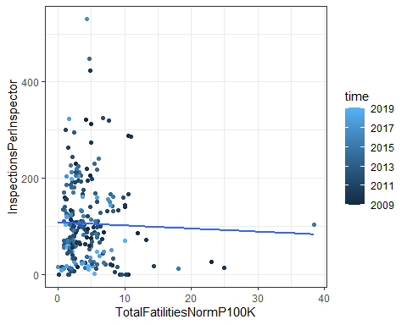

## `geom_smooth()` using formula 'y ~ x'

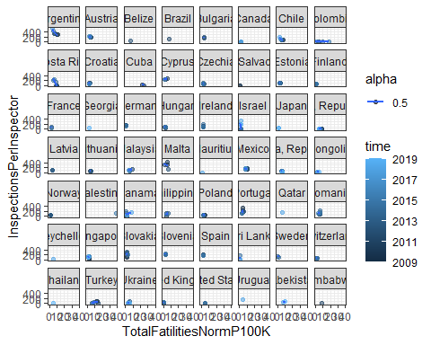

# Analysis of injuries

## ref_area TotalInjuriesNormP100K time classif1   
## Length:931 Min. : 0.0 Min. :2000 Length:931   
## Class :character 1st Qu.: 225.5 1st Qu.:2003 Class :character   
## Mode :character Median : 890.2 Median :2008 Mode :character   
## Mean : 6246.1 Mean :2008   
## 3rd Qu.: 2149.3 3rd Qu.:2013   
## Max. :947195.7 Max. :2019   
## ref_area.label   
## Length:931   
## Class :character   
## Mode :character   
##   
##   
##

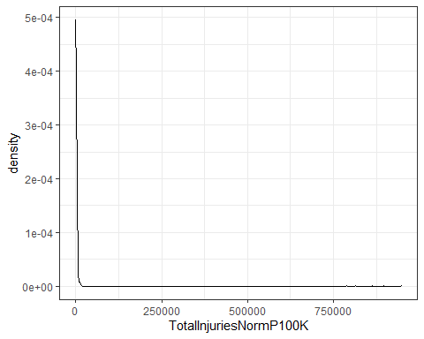

Them we combine and clean the injury data.

##   
## Call:  
## lm(formula = TotalInjuriesNormP100K ~ LaborInspectorsNormP10K *   
## InspectionsPerInspector, data = CombinedInjuryDataNoNA)  
##   
## Residuals:  
## Min 1Q Median 3Q Max   
## -2349.1 -1134.3 -549.4 622.6 10828.6   
##   
## Coefficients:  
## Estimate Std. Error t value  
## (Intercept) 1464.962 229.587 6.381  
## LaborInspectorsNormP10K -25.244 67.871 -0.372  
## InspectionsPerInspector 8.020 2.062 3.889  
## LaborInspectorsNormP10K:InspectionsPerInspector -8.158 2.182 -3.739  
## Pr(>|t|)   
## (Intercept) 9.46e-10 ***  
## LaborInspectorsNormP10K 0.710280   
## InspectionsPerInspector 0.000131 ***  
## LaborInspectorsNormP10K:InspectionsPerInspector 0.000233 ***  
## ---  
## Signif. codes: 0 '***' 0.001 '**' 0.01 '*' 0.05 '.' 0.1 ' ' 1  
##   
## Residual standard error: 2076 on 232 degrees of freedom  
## Multiple R-squared: 0.07787, Adjusted R-squared: 0.06595   
## F-statistic: 6.531 on 3 and 232 DF, p-value: 0.0002937

## `geom_smooth()` using formula 'y ~ x'

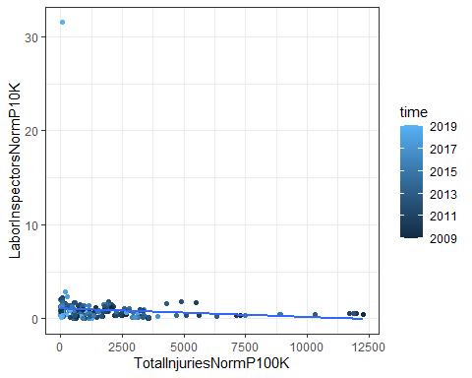

## `geom_smooth()` using formula 'y ~ x'

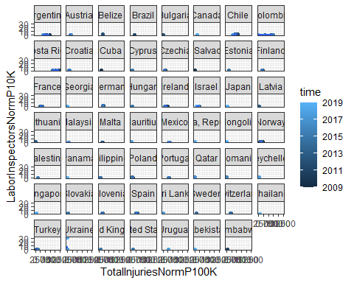

## `geom_smooth()` using formula 'y ~ x'

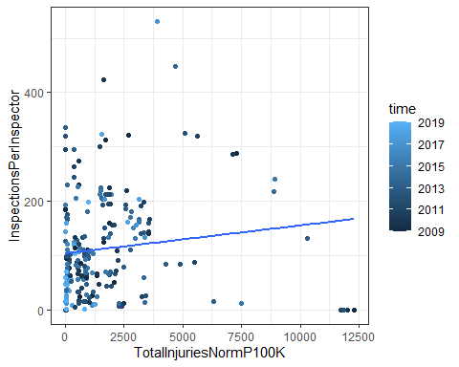

## `geom_smooth()` using formula 'y ~ x'

