Pursuing a Career in IT...Have you checked the numbers?
Exploration of data from a 2019 Stack Overflow Survey
B. W., March 2020


If you are reading this post, you are probably looking into a career in an IT related field (either that, or you are curious about the drawing of the elephant shrew). This post gives an analysis and interpretation of the results of a 2019 Stack Overflow Survey, with the intention of shedding light on the tech industry and is a prerequisite to a project of the Udacity Data Science Nanodegree.

As a prospective IT professional, you should have an affinity for numbers and therefore may be interested in an analysis of a survey of 88883 Stack Overflow users. Of particular interest is 1) how active is the open source community and what are peoples opinions of open source, 2) what sort of background to IT professionals come from and 3) what is a reasonable excpectation of earnings and are there any trend in earnings that you should know about.

So how important is open source to the IT world? A simple pie chart of surveyed opinions of Stack Overflow users shows that the majority thinks that OSS (open source software) is on par with, or better than proprietary software, however only ~one eighth of users actually contributes to OSS.

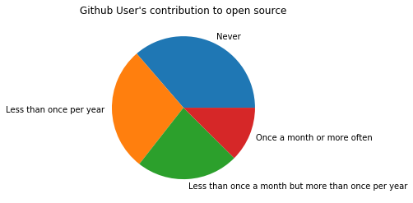
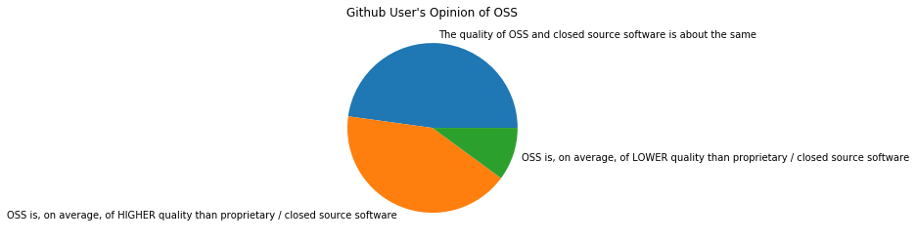

Business Understanding
Data gathered during the Stack Overflow survey has an abundance of data regarding Github user's backgrounds, careers, interests and job satisfaction. Because Github is primarily a platform for code sharing and version control, Github user's data can give insight on programmers and the technology sector.
The following questions are of interest to me as a newcomer to the world of tech:
- How important are open source tools to Github users?
  - Which environment do they use?
  - Which operating system do they use
  - How often do they contribute to open source?
  - What are their opinions of open source code?
- What background do Github users have?
  - What is the gender distribution of Github users?
  - How old are Github users?
  - What level of education do they have?
  - What major do Github users have?
  - Where do Github users live?
- What are the trends for Github user's salaries?
  - How much money do Github users earn does this depend on their gender?
  - Is there a correlation between age and income?
  - How do salaries compare across 14 countries with the most amount of Github users, and South Africa (my country of residence)?

Data Understanding¶
Survey results for 2019 were downloaded from Github as survey_results_public.csv. An explanation of the column labels is given survey_results_schema.csv in the git repository.

To answer the questions in the above business understanding section, the following columns are relevant:
- Columns relevant for determining Github user opinion regarding open source tools
  - 'DevEnviron' - Environment used
  - 'OpSys' - Operating system used
  - 'OpenSourcer' - How often contributes to open source projects
  - 'OpenSource' - Opinion of open source code quality
- Columns relevant to Github user's background
  - 'Gender'
  - 'Age'
  - 'EdLevel' - Highest level of education
  - 'UndergradMajor' - Undergraduate major
  - 'Country' - Country of residence
- Columns relevant in determining trends in Github user's salaries
  - 'ConvertedComp' - Salary converted to USD / year assuming 12 working months and 50 working weeks, using the exchange rate of 2019-02-01
  - 'Gender'
  - 'Age'
  - 'UndergradMajor' - Undergraduate major
  - 'OpSys' - Operating system used
  - 'DevEnviron' - Environment used

The most used environment is Microsoft's Visual Studio Code and Visual Studio. This could be interpreted to mean that proprietary software is more popular, but this is not the case. There is a larger variety of open source environments to choose from, meaning that the fans of open source software are 'spread thin' between all the available open source environments.

About half of users use Windows and roughly a quarter use Linux and Mac respectively. One quarter of Github users buy into an open source operating system.

Only a sixth of github users contribute regularly (more than once per month) to open source projects.

Open source code is generally either considered to be on-par-with or better then proprietary software.

Only a small minoriy of github users are women

the histogram is skewed to the right and shows that most Github users are 25 - 30 years old.

Almost three quarters of Github users have a Bachelor's or Master's degree, suggesting that programmers generally have tertiary education

Almost three quarters of Github users have a major in a tech-related field (CompSci, web development or information systems).

Most github users are from the USA, followed by India

There are far fewer female github users than men, which may be due to some sort of discrimination, but the histogram for salaries earned by women and men have a similar shape, suggesting that there is no gender discrimination when it comes to salaries in the tech industry. It must be said that when it comes to very high salaries > 1000000 /annum, women earn less than men.

This scatter plot seems to indicate that you either have a fast increase in salary, before you are 40, or you get stuck at you saraly. This scatterplot places emphasis on the outliers, and therefore it is suggested to look at the following 2D kde plot.

This kdeplot shows that Github users in general earn more with increasing age. The variation of earnings increases with age.

This violinplot shows the distribution of salaries by country, ordered by median salary of country. Interestingly english-speaking countries lead the way. In general the worst salaries are in India

Surprisingly, Github users with a tech-related major (web development, information systems or CompSci) earn less, by median, than users with a major in social sciences, fine arts or humanities.

Salaries earned by operating system used look relatively similar. The main difference is the intensity of the peak at ~USD 75000

The distribution of salaries does not differ significantly when grouped by contribution to OSS.

Evaluation

Q1: How important are open source tools to Github users?
Top 2 environments are MS Visual Studio Code and MS Visual Studio, suggesting that most users are pro-propitiatory, however there are much larger number of open source environments to choose from, and in total, most use open source. It must be said that only ~one quarter use linux and ~one eighth contribute to open source projects more than once per month. Most users think that open source software is on par with or better than proprietary software.
In general, Github users see the value in OSS, but not many contribute to it.
Q2: What background do Github users have?
Most are men, between 25 and 30 years in age. Three quarters have Bachelor or Master level tertiary education. Only few do not have tertiary education. Three quarters also have a major in a tech-related field. By far most Github users come from the USA, followed by India, Germany, the UK and Canada.
Q3: What are the trends for Github user's salaries?
As might be expected, the number of Github users decreases with increasing earnings. A salary of USD1000000/year and USD2000000/year seem to be standard salaries for very high earners. Even though there are much fewer female than male Github users, their salary distribution seems similar, but women do earn less on the very high end of the salary spectrum. In general one earns more with increasing age, but the older, the larger the spread of salaries, suggesting that ones skill and dedication in ones career matter. Salaries in English-speaking countries are the highest, while India and Brazil have the lowest salaries. Surprisingly, the median salary of users with a tech-related major is lower than median salary of users with humanities major. No real differences in earnings by operating system used.

Deployment
Github users are mostly involved in the tech industry and therefore some parallells can be made with regard to this industry. In the context of this exersize, I interpret the “deployment” section of the CRISP-DM methodolotgy to include recommendations to myself or other individual who is intending to start a career in the tech industry. This will include 1) recommendations on going into a more open source vs proprietory career path, 2) looking if bias against people with a certain backgrounds exists and 3) what sort of earnings might be expected in this career path.

