In-game movie “Special operations group landing”
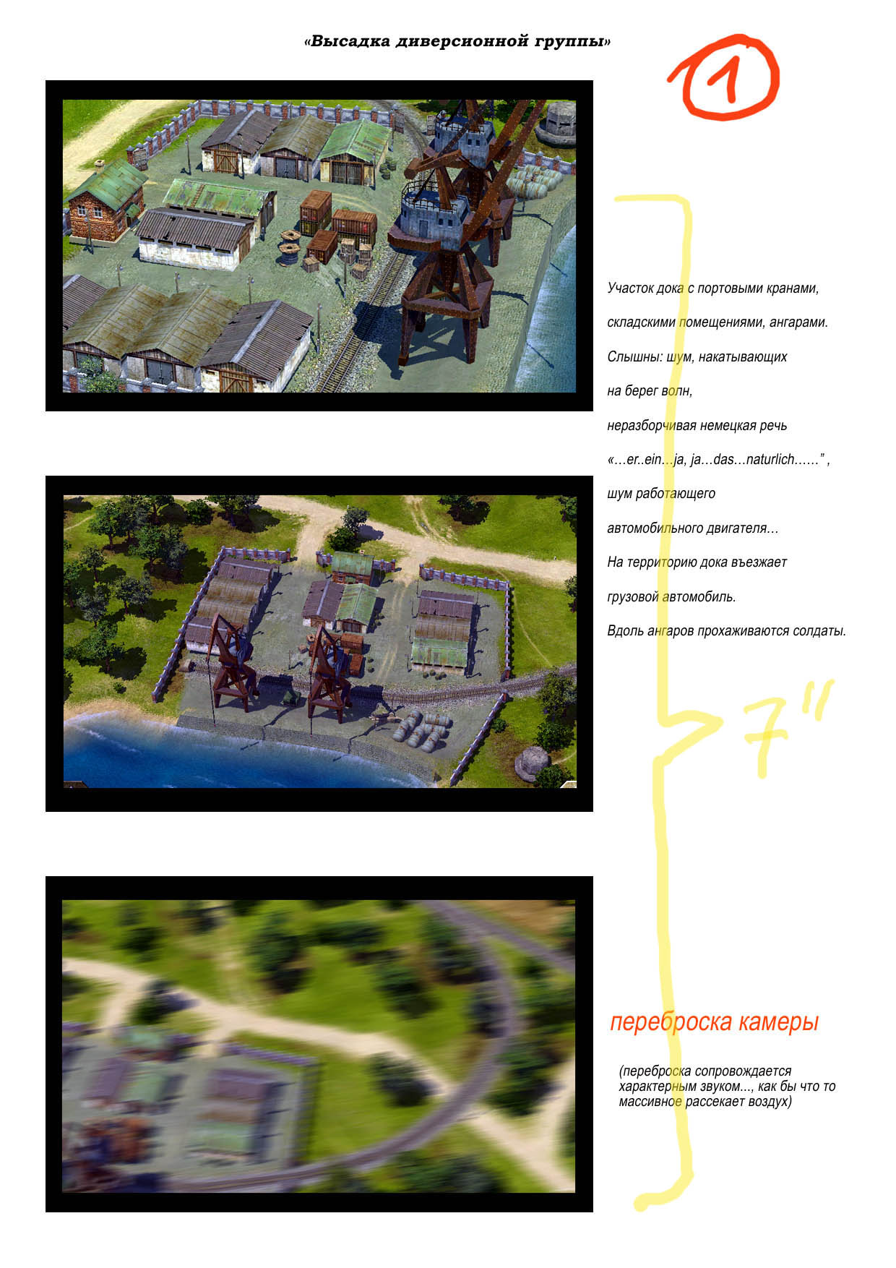
- Part of the port with port cranes, warehouses, hangars. SFX: sound of waves, muted German phrases “…er..ein…ja, ja…das…naturlich……”, the sound of the working engine. A truck is driving into the port area. Soldiers are walking along the hangars.
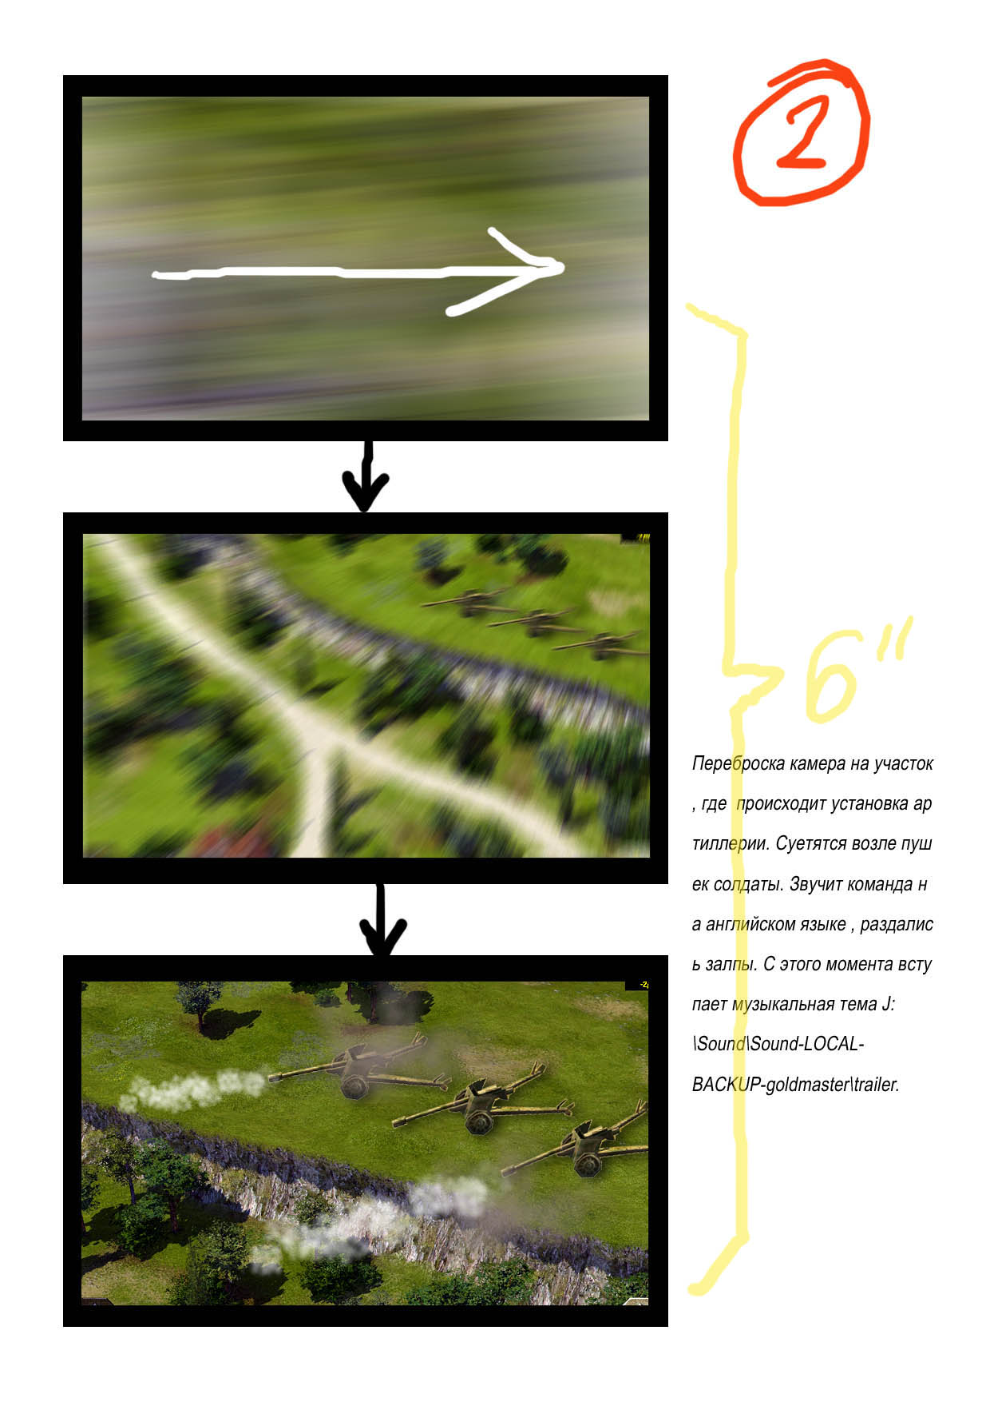
- Camera is panning fast to the area of artillery deployment. The panning is accompanied by a sound of something heavy flying through the air. Soldiers are running around setting up guns. A command in English and the first salvo is fired. Music: J:\Sound\Sound-LOCAL-BACKUP-goldmaster\trailer starts.
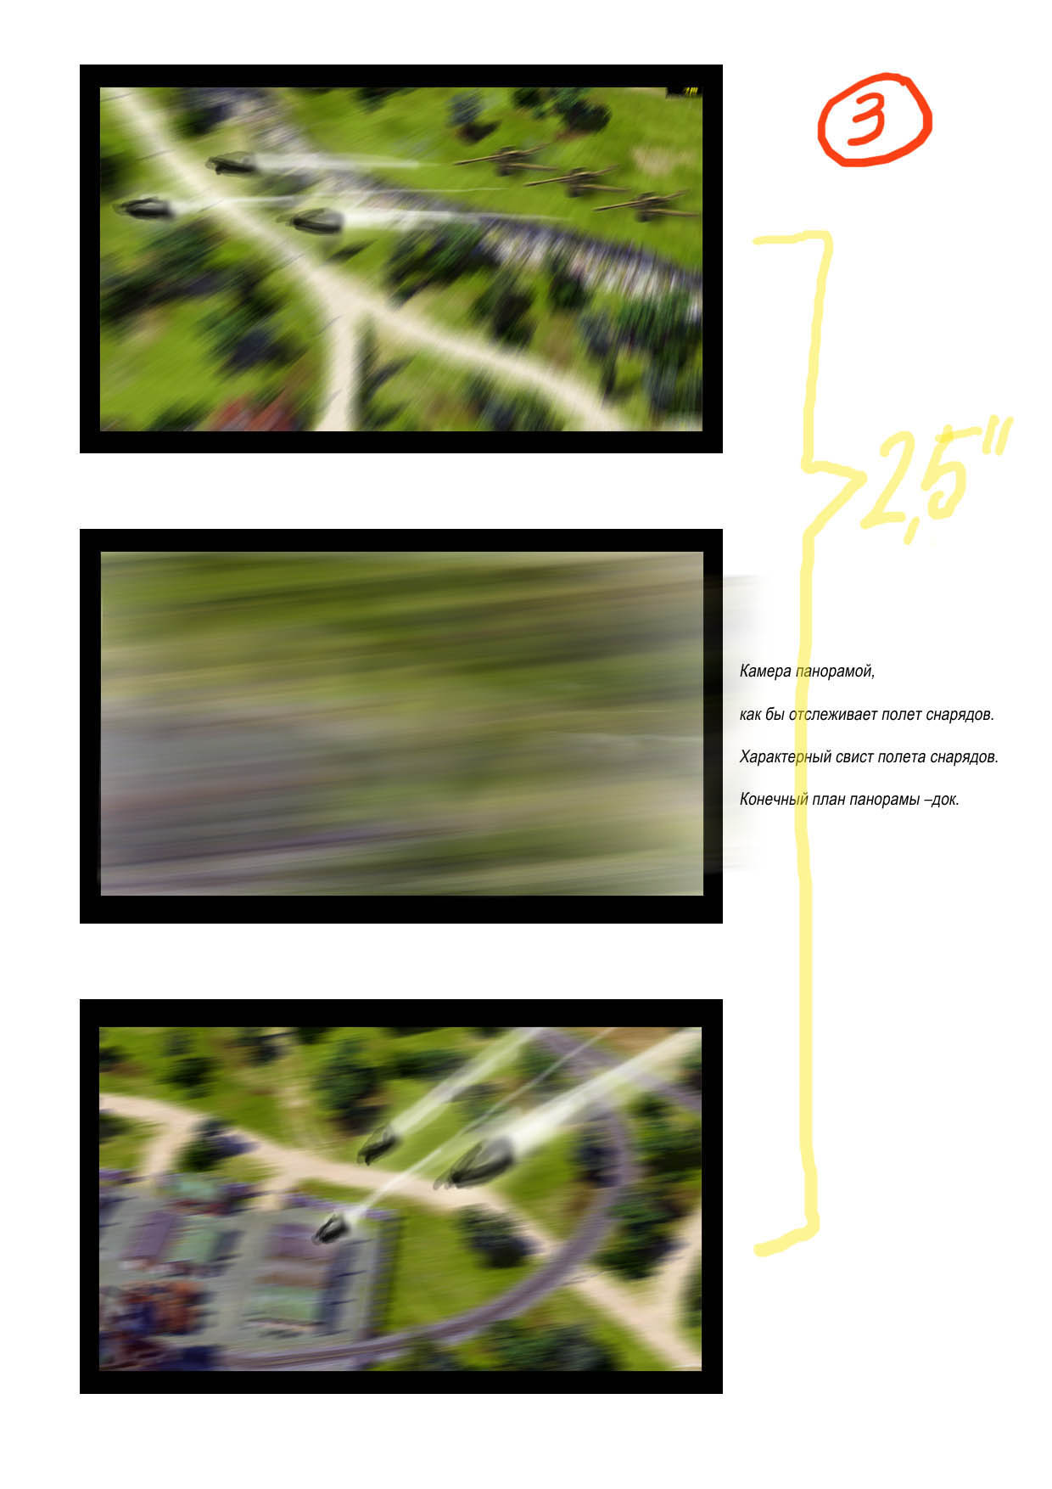
- Camera is panning and follows the shells flying. SFX: sound of the artillery shells flying. The and of the panning – port area.

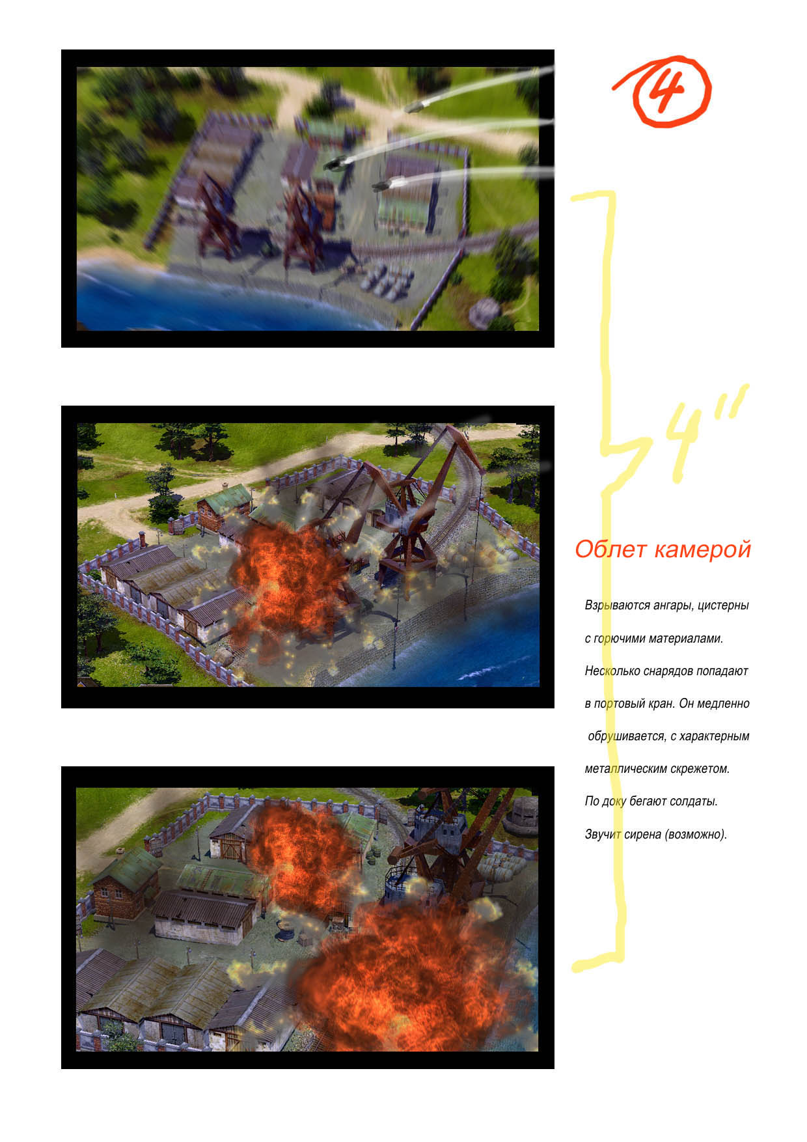
4. Hangars and barrels with flammable materials are exploding. Several shells are hitting the port crane. It starts to fall apart slowly accompanied by the SFX of metal twisting. Soldiers are running around in panic. Possible SFX: alarm sound.
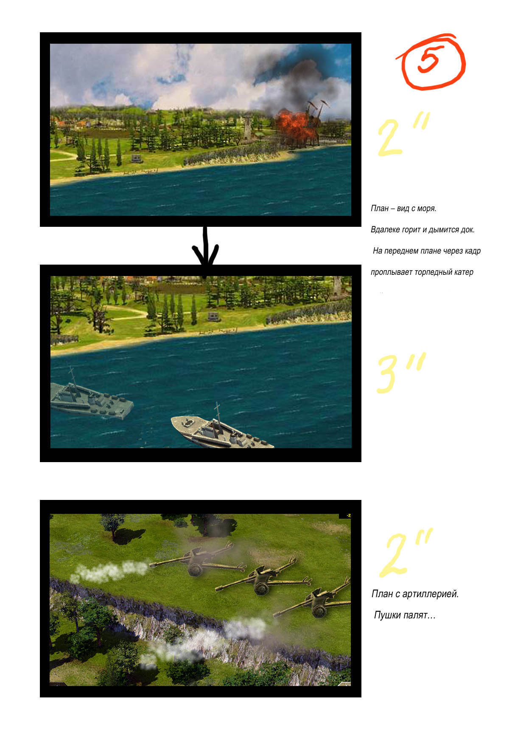
5. Camera from the sea. In the distance the port area is in smoke. On the foreground the torpedo boat is sailing across the screen.

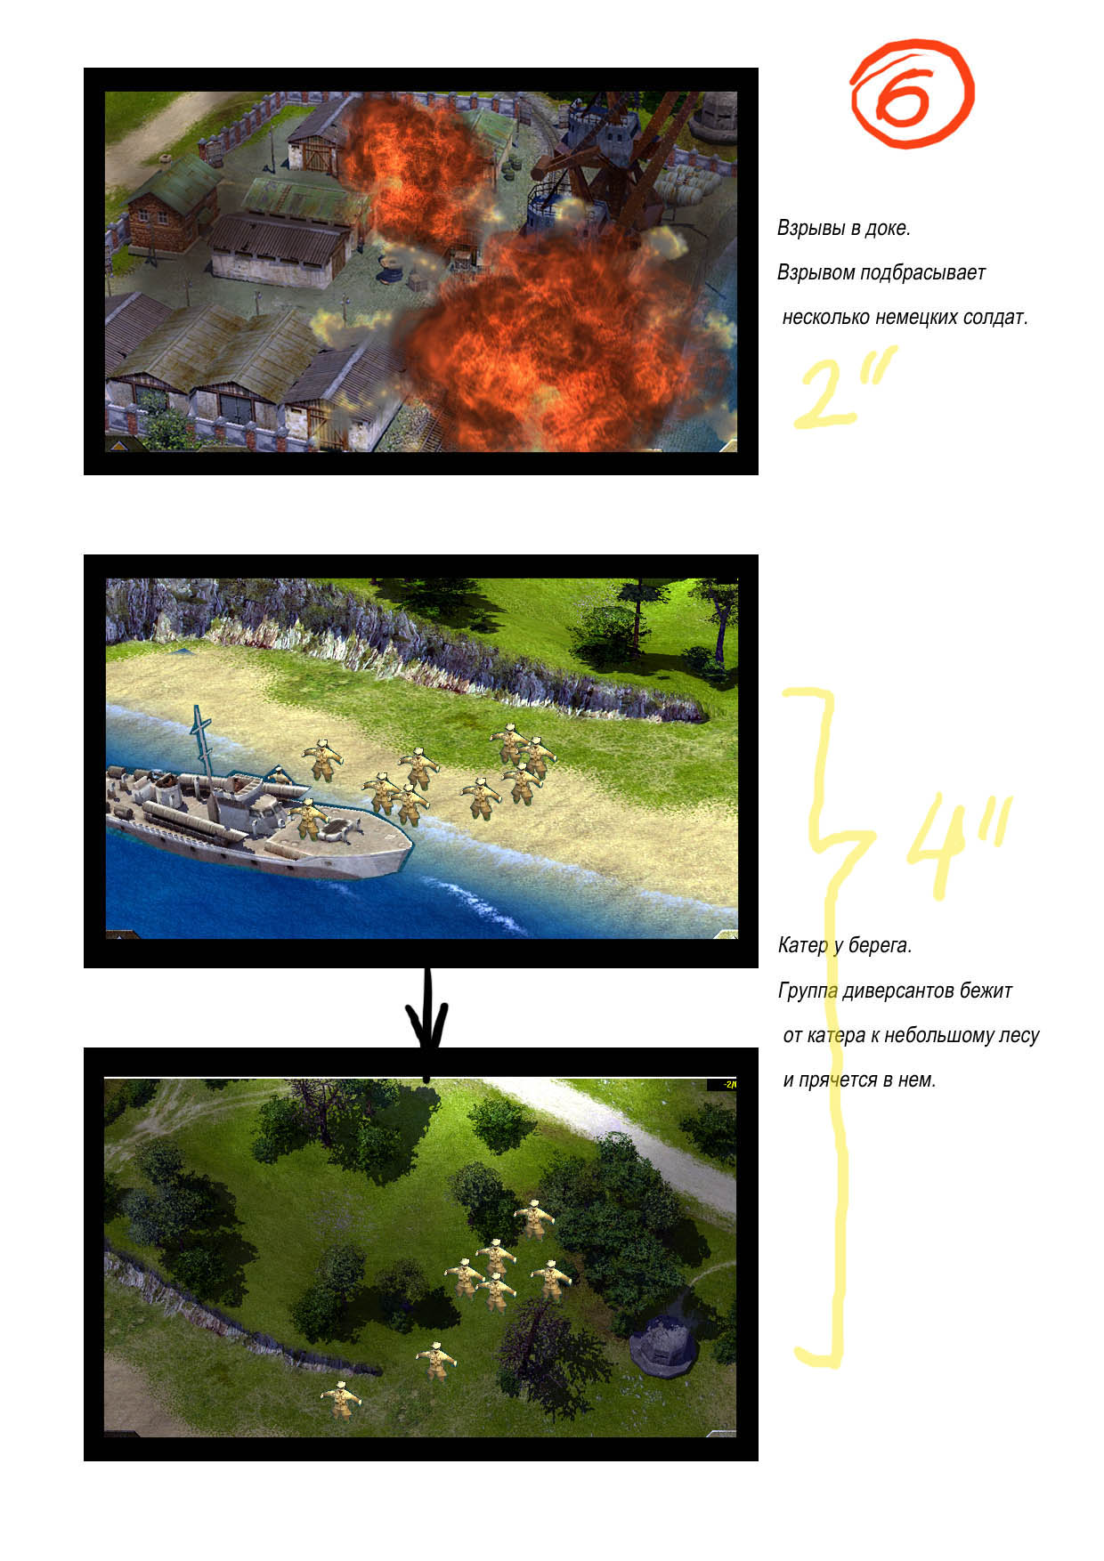
6. Explosions in the port. Several German soldiers are sent flying through the air by an explosion. Torpedo boat near the shore. A special ops group is running towards a small forest and hiding in it.

