Alpha Chapter – Battle for El Alamein.

The chapter consists of seven missions – six smaller ones and one large historical mission. All smaller missions in the chapter are available for the player right from the start of the chapter. The historical mission becomes available after the player completes at least any three smaller missions. At the beginning of the chapter fifteen reinforcements are available to the player.

Chapter scheme.
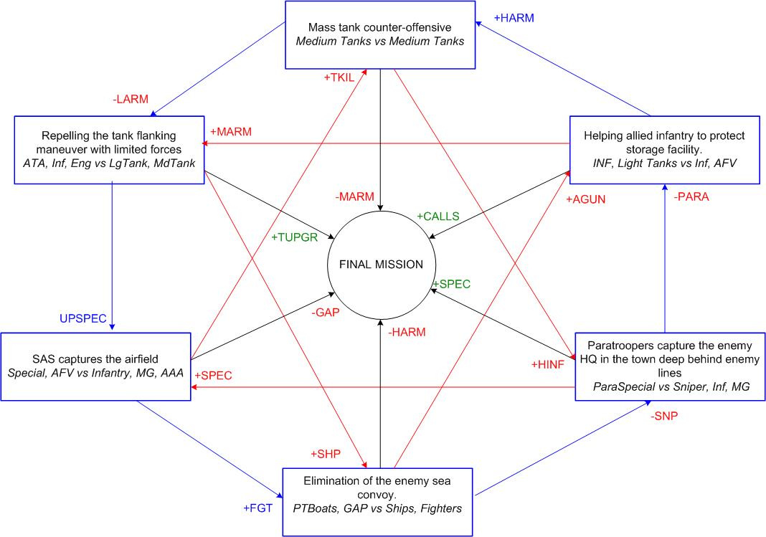

Smaller mission 1. Protecting the stores.
The player’s mission is to help the allied troops under the command of AI to repel the enemy attack aimed for capture of storage facility.
The allied troops are guarding the approaches to the storage facility. The player controls the light tanks and infantry, which she can use to reinforce the allied AI troops at the right place at the right time.
The enemy continuously attacks the stores from the several directions, using the armors and motorized infantry regiments. At the end of the mission the enemy will drop the paratroopers that will attempt to blow the stores up with the explosives. Without the aid from the player, the allied AI troops will not be able to repel these attacks. The player will have to distribute the available forces wisely in order to complete this mission.

The allied and enemy troops ratio: 1/3
Time: Day

Starting Player’s troops: Infantry, Light tanks
Player’s reinforcements: Infantry, Light tanks
Recommended number of reinforcements calls: 3

Starting Allied troops: Infantry
Allied reinforcements: none

Starting Enemy troops: Infantry, Light tanks AFV, APC
Enemy reinforcements: Infantry, Light tanks

Secondary bonus: for mission 2 – New reinforcement type – Heavy Tank.
Secondary penalty: for mission 3 – The enemies get Medium Tanks.

Bonus for final mission: Additional Reinforcements in final mission – 5

Incoming bonus: from mission 6, no enemy paratroopers
Incoming penalty: from mission 5 new enemy reinforcement Self-Propelled Gun.

Small mission 2 Massive Tank Counter-offensive

Massive tank counter-offensive on the open area. In the beginning of the mission there are 3-4 tank groups under player’s command. The total amount of these tank groups is 12-16 tanks. The player has time to place the tanks on the starting positions, form the reserve groups, call for the additional reinforcements etc. The player must be forced to attack, otherwise all mission might degrade into the shoot’em-up of the incoming enemy forces from the comfort of the fortified positions.
Player’s task: to eliminate all enemy forces in the mission.

The allied and enemy troops ratio: 1/1,5
Time: Day

Starting Player’s troops: Medium Tanks
Player’s reinforcements: Medium Tanks
Recommended number of reinforcements calls:2

Starting Allied troops: none

Starting Enemy troops: Medium Tanks
Enemy reinforcements: Medium Tanks

Secondary bonus: for mission 3 the enemy looses the Light tanks reinforcements
Secondary penalty: for mission 6 the enemy boosts the HQ guards by Heavy Infantry

Bonus for final mission: the enemy looses the Medium Tanks reinforcements

Incoming bonus: from mission 1 – New reinforcement type – Heavy Tank
Incoming penalty: from mission 4 – new enemy unit type Self-Propelled Gun

Small mission 3 Prevent of the enemy tank rush on the flanks of Allies positions.

The enemy managed to relocate the large amount of light tanks to the position from which they can attack the weak spot in Allied positions and disrupt the critical supply paths. The player has to prevent this from happening with the limited infantry and Anti-Tank artillery forces. The player can put up the mine fields, anti-tank defenses and dig the trenches.

The allied and enemy troops ratio: 1/4
Time: Day

Starting Player’s troops: Infantry, AT artillery, Engineering trucks.
Player’s reinforcements: Infantry, AT artillery
Recommended number of reinforcements calls: 3

Starting Allied troops: none

Starting Enemy troops: Light tanks AFV
Enemy reinforcements: Light tanks

Secondary bonus: for mission 4 – Player gets SAS upgrade
Secondary penalty: for mission 5 – the enemy boosts the convoy with additional ships.

Bonus for final mission: Player gets Medium Tanks upgrade

Incoming bonus: from mission 2 – enemy looses the Light tanks reinforcements
Incoming penalty: from mission – The enemies get Medium Tanks reinforcement type.

Small mission 4 Airport capture with SAS forces.

SAS squads on the light jeeps, after the day-long desert march, has reached the enemy airfield. The enemy has not expected the attack from this direction and SAS has the real chances to capture the airfield and deprive the enemy of air-support in the upcoming battles. The player has to eliminate the airfield defenders and take control over the airport.

The allied and enemy troops ratio: 1/3
Time: Night

Starting Player’s troops: SAS, AFV
Player’s reinforcements: SAS, AFV
Recommended number of reinforcements calls:2

Starting Allied troops: none

Starting Enemy troops: Infantry, HMG, ААА
Enemy reinforcements: Infantry

Secondary bonus: for mission 5 – New reinforcement type – Ground-Attack planes.
Secondary penalty: for mission 2 – new enemy unit type Self-Propelled Gun

Bonus for final mission: The enemy looses Ground-Attack planes

Incoming bonus: from mission 3 Player gets SAS upgrade
Incoming penalty: from mission 6, The enemy boosted guards at all locations with special forces Infantry

Small mission 5 – Attack on the enemy sea convoy.
The enemy is relocating the additional support for its forces near El Alamein. The player has to prevent the arrival of the enemy ships to the port of destination. The enemy convoy is protected by the torpedo boats and receive the air support from the fighter planes. The players task is to destroy as many enemy ships as possible using the ground-attack planes and torpedo boats.

The allied and enemy troops ratio: 1/3
Time: Day

Starting Player’s troops: Torpedo boats
Player’s reinforcements: GAP, Torpedo boats
Recommended number of reinforcements calls:3

Starting Allied troops: none

Starting Enemy troops: Transport ships, Torpedo boats
Enemy reinforcements: Fighter planes

Secondary bonus: for mission 6 – the enemy looses the elite snipers with experience at the Eastern front.
Secondary penalty: for mission 1 – the enemy relocates the SPGs to ensure the capture of the stores.

Bonus for final mission: The enemy looses the Heavy Tanks

Incoming bonus: from mission 4 New reinforcement type – Fighter planes
Incoming penalty: from mission 3 the enemy boosted the convoy with additional torpedo boats.

Small mission 6 Capture of the enemy HQ.

The squad of paratroopers land from the planes to capture the enemy headquarters. The HQ are located in the town, the drop zone is located at some distance from the HQ, since the HQ is protected by the AAA. The player has to lead the paratroopers through the city and capture the
HQ. The town buildings are dense and many houses contain the enemy strong points.

The allied and enemy troops ratio: 1/5
Time: Night

Starting Player’s troops: SAS
Player’s reinforcements: SAS
Recommended number of reinforcements calls:2

Starting Allied troops: none

Starting Enemy troops: Infantry, HMG, ААА, snipers
Enemy reinforcements: Infantry

Secondary bonus: for mission 1 – no enemy paratroopers
Secondary penalty: for mission 4 – The enemy boosts guards at all locations with Special Forces Infantry

Bonus for final mission: The player gets an additional squad of SAS

Incoming bonus: from mission 5 – the enemy looses the elite snipers with experience at the Eastern front.
Incoming penalty: from mission 2 – the enemy boosts the HQ guards by Heavy Infantry

