Intermission gameplay
Campaign and missions
Each campaign in Blitzkrieg II is divided into 4 chapters, each chapter represents one well known WWII battle divided into several mission. Each chapter consists of 4 to 8 small mission and one large final historical mission. Therefore there will be about 100 small missions and 16 historical missions.

Mission in chapter
At the beginning of the chapter all small missions are available, but the final mission becomes available only after completing some predefined number of small missions. This number depends on the chapter; usually between 2 and 4.

Small missions
Small missions represents some fragments of the whole operation, such as the defense of key areas of the front, counterattacks, special operations behind enemy lines, air strikes, artillery bombardments, etc. These fragments serve as a preparation for completing the final goal of the chapter – the historical mission.
Each of the small missions is build around some interesting feature of the game or uniqueness of the campaign it belongs to. For example, this could be a clash between some particular types of units, or a mini-game based on the gameplay not found in more typical historical battles.
As a rule, small missions have one or two primary objectives. The player can win the mission and collect the after-mission bonuses by completing these objectives. The size of such missions shouldn’t exceed 8 by 8 patches and the time to complete such mission should be around 30 minutes (note, that the typical size of random mission in Blitzkrieg I is also around 8 by 8 patches).

Historical missions
The final mission of the chapter serves as an apogee of the entire operation. The player delivers the final blow to the enemy and proceeds into the next chapter. Each historical mission consists of several primary objectives that the player should complete one by one in order to win the mission.
There are several factors that make the final mission more difficult to complete. These factors (for example, enemy strong points, presence of long range artillery, aviation, etc.) are placed on the map in such fashion that bypassing them is difficult or impossible. Nevertheless, the player can neutralize these factors or receive additional troops and unit types to help his cause by completing small missions. The size of the final missions shouldn’t exceed 16 by 16 patches and the time to complete should be no more then 2 hours.

Reinforcements
At the beginning of the chapter the player receives N reinforcement calls that he can spend to complete the chapter. Every reinforcement call the player makes inside the mission is deducted from N thus reducing the number of reinforcements available in the following missions. The player knows number of recommended number of reinforcement calls for each mission, and if he exceeds this number the warning is displayed in mission interface. At the beginning of each mission the player receives some fixed set of reinforcement types. This set depends on the design of the mission and on completing other missions in current chapter.

Bonuses in chapter
There are several kinds of bonuses available:
- Bonuses increasing the number of reinforcement calls in the mission
- Bonuses that help player to complete the final missions by removing enemy reinforcements or giving new reinforcement types to the player
- Bonuses that help player to complete other small mission
- Bonuses to the enemy in other small missions. This kind of negative bonuses in necessary to balance the advantages the player receives by completing all missions in the chapter. They are also helping the player to understand that not all missions are required to complete the chapter.
As a rule, completing each of the small missions gives player some bonuses for the final mission. At the same time, the mission can have either positive or negative effect on other small mission. The goal is to allow player to complete the majority of small missing but to make the remaining small missions more difficult and to encourage the player to go into the final mission. The meta-game in the chapter is based on finding the balance between collecting the maximum number of bonuses with minimum number of reinforcement calls and saving them for the final mission.

Summary of intermission gameplay:
- Small missions are mini-games that give player some unique experience in tactical methods. They also serve as waypoints on the route to chapter completion.
- Historical mission is apogee of the chapter, where the player can see if his plan of completing the chapter is successful or not.
- Reinforcement calls are resources that the player can spend to receive bonuses, upgrade his army, and make the final mission simpler. The player can balance between saving them and using the brute force in the final mission, and spending them on acquiring bonuses in small mission. The ultimate goal of the chapter meta-game is to find the best possible route and number of small missions to play.

Reinforcement in-mission interface:

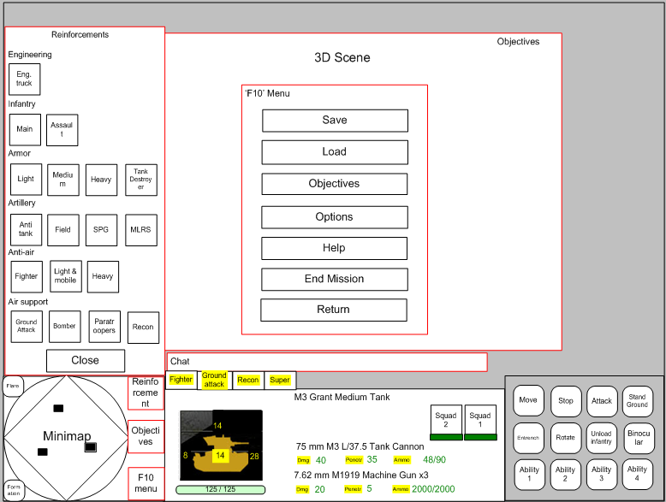
Chapter map interface:
