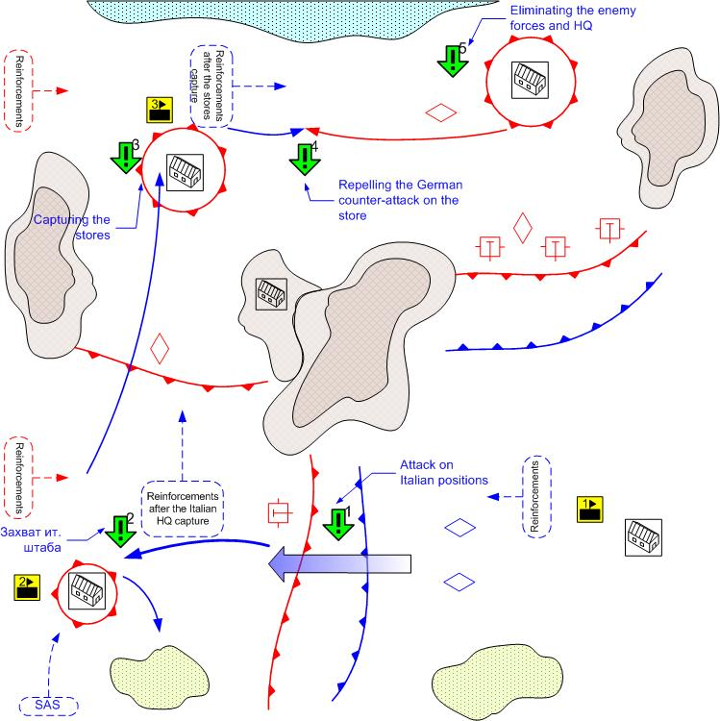

Size 12x12
Terrain: Africa, small towns, desert terrain, rocky plateaus, day lighting, good weather.

The final stage of the El Alamein battle.

Key buildings on the map.

1.- HQ (all initial reinforcements of the player)
2.- Italian HQ (New reinforcement arrival spot)
3. – Storage (New reinforcement arrival spot)

Player’s troops.
Starting troops.
AFV: [Humber Mk1] and [Crusader]
Anti-Tank Guns: [6pdr QFG ]
Anti-Aircraft Guns: [40mm Bofors]
Main Squads: [GB Main 1941]
AFV: [Willis] Desert Patrol (Jeeps), British SAS (Infantry)
Reinforcements.
Ground Attack: [Hawker Hurricane MK-1]
Fighters: [Spitfire MkII]
AFV & Light Tanks: [Humber Mk1] or [Crusader]
Medium Tank: [Valentine] or [M3 Grant]
Main Squads: [GB Main 1941]
Assault Guns: [Bishop]

Enemy Troops.
Starting troops:
Field Artillery: 6 [10.5-cm_leFH_18, 15-cm_K39]
Anti-Aircraft Guns: [2-cm_FlaK30/38, 8.8 FlaK18]
Tanks: [Pz.Kpfw IV.Ausf_D, G]
Light Tanks: [Pz.Kpfw_III.Ausf_E,] [Italian M13/40]
Main Squads: [German Squad 1941] [Italian Main 1941]
Tank Destroyer: [Italian Semovente 75/46]
AT Gun: [5cm PaK38]

Reinforcements:
Light Tanks: [Pz.Kpfw_III.Ausf_J]
Tanks: [Pz.Kpfw IV.Ausf_D]
Heavy Tanks: [Pz.Kpfw IV.Ausf, G]
Assault Guns: [StuG III D]
Ground Attack Planes: [Ju-87D1]
Fighters: [Bf-109F]

Mission overview.
This is the final stage of the El Alamein battle. The player’s forces are located at the southeast of the map and are prepared to attack the enemy positions. To the south east lie the dense German defenses. Beyond the line of these defenses are the powerful tank reserves. To the south west are the relatively weak Italian positions.
The player’s task is to eliminate the opposing enemy forces. The player attacks the weak Italian positions first and having crushed them completes the first sub-objective. After that the player captures the HQ of the Italian forces and gains the new reinforcement arrival point. Then the player moves to the north and captures the enemy stores and completes the third objective. The surrounded enemy counter attacks the player. After the player repels this attack the fourth objective is completed. The last player’s objective is to eliminate the remaining German forces and to capture their HQ.

Objectives.

- To penetrate the enemy defenses to the south-east.
Prerequisite Condition: Mission start
Completion Condition: The player’s units are behind the enemy defense lines.
- To capture the Italian troops HQ
Prerequisite Condition: Completion of objective 1
Completion Condition: In the area of the HQ there are some player’s troops and no enemy troops.
- To capture the stores
Prerequisite Condition: Completion of objective 2
Completion Condition: In the area of the stores there are some player’s troops and no enemy troops.
- To repel the German attack at the stores
Prerequisite Condition: Completion of objective 3
Completion Condition: The attacking enemy group has no units
Fail Condition: In the area of the HQ there are some enemy troops and no player’s troops.
- To capture the German troops HQ.
Prerequisite Condition: Completion of objective 4
Completion Condition: In the area of the HQ there are some player’s troops and no enemy troops.

Bonuses received for completing the smaller missions.

Mission 1 – Additional reinforcement calls
Mission 2 – The enemy looses the Medium Tanks reinforcement [Pz.Kpfw IV.Ausf_D].
Mission 3 – The player receives the Medium Tanks upgrade [M3 Grant].
Mission 4 – The enemy looses GAP [Ju-87D1].
Mission 5 – The enemy looses the Heavy Tanks reinforcement [Pz.Kpfw IV.Ausf, G].
Mission 6 – The player receives the SAS reinforcement behind the enemy lines. British SAS (Infantry).

