GB Chapter #2. Battle for El-Alamein.

The chapter consists of seven missions – six smaller ones and one large historical mission. All smaller missions in the chapter are available for the player right from the start of the chapter. The historical mission becomes available after the player completes at least any three smaller missions. At the beginning of the chapter fifteen reinforcements are available to the player.

Starting reinforcement types: Light Tanks, Main Infantry, GAP, AT Artillery
Bonus reinforcement types: Medium Tanks, Paratroopers, Elite Infantry, Assault Infantry, Engineers, Field Artillery, Mobile Artillery, Recon

Chapter scheme.
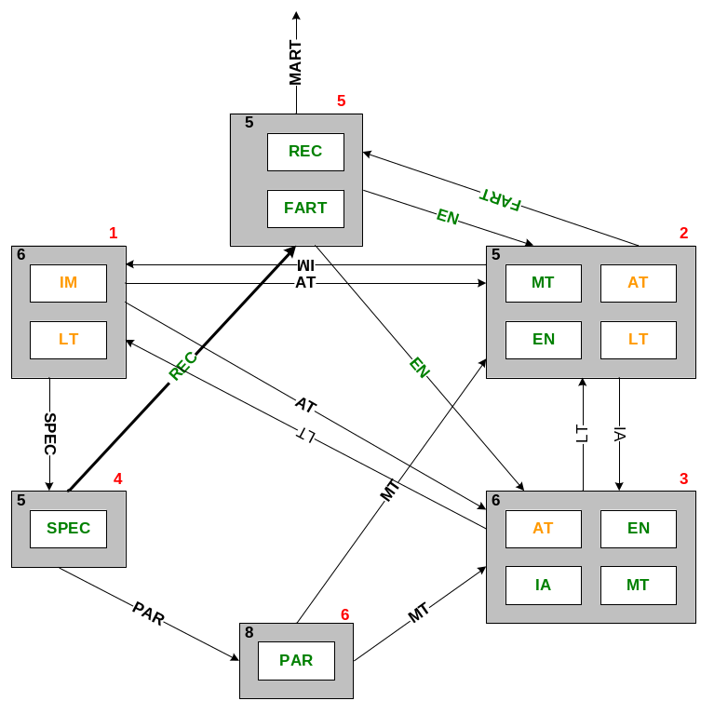

Small mission #1. Protecting the stores.

The player’s mission is to help the allied troops under the command of AI to repel the enemy attack aimed for capture of storage facility.
The allied troops are guarding the approaches to the storage facility. The player controls the light tanks and infantry, which she can use to reinforce the allied AI troops at the right place at the right time.
The enemy continuously attacks the stores from the several directions, using the armors and motorized infantry regiments. At the end of the mission the enemy will drop the paratroopers that will attempt to blow the stores up with the explosives. Without the aid from the player, the allied AI troops will not be able to repel these attacks. The player will have to distribute the available forces wisely in order to complete this mission.

The allied and enemy troops ratio: 1/3
Time: Day

Starting Player’s troops: Infantry, Light tanks
Player’s reinforcements: Infantry, Light tanks
Recommended number of reinforcements calls: 3

Starting Allied troops: Infantry
Allied reinforcements: none

Starting Enemy troops: Infantry, Light tanks
Enemy reinforcements: Infantry, Light tanks, Assault SPG

Bonuses:
- Upgrade: AT Guns
- New reinforcements: Elite Infantry

Small mission #2. Massive Tank Counter-offensive.

Massive tank counter-offensive on the open area. In the beginning of the mission there are 3-4 tank groups under player’s command. The total amount of these tank groups is 12-16 tanks. The player has time to place the tanks on the starting positions, form the reserve groups, call for the additional reinforcements etc. The player must be forced to attack, otherwise all mission might degrade into the shoot’em-up of the incoming enemy forces from the comfort of the fortified positions.
Player’s task: to eliminate all enemy forces in the mission.

The allied and enemy troops ratio: 1/1,5
Time: Day

Starting Player’s troops: Light Tanks, Medium Tanks
Player’s reinforcements: Light Tanks, Medium Tanks, Engineering Trucks
Recommended number of reinforcements calls:2

Starting Allied troops: none

Starting Enemy troops: Light Tanks, Medium Tanks
Enemy reinforcements: Light Tanks, Medium Tanks

Bonuses:
- New reinforcements: Field Artillery, Assault Infantry.
- Upgrade: Main Infantry

Small mission #3. Prevent of the enemy tank rush on the flanks of Allies positions.

The enemy managed to relocate the large amount of light tanks to the position from which they can attack the weak spot in Allied positions and disrupt the critical supply paths. The player has to prevent this from happening with the limited infantry and Anti-Tank artillery forces. The player can put up the mine fields, anti-tank defenses and dig the trenches.

The allied and enemy troops ratio: 1/4
Time: Day

Starting Player’s troops: Infantry, AT Guns, Engineering Trucks.
Player’s reinforcements: Infantry, AT Guns, Engineering Trucks.
Recommended number of reinforcements calls: 3

Starting Allied troops: Infantry, AFV

Starting Enemy troops: Light tanks
Enemy reinforcements: Light tanks, Medium Tanks

Bonuses:
- Upgrade: Light Tanks.

Small mission #4. Airfield capture with SAS forces.

SAS squads on the light jeeps, after the day-long desert march, have reached the enemy airfield. The enemy has not expected the attack from this direction and SAS has the real chances to capture the airfield and deprive the enemy of air-support in the upcoming battles. The player has to eliminate the airfield defenders and take control over the airport.

The allied and enemy troops ratio: 1/3
Time: Night

Starting Player’s troops: Elite Infantry
Player’s reinforcements: Elite Infantry
Recommended number of reinforcements calls:2

Starting Allied troops: none

Starting Enemy troops: Infantry, AFV, AA Guns
Enemy reinforcements: Infantry, Light Tanks

Bonuses:
- Upgrade: GAP
- New reinforcements: Recon, Paratroopers

Small mission #5. Attack on the enemy sea convoy.

The enemy is relocating the additional support for its forces near El Alamein. The player has to prevent the arrival of the enemy ships to the port of destination. The enemy convoy is protected by the torpedo boats and receives the air support from the fighter planes. The player’s task is to destroy as many enemy ships as possible using the ground-attack planes and torpedo boats.

The allied and enemy troops ratio: 1/3
Time: Day

Starting Player’s troops: Torpedo boats, Coast Guns
Player’s reinforcements: Recon, Fighters, Field Artillery
Recommended number of reinforcements calls: 3

Starting Allied troops: none

Starting Enemy troops: Transport ships, Torpedo boats
Enemy reinforcements: Fighter planes

Bonuses:
- New reinforcements: Engineering Truck, Assault SPG

Small mission #6. Capture of the enemy HQ.

The squad of paratroopers land from the planes to capture the enemy headquarters. The HQ are located in the town, the drop zone is located at some distance from the HQ, since the HQ is protected by the AAA. The player has to lead the paratroopers through the city and capture the
HQ. The town buildings are dense and many houses contain the enemy strong points.

The allied and enemy troops ratio: 1/5
Time: Night

Starting Player’s troops: none
Player’s reinforcements: Paratroops
Recommended number of reinforcements calls: 2

Starting Allied troops: none

Starting Enemy troops: Infantry, AA Guns, Light Tanks, AFV
Enemy reinforcements: Infantry

Bonuses:
- New reinforcements: Medium Tanks

