GB Campaign
Chapter #3
Mission: Battle for Monte-Cassino
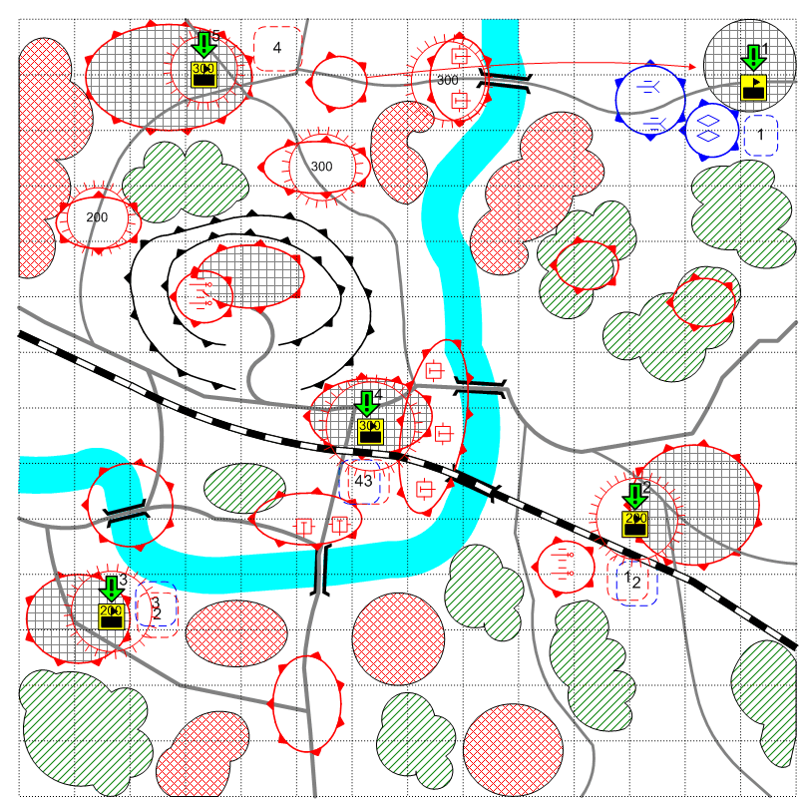
Size: 14x14
Setting: Summer, Italy, hills and mountains, big mountain with Monte-Cassino monastery.

Player troops.
Starting troops:
AFV: [Humber]
Medium Tank: [Cromwell]
Anti-Tank Gun: [17-pdr QFG]
Main Squad: [British Main 43]
Reinforcements:
Fighters: [Spitfire MkXIV]
Ground Attack: [Hawker Tempest]
AT Gun: [17pdr QFG]
Main Squad: [British Main 43]
Assault Squad: [British Assault 43]
Heavy Artillery: [4.5_inch_Gun_GB]
AA Gun: [40mm Bofors]
Medium Tanks: [Cromwell]
Light Tanks: [Valentine]
Assault Gun: [Sexton II]
Bombers: [Vicker Wellington MK-1]

Enemy troops.
Starting troops:
Field Artillery: [10.5-cm_leFH_18], [15-cm_K39]
Anti-Aircraft Gun: [2-cm_30/38], [8.8_FlaK18]
Anti-Tank Gun: [PaK40]
Heavy Tank: [Tiger_Pz.Kpfw VI_ Ausf_E]
Tank: [Pz.Kpfw_IVAusf_G], [Panther_Pz.Kpfw_V.Ausf_G], [Pz.Kpfw_III.Ausf_J]
Main Squad: [German Squad 43]
Tank Destroyer: [StuG_III_F], [Ferdinand_SdKfz184]
Assault Gun: [Hummel Sdkfz165], [Wespe Sdkfz127]
Reinforcements:
Fighter: [Bf-109F]
Ground Attack: [FW-190]
Main Squad: [German Main 1943]
Tank: [Pz.Kpfw_IV.Ausf_G], [Panther_Pz.Kpfw Ausf_G]
Light Tank: [SdKfz_231], [Pz IIIJ]
Artillery: [7.5cm PaK40],
Tank Destroyer: [StuG III F], [Ferdinand_SdKfz184]
Assault Gun: [Hummel_SdKfz165]
Bomber: [He-111]

Description.
British troops offensive near the Monte-Cassino. River lays across the map. There is strong defense of the bridges, so player can't cross the river by bridges, except the leftmost one. Player starts in the right top corner of the map. Enemy tanks group attacks (by script) first keybuilding when the mission starts.

Objectives.
- Defend warehouse. Completion condition: appropriate units group is eliminated. Fail condition: keybuilding is owned by enemy.
- Secure the railway station. condition: objective #1 is completed. Completion condition: keybuilding is owned by player.
- Capture german HQ. condition: objective #2 is completed. Completion condition: keybuilding is owned by player.
- Capture warehouse. condition: objective #3 is completed. Completion condition: keybuilding is owned by player.
- Capture the townhall. condition: objective #4 is completed. Completion condition: keybuilding is owned by player.

