Mission GB3.7 Double siege
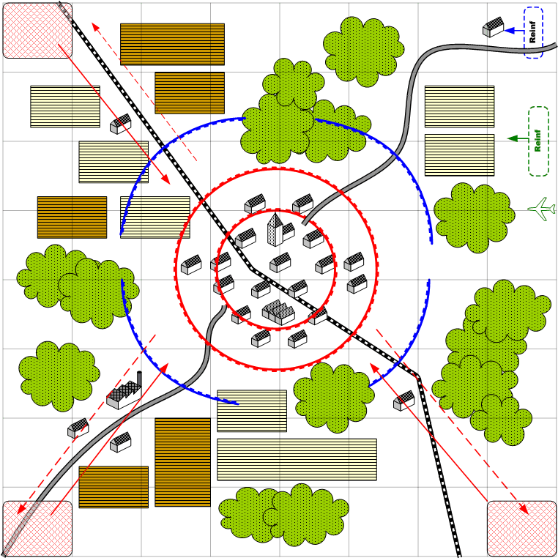

Size: 8x8. Europe Italy. The town in the middle of the map surrounded by the fields and farms.

Mission overview

The starting forces of the player are positioned around the town occupied by the enemy. The adversaries are holding a tight defense. In the briefing the player is let to know that he is to hold the siege until the major forces arrive. The forces of the player are not sufficient for the capture of the town, even when counting the available reinforcements. The goal of the player is to prevent the enemy reinforcements braking through the encirclement. These enemy forces arrive from the three corners of the map. The player has lost when more then two enemy units have reached the town.
The enemy forces inside the besieged town do not take offensive actions against the player.
The mission is won when the allied tanks and bombers arrive at the scene. At that moment the attacks of the enemy end and controlled by a script, the allied bombers destroy the town. Heavy tanks and infantry simultaneously attack. The mission continues at this point so that the player is able to take part in finishing the town garrison.

Player troops
Starting troops:
Infanty, AT guns, light tanks, AAA

Reinforcements.
Middle and Heavy tanks, infantry.

Allied troops
Starting troops:
None.
Reinforcements
Bombers, heavy tanks, assault infantry.

Enemy troops.
Starting troops:
Infantry, AT guns, light tanks and heavy tanks, AAA

Reinforcements
Assault infantry, middle and light tanks.

Objective.

Hold the siege until the main forces arrive.

Recommended number of reinforcement calls: 4

