RUS4.0
«Capture of Berlin»

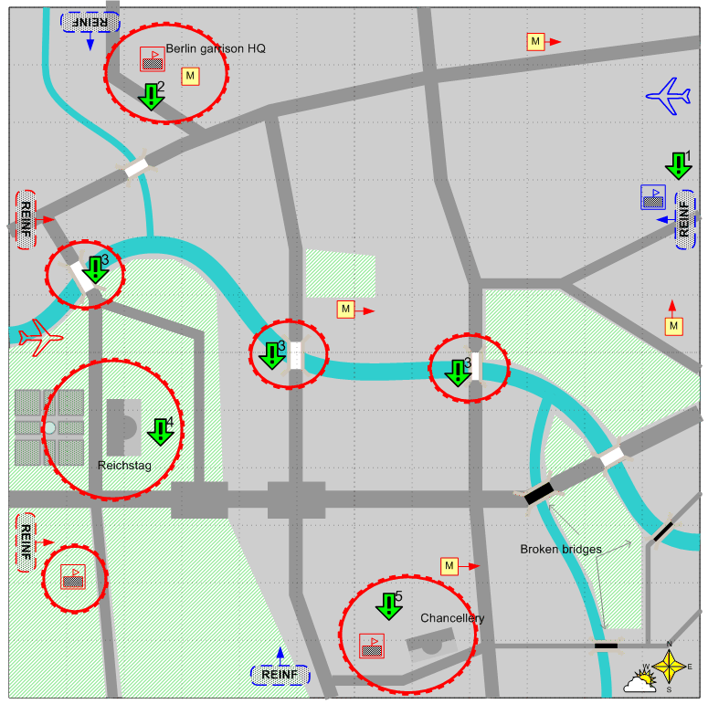

Map Size 12 by 12. Europe. Spring. Cloudy.

Landscape.
All of the map is the streets in the central part of Berlin. Main streets should be layed out according to the dark grey areas on the sketch. The streets should be wide enough to allow easy movement of the groups of armored vehicles. Other streets and blocks can be placed by designer according to her judgement.
Light green areas are primarily parks, Yellow squares with M letter are the entrances to the subway (metro). Only the largest of the enemy defence areas are placed on the sketch. In general there should be plenty fortified positions throughout the city. Many locations should feature the destroyed buildings and the areas that sustained heavy bombing.

Description.

At the start of the map the player will get the first objective – to prevent the enemy from capturing the friendly depot and the starting location of the player. In the different places of the city there are metro stations. Controlled by the script the enemy soldiers appear near the metro stations (arrive through the underground pathways) and attack across the map towards the starting location of the player.
After the first objective is given, the second follows closely – to capture the command post of Berlin garrison. With completing this objectives the attacks from the metro stations stop. After that the player is given objective 3, if he has not captured the bridges already. In mission breefing the player is warned that the enemy is planning to blow up the three bridges across the Shpree river. In 10-15 minutes from the beginning of the mission all the bridges will blow up unless captured. It will be possible to repair them though.
Objective 4 will be given once the 3rd one is either completed or failed, or if at least one player’s land unit is in the Reichstag area. If the player has not completed the second objective, the infinite enemy reinforcements start to arrive to this area, which makes completing this objective impossible.
Objective 5 will be given once the 4th one is either completed or failed, or if at least one player’s land unit is in the Chancellery area.

Loosing condition
The player has no troops and reinforcements.

Winning Condition
Objectives 2, 4 and 5 are all completed.

Recommended number of reinforcements.
16 - 20

Difficulty
High.

Objectives.
- Hold the starting location and the warehouse under control for the duration of the mission.
- Capture Berlin garrison HQ. (It is stated in briefing that capturing this hq will end the attacks of German troops that use underground for movement.
- Capture one of the three bridges across the Shpree river before they are destroyed by the enemy. (This objective is given only if the second objective is completed and none of the bridges are captured by the player yet). This objective can be failed.
- Capture Reichstag.
- Capture Сhancellery.

Player’s troops.

According to the designer’s judgment and reinforcement scheme for the chapter.

Player’s reinforcements.

All available in the chapter.

Allied forces
None.

Allied reinforcements.
None.

Enemy forces.
According to designer’s judgment and reinforcement scheme for this chapter.
A lot of heavy AA and long range artillery. Heavy tanks and SPGs. Infantry with bazookas and flamethrowers.

Enemy reinforcements.
According to designers judgment and reinforcement scheme for this chapter.
Mostly elite infantry and infantry with bazookas. Rarely heavy tanks. Two or three times – scripted aviation attack.

