Russian Campaign, Chapter 4, Mission 0: «Capturing Berlin»
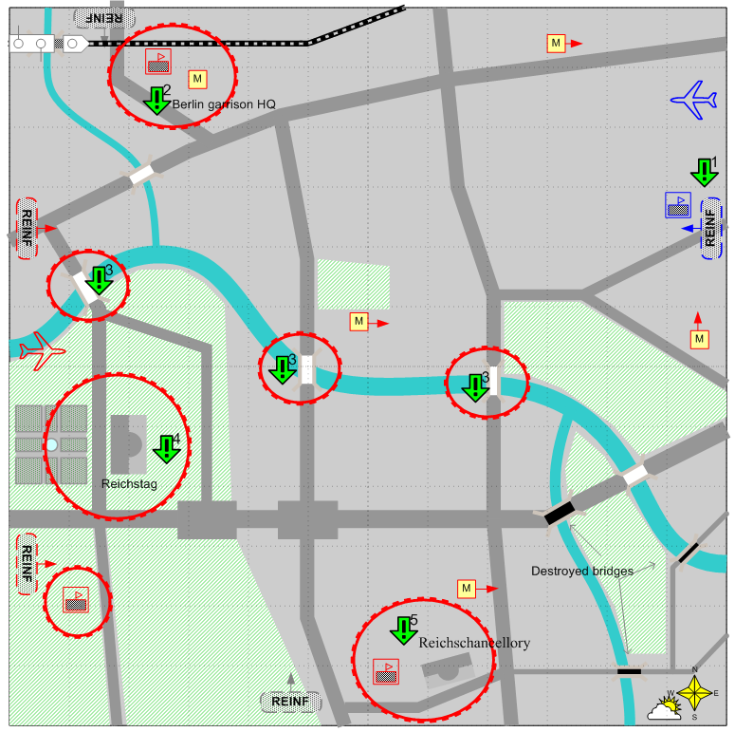

Mapsize 12 x 12. Europe. German. Spring. Clear. Hard.

Landscape

This is the map of the center of Berlin. The main streets must correspond to their position on the sketch (of dark grey) and be wide enough to allow the mechunits groups move along them. The other streets and blocks are to discretion of the designer. The light green zones are mainly parks. The yellow squares with the letter M are metro stations.

Only the main and the biggest defense centers of the enemy are shown on the map. Generally, there must be many fortified points over the entire map. In many places there are destroyed buildings and bombardment traces.

Description

The Soviet troops are entering Berlin. Their goal is to capture the Reichstag and the Reichschancellory.

All Berlin is one big defense zone.

At the rear of the player the German elite forces appear from time to time (rise to the surface from the metro stations scattered over the city).

The enemy shows fierce resistance, using elite forces and heavy mechunits.

Details

When starting the player gets the objective not to allow the enemy to capture their depot and start location 1.

There are metro stations in the different districts of the city. According to the script, in a time period, the enemy’s elite infantry appears in different places (goes out) near metro stations and swarms on the map to the direction of the player’s start location.

After giving objective [1], objective [2] is given – to capture the command post of Berlin garrison. When this objective is fulfilled, the enemy’s attacks from the metro stop. Then the player gets objective [3], if he has not captured any of the bridges earlier. The player is informed in the briefing that the enemy is going to explode three main bridges over the Spree. In 10-15 minutes after giving the objective all the bridges on the map, which have not been captured by the player are destroyed.
Objective [4] is given after fulfilling or failing objective [3] or, in case at least one player’s ground unit is in the Reichstag zone.
You should set the attention zone in the Reichstag district in such a way, that, if the player has not fulfilled objective [2], the extra reinforcements start to enter the zone. In this case it is much more difficult to fulfill objective [4].
Objective [5] is given after fulfilling objective [4] or if at least one player’s ground unit is in the Reichschancellory zone.

According to the script, you there must be several bombing raids (5-6) of the enemy.

Defeat conditions

The player has no forces and reinforcements.

Winning conditions

Objectives 2, 4 and 5 have been fulfilled.

Objectives

- Hold the start location and the depot during the mission.
- Capture the command post of the German Harrison. (The briefing informs that after capturing the command post, the German infantry, using communications and metro stations, will stop attacks).
- Capture one of the three bridges over the Spree before they are destroyed by the enemy. (The objective is given only if objective 2 is fulfilled and none of the bridges has not been captured by the player before that). May be failed by the player.
- Capture the Reichstag.
- Capture the Reichschancellory.

