Authentic map
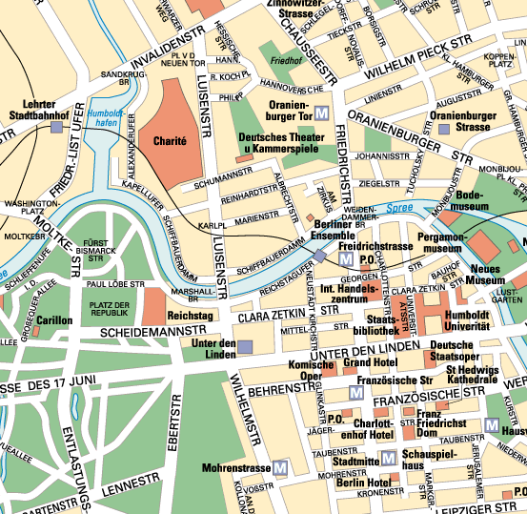
(missinaexemple-010.bmp)

Sketch
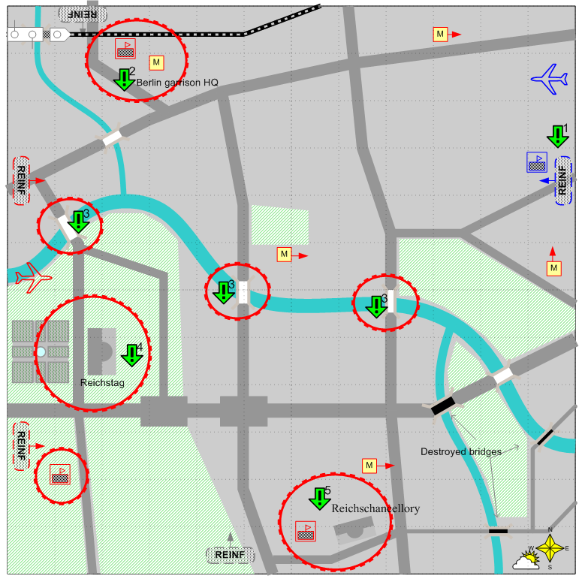
(missinaexemple-020.bmp)

Ingame view
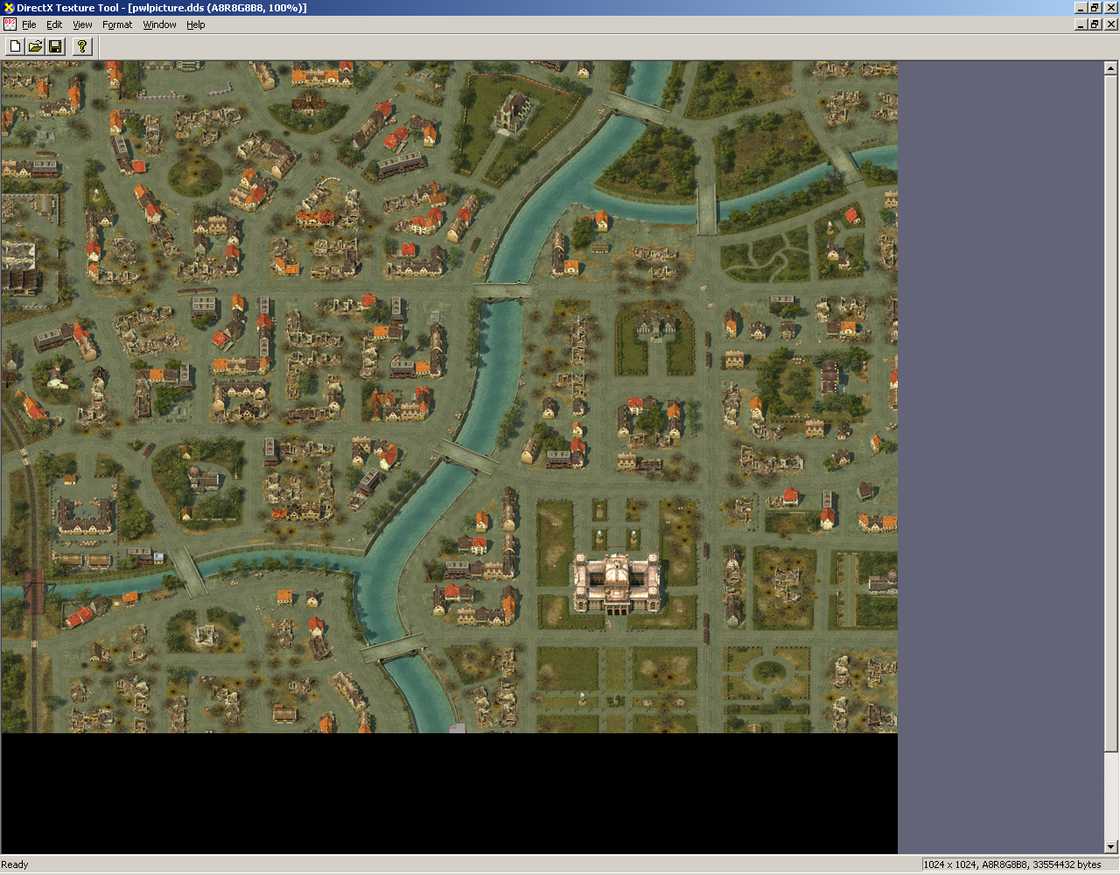
(missinaexemple-030.bmp)

