Chapter 1

1-01 Introduction

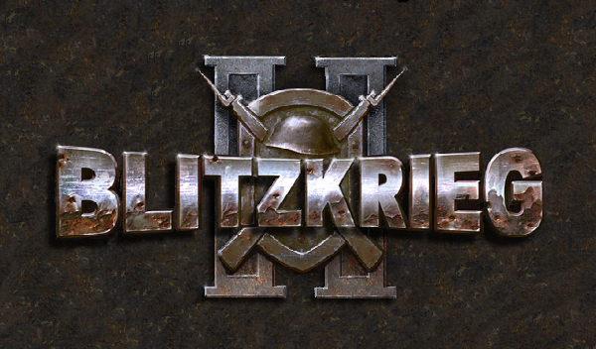
(splash.bmp)

This reference file contains the manual and information on the map editor for the game “Blitzkrieg 2”.

The reference file describes the map editor’s main functions in the sequence recommended for examining the map editor and also creating maps and missions for the game “Blitzkrieg 2”.

After reading this manual you will get to know:

- What can be done with the help of the map editor and its main functions (link 2-01 General information)
- What the map editor’s interface (link 2-03 Interface), its main menu (link 2-04 Map editor’s commands) and toolbars look like
- What tools (link 2-05 Tools) are used for creating maps
- How to fulfill the main repeated actions (link 2-07 Main operations and terms) in the editor and what hot keys (link 2-14 Hot keys) should be used
- How to save (link 2-08 Creating and saving a map ), load (link 2-09 Opening the map for editing ), transfer to each other (link 2-14 Share and transfer custom maps) and run (link 2-13 Running the new map in the game) missions designed in the map editor
- How to set the editor’s appearance (link 2-06 Interface setting), and also filters and tables (link 2-15 Tables and filters)
- What to start with in creating missions (link 3-01 Before you start…) and what the differences (link 3-02 Defining the missions type) between the singleplayer and multiplayer missions are.

Also, you will learn everything about creating maps for “Blitzkrieg 2”:

- How to create a new map, choose the season or the setting and choose players and sides they play for (link 4-01 Creating a new map)
- How to prepare the landscape of the map (link 4-05-1 Preparing the landscape of the map), create heights (link 4-05-3 Designing the terrain) and pattern textures (link 4-05-4 Patterning textures)
- How to place common objects and units on the map (link 4-09 Map objects) and terrain objects (link 4-07 Placing terrain objects), and, also, automatically fill the parts of the area with the flora and terrain patterns (link 4-05-5 Fields)
- How to set start commands for units (link 5-07 - Unit Start Commands) and set their parameters (link 4-12 Objects parameters)
- What players’ parameters consist of and how to set diplomacy (link 5-02 Player’s parameters)

And, of course, the main info, what creation of the complete mission consists of:

- What Map Info consists of (link 4-02 MapInfo) and what useful information it contains (link 4-04 The parameters of the map)
- How to set the weather on the map (link 4-03 Setting the weather) and what it influences
- How to create your own hyper screenshot (link 6-01 Hyperscreenshot) and how to create a minimap (link 6-02 MINIMAP)
- How to attach music (link 6-03 Music) to your map or create your movies on the game’s engine (link 6-06 Script Movie)
- How to set start cameras (link 5-03-1 Setting Start Cameras), players’ positions in the multiplayer mission (link 5-03-2 Setting Multiplayer Start Position) and final points (link 5-04 Final Positions)
- What reinforcements are (link 5-05 - Reinforcements), how to set them (link 5-05-2 Setting reinforcement units parameters) and what reinforcements points are (link 5-05-5 Reinforcement points)
- How to set the computer opponent and what AI General is needed for (link 5-08 – AI General)
- What script is (link 5-12 Making script) in the missions for “Blitzkrieg 2”, why we need script zones (link 5-14 Script Zones) and how to write Objectives (link 5-15 – Objectives)
- Also you will learn the full list of script functions (link ) and our recommendations (link 2-16 Tips when working with the editor) on creating the map.

And, finally:
- In the appendix (link) you can find the sample scenario and sketch of one original Blitzkrieg 2 map, which can be used as a sample for creating your own maps.

1-02 Warning

This manual does not describe 100% map editor’s functions for the game “Blitzkrieg 2”. Mainly, it is connected with the fact, that the map editor is the company Nival’s internal tool and initially was assigned to produce the entire work cycle for the game “Blitzkrieg 2”.

All the commands and tools, which ought to be known and used, when creating maps and missions, are completely described in this manual.

If you want to know how to do something greater than maps and separate missions for the game “Blitzkrieg 2” or you are ready to try yourself in MOD’s creation, you can attend “Blitzkrieg 2”’s official site and forum. The list of all sites and game forums are in the “Blitzkrieg 2” game manual.

1-03 Copyrights and info

Blitzkrieg 2 Map Editor © 2005 Nival Interactive. All rights reserved. Blitzkrieg is a trademark of Nival Interactive.

The following trademarks of other companies mentioning in this manual: Microsoft, Windows, Windows 98, Windows NT, Windows 2000, Windows XP, Visio, Excel, Excel 97, Excel 2000, Excel 2002, UDA, OLE DB and ODBC are registered trademarks of Microsoft Corporation in the United States and/or other countries.

Adobe / Adobe Photoshop and logos Adobe и Adobe Photoshop are trademarks of Adobe System Incorporated.
All other trademarks are the property of their respective owners.

Chapter 2

2-01 General information

The map editor is used for creating and editing maps for the game “Blitzkrieg 2”. However, maps from the game “Blitzkrieg” (published in 2003) cannot be opened and edited with the map editor.

Every map for the game “Blitzkrieg 2” is the set of files, kept in one folder (as a rule, the name of the folder is the name of the map/mission, given when creating the map). Generally, these files contain information in XML format, but there are some binary ones (for example, a minimap), too.

The key file, containing the main information about the map and used when loading as in the editor and also in the game, is “mapinfo.xdb”.

The folder with the files ought to be located in “<Blitzkrieg 2_Game>\Data\Custom\Mission\<Your_Map_folder>” so that the editor and the game can find it and load maps for editing.

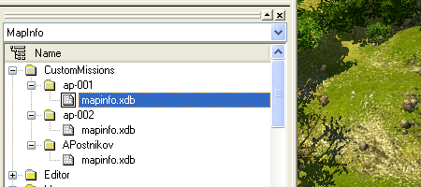
(Intro-020.bmp)

Yet, the editor will not see the map if is not indexed (all the maps, you are creating on your computer, are indexed automatically and are available in your editor). Maps, created on your computer or indexed, are available in the table Mapinfo and can be opened in the editor.

(I)You can open all the maps of the chapters and campaigns of the game “Blitzkrieg 2” in the editor – they have already been indexed. However, you can edit these maps only if you have data.pak unpacked.

See Chapter 2-10 “Indexing a map” for more information on indexing and opening a map, created by the other user, in the editor.

2-02 Working with the map editor

In the Blitzkrieg 2 editor there are three main ways to work with the data: using different menus, toolbars or context menus.

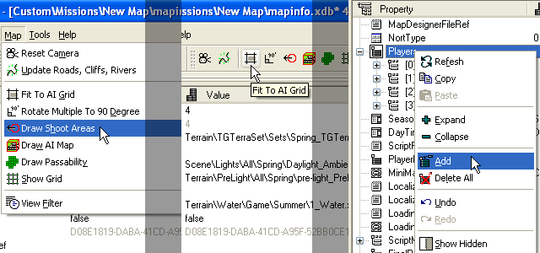
(Intro-025.bmp)
(the menu) (the toolbar) (the context menu)

All these methods almost entirely duplicate each other. But some commands appear only in the certain map editors working modes – for example, when working with terrains, objects on the map (units, building etc.), in properties tables etc.

Besides, there are some info windows and Tools Window, including the main tools for working with the map.

2-03 Interface

The map editor interface for the game “Blitzkrieg 2” consists of:

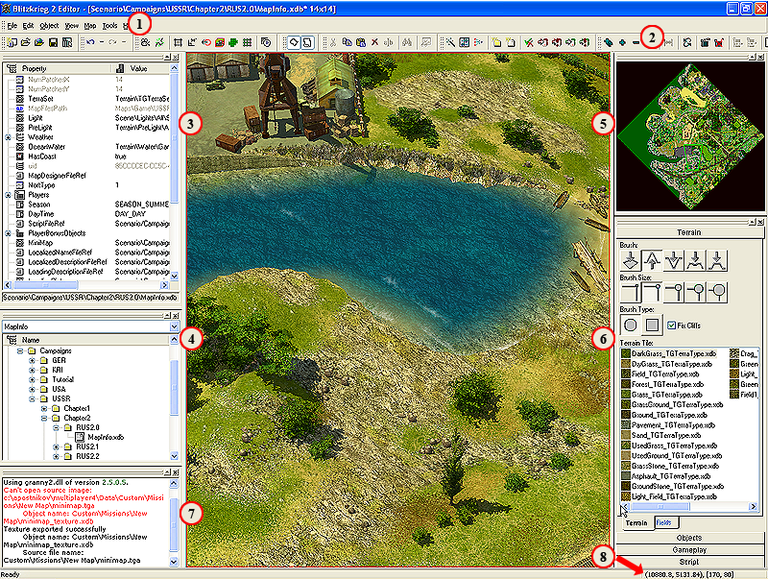
(Intro-030.bmp)

- Different menus
Several menus contain all the necessary commands for working with the map editor.

- Toolbars
Toolbars display icons of the commands, duplicating commands in different menus. You can hide or show toolbars choosing the options in the menu View.

- Selection Property Window
This window displays properties of the selected or chosen object. As a rule, these are properties of the map and units / buildings. You can hide or show windows choosing the options in the menu View.

- Game Database Window
This window displays the list of the objects in the current game’s data table. As for the map editor – it displays the list of maps, indexed by the editor.

- Minimap Window
The window with the minimap. It displays the sketchy view of the terrain’s peculiarities in the current map.

- Tools Window
The window with the main tools, used when creating and setting the map. It contains tools Terrain, Objects, Gameplay and Script (for details see Chapter 2-05 “Tools”).

- Log Window
The window with the editor’s work log. It records the operations, such as opening and saving a map, creating a minimap and a hyper screenshot, and also about all the errors occurred in the editor’s work.

8. Coordinates
The current cursor coordinates are displayed here (both in pixels and tiles).

2-04 Map editor’s commands

Before you start working with the Blitzkrieg 2 map editor, you should get to know the structure and functions of the Blitzkrieg 2’s main commands and tools.

Important Note: This manual describes only the commands used for creating maps and missions.

2-04-1 Menu File commands

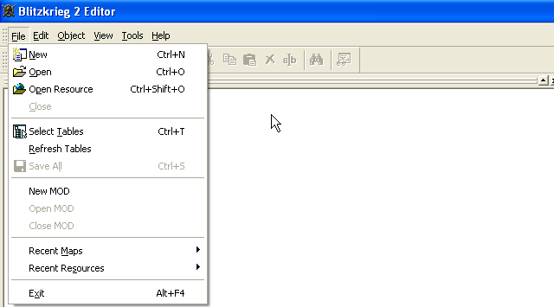
(Menu-010.bmp)

New – create a new Blitzkrieg 2 map
Open – open a Blitzkrieg 2 map
Close – close a current map (if the map has changes, which were not saved, the dialogue window will appear suggesting that you should save the changes)

Save All – Save all the data (a map, object’s properties etc.)

Recent Maps – the list of the links to the maps created/edited earlier
Recent Resources - the list of the links to the resources created/edited earlier (set for MOD’s creators)

Exit – exit the editor (if the map has changes, which were not saved, the dialogue window will appear suggesting that you should save the changes)

2-04-2 Menu Edit commands

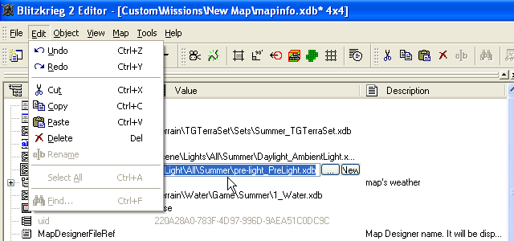
(Menu-020.bmp)

Undo – Undo the last action. This command works only with the objects and when changing the terrain
Redo – Repeat the last action (works in the same cases as Undo)

Cut – Cut (copy and delete) the resource / object / value
Copy – Copy the resource / object / value
Paste – Paste the copied resource / object / value
Delete – Delete the resource / object / value
Rename – Rename the resource / object / value

2-04-3 Menu Object commands
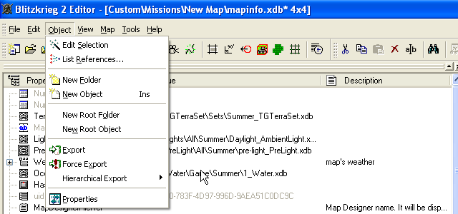(Menu-030.bmp)

Edit Selection – Open for editing (edit) the object / resource

New Folder – Create a new folder
New Object – Create a new object / resource

Export – Export the texture into the data file (used when creating the screenshot)

Properties – Open the properties of the current map (in Selection Property Window)

2-04-4 Menu View commands
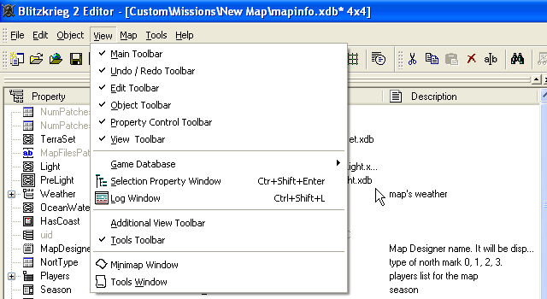
(Menu-040.bmp)
Main Toolbar – Show / hide the main toolbar
Undo / Redo Toolbar – Show / hide the Undo / Redo toolbar
Edit Toolbar – Show / hide the Edit toolbar
Object Toolbar – Show / hide the Object Toolbar
Property Control Toolbar – Show / hide the Property Control Toolbar
View Toolbar – Show / hide the View Toolbar

Game Database – Open / close Game Database Window
Selection Property Window - Open / close Selection Property Window
Log window - Open / close Log window

Additional View Toolbar – Show / hide Additional View Toolbar
Tools toolbar – Show / hide Tools toolbar

Minimap window - Open / close Minimap window
Tools Window - Open / close Tools Window

2-04-5 Menu Map commands
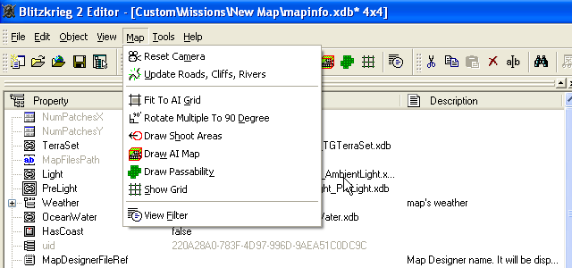
(Menu-050.bmp)
Reset Camera – Return the camera (the angle, height and orientation) to the standard position over the map.
Update Roads, Cliffs, Rivers – Allows to solve the problem of showing the vector objects on the map with compulsory re-render.

Fit to AI Grid – When placing Map objects (except units), “stick” to the mesh point (Grid) in the mode AI Tile.

(I) This option is necessary when placing buildings and other objects on the map, which can be obstacles for the units on their way. If this option is off – the objects can be moved on the map by pixel.

Rotate Multiple To 90 Degree – When orienting the map objects (except units) they rotate by 90 degrees.

Draw shoot areas – Show unit’s fire range and area
Draw AI Map – Show units’ borders as they are recognized by AI.

(I) As the complicated geometry of the objects in the game, AI recognizes them not by the form of the object, but by the special form, shown especially for AI.

Draw Passability – show the parts of the terrain impassable for the ground units
Show Grid – Show grid (the grid tile modes can be set)

View filter – Open the filters’ setting window

2-04-6 Menu Tools commands
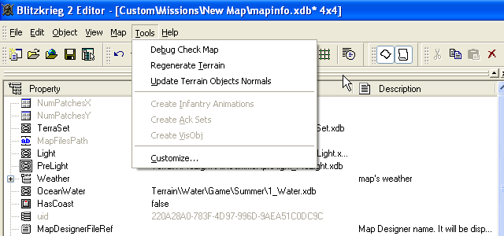
(Menu-060.bmp)

Regenerate Terrain - Allows to solve the problem of showing the heights on the map with compulsory re-render.

Customize – Customize toolbars.

2-04-7 Objects Properties

The command “Show the selected object properties” (equivalent to pressing the key Enter) is available only in the toolbar and marked with the icon shown.

(Menu-070.bmp)

2-05 Tools

The main tools necessary for creating maps and missions are in Tools Window. If you cannot find Tools Window after running the map editor – try to run it with the help of the menu View or the icon on Toolbar.

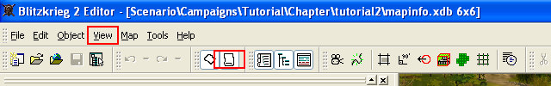
(Tools-010.bmp)

Tools Window includes several main sections with the tools grouped as:

2-05-1 Terrain

The tools section for working with the terrain.

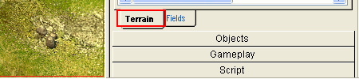
(Tools-020.bmp)
The tab Terrain includes tools changing heights on the map and patterning certain textures types on the surface parts (for details see Chapter 4-05-2 Preparing the terrain of the map ).

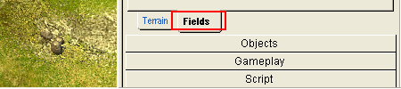
(Tools-030.bmp)
The tab Fields allows to create a lot of different automatically generated fields with the patterns available (for details see Chapter 4-05-5 Fields ).

2-05-2 Objects
The tools section for placing common objects or units and terrain objects (VSO) on the map.

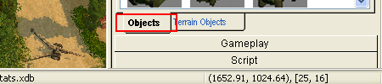
(Tools-040.bmp)
The tab Objects allows to place all map objects, which do not require additional setting of the shape and etc., on the map – i.e. all unites types, buildings, fortifications, bridges, simple objects, flora etc. (for details see Chapter 4-10 Placing objects on the map ). Within this manual, they are called map objects for convenience.

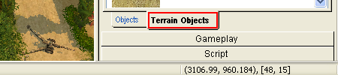
(Tools-050.bmp)

Terrain objects tab allow to place Terrain objects – the main landscape modifiers in Blitzkrieg 2. Terrain objects are also called Vector Stripe Objects or VSO - i.e. objects, whose shape and some parameters require additional configuration, when being placed on the map: rivers, roads, lakes, cliffs and a coast (for details see Chapter 4-07 Placing terrain objects)..

2-05-3 Gameplay
The tools section for setting Reinforcement Points, Start Cameras, AI General and Unit Start Commands.

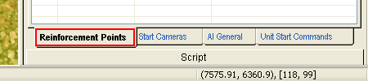
(Tools-060.bmp)
The tab Reinforcement Points allows to place and set the reinforcements points (for details see Chapter 5-05-5 Reinforcement points ).

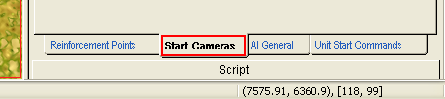
(Tools-070.bmp)
The tab Start Cameras is necessary for placing start cameras on the map – coordinates and positions, in which players of the different sides (teams) will start the game (for details see Chapter 5-03-1 Setting Start Cameras ).

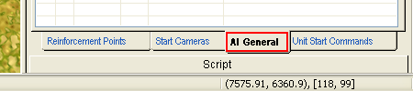

(Tools-080.bmp)
The tab AI General allows to set the computer opponents’ (called AI General) actions and attention zones (used for designing singleplayer missions) (for details see Chapter 5-08 – AI General ).

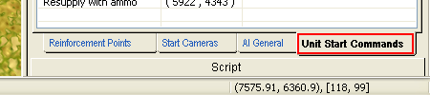
(Tools-090.bmp)
The tab Unit Start Commands allows to assign the starting commands to the units on the map – i.e. commands, which will be executed by these units immediately after starting the mission (used, mainly, when designing singleplayer missions) (for details see Chapter 5-07 - Unit Start Commands ).

2-05-4 Script
The tools section for placing and setting Script Areas and Script Movies on the game’s engine.

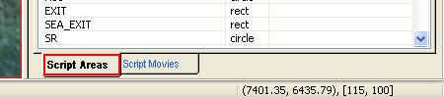
(Tools-100.bmp)
The tab Script Areas allows to place the certain areas on the map, which will be used afterwards when scripting missions (used, mainly, when designing singleplayer missions) (for details see Chapter 5-14 Script Areas ).

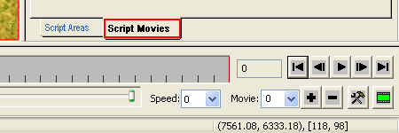
(Tools-110.bmp)
The tab Script Movies allows to create a script movie on the game's engine. Switching to this tab opens the special keyframes editor and camera’s positions, where the user can set the keyframe sequence and set the position and orientation of the camera in every keyframe (for details see Chapter 6-06 Script Movie ).

2-06 Setting Interface

What is comfortable when working with a program is individual for every user. So, in Blitzkrieg 2 map editor every user can set the view, the size and position of all main windows (Selection Property, Game Database, Minimap, Tools and Log) according to his preferences.

To change the position of the window – point the cursor at the two stripes at the top.

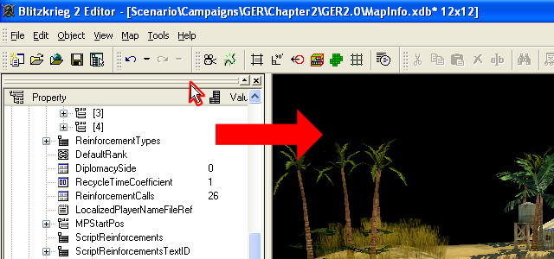
(GettingStarted-010.bmp)
Pressing and holding LMB drag the window to any convenient place of the editor workspace. When approaching the borders of the workspace the window will stick to it taking the optimal form.

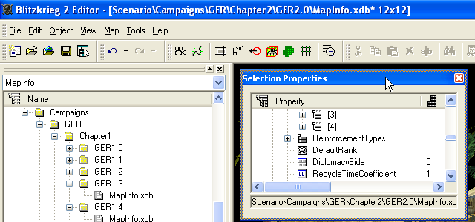
(GettingStarted-020.bmp)
And when moving away from the borders of the workspace there will be the separate window.

To change the sizes of the window pull one of the borders to any direction.

Besides, you can maximize / minimize or close the window with the buttons in the top right corner of every window.

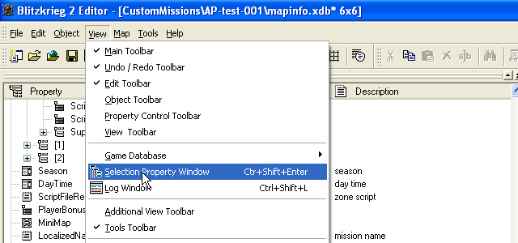
(GettingStarted-030.bmp)
All windows are shown / hidden also with the help of the menu.

2-07 Main operations and terms

When you are working in the map editor you will often have to fulfill the same operations.

2-07-1 Create a new object (file) for a parameter

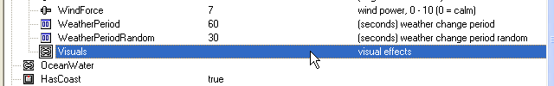
(GettingStarted-040.bmp)

To create a new object (file) for a parameter choose the line with this parameter...

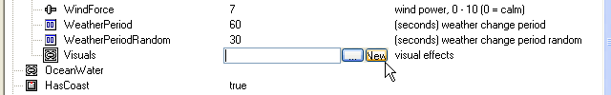
(GettingStarted-045.bmp)

... and left-click in the column Value. Two buttons will be displayed – the ellipsis and New. To create a new object / file press the button New.

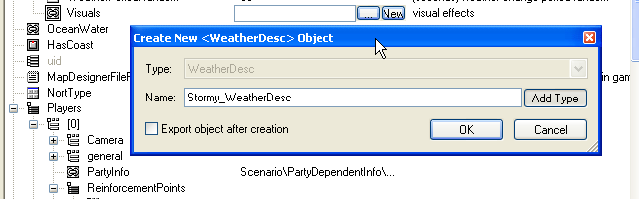
(GettingStarted-060.bmp)

The new window will be displayed, in which you should enter the name of the new object (file name).

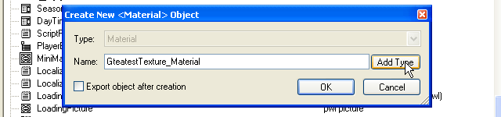
(GettingStarted-080.bmp)

If you press the button Add Type, the type of the object (file) will be added to the name automatically.

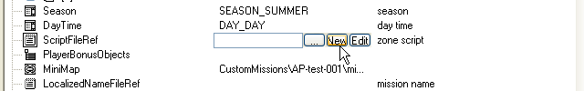
(GettingStarted-050.bmp)

In some cases the third button “Edit” is added. It means that this file can be edited with the internal text or script editor.

2-07-2 Select the path to the object (file) for a parameter

If you do not want to create a new object (file) and just want to choose the object (file), which already exists, choose the line with this parameter and left-click in the column value. Two buttons will be displayed – the ellipsis and New.

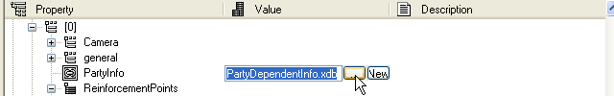
(GettingStarted-090.bmp)
To open the window with the list of the objects (files) of this class available press the ellipsis.

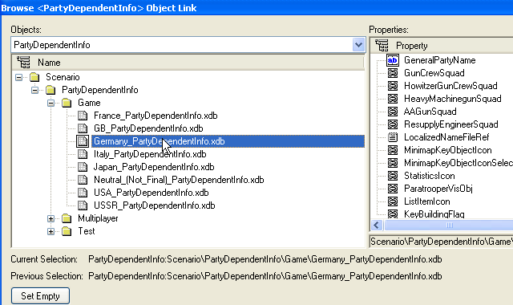
(GettingStarted-100.bmp)
In the left part there is the tree with the list of the objects (files) of this class.
Choose the one you want and press OK.

2-07-3 Editing the value of the object (file) parameter

If you want to change properties of the object (file) for some parameter, it must be opened for editing. The steps are the same as indicating the path to the object (file). (see above)

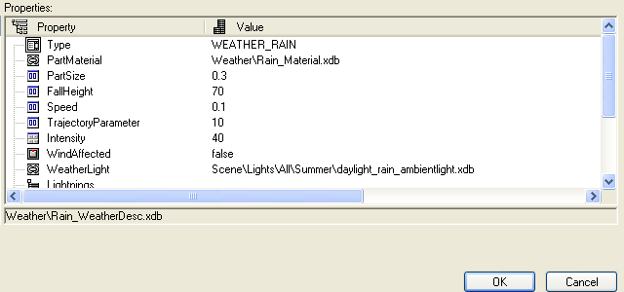
(GettingStarted-110.bmp)

In the window of choosing objects (files) displayed the window of the object (file) properties is on the right.

Sometimes when setting and editing parameters of the object (file) you may need to open the subordinate objects (files) for editing. (For example – see Chapter 6-03 Music)

2-07-4 Using context menu

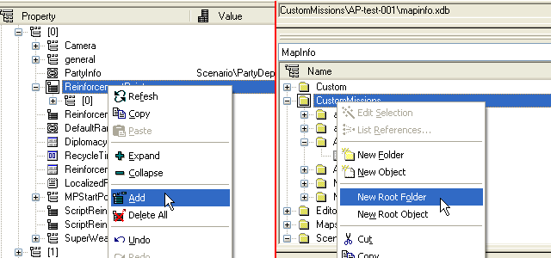
(GettingStarted-120.bmp)

When working with the map and objects properties you often have to add / delete parameters and objects and also to minimize (Collapse) and maximize (Expand) their lists. Use the context menu to do it. To call up the context menu choose the field with the parameter you need and right-click on it. In the menu displayed choose the operation you need.

2-07-5 Choosing or entering the parameter

Also, when working with different properties and parameters of the map or objects you often need to enter or choose the value of these parameters in letters / numbers.
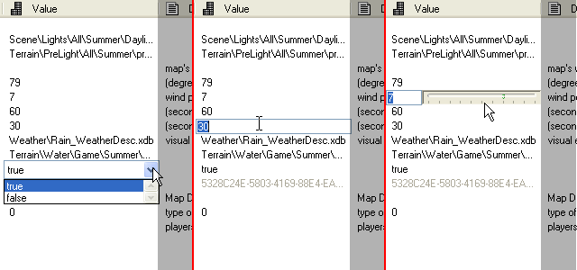
(GettingStarted-130.bmp)

You can do it with the jump-menu, type the value or choose it with a slider.

Choose the parameter you need and left-click in the column Value of the corresponding line. After that choose the value in the jump-menu or with the slider. Or just type it.

2-08 Creating and saving a map

For creating a new map choose the item New in the File menu or press the keys [Ctrl]+[N].

To save the current map and all changes that have been done choose the item Save all in the File menu or press the keys [Ctrl]+[S].

2-09 Opening the map for editing

To open the map already created for editing – it must be in the maps and missions list (Game Database Window).

If the map you need is in the list – just double left-click on it. Also, you can open the map through the item Open in the menu File or with the keys combination [Ctrl]+[O]. When opening the map with the help of the menu or keys combination – the window with the list of all maps known to the editor will open.

If in the maps list, known to the editor there is no map you need, it means that it has not been indexed and put in the files list, used by the editor. How to index the map, see the next chapter – Indexing maps.

If at the moment you are opening the map you have already the other map opened – you will be offered to save all the changes made on the current map.

2-10 Indexing maps

You can index the map in two different ways.

Variant 1:

Put the map folder into the Data folder of Blitzkrieg 2 game so that the path looks as follows: “<Blitzkrieg 2_Game>\Data\<Your_Map_folder>”.

Make sure the map folder contains the file “mapinfo.xdb”.

Open the map editor and Windows Explorer.

Drag the file “mapinfo.xdb” from Windows Explorer to the map editor workspace. Save the map. After that the new map will be automatically indexed and afterwards it will be available in the list of the maps indexed.

Variant 2:

Put the map folder into the Data folder of Blitzkrieg 2 game so that the path looks as follows: “<Blitzkrieg 2_Game>\Data\<Your_Map_folder>”.

Make sure the map folder contains the file “mapinfo.xdb”.

Find the file “dbindex.bat” in the folder “<Blitzkrieg 2_Game>\Data\” and run it. After that all files in the folder “<Blitzkrieg 2_Game>\Data\” will be indexed again and all new maps will be available in the map editor for editing.

2-11 Exiting the editor

To exit the editor – choose the item Exit in the menu File or use the keys combination [Alt]+[F4].

When exiting the editor you will be offered to save all the changes made on the current map.

2-12 Links history

When working with files the map editor saves all links history of the maps opened before. You can load any of the maps opened earlier, choosing them from the list (the item Recent Maps) in the menu File on the condition that the map opened was not renamed or removed.

2-13 Running the new map in the game

To run the map created before is possible in two different ways:

Variant 1:

If the map created in the editor or the map folder are in <Blitzkrieg 2_Game>\Data\Custom\Missions\<Path_to_Your_Map_folder>, it can be run with the help of the menu item Custom Missions, available from the main game menu.

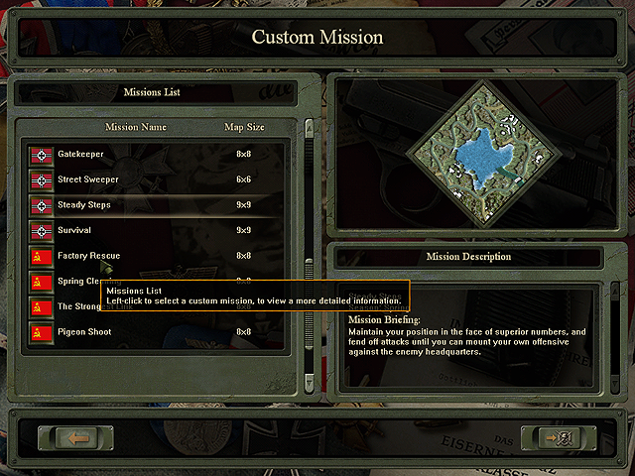
(GettingStarted-140.bmp)

When choosing the item Custom Missions in the main game menu the window of choosing users maps is opened. Choose the map and run it, pressing OK.

Variant 2:
To run the mission in “Blitzkrieg 2” game created in the map editor before do the following (the map folder must be in the folder “<Blitzkrieg 2_Game>\Data\Custom\Missions\<Path_to_Your_Map_folder>”):

- Run “Blitzkrieg 2” game
- In the main menu open the console with the help of the key tilde (~)
- In the console displayed type (without quotes) the command “map” (in lower-case) and the path to your map, beginning with the folder which is the first after the folder Data. You will get something like this: “map Custom\Missions\MyTestMap-003\mapinfo.xdb”
The full path to this map will be as follows:
“C:\ Blitzkrieg 2\data\Custom\Missions\MyTestMap-003\mapinfo.xdb”
- After pressing the key Enter the map will be loaded. If you have not done the hyper screenshot for your map yet– the map will be loaded with the standard hyper screenshot.

2-14 Share and transfer custom maps
If you want to share a map you’ve created with your friends or publish it on an Internet resource, dedicated to Blitzkrieg 2, you must pack the whole folder with your map (or mission)

For example, if you’ve created the map that is located in «C:\ Blitzkrieg 2\data\Custom\Missions\MyTestMap-003\» folder, you must pack the whole contents of the folder. Make sure, that no files are missed, especially – mapinfo.xdb.

You can send the archive that you’ve made to your friends or publish it in the Internet.

2-15 Hot keys

When working with the map editor some actions are easier to fulfill with the help of hot keys. Here are the keys combinations, which will be useful when creating maps.

[Ctrl]+[N] – create a new map
[Ctrl]+[O] – open the map created and indexed before
[Ctrl]+[S] – save all the changes on the map
[Alt]+[F4] – save all the changes on the map and exit the editor

[Insert] – insert an object, value (file name), control point
[Delete] - delete an object, value (file name), control point
[Home] – unlink objects

[Enter] – open object properties (unit / building etc.) in the Selection Property Window / Complete creating VSO or Field

[Ctrl]+[C] – copy the value (file name)
[Ctrl]+[V] – insert the value (file name)

[Ctrl]+[Z] – undo the last change (only when working with objects and the terrain)
[Ctrl]+[Y] – redo the last change if it has not been cancelled before (only when working with objects and the terrain)

[Ctrl]+[Shift]+[Enter] – show / hide Selection Property Window
[Ctrl]+[Shift]+[B] – show / hide Game Database Window
[Ctrl]+[Shift]+[L] – show / hide – Log Window

When working on the map you can use the left key ALT and the mouse cursor for rotating the map.

Moving the mouse when pressing RMB you can zoom in and out.

The unit and the object will be linked if you drag the unit on the object (or the vehicle) when pressing the key Shift.

2-16 Tables and filters

The experienced users can use the opportunity to set the filters and additional database tables.

2-16-1 Game Database Tables
Game Database Tables – all the game data are sorted out in types. For example, when you are editing the map, you automatically work with the table MapInfo. You can work with many other objects and data types of “Blitzkrieg 2” game in the same way.

Important Note: We recommend only experienced users to work directly with the tables, as in the working process the game data can be changed, what can lead to the incorrect game’s or users map’s functioning.

As it is recommended only to the experienced users to work with the data through Game Database Tables, this manual does not contain the descriptions of the tables and data types. You can change them at your own risk.

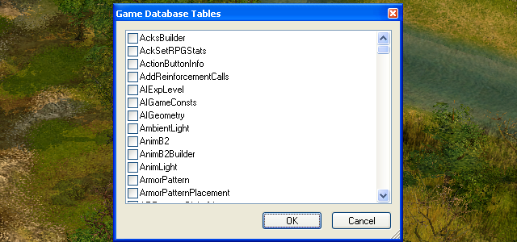
(GettingStarted-150.bmp)
To call up the Game Database Tables of Blitzkrieg 2 press the key combination [Ctrl]+[T], alternatively, use the command Select Tables in the menu File or its analogue on the toolbar.

To use the table with one or the other data type put a tick in the corresponding line.

2-16-2 Filters
When creating and editing maps you can use the opportunity to work with objects filters and map’s properties. Also you can turn on and set the Grid according to your needs – when working with the terrain and placing objects on the map.

To call up the window of filters setting choose the line View Filter in the menu tools or use the button on the toolbar.

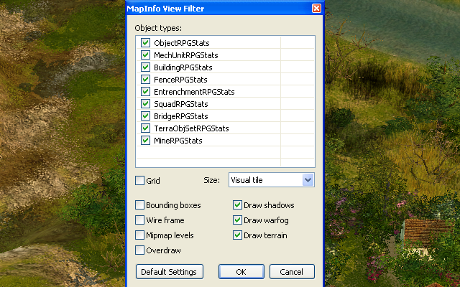
(GettingStarted-160.bmp)
In the window displayed you can turn on the filters of the objects visible on the map:

Object – turn on / off all the simple objects, including Flora.
MechUnit – turn on / off all the vehicles
Building – all the buildings
Fences – all the fences
Entrenchments – the entrenchments
Squad – the personnel
Bridge – the bridges
Terra – the spots of the terrain
Mine – the mines and mine fields

Besides filters, you can turn on or off the Grid for different objects and switch it to on the Tiles menu – Visual tile or AI tile. It is convenient, for working with the terrain and when placing objects.

2-17 Tips when working with the editor

General tips.

- Often save your map.
- Check passability on the map.
- When placing objects on the map do not forget to optimize your map. For example, you should not cover the map 14 by 14 with a thick layer of grass even it is the jungle. The grass will not be seen under the trees.
- A great number of the forces densely deployed on the map will not guarantee that the mission will be interesting, but it will be complicated and slow.
- Before placing cliffs it is more reasonable to make a hill first and then to surround it with the cliffs.
- If at the start of the mission the air force must be on the map, you can just place aircraft on the map and set start command for them. For example, it is suitable for placing the recon aircraft.
- If the game hangs right after the loading the mission, the most probably it is because of the script. Unfortunately, despite the syntax check, the editor cannot reveal errors.
Chapter 3

The optimal order of the stages for creating a map (mission) can be arranged based on the experience of “Blitzkrieg 2” maps creation:

Preparation (defining the type, scenario, map, sketch)
Creation of the map (terrain, VSO, settlements)
Creation of the mission (players’ parameters, units, reinforcements, AI General, scripting)

The following information on maps and missions creation lists these stages in the order given.

3-01 Before you start…

So, before starting to work with the editor, some preparation must be done.

It consists of the following stages:

- Define the type of the mission
- Make up the scenario of the mission
- It is advisable to find the map of the area or the historic map (if the mission is based on the historic events)
- Draw the sketch of the mission (you can use the programs such as Microsoft VISIO ™ and others)

This preparation allows to solve a lot of questions, appearing in the process of creating a map and not to waste time on doing the same thing many times.

3-02 Defining the missions type

Before you start to create a map you should define the future missions’ type.

The first question – if it is a single player or a multiplayer mission?

The multiplayer mission assumes less amount of setting without such work as setting AI General and scripting missions. In any case it is unlikely to make a great map in just one hour. A long tuning and balancing procedure will be required.

The single player mission, as a more complicated one, assumes more amount of laborious work. But single player missions stand out against a background of numerous multiplayer missions.

Thus, we choose:

The multiplayer mission
or
The single player mission

If you choose the single player mission, you have to decide if you keep to the historic events:

The historic mission is entirely based on the historic events and follows the known facts about this event (the troops ratio for all sides, the sequence of main events, the terrain etc.).
The alternative (hypothetical) mission is based on the historic events, but something like “if the Fifth Cavalry meet Guderian’s iron fist …”

The fictitious mission is an entirely imaginary mission, based on the fabricated events.

After defining the missions’ type you can proceed to the next stage.

3-03 The scenario of the mission

When creating any mission even the multiplayer one you have to be aware of the events and their sequence happening on the map. The scenario can help you to do it.

After describing the main objects and units on the map, main terrain elements and the sequence of events in the mission the map designer can see if the idea is viable and define the priorities.

The scenario allows to plan the events in the mission and understand if it will be interesting for the player to participate in the events occurring.

(I) You can view the example of mission scenario for Blitzkrieg 2 game in the appendix.

3-04 The map

In case you are making a single player or a multiplayer mission based on the historic events, it will be useful to find an authentic map of the area where these events happened or the map with the positions and directions of the main blows and forces movements within this historic events.

Generally speaking, transferring the topography of the real area (corresponding to the historic events or not) simplifies the map creation process. So, even if you are creating an imaginary mission, try to find the topographic or geographic maps something suitable among the topographic or geographic maps. It is desirable to keep a reasonable compromise between a real map and the map used in the game.

(I) You can view the example of the used map and the result in the appendix.

3-05 The mission’s sketch

In any case, if you find a real map or not, you have to make a sketch of the mission. You should mark the main terrain elements, forests and settlements, the key buildings and reinforcements points and also plan the missions’ objectives and position of the units of all sides, participating in the mission.

Sometimes you have to create several sketches, which show the stages of the situation development on the map and allow to plan the sequence and correlation of the script events, the conditions of the victory and defeat.
(I) You can view the example of the mission sketch in the appendix.

