Chapter 6
6-01 Hyper screenshot

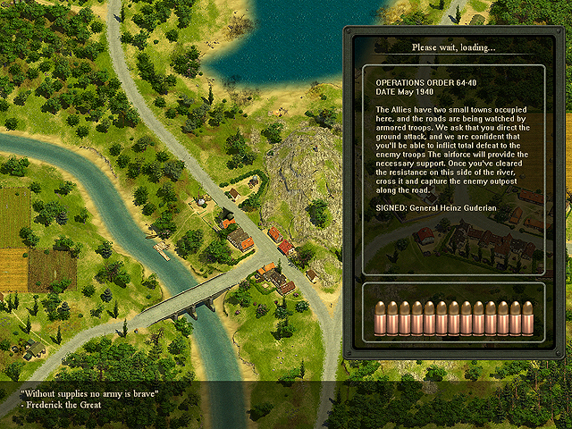
(Hypershot-010.bmp)
Every mission always starts with loading a hyper screenshot, which displays the entire map without mechunits and squads. It allows to use the idle time while the map data are being loaded.

6-01-1 Creating a hyper screenshot
To create a hyper screenshot you should fulfill the following actions in order (preferably on the ready map):

- Run Blitskrieg 2 game.
- In the main menu open the console with the key tilde (~).
- In the console displayed type the command “map” (in lower-case without quotes) in the command line and the path to your map, beginning with the folder, which is the first after the folder Data. You will get something like “map CustomMissions\MyTestMap-003\mapinfo.xdb”. The full way to this map is as follows: “C:\b2\data\CustomMissions\MyTestMap-003\mapinfo.xdb”.
- Press Enter and loading your map will begin. If you have not made your own hyper screenshot for your game, the map will be loaded with the standard hyper screenshot.
- After loading the map (it is loaded as any other mission in the game), call up the console again.
- In the command line type “pwl_prepare 90” – this command will automatically display the map and set the camera in the coordinates needed to start creating a hyper screenshot. Note: You can set any angle, but 0, 90, 180, 270 are recommended. After that you should not move the mouse, rotate the map or move the camera over the map – it will break the camera setting for creating a hyper screenshot.

(I) Hypershot is created with taking a screenshots of the entire map. Usually it takes from several seconds to several minutes (depending on the size of the map and you computer’s processing speed)

- Hide the console, pressing the key tilde (~).
- Press the keys Left Shift + Left Control + Print Screen to start the process of creating a hyper screenshot.
- The result will be saved in the folder <Brlitzkrieg2>\Data\ScreenShots as “mapshot-2005.05.24-13.48.42.tga” – i.e. the name of the screenshot, the time and date of its creation.

6-01-2 Processing and adjusting the hyper screenshot
To integrate you hyper screenshot in your map successfully you should accomplish several operations on the image in the raster editor (for example, Adobe Photoshop®).

- Run the raster editor and open the file of the hyper screenshot you created.

(I) Note – the hyper screenshot created has very large measurements and takes much space. For normal integration in the map it must be made smaller and adjusted to the certain parameters.

- Create two templates (new files) in the raster editor: one with the measurements 1024 by 768 pixels and the other 1024 by 1024 pixels.

(I) The texture of the hyperscreenshot must be 1024 by 1024 and Blitskrieg 2 game interface is 1024 by 768 pixels. I.e. the part of the screenshot to be seen is 1024 by 768 pixels.

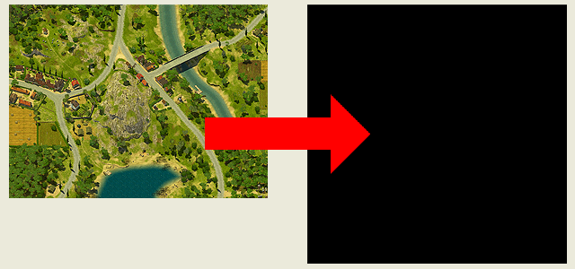
(Hypershot-020.bmp)

  - To display your screenshot correctly in the game you should adjust the hyper screenshot to the measurements 1024 by 768, having placed it on the texture of 1024 by 1024 pixels.

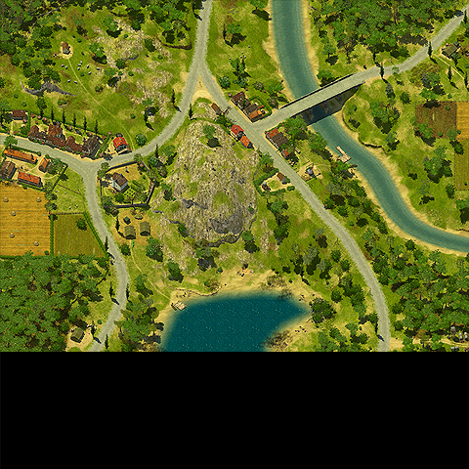
(Hypershot-030.bmp)

4. Having decreased the measurements and adjusted the screenshot to the template, save it in tga format as, for example, Gipershot-MyTestMap-003.tga in the folder with your map or the folder data\UI\LoadingPictures\.

6-01-3 Integration of the hyper screenshot in the map
Thus, the hyper screenshot for your map has been created. Now you should integrate it in the map.

Take the following steps to do it:

- Run Blitskrieg 2 map editor, switch to the map.

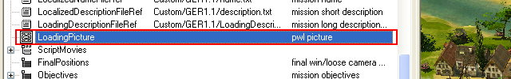
(Hypershot-040.bmp)

- Find the line LoadingPicture in the map properties.
- Click in the column Value to display the field for choosing the file.

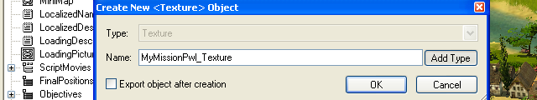
(Hypershot-050.bmp)

As we are creating a new map – you should create an XDB file, in which the texture with the hyper screenshot for your map will be saved.

  - Create a new file for the hyper screenshot.
  - In the window displayed enter the file name (for example, “MyMissionPwl”) and press OK. If you press the button “Add type”, the file type will be added automatically to your file name (in this case it is“Texture).

(I) pwl stands for Please Wait Loading.
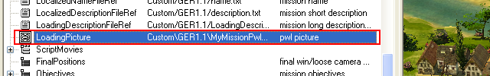
(Hypershot-060.bmp)

Now the path to the file in your map folder is displayed in the window of choosing the file with hyper screenshot texture. We need to export the texture (hyper screenshot), created before, to this file.

  - Press the button with the ellipsis located after the path to the file with the hyper screenshot to do it.

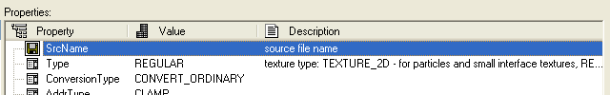
(Hypershot-070.bmp)

In the window displayed you will see the path to the file with the texture (the field ScrName) and the list of parameters (their setting will be described below).

(I) The hyper screenshot is the certain type of textures, which requires the number of parameters, so do not forget to set them correctly.

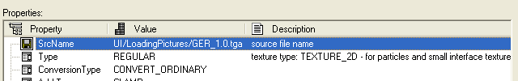
(Hypershot-080.bmp)

7. Choose the path to the file with the texture.

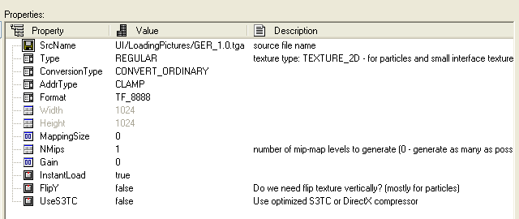
(Hypershot-090.bmp)

8. Set the parameters according to the pointed template (these parameters are needed to display this textures type correctly).

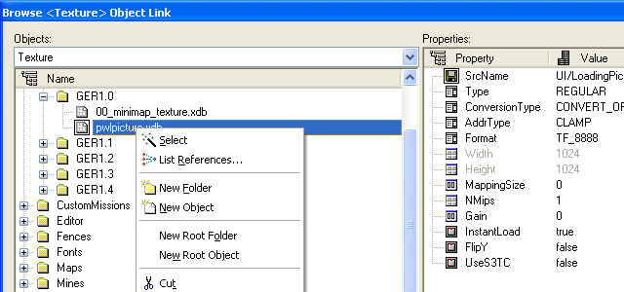
(Hypershot-100.bmp)

9. Now, WITHOUT CLOSING the window with parameters of hyper screenshot textures, choose the file name, where the hyper screenshot is saved and call up the commands list with right-click.

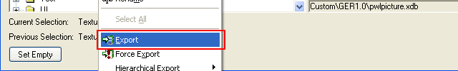
(Hypershot-100.bmp)

10. Choose the item Export

«(Texture exported successfully
Object name: Test\TestMaps\APostnikov\Test-001\pwlpicture1.xdb
Source file name: UI\LoadingPictures\test-001-pwl.tga/)»

11. If everything has been done correctly, you will see the notice in the Log window that the texture has been successfully exported, otherwise you will have to make sure that everything is correct and repeat the hyper screenshot integration.

6-01-4 Testing hyper screenshot
If everything has been done correctly, you will see the hyper screenshot when loading your map.

6-02 MINIMAP
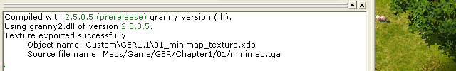
(Minimap-010.bmp)
The minimap texture is created automatically when saving the current map, which is noted in the Log Window.

6-03 Music

Music accompaniment is one of the most important parts of the atmosphere or the so called “spirits” of the map or the mission.

In B2 map editor you can use the opportunity to create playlists for this map.

For every mission there must be two playlists - #0 - Adventure Playlist, which can be heard, when the player does not take part in the battle, and #1 – Combat Playlist, which sounds during the operations with the participation of the player.

When creating new maps it is better to use playlists already made up by the developers. However, if you want to create a map with your own music accompaniment – read the following instructions:

The basic sequence of actions when creating the list MapMusic is the following:

- Create and edit the list MapMusic

a. Add playlists to the list

2. Create and edit the playlist

Create and edit the composition in the list StillOrder
- Choose the music track
i. Choose the music file in wav, ogg, mp3 format
- Choose FadeIn parameters
i. . Choose the file with FadeIn or create your own one
- Choose FadeOut parameters
i. . Choose the file with FadeOut or create your own one
- Choose the play mode
i. Choose the file with play parameters or create your own one
- Set the pauses before and after playing the composition.

Create and choose the composition in the list RandomOrder (the same for the list StillOrder)
f. Indicate the weight of the composition, which affects the frequency this composition is played with in the list RandomOrder

Choose FadeIn parameters
g. Choose the file with FadeIn parameters or create your own one

Choose FadeIn parameters
h. Choose the file with FadeOut parameters or create your own one

6-04 Creating the playlist for the map

Find the field Music in the table MapInfo.

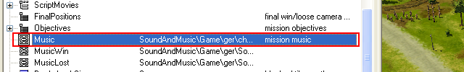
(Music-010.bmp)

Create a new playlist and open it for editing

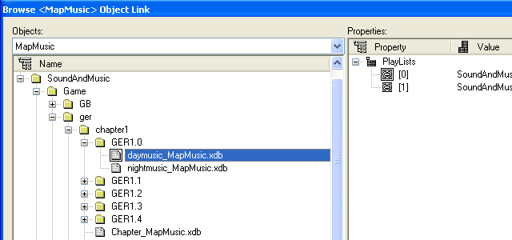
(Music-020.bmp)

Now create two playlists. The playlist #0 will be played in Adventure Mode and #1 – in Combat Mode.

(I) If you create more than two playlists all the rest, except #0 & #1, will be ignored.

After creating playlists open one of them for editing.

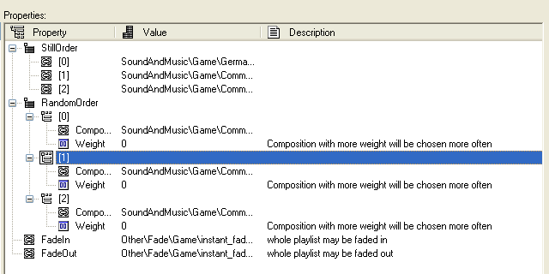
(Music-030.bmp)

In any playlist you can create the files list, which will be played in the order given, and also the files list, which will be played randomly, taking into account their significance. Such lists are named StillOrder and RandomOrder.

These lists are played as follows – first the list StillOrder is always played (compositions are played in the sequence they are set in the editor), and then, if there is a composition in the list RandomOrder, the list RandomOrder is always played (compositions will be chosen randomly). Accordingly – if there is no composition in the list RandomOrder, the list StillOrder will be played again.

StillOrder
Choose and set music compositions

RandomOrder
Choose and set music compositions. Remember to set the weight of every composition.

(I) The field Weight is responsible for the choice of the compositions (The more the value Weight is, the more often this composition will be chosen).

FadeIn
Indicate FadeIn parameters, to make the volume increase smoothly at the beginning of the composition.

FadeOut
Indicate FadeOut parameters, to make the volume decrease smoothly at the end of the composition.

(I) The parameters FadeIn and FadeOut ought to be set for every playlist and composition. It allows to achieve a smooth crossover between compositions and playlists.

6-05 Setting a composition with the music

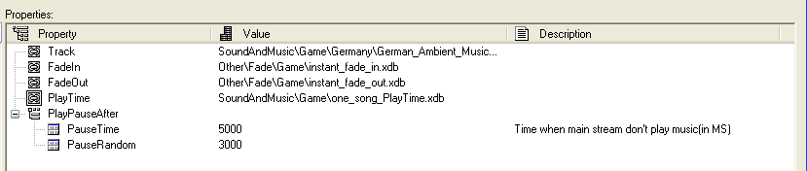
Having opened the screen of setting a composition, you will see the following parameters:

Track
Choosing the music file on the disc. The format of the files supported – wav, ogg, mp3.

FadeIn и FadeOut
Choosing the parameters of changing music during the fixed time at the beginning and at the end of the composition.
(I) Fade – changing the music volume during the fixed period of time. Fade depends on the two main parameters – the final set volume of the composition and the time interval, when the fixed change of the volume happens. FadeVolume and FadeTime, accordingly.

PlayTime
This parameter sets the time and parameters of playing the composition. You can play the composition the fixed number of times or repeat the composition during the period of time.

PlayPauseAfter
Choosing the duration of the pause after playing every composition.

6-06 Script Movie

The special mini editor of script movies is integrated in B2 map editor. Using it you can set the sequence of keyframes and set the corresponding position of the camera.

(I) All data on the camera position are displayed and may be edited in the field ScriptMovies in map properties.

Running script movies is possible only with script functions and commands.

6-06-1 Creating a script movie
To create a script movie for playing during the mission open the tab Script Movies of the section Script in Tools Window.

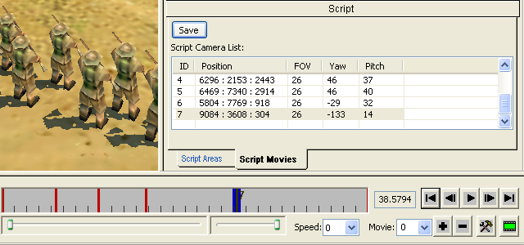
(ScriptMovies-010.bmp)
The panel of the keyframes editor and their list will be displayed.

6-06-2 The keyframe editor

The keyframe editor allows to:
- add or remove movies for this mission / map

To add or remove the movie for the current map / mission use the buttons plus or minus. All movies for the current mission are displayed in the list next to these buttons.

- switch between movies being edited

To switch between movies use the list-box.

- set the movie’s time-keeping in seconds

To set the time-keeping of the current movie in seconds press the button of settings and enter the number of seconds.

- add keyframes on the movie’s timeline

To add a keyframe on the timeline of the movie choose the right point with left-click (the blue label appears on the right place), then right-click on the blue label and choose the item Insert Key in the menu displayed.

- edit keyframes properties

To edit keyframe properties first left-click on it to select it, so that the frame number will be displayed, then right-click on it and choose the item needed in the menu displayed.

- assign the position and orientation of the camera for ketframes

To assign the new position and the orientation of the camera for the keyframe choose the keyframe on the timeline, after that set and orient the camera over the map as you need it. Right-click on the keyframe and choose the item Save Key. The keyframe parameters must change.

Before saving the camera parameters for the keyframe make sure that the user will see it on the screen as you planned.

- edit the speed of playing the movie in the editor;

You can change the speed of playing the movie in the editor with the list-box Speed.

- check the zone visible to the user;

To watch the movie as it will be seen by the user in the game – switch the game screen proportions mode.
(I) the game screen proportions mode works regardless of the tool you are using – Script Movie, Terrain, Objects etc.

- scroll the movies timeline;

Use the slider to scroll the Movies timeline (on the left under the timeline) to see the part of the movie needed.

- editing zoom of the movie timeline

To edit the zooming of the timeline use the slider (on the right under the timeline)

6-06-3 Keyframes list
This list contains the keyframes and their parameters. Editing this list is recommended only to the experience users.

