Blitzkrieg II Writer’s Assignment - GB Campaign Chapter 2

According to the specification below write

- Chapter Description
- Mission Names
- Mission Long Descriptions
- Mission Short Descriptions
- Mission Objectives

Please enter your work results in the provided table at the end of this document.

Specification

GB Campaign Chapter 2 (GB2) - The Battle for El Alamein

Chapter overview

The chapter consists of seven missions – six smaller ones and one large historical mission. All smaller missions in the chapter are available for the player right from the start of the chapter. The historical mission becomes available after the player completes at least any three smaller missions. At the beginning of the chapter fifteen reinforcements are available to the player.

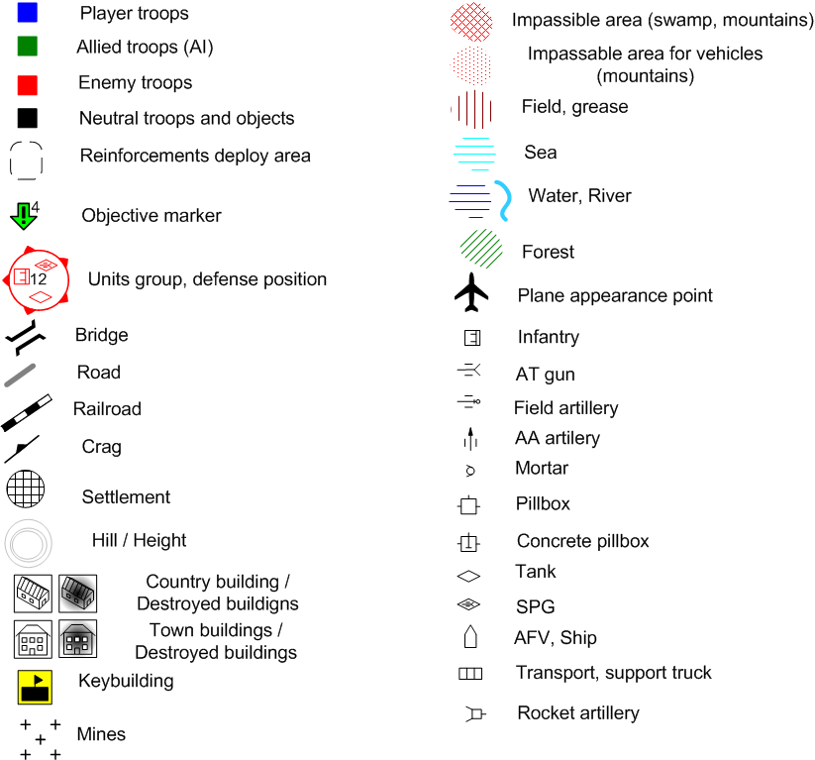

Mission Sketch legend used in this document.
Mission GB2.0

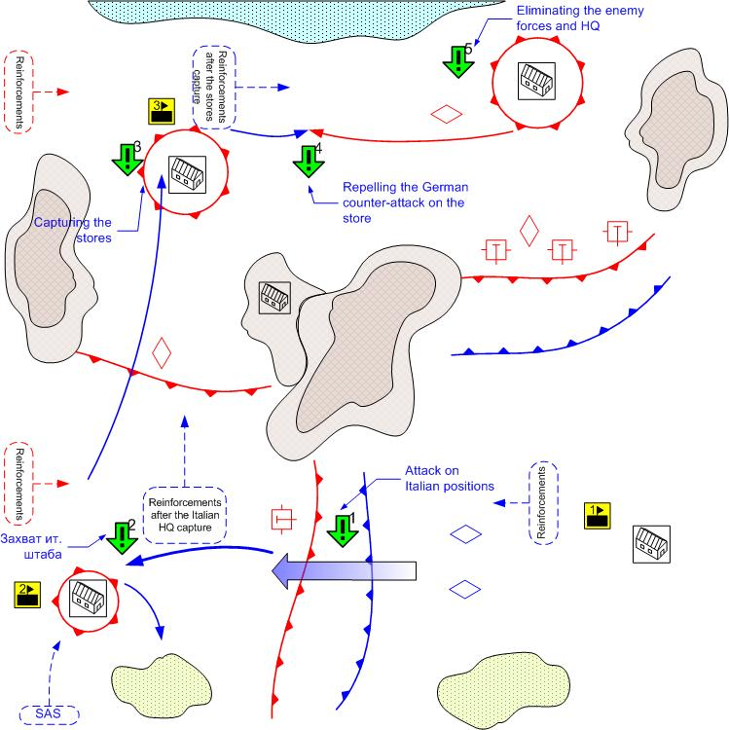

Size: 12x12
Terrain: Africa, small towns, desert terrain, rocky plateaus, day lighting, good weather.

Key buildings on the map.

1.- HQ (all initial reinforcements of the player)
2.- Italian HQ (New reinforcement arrival spot)
3. – Storage (New reinforcement arrival spot)

Player’s troops
Starting troops:
AFV: [Humber Mk1] and [Crusader]
Anti-Tank Guns: [6pdr QFG ]
Anti-Aircraft Guns: [40mm Bofors]
Main Squads: [GB Main 1941]
AFV: [Willis] Desert Patrol (Jeeps), British SAS (Infantry)
Reinforcements:
Ground Attack: [Hawker Hurricane MK-1]
Fighters: [Spitfire MkII]
AFV & Light Tanks: [Humber Mk1] or [Crusader]
Medium Tank: [Valentine] or [M3 Grant]
Main Squads: [GB Main 1941]
Assault Guns: [Bishop]

Enemy Troops
Starting troops:
Field Artillery: 6 [10.5-cm_leFH_18, 15-cm_K39]
Anti-Aircraft Guns: [2-cm_FlaK30/38, 8.8 FlaK18]
Tanks: [Pz.Kpfw IV.Ausf_D, G]
Light Tanks: [Pz.Kpfw_III.Ausf_E,] [Italian M13/40]
Main Squads: [German Squad 1941] [Italian Main 1941]
Tank Destroyer: [Italian Semovente 75/46]
AT Gun: [5cm PaK38]

Reinforcements:
Light Tanks: [Pz.Kpfw_III.Ausf_J]
Tanks: [Pz.Kpfw IV.Ausf_D]
Heavy Tanks: [Pz.Kpfw IV.Ausf, G]
Assault Guns: [StuG III D]
Ground Attack Planes: [Ju-87D1]
Fighters: [Bf-109F]

Mission overview
This is the final stage of the El Alamein battle. The player’s forces are located at the southeast of the map and are prepared to attack the enemy positions. To the south east lie the dense German defenses. Beyond the line of these defenses are the powerful tank reserves. To the south west are the relatively weak Italian positions.
The player’s task is to eliminate the opposing enemy forces. The player attacks the weak Italian positions first and having crushed them completes the first sub-objective. After that the player captures the HQ of the Italian forces and gains the new reinforcement arrival point. Then the player moves to the north and captures the enemy stores and completes the third objective. The objective is completed. The last player’s objective is to eliminate the remaining German forces and to capture their HQ.

Objectives

- To penetrate the enemy defenses to the south-east.
Prerequisite Condition: Mission start
Completion Condition: The player’s units are behind the enemy defense lines.
- To capture the Italian troops HQ
Prerequisite Condition: Completion of objective 1
Completion Condition: In the area of the HQ there are some player’s troops and no enemy troops.
- To capture the stores
Prerequisite Condition: Completion of objective 2
Completion Condition: In the area of the stores there are some player’s troops and no enemy troops.
- To repel the German attack at the stores
Prerequisite Condition: Completion of objective 3
Completion Condition: The attacking enemy group has no units
Fail Condition: In the area of the HQ there are some enemy troops and no player’s troops.
- To capture the German troops HQ.
Prerequisite Condition: Completion of objective 4
Completion Condition: In the area of the HQ there are some player’s troops and no enemy troops.

Bonuses received for completing the smaller missions

GB2.1 – Additional reinforcement calls
GB2.2 – The enemy looses the Medium Tanks reinforcement [Pz.Kpfw IV.Ausf_D].
GB2.3 – The player receives the Medium Tanks upgrade [M3 Grant].
GB2.4 – The enemy looses GAP [Ju-87D1].
GB2.5 – The enemy looses the Heavy Tanks reinforcement [Pz.Kpfw IV.Ausf, G].
GB2.6 – The player receives the SAS reinforcement behind the enemy lines. British SAS (Infantry).
Mission GB2.1
Protecting the stores

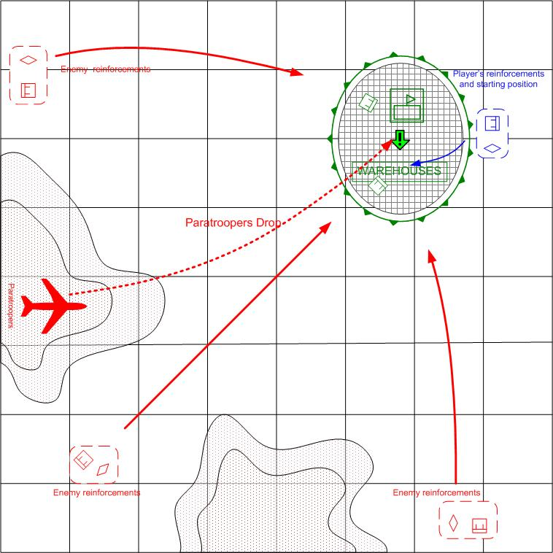

Size: 8x8
Terrain: Africa, Day.

Player’s troops
Starting troops:
AFV & Light Tanks: [Humber Mk1] and [Crusader]

Reinforcements:
AFV & Light Tanks
Main Squads

Ally’s troops
Starting troops:
Main Squads: [GB Main 1941]
Heavy Machine guns

Reinforcements:

None.

Enemy’s troops
Starting troops:
Нет.
Reinforcements:
Light Tanks: [Pz.Kpfw_III.Ausf_J, E]
Main Squads: [German Squad 1941]
Main Squads: [German Para 1941]
Assault Guns: [StuG III D]

Mission overview

The player’s mission is to help the allied troops under the command of AI to repel the enemy attack aimed for capture of storage facility.
The allied troops are guarding the approaches to the storage facility. The player controls the light tanks and infantry, which she can use to reinforce the allied AI troops at the right place at the right time.
The enemy continuously attacks the stores from the several directions, using the armors and motorized infantry regiments. At the end of the mission the enemy will drop the paratroopers that will attempt to blow the stores up with the explosives. Without the aid from the player, the allied AI troops will not be able to repel these attacks. The player will have to distribute the available forces wisely in order to complete this mission.

Bonuses for completing the mission
New reinforcement type: SAS.
Reinforcement update: AT guns

Mission GB2.2 Massive Tank Counter-offensive

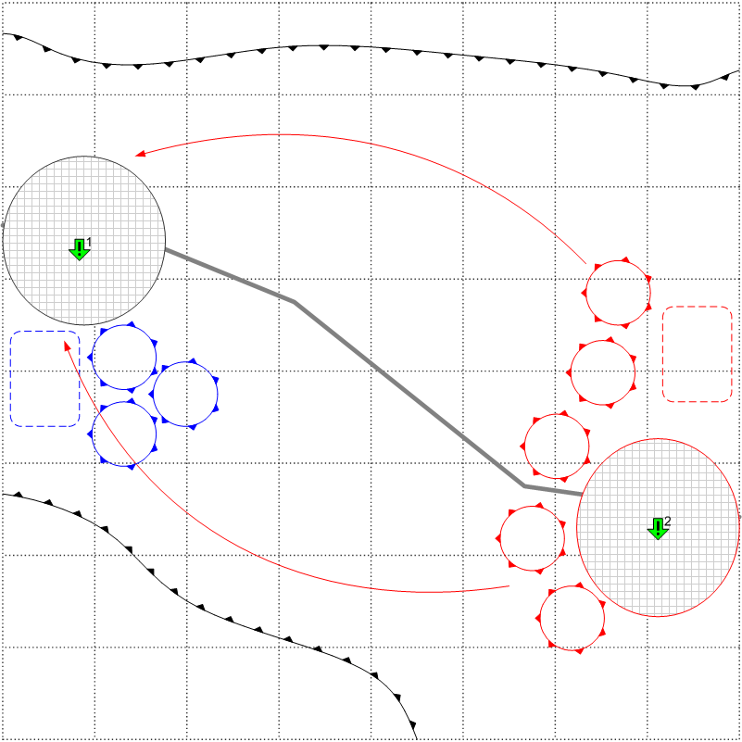

Size: 8x8
Terrain: Africa. Two settlements, desert, some rocks, day lighting, good weather.

Player’s troops
Starting troops:
Light Tanks: [Crusader], [Humber Mk.I]
Medium Tanks: [Valentine], [M3 Grant]

Reinforcements:
Light Tanks
Medium Tanks
AT Guns
Engineering trucks
Recommended number of reinforcements’ calls: 2

Enemy’s troops
Starting troops:
Tanks: [Pz.Kpfw IV.Ausf_D], [Pz.Kpfw IV.Ausf_G]
Light Tanks: [Pz.Kpfw_III.Ausf_E], [Pz.Kpfw_III.Ausf_J]
Reinforcements:
Light Tanks: [Pz.Kpfw_III.Ausf_J]
Medium Tanks: [Pz.Kpfw IV.Ausf_D]
Tank Destroyers: [StuG IIIF]

Mission overview
Massive tank counter-offensive on the open area. In the beginning of the mission there are 3-4 tank groups under player’s command. The total amount of these tank groups is 12-16 tanks. The player has time to place the tanks on the starting positions, form the reserve groups, call for the additional reinforcements etc. The player must be forced to attack, otherwise all mission might degrade into the shoot’em-up of the incoming enemy forces from the comfort of the fortified positions.
The enemy starts to attack, (in several small groups consequently) when the player accumulated a certain amount of forces in some area. The number of enemy attacks is unlimited – therefore the player will have to counter-attack and maneuver.

Objectives

- Prevent the capture of the settlement
- Regain control over the lost settlement.

Bonuses for completing the mission:
New reinforcement type: Heavy artillery, Assault Infantry.
Unit Upgrades: Main Infantry.

Mission GB2.3 Prevent of the enemy tank rush on the flanks of Allies positions.

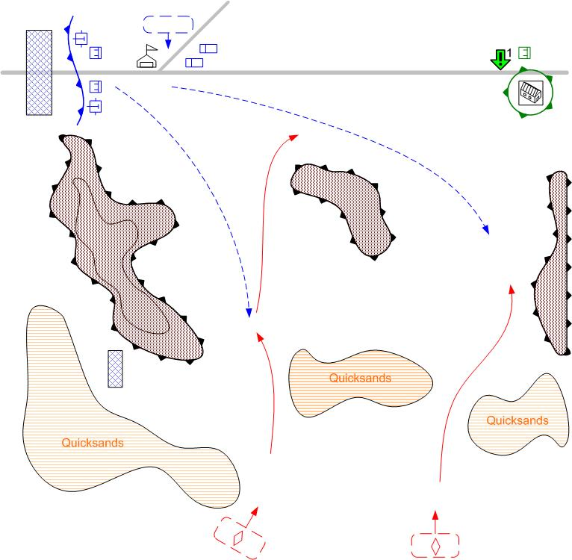

Size: 7x7
Terrain: Morning, Africa, road in the desert, mountains, quicksands to the south.
Player’s troops.
Starting troops:
Engineering Truck
Light AA Gun [Bofors]
Anti-Tank Gun [2pdr_QFG]
Reinforcements:

Anti-Tank Gun
Assault Infantry:
Engineering Truck
Medium Tank
Recommended number of reinforcements’ calls: 2

Ally’s troops:
Infantry: [GB MAIN 1941]

Enemy’s troops
Starting troops:
Нет.
Reinforcements:

Medium Tank [PzKpfw_IV_Ausf_D]
Light Tank [M13_40_Italian]
Light Tank [PzKpfw_III_Ausf_E]
AFV [SdKfz_222]

Objectives

- Defend the outpost to the east

Completing condition: The end of scripted enemy attacks.
Failure condition: there are no player’s units near the outpost and there is at least one enemy unit near the outpost.

Mission overview
The enemy tank forces managed to flank the main defences of our forces and discover the passage through the desert quicksands at the south from your position. The enemy will try to reach the road that leads deep behind the lines of our positions.
The player has the fortified positions to the west. But the enemies will strike at the outpost at the east of the area. It is located on the road that leads to the east. It is necessary to set up the defences in the passages through the quicksands. The player has time to call one reinforcement, move the starting troops and possibly to do some fortification. After that the enemy start to attack through the passages.
Mission is failed id the enemy captures the outpost.

Bonuses for completing the mission:

Unit Upgrades: Light tanks.

Mission GB2.4 Airport capture with SAS forces.

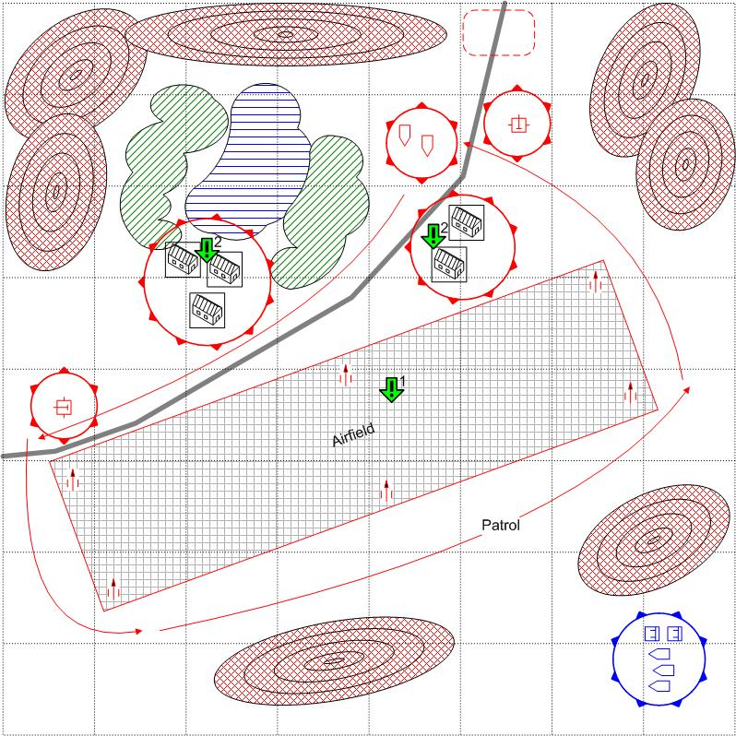
Size: 8x8
Terrain: Africa, oasis in the desert, mountains, night lighting, airfield.
Player’s troops.
Starting troops:
Elite Infantry: [GB Elite 1941+ WillisMB]

Reinforcements:

AFV
Elite Infantry

Recommended number of reinforcements’ calls: 2

Enemy’s troops
Starting troops:
Anti-Aircraft Gun: [2-cm_FlaK30/38], [8.8-cm_FlaK_18]
AFV: [SdKfz 222]
Main Squads: [German Main 1941]
Reinforcements:
Main Squad: [German Main 1941]

Objectives

- Capture the airfield
Completing condition: there are no enemy units at the airfield and there is at least one player’s unit at the airfield.
Condition for re-issue: there are no player’s units at the airfield and there is at least one enemy unit at the airfield.
- Search all buildings at the airfield and discover important documents.
Prerequisite: Task 1 complete.
Completing condition: The specific building belongs to the player.

Mission overview
SAS squads on the light jeeps, after the day-long desert march, has reached the enemy airfield. The enemy has not expected the attack from this direction and SAS has the real chances to capture the airfield and deprive the enemy of air-support in the upcoming battles. The player has to eliminate the airfield defenders and take control over the airport.
Some enemy units patrol the airfield, the base, the roads at the entrance to the oasis.
At the start of the mission one building is selected at random to be the goal for the Objective 2.

Bonuses for completing the mission:
New reinforcement type: Paratroopers, Recon planes.
Upgrades: Ground-attack planes.

Mission GB2.5 – Attack on the enemy sea convoy.

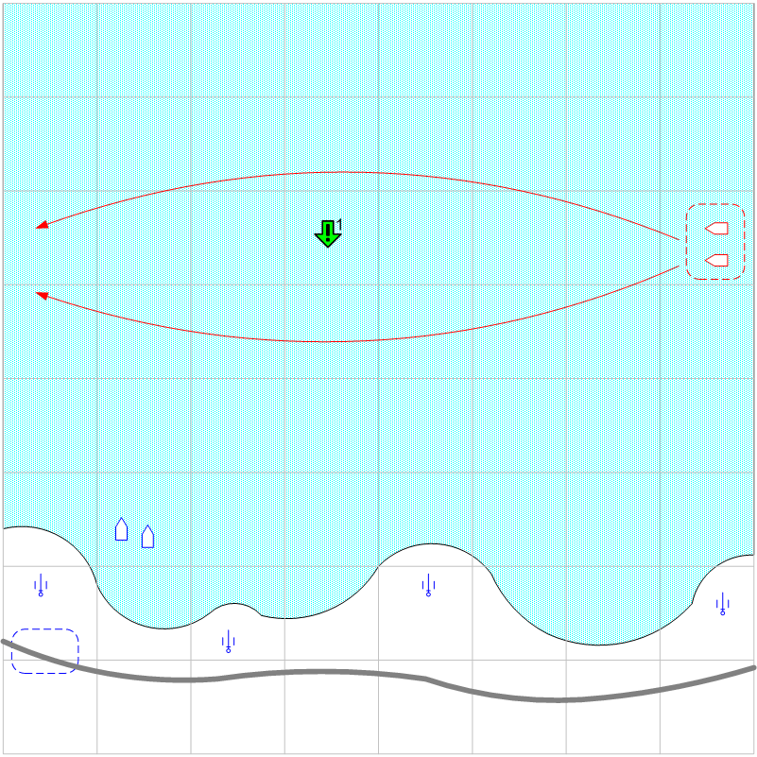

Size: 8x8
Terrain: Evening, Africa, sea, stripe of land to the south.
Player’s troops.
Starting troops:
Torpedo Boat: [Vosper]
Coast Gun
Reinforcements:
Ground Attack Plane
Fighters
Recon
Field Artillery

Enemy’s troops
Starting troops:
Нет
Reinforcements:
Torpedo Boat: [Schnellboot]
Transport: [Siebel]
Fighter: [Messerschmitt_Bf_109e]

Objectives

Destroy a certain amount of enemy ships.

Mission overview

Mostly a sea map, with a small stripe of land at the south. The enemy convoys arrive from the North. (Transports and escort boats). If the enemy transports reach a designated area at the west, they are assumed reaching their destination and disappear from the map.
The convoys choose one of two ways at random. The player has to destroy some of the transports with coast guns. It is difficult, because the player can not see the convoys and has to discover them with boats and planes. The player can make this mission easier, by making Field Artillery reinforcement available earlier in the chapter.

Bonuses for completing the mission:
New reinforcement type: Engineers, SPG.

Mission GB2.6 Capture of the enemy HQ.

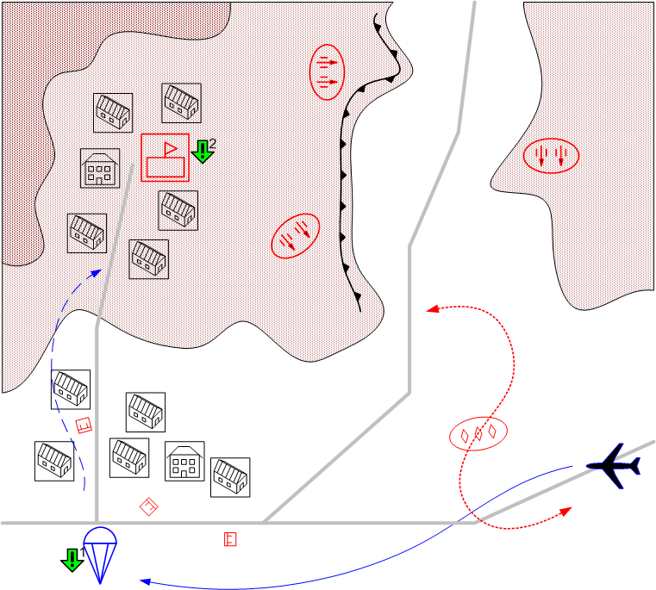

Size: 8x8
Terrain: Night, Africa, the road through a settlement, enemy HQ in the mountains nearby.

Player’s troops.
Starting troops:
Cargo Plane [Douglas_C47_Dakota]
Infantry: [GB PARA (Spec.) 1941]
Reinforcements:
Cargo Plane+Infantry PARA

Recommended number of reinforcements’ calls: 2

Enemy’s troops
Starting troops:
Snipers.
AFV: [SdKfz 222]
Main Squads: [German Squad 1941]
Anti-Aircraft Guns: [8.8 FlaK18]
AT Gun: [5cm PaK38]
Light Tanks [Pz.Kpfw_II.Ausf_F]

Reinforcements:
Main Squads: [German Squad 1941]

Objectives

- Drop the paratroopers outside the enemy AAA fire range
- Capture HQ with paratroopers.

Mission overview

The squad of paratroopers land from the planes to capture the enemy headquarters. The HQ are located in the town, the drop zone is located at some distance from the HQ, since the HQ is protected by the AAA. The player has to lead the paratroopers through the city and capture the
HQ.

Bonuses for completing the mission:
New reinforcement type: middle tanks.

