Blitzkrieg II Writer’s Assignment - GB Campaign Chapter 2

According to the specification below write

- Chapter Description
- Mission Names
- Mission Long Descriptions
- Mission Short Descriptions
- Mission Objectives

Please enter your work results in the provided table at the end of this document.

Specification

GB Campaign Chapter 2 (GB2) - The Battle for El Alamein

Chapter overview

The chapter consists of seven missions – six smaller ones and one large historical mission. All smaller missions in the chapter are available for the player right from the start of the chapter. The historical mission becomes available after the player completes at least any three smaller missions. At the beginning of the chapter fifteen reinforcements are available to the player.

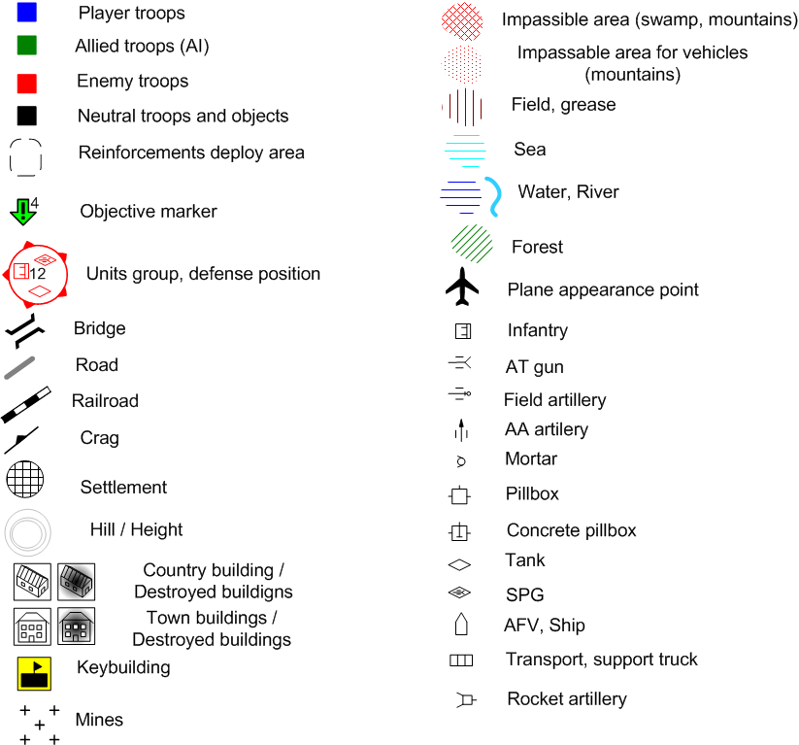

Mission Sketch legend used in this document.
Mission GB2.0

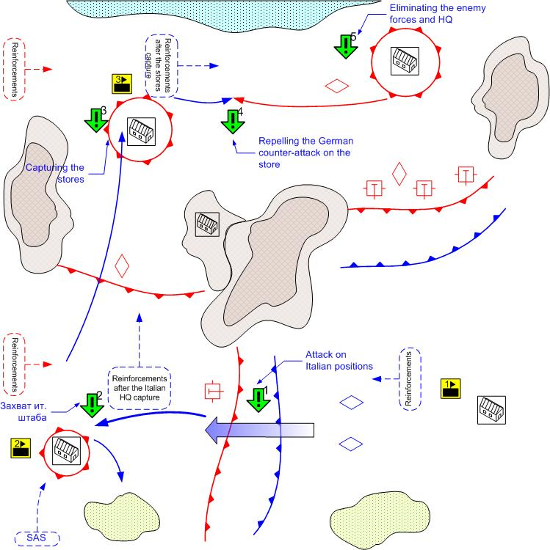

Size: 12x12
Terrain: Africa, small towns, desert terrain, rocky plateaus, day lighting, good weather.

Key buildings on the map.

1.- HQ (all initial reinforcements of the player)
2.- Italian HQ (New reinforcement arrival spot)
3. – Storage (New reinforcement arrival spot)

Player’s troops
Starting troops:
AFV: [Humber Mk1] and [Crusader]
Anti-Tank Guns: [6pdr QFG ]
Anti-Aircraft Guns: [40mm Bofors]
Main Squads: [GB Main 1941]
AFV: [Willis] Desert Patrol (Jeeps), British SAS (Infantry)
Reinforcements:
Ground Attack: [Hawker Hurricane MK-1]
Fighters: [Spitfire MkII]
AFV & Light Tanks: [Humber Mk1] or [Crusader]
Medium Tank: [Valentine] or [M3 Grant]
Main Squads: [GB Main 1941]
Assault Guns: [Bishop]

Enemy Troops
Starting troops:
Field Artillery: 6 [10.5-cm_leFH_18, 15-cm_K39]
Anti-Aircraft Guns: [2-cm_FlaK30/38, 8.8 FlaK18]
Tanks: [Pz.Kpfw IV.Ausf_D, G]
Light Tanks: [Pz.Kpfw_III.Ausf_E,] [Italian M13/40]
Main Squads: [German Squad 1941] [Italian Main 1941]
Tank Destroyer: [Italian Semovente 75/46]
AT Gun: [5cm PaK38]

Reinforcements:
Light Tanks: [Pz.Kpfw_III.Ausf_J]
Tanks: [Pz.Kpfw IV.Ausf_D]
Heavy Tanks: [Pz.Kpfw IV.Ausf, G]
Assault Guns: [StuG III D]
Ground Attack Planes: [Ju-87D1]
Fighters: [Bf-109F]

Mission overview
This is the final stage of the El Alamein battle. The player’s forces are located at the southeast of the map and are prepared to attack the enemy positions. To the south east lie the dense German defenses. Beyond the line of these defenses are the powerful tank reserves. To the south west are the relatively weak Italian positions.
The player’s task is to eliminate the opposing enemy forces. The player attacks the weak Italian positions first and having crushed them completes the first sub-objective. After that the player captures the HQ of the Italian forces and gains the new reinforcement arrival point. Then the player moves to the north and captures the enemy stores and completes the third objective. The objective is completed. The last player’s objective is to eliminate the remaining German forces and to capture their HQ.

Objectives

- To penetrate the enemy defenses to the south-east.
Prerequisite Condition: Mission start
Completion Condition: The player’s units are behind the enemy defense lines.
- To capture the Italian troops HQ
Prerequisite Condition: Completion of objective 1
Completion Condition: In the area of the HQ there are some player’s troops and no enemy troops.
- To capture the stores
Prerequisite Condition: Completion of objective 2
Completion Condition: In the area of the stores there are some player’s troops and no enemy troops.
- To repel the German attack at the stores
Prerequisite Condition: Completion of objective 3
Completion Condition: The attacking enemy group has no units
Fail Condition: In the area of the HQ there are some enemy troops and no player’s troops.
- To capture the German troops HQ.
Prerequisite Condition: Completion of objective 4
Completion Condition: In the area of the HQ there are some player’s troops and no enemy troops.

Bonuses received for completing the smaller missions

GB2.1 – Additional reinforcement calls
GB2.2 – The enemy looses the Medium Tanks reinforcement [Pz.Kpfw IV.Ausf_D].
GB2.3 – The player receives the Medium Tanks upgrade [M3 Grant].
GB2.4 – The enemy looses GAP [Ju-87D1].
GB2.5 – The enemy looses the Heavy Tanks reinforcement [Pz.Kpfw IV.Ausf, G].
GB2.6 – The player receives the SAS reinforcement behind the enemy lines. British SAS (Infantry).

MISSION NAME:

“English Lightning”

MISSION LONG DESCRIPTION:

Your mission here is to push the Afrika Korps back from El Alamein. You will find the Italian forces on Jerry’s right flank to be of poorer quality than Rommel’s own troops, indicating an initial breakthrough in that sector might be easier than attempting to confront the field marshal’s panzers head-on. Actual enemy strength is unknown, but the Afrika Korps’ supply system has obviously been strained to its limits, so it would be expedient to deny them the use of their own supply depot.

MISSION SHORT DESCRIPTION:
The goal of this mission is to preempt further Axis offensive activity towards El Alamein and push the enemy to retreat before they can regroup.

MISSION OBJECTIVES:

GB2.0 – First Objective

It would be wise to defeat the weaker Italian forces to the west before taking on the German forces in the north. We’ll first need to punch a hole in the enemy’s outer defenses, in order to best dispatch the Italian defenders. There is no prize for second place, old chap, so do try to achieve your aims. Mr. Churchill is not prepared to hear more news of failure from Eighth Army.

GB2.0 – Second Objective

Very well, now that you have swept aside the resistance in the south-east, proceed to the west and capture the Italian headquarters bunker. By applying the most appropriate blow against the Italian defences, you should be able to sweep the entire position and proceed with the rest of the operation. I shall also send an S.A.S. team to help you accomplish your task.

GB2.0 – Third Objective

Intelligence has located Rommel’s forward supply base. Capturing this facility should allow us to dedicate additional reinforcements to your command, in addition to denying these important supplies to the Jerries. Once you have captured the Axis supply dump and disposed of all enemy resistance thereabouts, you will have the initiative to press on.

GB2.0 – Fourth Objective

We anticipate that the Germans are about to launch a counter-stroke to reclaim their supply base. You must hold this objective whatever the cost. If the Germans are permitted to resupply their forces and regain some momentum, our operation could quickly unravel and we might find ourselves covering an Eighth Army retreat into Alexandria. You must prevent this.

GB2.0 – Fifth Objective

Things have progressed well thus far, but we mustn’t let up on the Germans. You are authorized to cut off and eliminate the German military headquarters, stopping Rommel’s ability to give orders to his forces. If you can successfully subdue all enemy resistance in and around the German headquarters bunker, the victory shall be ours. Good luck and Godspeed.

Mission GB2.1
Protecting the stores

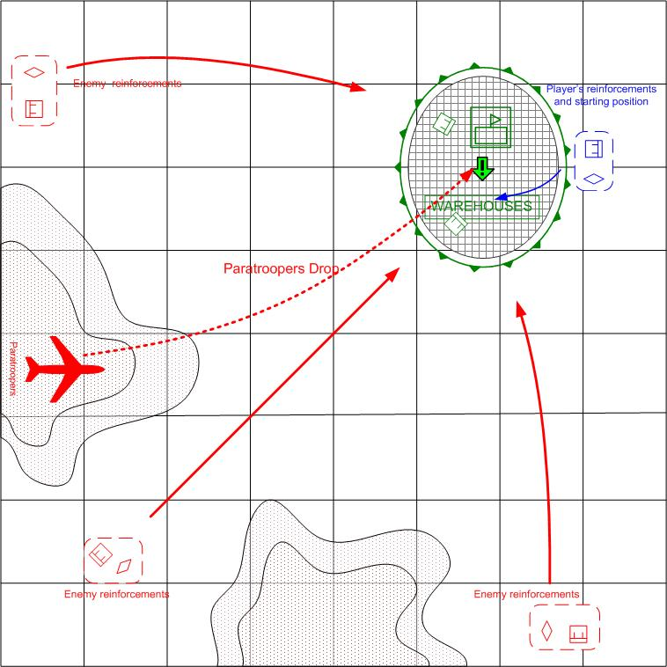

Size: 8x8
Terrain: Africa, Day.

Player’s troops
Starting troops:
AFV & Light Tanks: [Humber Mk1] and [Crusader]

Reinforcements:
AFV & Light Tanks
Main Squads

Ally’s troops
Starting troops:
Main Squads: [GB Main 1941]
Heavy Machine guns

Reinforcements:

None.

Enemy’s troops
Starting troops:
Нет.
Reinforcements:
Light Tanks: [Pz.Kpfw_III.Ausf_J, E]
Main Squads: [German Squad 1941]
Main Squads: [German Para 1941]
Assault Guns: [StuG III D]

Mission overview

The player’s mission is to help the allied troops under the command of AI to repel the enemy attack aimed for capture of storage facility.
The allied troops are guarding the approaches to the storage facility. The player controls the light tanks and infantry, which she can use to reinforce the allied AI troops at the right place at the right time.
The enemy continuously attacks the stores from the several directions, using the armors and motorized infantry regiments. At the end of the mission the enemy will drop the paratroopers that will attempt to blow the stores up with the explosives. Without the aid from the player, the allied AI troops will not be able to repel these attacks. The player will have to distribute the available forces wisely in order to complete this mission.

Bonuses for completing the mission
New reinforcement type: SAS.
Reinforcement update: AT guns

MISSION NAME:

“A Stubborn Defence”

MISSION LONG DESCRIPTION:

Your force has been redirected to the aid the defence of checkpoint ‘Oberon’, where Commonwealth forces are now holding a captured German supply centre. You are to proceed immediately to defend this facility at all costs; the Jerries are expected to make a determined counter-attack at any time. Continued possession of ‘Oberon’ will limit enemy capability in this campaign, but losing control of this area would give Rommel a chance at regrouping, and launching a devastating sally into our rear areas. That, we cannot allow.

MISSION SHORT DESCRIPTION:

Having seized a major Axis supply base, your force shall fend off a determined German counter-stroke. Prevent the recapture of this base at all costs.

MISSION OBJECTIVES:

GB2.1 First Objective:

You are advised to assist the Commonwealth troops guarding the approaches to the supply depot. Be vigilant and ready to change tactics quickly. Bear in mind that the Rommel considers this depot the fulcrum of his counter-attack. You must use every asset at your disposal wisely to frustrate the German advance. The troops holding the depot require immediate aid.

Mission GB2.2 Massive Tank Counter-offensive

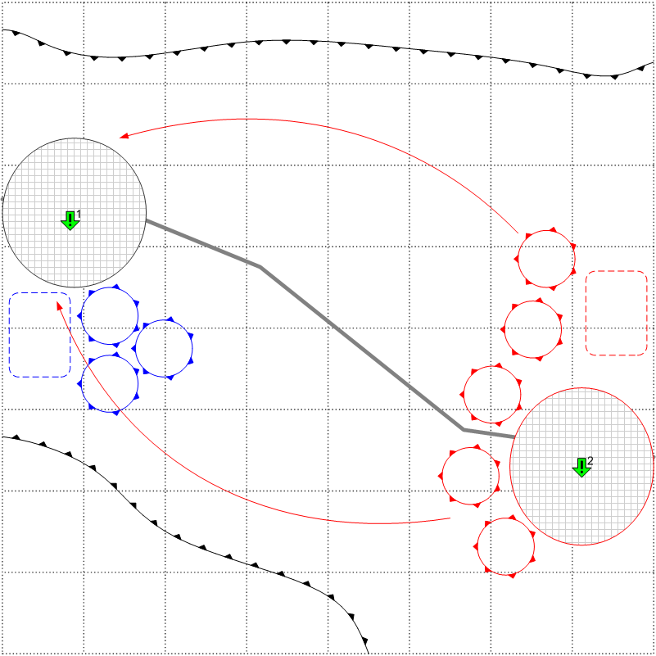

Size: 8x8
Terrain: Africa. Two settlements, desert, some rocks, day lighting, good weather.

Player’s troops
Starting troops:
Light Tanks: [Crusader], [Humber Mk.I]
Medium Tanks: [Valentine], [M3 Grant]

Reinforcements:
Light Tanks
Medium Tanks
AT Guns
Engineering trucks
Recommended number of reinforcements’ calls: 2

Enemy’s troops
Starting troops:
Tanks: [Pz.Kpfw IV.Ausf_D], [Pz.Kpfw IV.Ausf_G]
Light Tanks: [Pz.Kpfw_III.Ausf_E], [Pz.Kpfw_III.Ausf_J]
Reinforcements:
Light Tanks: [Pz.Kpfw_III.Ausf_J]
Medium Tanks: [Pz.Kpfw IV.Ausf_D]
Tank Destroyers: [StuG IIIF]

Mission overview
Massive tank counter-offensive on the open area. In the beginning of the mission there are 3-4 tank groups under player’s command. The total amount of these tank groups is 12-16 tanks. The player has time to place the tanks on the starting positions, form the reserve groups, call for the additional reinforcements etc. The player must be forced to attack, otherwise all mission might degrade into the shoot’em-up of the incoming enemy forces from the comfort of the fortified positions.
The enemy starts to attack, (in several small groups consequently) when the player accumulated a certain amount of forces in some area. The number of enemy attacks is unlimited – therefore the player will have to counter-attack and maneuver.

Objectives

- Prevent the capture of the settlement
- Regain control over the lost settlement.

Bonuses for completing the mission:
New reinforcement type: Heavy artillery, Assault Infantry.
Unit Upgrades: Main Infantry.

MISSION NAME:

“The Snake and the Mongoose”

MISSION LONG DESCRIPTION:

Army Intelligence believes that Afrika Korps is probing this area in order to find an escape route from El Alamein. We have placed you in command of an ad-hoc armoured brigade with the task of blocking a panzer assault upon Bir Shahaab, and then seizing the settlement of Balad Aziza. The burden you must shoulder is immense – you will be up against Rommel’s most seasoned tank veterans, possibly the entire 15th Panzer Division. Past experience with this lot has been memorable, to say the least.

MISSION SHORT DESCRIPTION:

Secure and protect a friendly-held village against a panzer attack. After defeating the enemy, press on and capture the enemy-held village before additional Germans arrive.

MISSION OBJECTIVES:

GB2.2 First Objective:

Now that we’ve assembled for battle, the first thing that must be done would be to secure Bir Shahaab against German assault. Air reconnaissance indicates German tank columns in your area, and have also spotted Luftwaffe assets which may be brought to bear. Do what you can to keep the Afrika Korps from pushing us out of this sector. You must hold until relieved.

GB2.2 Second Objective:

The Germans are sending in more panzers. Rommel thinks he can corner and destroy a major part of 8th Army’s armoured strength here. You can disrupt Rommel’s plan by taking Balad Aziza and denying its use as a German staging area. Resistance is estimated to be heavy. There is nothing that can be done to salvage the situation if you should fail in your assignment.

Mission GB2.3 Prevent of the enemy tank rush on the flanks of Allies positions.

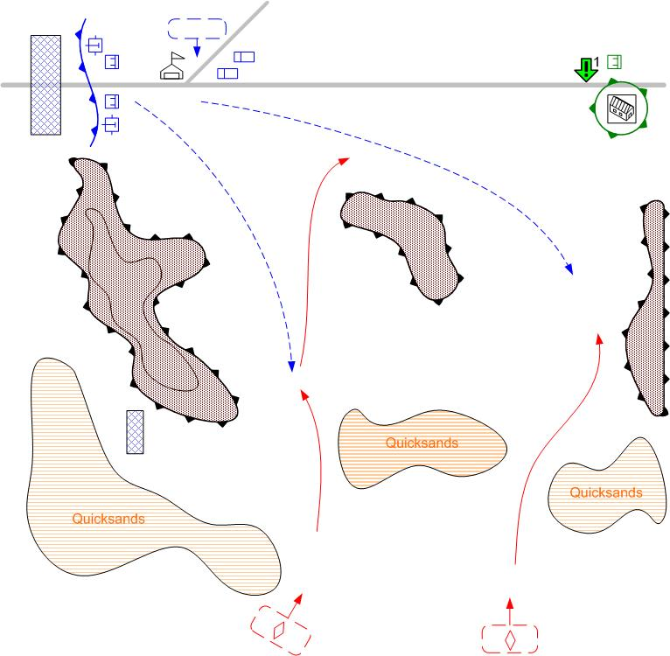

Size: 7x7
Terrain: Morning, Africa, road in the desert, mountains, quicksands to the south.
Player’s troops.
Starting troops:
Engineering Truck
Light AA Gun [Bofors]
Anti-Tank Gun [2pdr_QFG]
Reinforcements:

Anti-Tank Gun
Assault Infantry:
Engineering Truck
Medium Tank
Recommended number of reinforcements’ calls: 2

Ally’s troops:
Infantry: [GB MAIN 1941]

Enemy’s troops
Starting troops:
Нет.
Reinforcements:

Medium Tank [PzKpfw_IV_Ausf_D]
Light Tank [M13_40_Italian]
Light Tank [PzKpfw_III_Ausf_E]
AFV [SdKfz_222]

Objectives

- Defend the outpost to the east

Completing condition: The end of scripted enemy attacks.
Failure condition: there are no player’s units near the outpost and there is at least one enemy unit near the outpost.

Mission overview
The enemy tank forces managed to flank the main defences of our forces and discover the passage through the desert quicksands at the south from your position. The enemy will try to reach the road that leads deep behind the lines of our positions.
The player has the fortified positions to the west. But the enemies will strike at the outpost at the east of the area. It is located on the road that leads to the east. It is necessary to set up the defences in the passages through the quicksands. The player has time to call one reinforcement, move the starting troops and possibly to do some fortification. After that the enemy start to attack through the passages.
Mission is failed id the enemy captures the outpost.

Bonuses for completing the mission:

Unit Upgrades: Light tanks.

MISSION NAME:

“Desert Scimitar”

MISSION LONG DESCRIPTION:

I’m afraid we shall require your assistance for an emergent situation. German mechanized forces have managed to skirt around 8th Army’s outer defences and are now approaching our supply outpost 10km northeast of Sinjabi Jabal. It seems a Bedouin tribesman in the area has sold the Germans an accurate map of the route through the treacherous quicksands to the south. You’ll be required to form a defensive battlegroup out of engineers, artillerymen, and whoever else we could scrape together, and protect the outpost from capture.

MISSION SHORT DESCRIPTION:

Hold off a determined German mechanized attack upon one of our main supply hubs. You’ll need to make maximum use of an unconventional force mix.

MISSION OBJECTIVES:

GB2.3 First Objective:

This attack caught us by surprise, with most forces too distant to provide much help. You will have to position your anti-tank guns very carefully, as there is little else in your inventory which will stop armoured vehicles from reaching the outpost. The Germans are still trying to stop our advance by interfering with our ability to keep our forces supplied.

Mission GB2.4 Airport capture with SAS forces.

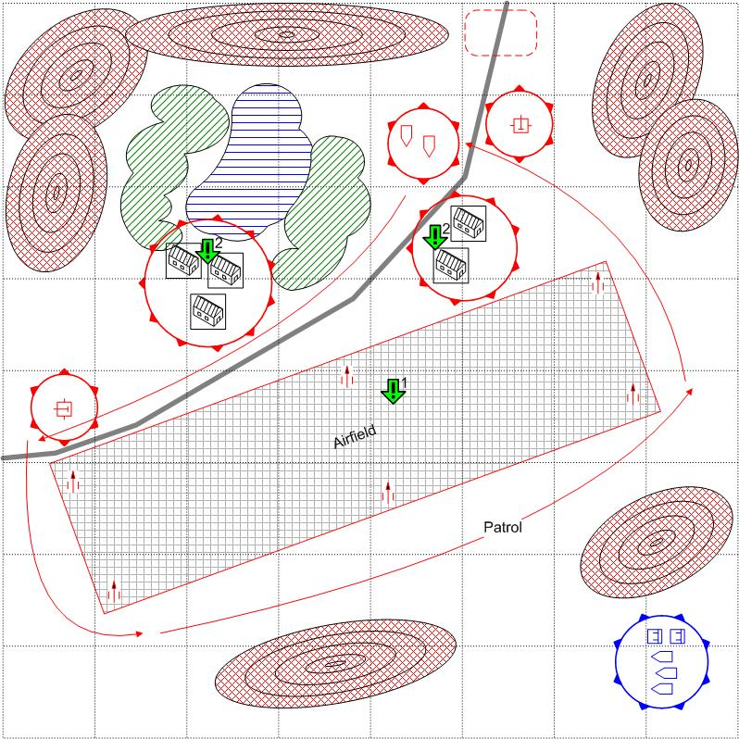
Size: 8x8
Terrain: Africa, oasis in the desert, mountains, night lighting, airfield.
Player’s troops.
Starting troops:
Elite Infantry: [GB Elite 1941+ WillisMB]

Reinforcements:

AFV
Elite Infantry

Recommended number of reinforcements’ calls: 2

Enemy’s troops
Starting troops:
Anti-Aircraft Gun: [2-cm_FlaK30/38], [8.8-cm_FlaK_18]
AFV: [SdKfz 222]
Main Squads: [German Main 1941]
Reinforcements:
Main Squad: [German Main 1941]

Objectives

- Capture the airfield
Completing condition: there are no enemy units at the airfield and there is at least one player’s unit at the airfield.
Condition for re-issue: there are no player’s units at the airfield and there is at least one enemy unit at the airfield.
- Search all buildings at the airfield and discover important documents.
Prerequisite: Task 1 complete.
Completing condition: The specific building belongs to the player.

Mission overview
SAS squads on the light jeeps, after the day-long desert march, has reached the enemy airfield. The enemy has not expected the attack from this direction and SAS has the real chances to capture the airfield and deprive the enemy of air-support in the upcoming battles. The player has to eliminate the airfield defenders and take control over the airport.
Some enemy units patrol the airfield, the base, the roads at the entrance to the oasis.
At the start of the mission one building is selected at random to be the goal for the Objective 2.

Bonuses for completing the mission:
New reinforcement type: Paratroopers, Recon planes.
Upgrades: Ground-attack planes.

MISSION NAME:

“Inside the Wire”

MISSION LONG DESCRIPTION:

With surprise on our side for once, High Command has seen fit to strike at one of the main German airfields far behind enemy lines. We have crossed the desert wastes with little time for rest or repair, and have caught the German airfield with only a small covering force present. You must deal effectively with the defensive patrols and secure the airfield, seizing whatever documents you may find in the nearby buildings. Neutralizing the airfield will increase our own air superiority in the region.

MISSION SHORT DESCRIPTION:

Assault a major German airfield, dispose of enemy resistance, and conduct a thorough search of the airfield’s outbuildings for intelligence information.

MISSION OBJECTIVES:

GB2.4 First Objective:

Taking the airfield requires you to eliminate both the armoured car patrols taking place along the airfield perimeter and the infamous ‘88’ flak gun emplacements at each corner of the tarmac. Our tactical intelligence also places German infantry within the airfield’s barracks buildings, and stationed near the entrance to the nearby oasis.

GB2.4 Second Objective:

Having taken the airstrip, our next objective is somewhat more subtle. We must liberate the German air operations centre on the base and confiscate any documents relating to the Afrika Korps’ general operational plans. Not knowing which building this is, our men will need to scour each of the buildings at the airbase until we have found the items we seek.

Mission GB2.5 – Attack on the enemy sea convoy.

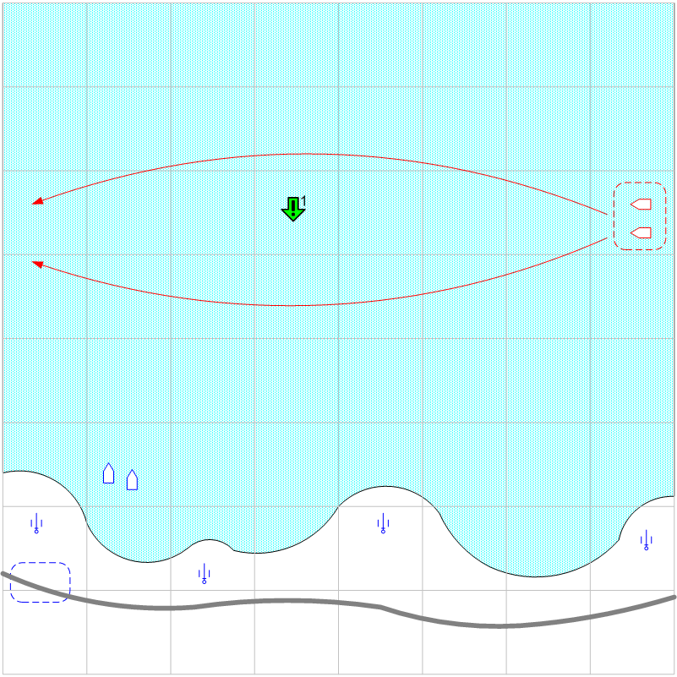

Size: 8x8
Terrain: Evening, Africa, sea, stripe of land to the south.
Player’s troops.
Starting troops:
Torpedo Boat: [Vosper]
Coast Gun
Reinforcements:
Ground Attack Plane
Fighters
Recon
Field Artillery

Enemy’s troops
Starting troops:
Нет
Reinforcements:
Torpedo Boat: [Schnellboot]
Transport: [Siebel]
Fighter: [Messerschmitt_Bf_109e]

Objectives

Destroy a certain amount of enemy ships.

Mission overview

Mostly a sea map, with a small stripe of land at the south. The enemy convoys arrive from the North. (Transports and escort boats). If the enemy transports reach a designated area at the west, they are assumed reaching their destination and disappear from the map.
The convoys choose one of two ways at random. The player has to destroy some of the transports with coast guns. It is difficult, because the player can not see the convoys and has to discover them with boats and planes. The player can make this mission easier, by making Field Artillery reinforcement available earlier in the chapter.

Bonuses for completing the mission:
New reinforcement type: Engineers, SPG.

MISSION NAME:

“Interception Force”

MISSION LONG DESCRIPTION:

Because of your excellent performance in high-risk exploits up to now, 8th Army General Staff has decided to place you in charge of guarding the approaches to Mersa Matruh now that we have successfully pushed the Germans back from El Alamein. There will be a German reinforcement convoy arriving from Greece arriving shortly, and it will be up to you to destroy this force before it can make port. Constant air reconnaissance will be key to discovering the enemy convoy and its escort ships.

MISSION SHORT DESCRIPTION:

Intercept an enemy convoy attempting to reinforce the Afrika Korps, destroying as many ships as possible before they exit the battle area to the west.

MISSION OBJECTIVES:

GB2.5 First Objective:

Destroy as many of the German transport ships as you can. Each one of the freighters is attempting to bring troops, equipment, and supplies to the Afrika Korps, and therefore must be stopped. Air and sea reconnaissance will be necessary to detect the enemy convoy, in turn allowing artillery to come to bear on convoy targets. Beware of the German escort boats.

Mission GB2.6 Capture of the enemy HQ.

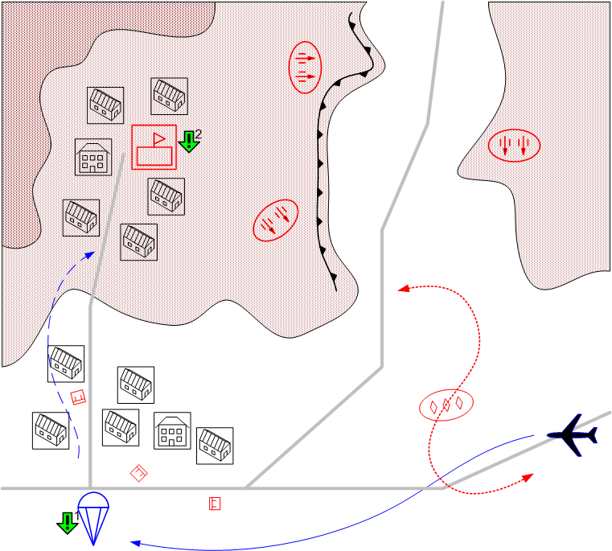

Size: 8x8
Terrain: Night, Africa, the road through a settlement, enemy HQ in the mountains nearby.

Player’s troops.
Starting troops:
Cargo Plane [Douglas_C47_Dakota]
Infantry: [GB PARA (Spec.) 1941]
Reinforcements:
Cargo Plane+Infantry PARA

Recommended number of reinforcements’ calls: 2

Enemy’s troops
Starting troops:
Snipers.
AFV: [SdKfz 222]
Main Squads: [German Squad 1941]
Anti-Aircraft Guns: [8.8 FlaK18]
AT Gun: [5cm PaK38]
Light Tanks [Pz.Kpfw_II.Ausf_F]

Reinforcements:
Main Squads: [German Squad 1941]

Objectives

- Drop the paratroopers outside the enemy AAA fire range
- Capture HQ with paratroopers.

Mission overview

The squad of paratroopers land from the planes to capture the enemy headquarters. The HQ are located in the town, the drop zone is located at some distance from the HQ, since the HQ is protected by the AAA. The player has to lead the paratroopers through the city and capture the
HQ.

Bonuses for completing the mission:
New reinforcement type: middle tanks.

MISSION NAME:

“Curtains for Afrika Korps”

MISSION LONG DESCRIPTION:

After heavy fighting, the Desert Rats have surrounded and isolated a portion of the Afrika Korps, as well as its command headquarters. The likelihood of Rommel himself actually being present is rather low, but we are giving you the task of leading an airborne assault inside the German pocket to capture the enemy headquarters and thereby prevent the coordination of new enemy operations. These Germans are die-hards and will not submit gladly to our attempt to destroy their main base of operations. As always, Godspeed.

MISSION SHORT DESCRIPTION:

Land your paratroops outside German anti-aircraft range, and begin offensive operations to destroy the headquarters of the Afrika Korps in the face of heavy resistance.

MISSION OBJECTIVES:

GB2.6 First Objective:

There are many places where we could land our airborne assault infantry, but the most practical might be areas far from interference by the German ‘88’s, which are just as adept at shooting down our aircraft as they are at destroying our tanks. The choice of the landing zone will of course be at your discretion, Commander.

GB2.6 Second Objective:

Now that we have landed and are regrouping, it might be wise to find some cover while we press on with the mission to destroy the enemy headquarters. The enemy appear to have some armoured units in the area, along with their flak guns and at least a company of infantry. Let’s keep our heads down and get on with it. The HQ building is just up the side of that hill.

