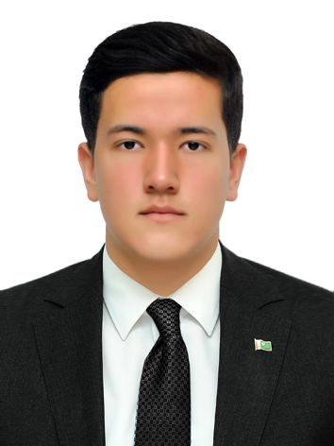

CURRICULUM VITAE

PERSONAL DATA:
Name and last name: Kakajan Dovranov
Telephone Mobile: +99362662306
Email: kakajan697989@gmail.com
Marital Status: single
Date of Birth: 29/June/2006
Gender: male
Country of Origin: Turkmenistan
Present Citizenship: Turkmenistan
Languages (Fluency Level): English (good), Russian (good)

EDUCATION:

School:
Ashgabat Specialized Secondary School No. 69 for Advanced Instruction in English

University:
International University for the Humanities and Development, Ashgabat, Turkmenistan;
08/02/2021 - 10/04/2021
Elementary English course at “Pak Nesil” economy society
01/02/2022 - 24/05/2022
Pre-Intermediate English course at “Diller Dunyasi” Language Centre
05/09/2022 - 25/11/2022
Intermediate English course at “Pak Nesil” economy society
19/12/2022 - 11/03/2023
Upper-Intermediate English course at “Pak Nesil” economy society
27/03/2022 - 17/06/2023
Advanced English course at “Pak Nesil” economy society
01.09.2023-
“Sanly çözgüt IT meydança” economic society

Computer skills:
Confident PC user - excellent knowledge of office programs (MS Word, Power Point, Excel)

Programming:

Git, Github (Marshall-06)

Frontend: HTML/CSS, Bootstrap (base)

Backend: Python(base), Nodejs, Golang, Mysql (sequelize),

