# User Guide

* About the User Guide

This is the user guide for Expiration Management & Cooking Suggestion System (EMCS), which explains all the functions in the system

* System Summary

EMCS is a web-based system, which helps you track food expiration date, create shopping list and suggest you on cooking. It was designed to aim at reducing household food waste. You can use web browser to access to the system through the following URL: [https://marshal1.tech](https://marshal1.tech/FYP)(expired), on any devices without any installation, although the experience may vary from different browser. We recommend you to use Chrome browser in order to gain the best experience.

* Log in & Sign up

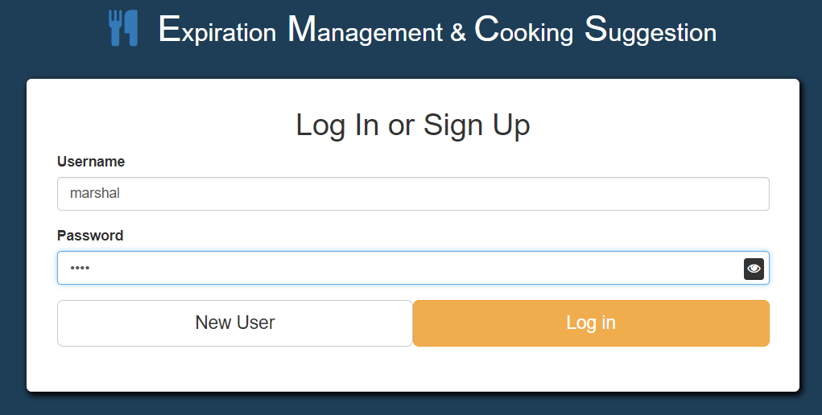If you are current user, please fill your username and password, and then click on “Log in” button

*Test account username: Marshall; password: 1234*

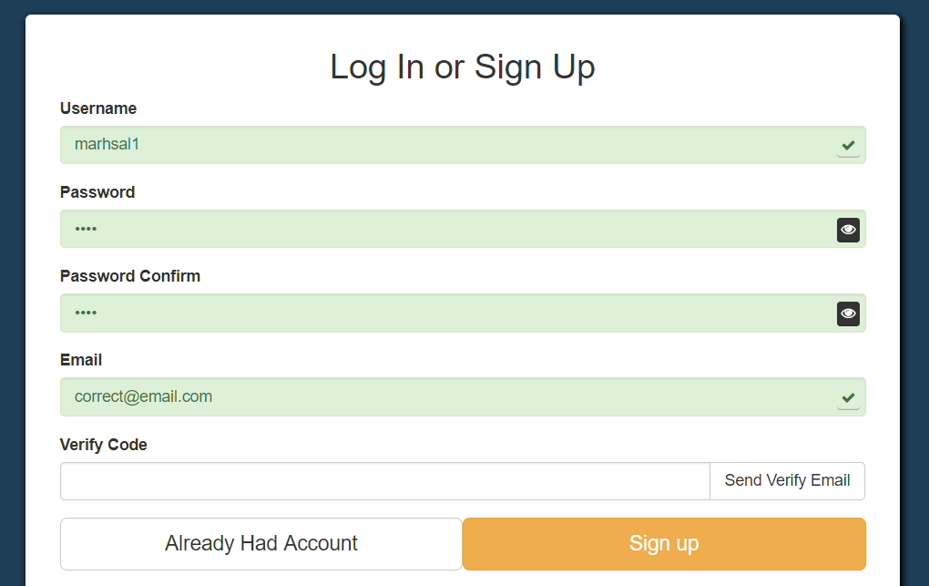If you are new user who first use this system, you should register a new account. By clicking “New User”, you will get a longer form. Please input your new unique username, as it will prompt you with red background colour if it has already been used. And then, input same password twice, which should have at least 4 characters. As well, input your email, and click “Send Verify Email”, make sure it has not been registered before. If everything goes well, the form will be showed like following:

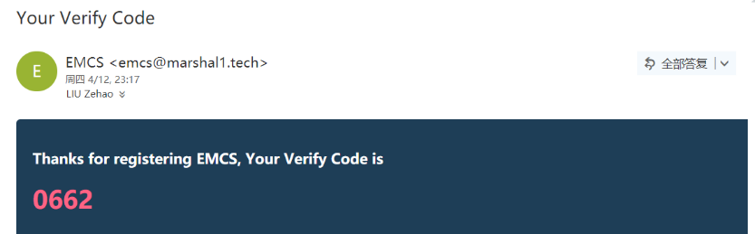Go to your email, check if there is any new, and please check your “Trash Mail” category if you have not received any email. If you find our email like following, please input the verify code and click on sign up to finish registering.

* Food Storage Page

After you logging in to the system, the home page is the food storage page shows food in “all” place. In left navigation bar, you can change the current showing place. There are four places that you can store your food: “Refrigerator”, “Freezing Chamber”, “Pantry” and “Other”. And on the top tabs, you can choose to view food in blocks or table.

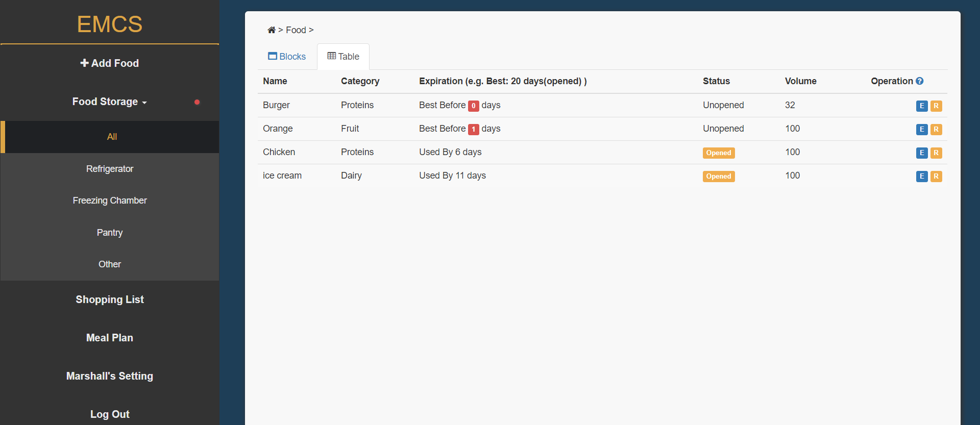

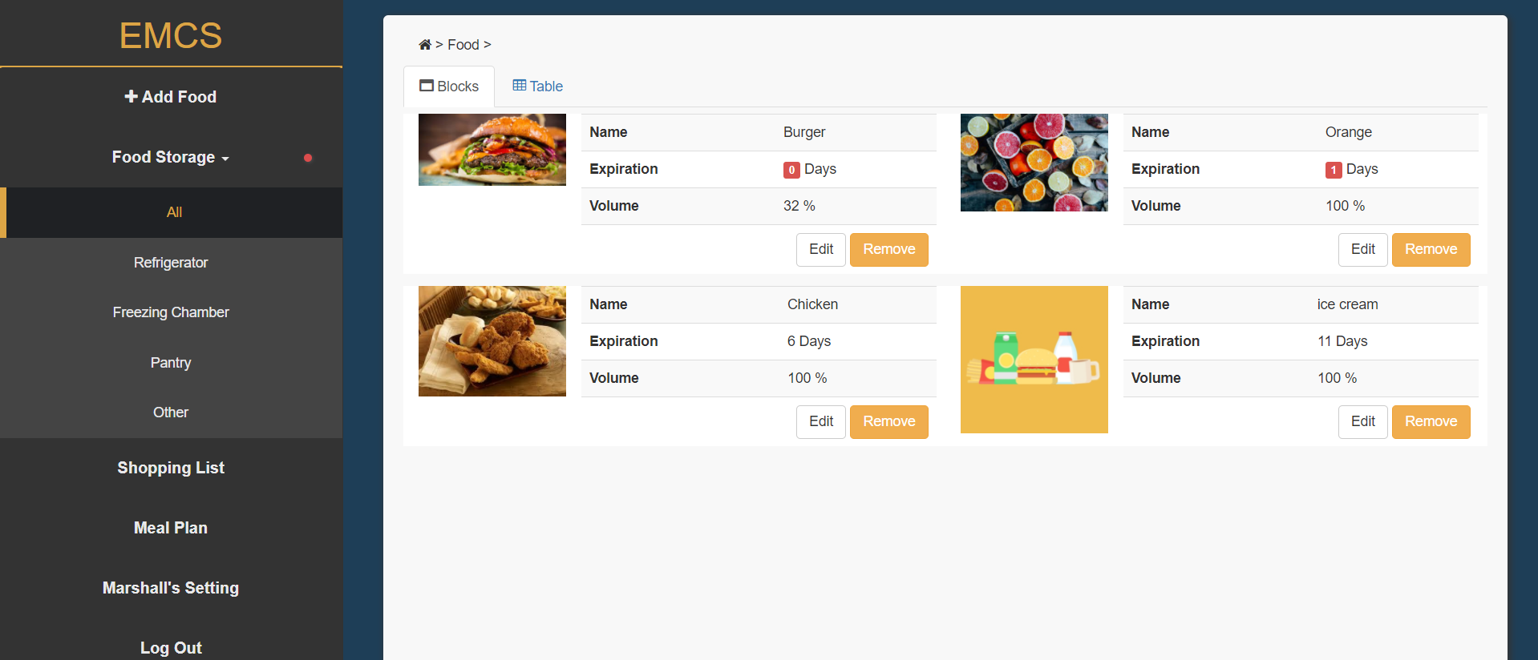

If there are no food in the storage, you may find an empty statement, especially for new users. Don’t worry, let’s create some new food first.

* Add New Food

Clicking the “Add Food” button on the left navigation bar, you will see the following form. Although there are lot inputs, only the “Food Name”, “Storage Place” and the “Expiration Date” is compulsory.

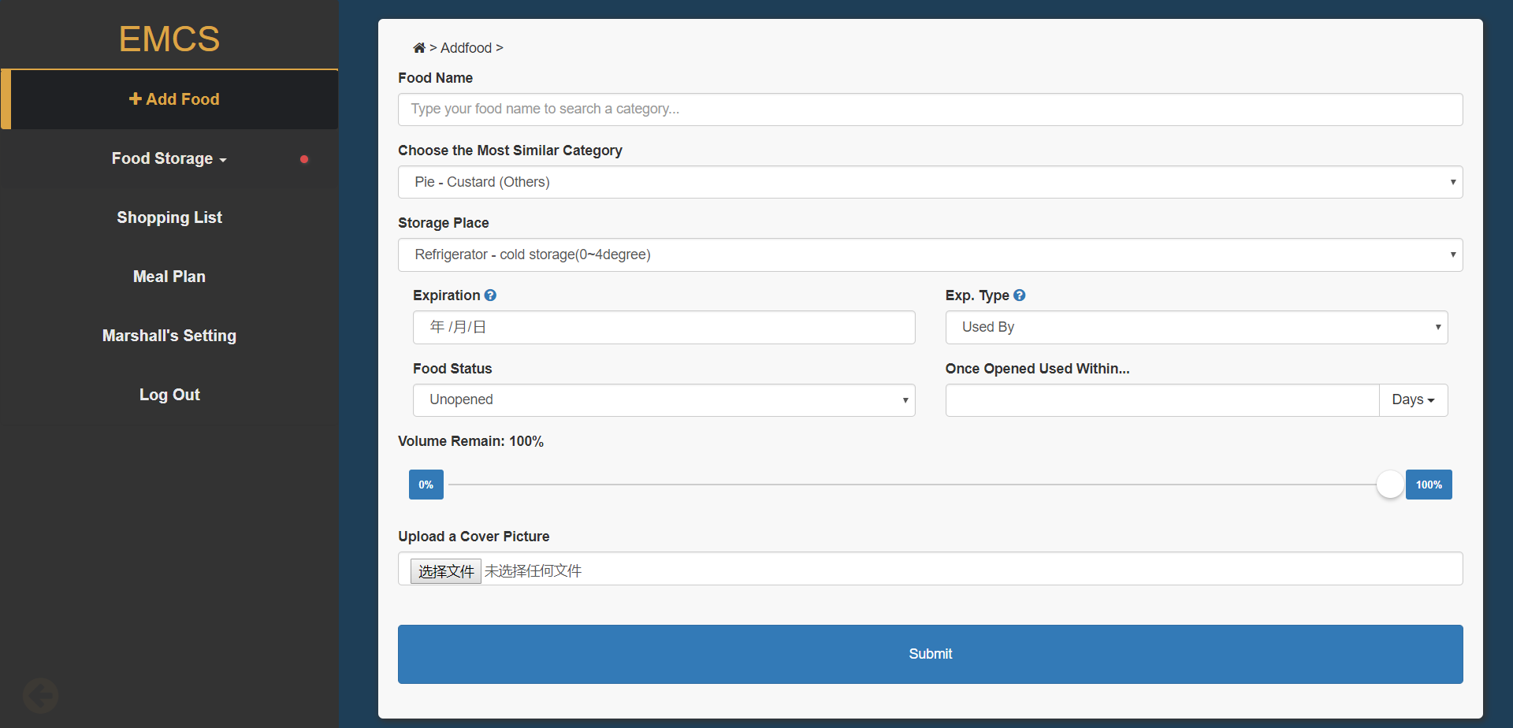 While you inputting your food name, the system will use ajax to find the most similar food category automatically. You can also click the category selection to choose the right one. If you type “– “after your food name, it will become “uncategorized”. Meanwhile, a food storage shelf life table will be showed on the right of screen, which give you advices on food storage.

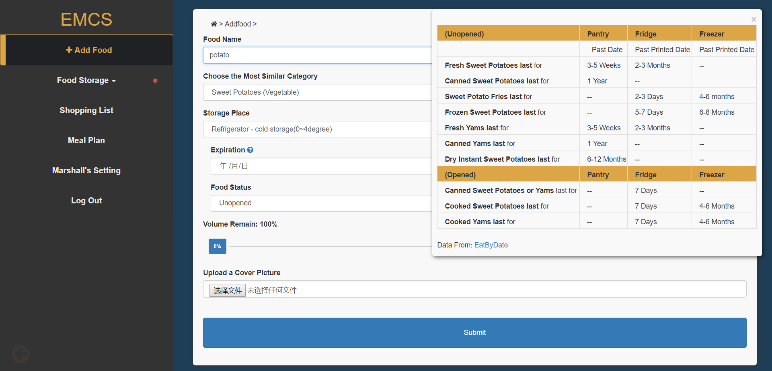

You can input relevant information references to the table, if you are not sure about your food expiration dates. The data is from <http://www.eatbydate.com/>. Moreover, you can upload a photo of your food, if you do not want to use default picture. Finally, clicking “Submit” button, and you will see your food in the storage.

* Remove & Edit Food

In the food storage page, you can click on “Remove” button to remove the food, and you can also click on “More” button to open the editing form, which is quite similar to the one adding new food. You can change information and click “Edit” button to submitting.

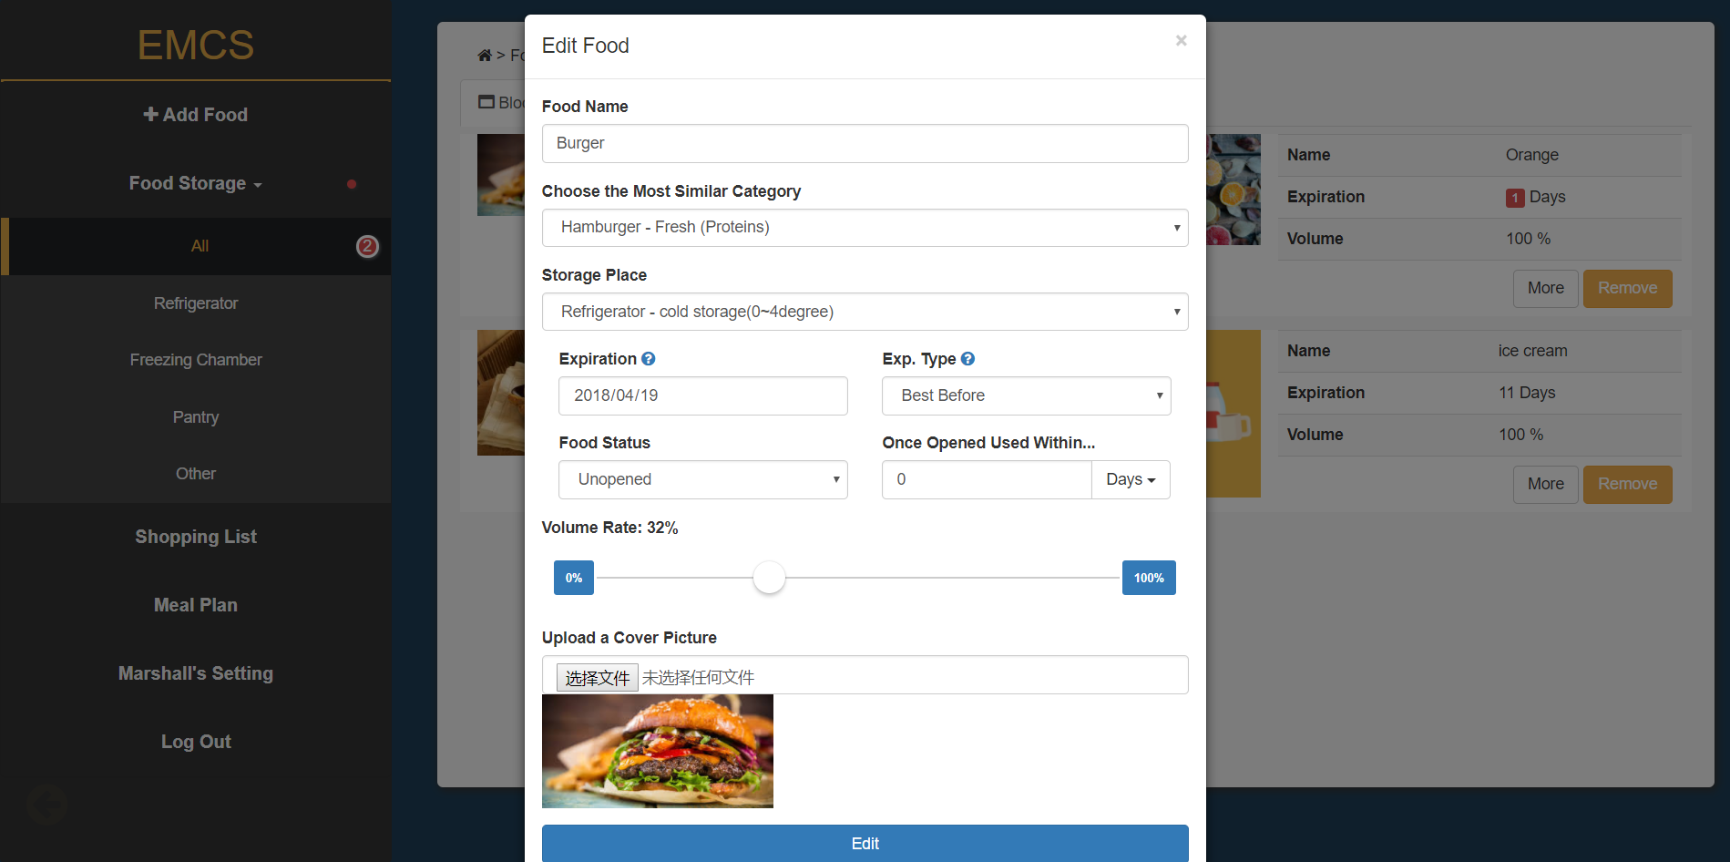

* Shopping List

Clicking on “Shopping List” on the left navigation bar, you will see your shopping list, which could remind you while shopping. You can tick the bought button after you have bought, and then you can click “Move” button to move it to your storage. The form is also similar to the add food form.

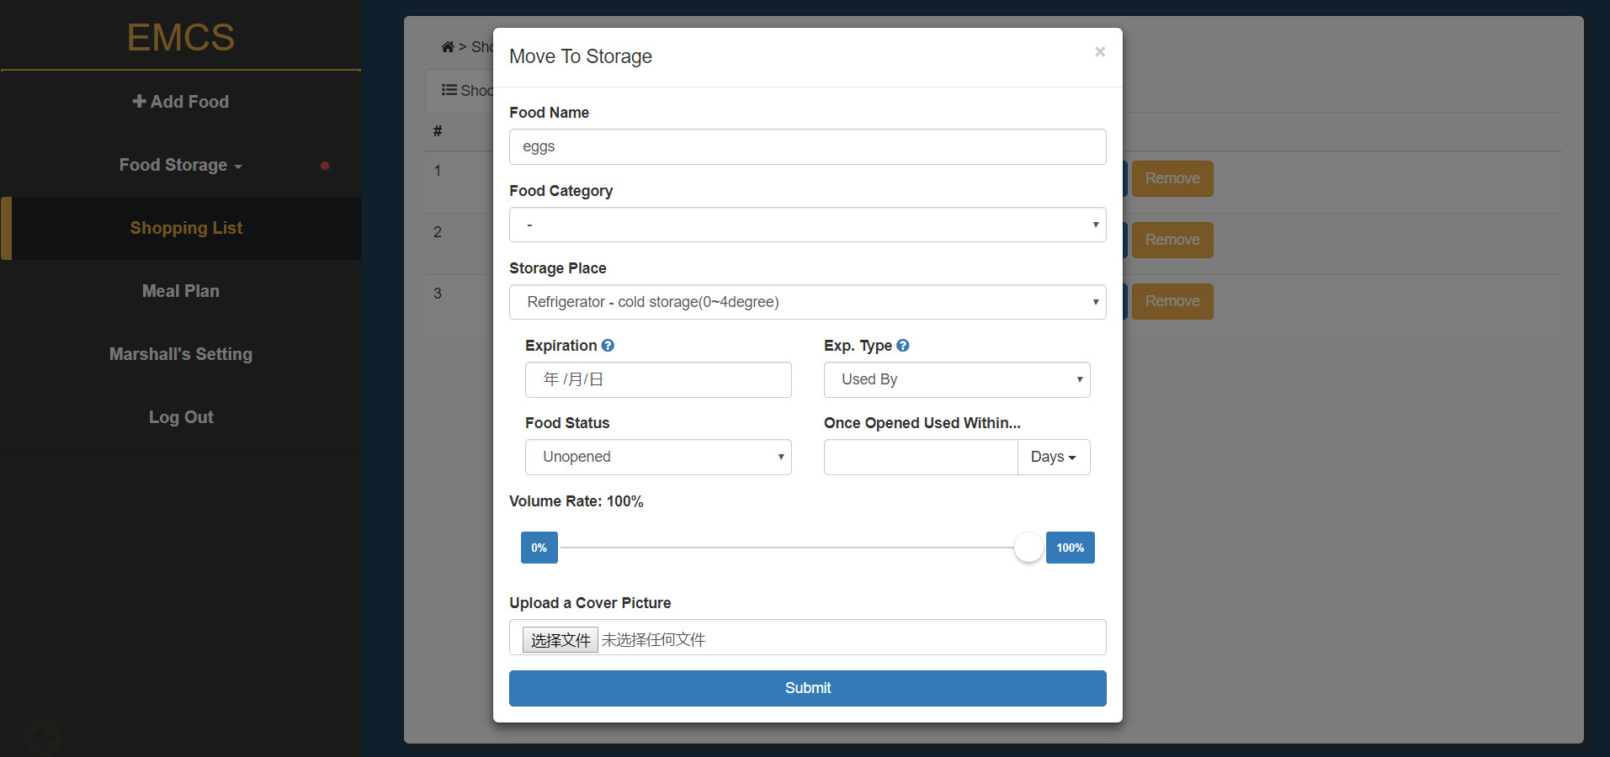

Moreover, you can click “Remove” button to delete items in shopping list and click “Edit” button to change items information in following form.

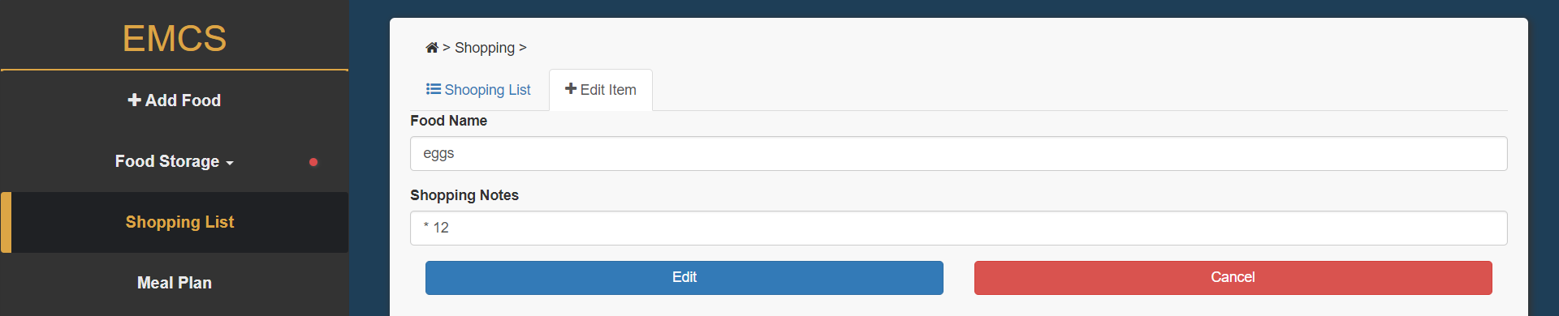

When you click on the “Add New Item” on the top tab, you will get a similar form to add new items in your shopping list.

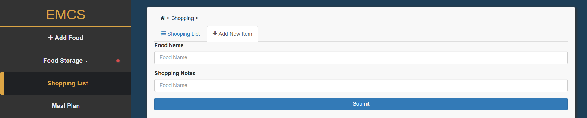

* Meal Plan

When you click on “Meal Plan” on the left navigation, you will get recipes recommendations according to your food. You may get an empty state like following if system cannot find a proper recipe which contains all of your food. Try to only tick some of your food, and click on “Search Recipes” button, and you will get a list of recipes based on your selected food.

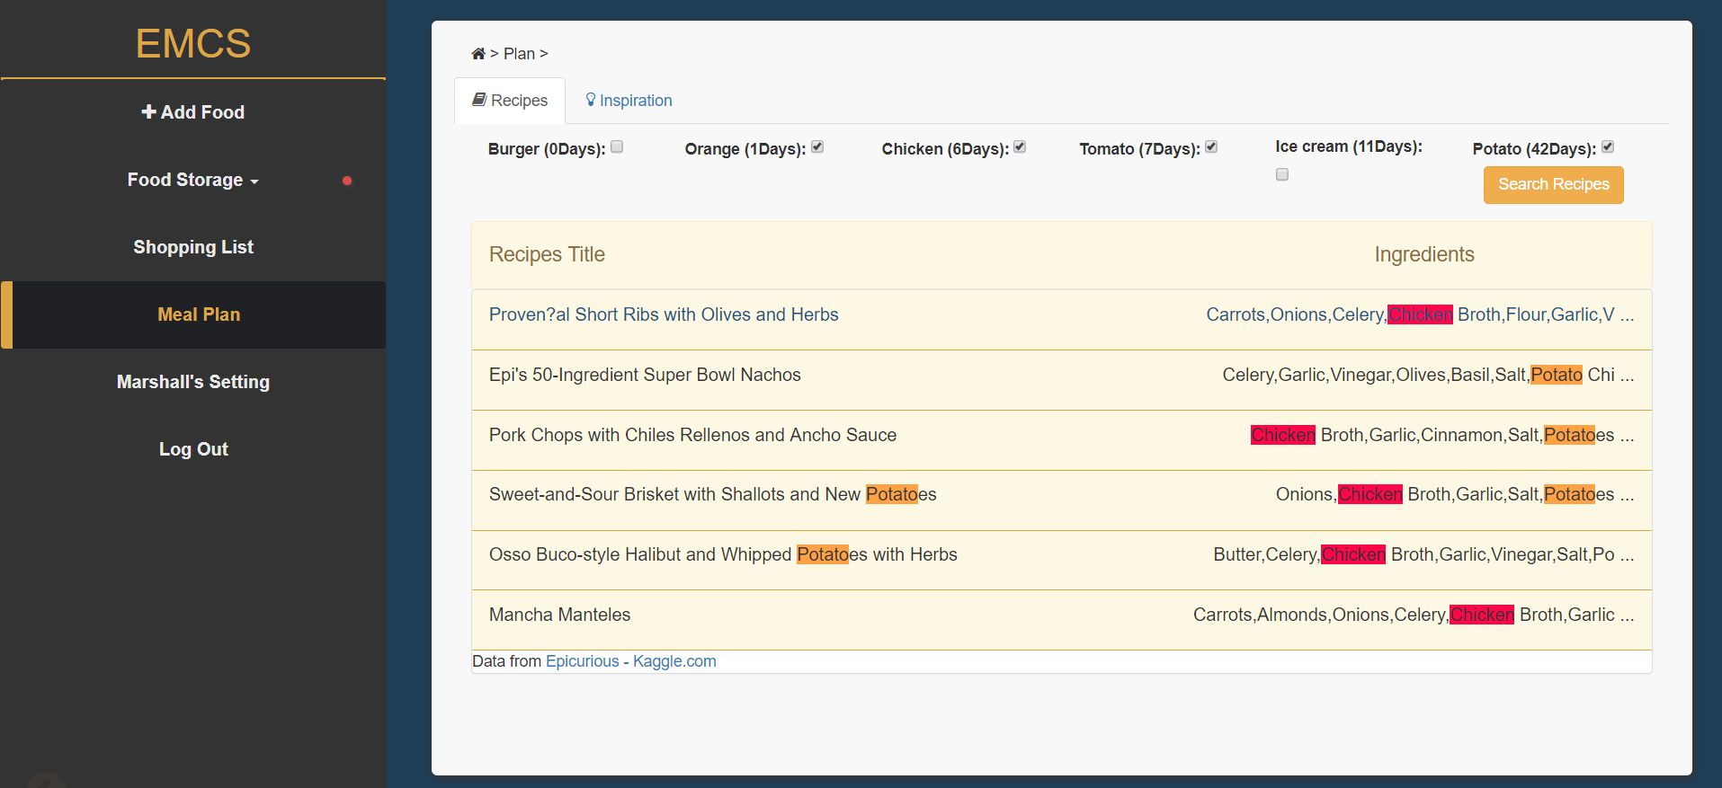

Your food will be highlighted in the recipes title and the ingredients list. Click on one of recipe, you will see detail ingredients, direction, calories, and rating from [Epicurious](https://www.kaggle.com/hugodarwood/epirecipes), like following. When you click on” Consume Selected Foods”, you can consume all your selected food once. 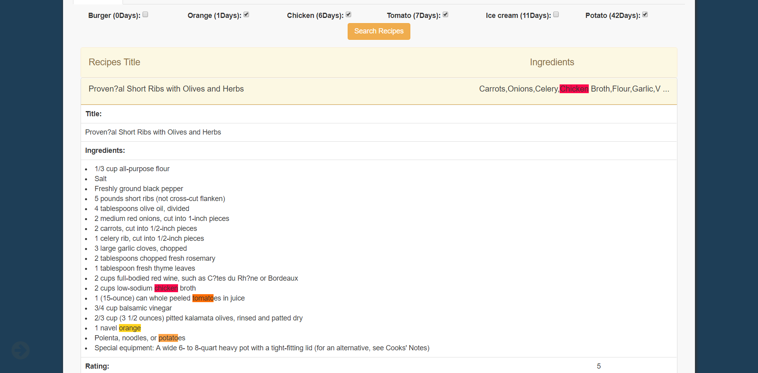 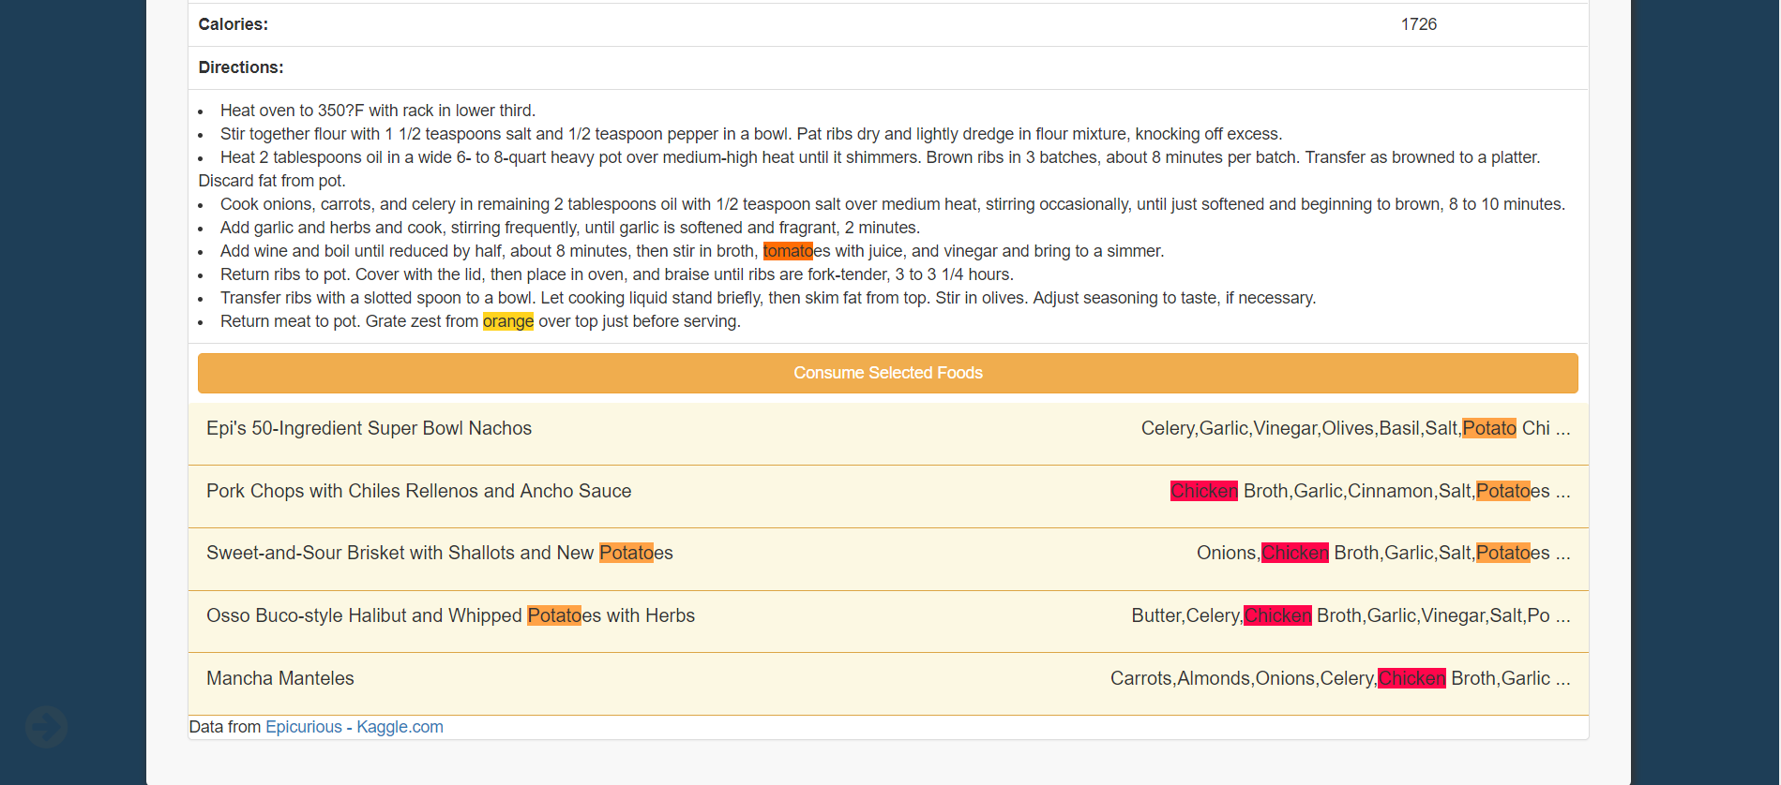

Moreover, clicking the “Inspiration” tab can show you the associations relationships among foods.

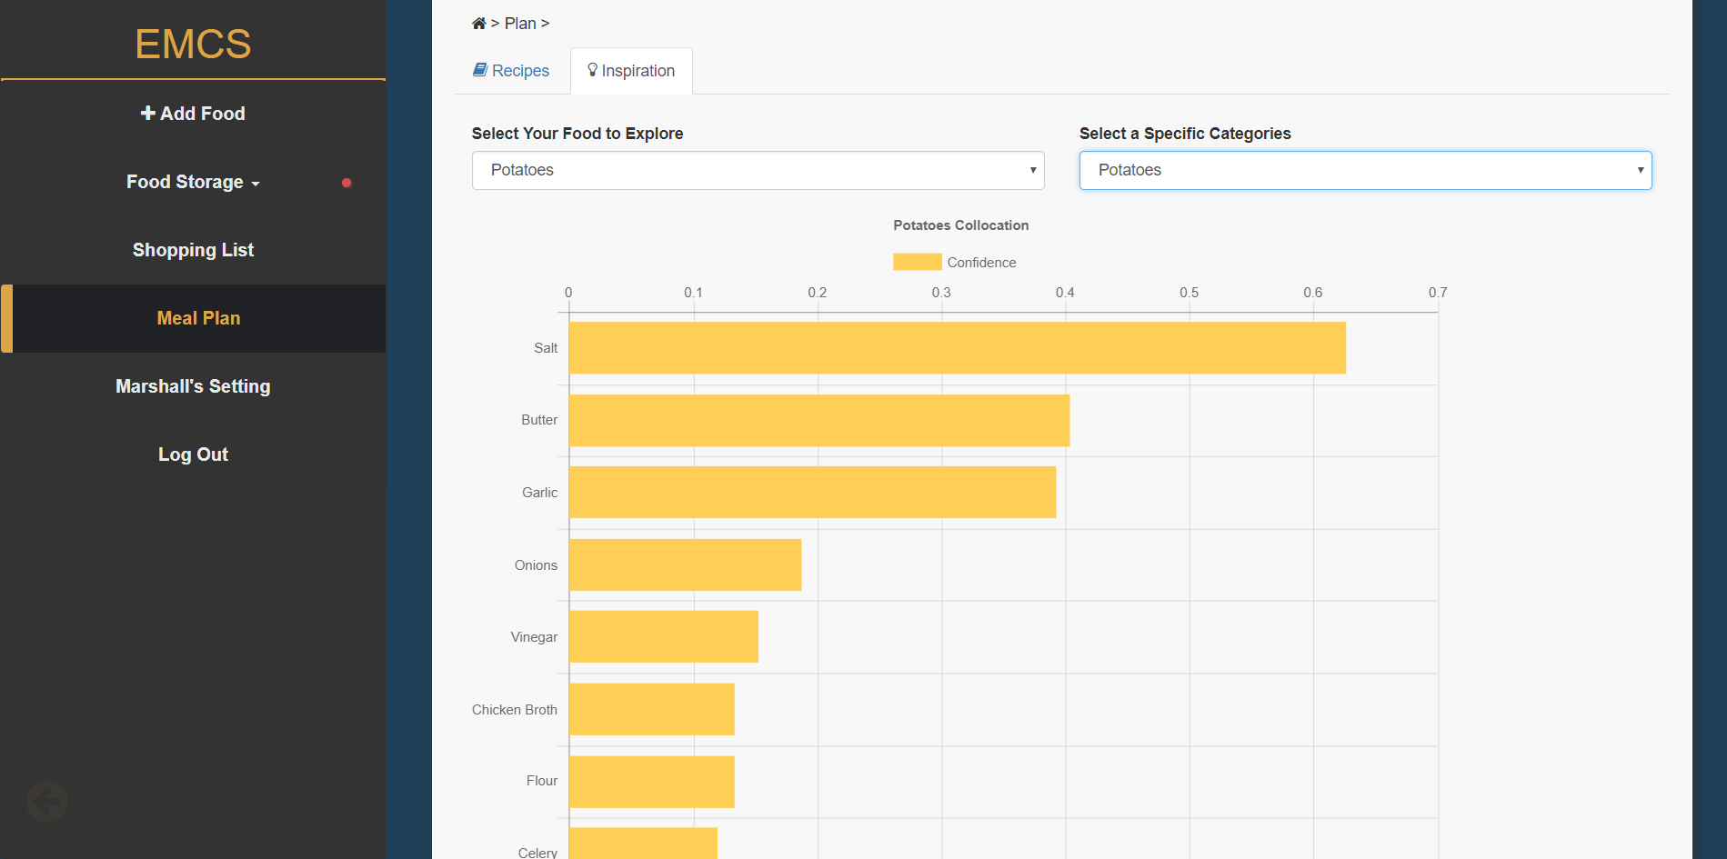

You can select one of your food from your storage, and it will find the most related foods, based on the data from [Epicurious](https://www.kaggle.com/hugodarwood/epirecipes). Explore it and find interesting relationships, you may create new recipes according to it.

* Account Setting

Clicking on “Your Setting” on the left navigation will leads you to the account setting page like following. You can change your password, email and more of your profile information.

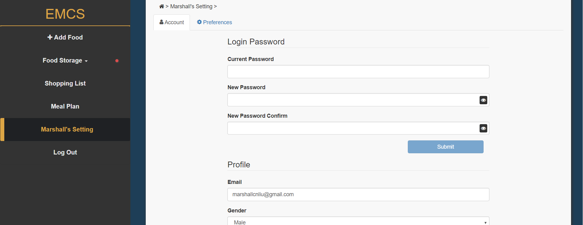

Clicking on the “Preferences” tab on the top, it will lead you to the following page. You can choose open or close Chrome and Email notification and set the ahead of days and repeat times.

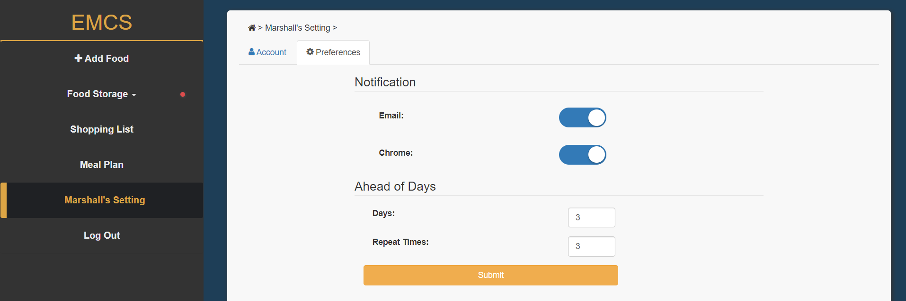

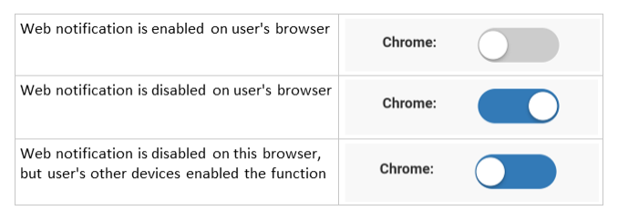User can set different chrome notification preferences on different devices. Following table shows 3 conditions.

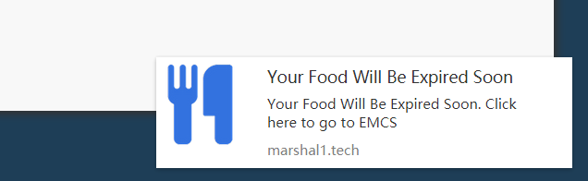A Chrome Notification will be showed like following, even have not open the EMCS website in your Chrome. And if you click on it, it will lead you to the EMCS system. It can work on Chrome browser in both PC and Android devices.

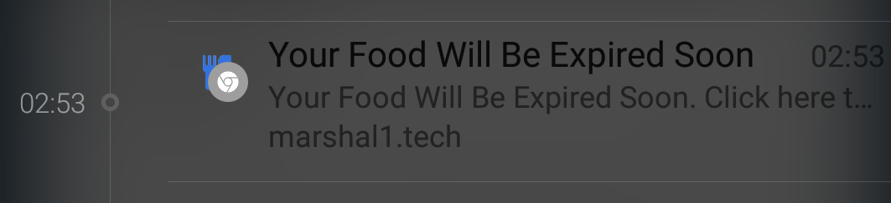The Chrome notification on Andoid sevices will be similar to following:

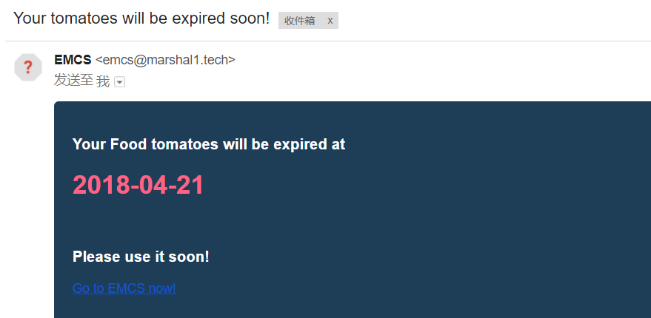And an email notification will be similar to following:

Moreover, if you cannot receive this email, please check you trash bin, and move it to your inbox. In setting page “Days” is default set to 3, which means it will notify you 3 days before a food expired, and “repeat time” is set to 3, which means it will notify you 3 times (once a day) before a food expired.

* Compatibility

This system could run in most current web browser, due to its responsive design. But the Web notification function is only available for Chrome browser on Android and PC, IOS is not supported.

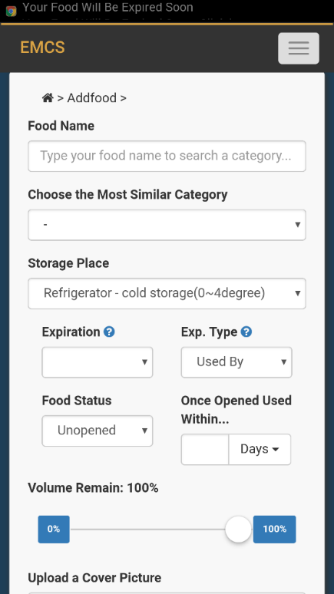Following screenshots shows the system sunning on Android and IOS phone.

