1997B2 (modified)

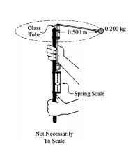 a) Explain how the students, by using a timer and the information given above, can determine the speed of the ball as it is revolving.

b) The speed of the ball is determined to be 3.7 m/s. Assuming that the cord is horizontal as it swings, calculate the expected tension in the cord.

c) The actual tension in the cord as measured by the spring scale is 5.8 N. What is the percent difference between this measured value of the tension and the value calculated in part b.?

d)

i) On the picture of the ball below, draw vectors to represent the forces acting on the ball and identify the force that each vector represents.

ii) Explain why it is not possible for the ball to swing so that the cord remains exactly horizontal.

iii) Calculate the angle that the cord makes with the horizontal