**Student Number : __A00248125__**

**Web Technologies – Write Up for Sprint#1**

Sprint #1 Stories

1. As a customer, I want to display the home page, so that I can view current special offers.
2. As a customer, I want to display all the products with their names, prices and descriptions, so that I can easily find product.
3. As a customer, I want to display 2 products per row on small devices, so that I can easily find product.
4. As a customer, I want to display 3 products per row on medium devices, so that I can easily find product.
5. As the administrator, I want to display all products in a table, so that I can view all products.
6. As the administrator, I want to display one product in popup box, so that I can view the details.
7. As the administrator, I want to select a product to update information, so that I can keep information updated.
8. As the administrator, I want to delete a product, so that I can remove unavailable products.
9. As the administrator, I want to create a new product, so that I can add new products.
10. As the administrator, I want to be notified with the result when I tried to make any change, so that I am aware if the data in database has been modified.

Test Documentation

# Manual Testing

|  |  |
| --- | --- |
| User Story | As a customer, I want to display the home page, so that I can view current special offers. |
| Test Case ID | 1 |
| Description | Display Home Page |
| Preconditions | Server is running  The browser is open |
| Actions | The address ‘http://localhost:8080/SmurfShop/’ is entered in the browser |
| Expected Results | Home Page is displayed. |
| Test Status | Passed |

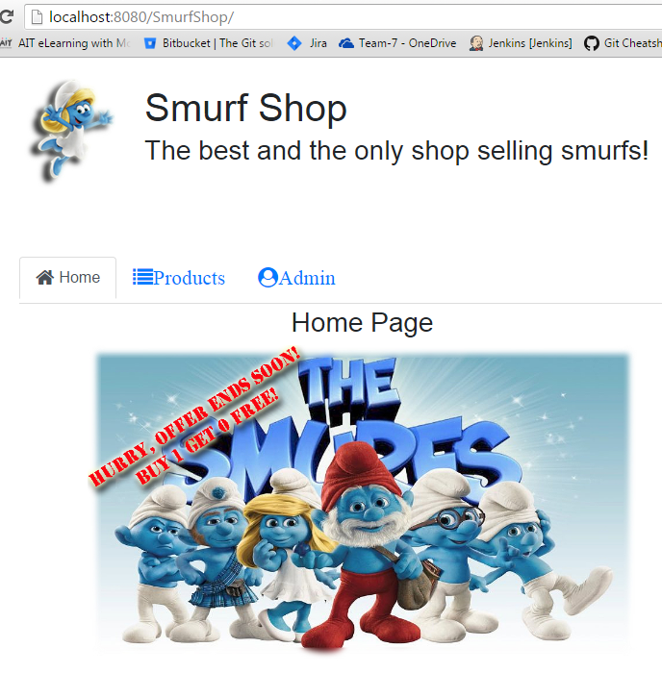

Test Documentation

# Manual Testing

|  |  |
| --- | --- |
| User Story | As a customer, I want to display all the products with their names, prices and descriptions, so that I can easily find product. |
| Test Case ID | 2 |
| Description | Display Products Page |
| Preconditions | Server is running  The browser is open |
| Actions | The address ‘http://localhost:8080/SmurfShop/’ is entered in the browser.  Click “Products” Tab |
| Expected Results | Products Page is displayed. |
| Test Status | Passed |

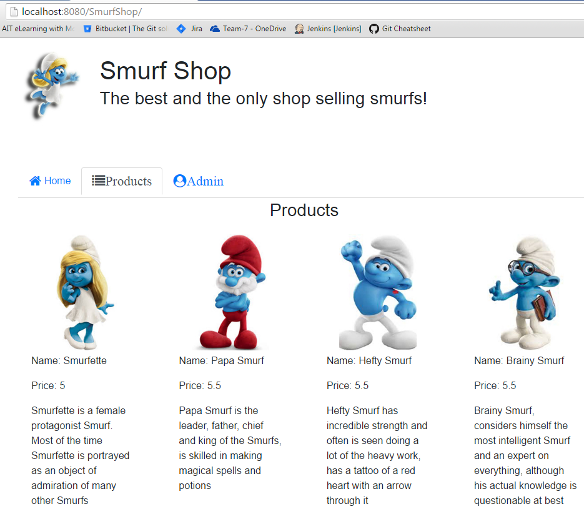

Test Documentation

# Manual Testing

|  |  |
| --- | --- |
| User Story | As a customer, I want to display 2 products per row on small devices, so that I can easily find product. |
| Test Case ID | 3 |
| Description | Display Products Page on Small Device |
| Preconditions | Server is running  The browser is open |
| Actions | The address ‘http://localhost:8080/SmurfShop/’ is entered in the browser.  Click “Products” Tab.  Change browser(eg. Chrome) setting to small device |
| Expected Results | Products page shows 2 products per row. |
| Test Status | Passed |

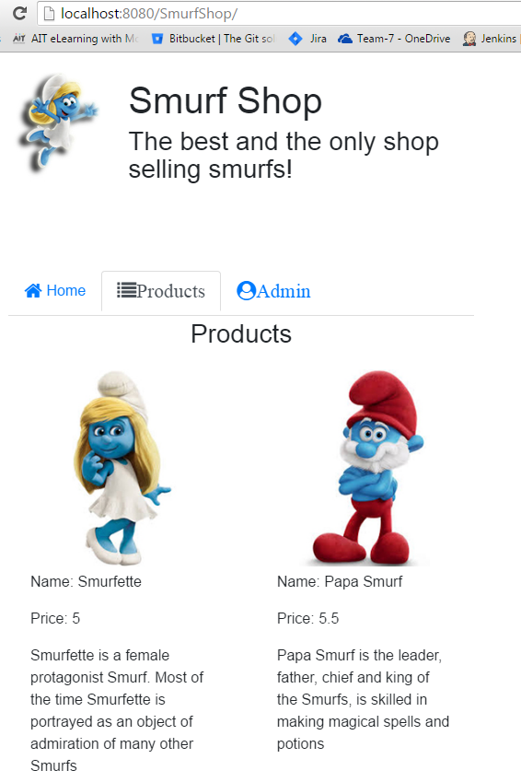

Test Documentation

# Manual Testing

|  |  |
| --- | --- |
| User Story | As a customer, I want to display 3 products per row on medium devices, so that I can easily find product. |
| Test Case ID | 4 |
| Description | Display Products Page on medium device |
| Preconditions | Server is running  The browser is open |
| Actions | The address ‘http://localhost:8080/SmurfShop/’ is entered in the browser.  Click “Products” Tab.  Change browser(eg. Chrome) setting to medium device |
| Expected Results | Products page shows 3 products per row. |
| Test Status | Passed |

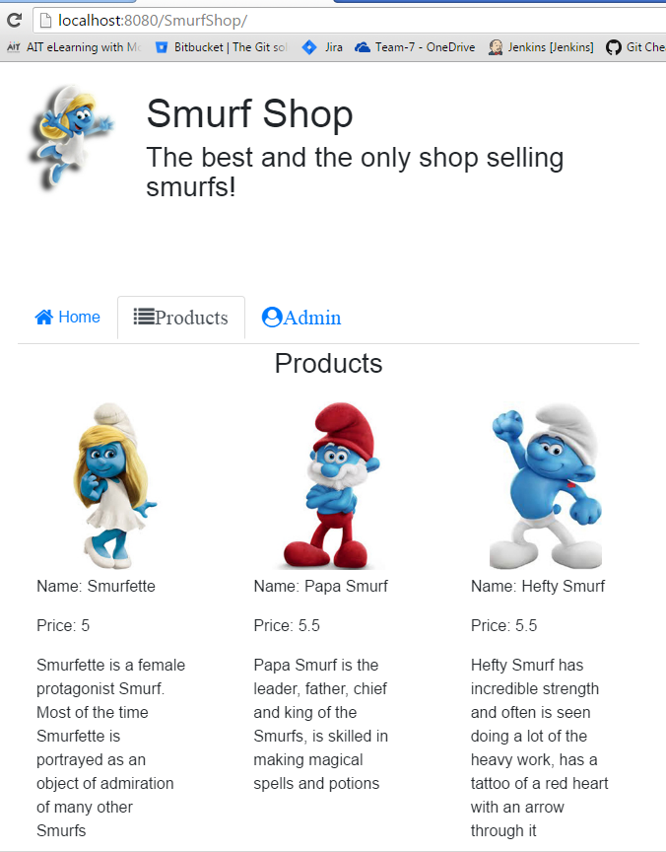

Test Documentation

# Manual Testing

|  |  |
| --- | --- |
| User Story | As the administrator, I want to display all products in a table, so that I can view all products. |
| Test Case ID | 5 |
| Description | Display Products Table |
| Preconditions | Server is running  The browser is open |
| Actions | The address ‘http://localhost:8080/SmurfShop/’ is entered in the browser  Click “Admin” tab |
| Expected Results | Products table with built-in search/page functions displayed. |
| Test Status | Passed |

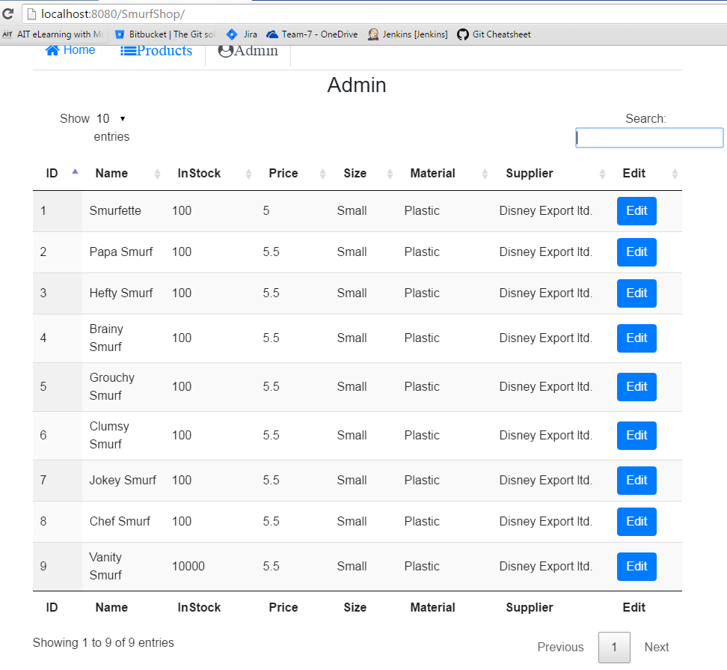

Test Documentation

# Manual Testing

|  |  |
| --- | --- |
| User Story | As the administrator, I want to display one product in popup box, so that I can view the details. |
| Test Case ID | 6 |
| Description | Display A Product in Popup Window |
| Preconditions | Server is running  The browser is open |
| Actions | The address ‘http://localhost:8080/SmurfShop/’ is entered in the browser  Click “Admin” tab  Click “Edit” for a selected product |
| Expected Results | All details about the selected product are displayed in popup window |
| Test Status | Passed |

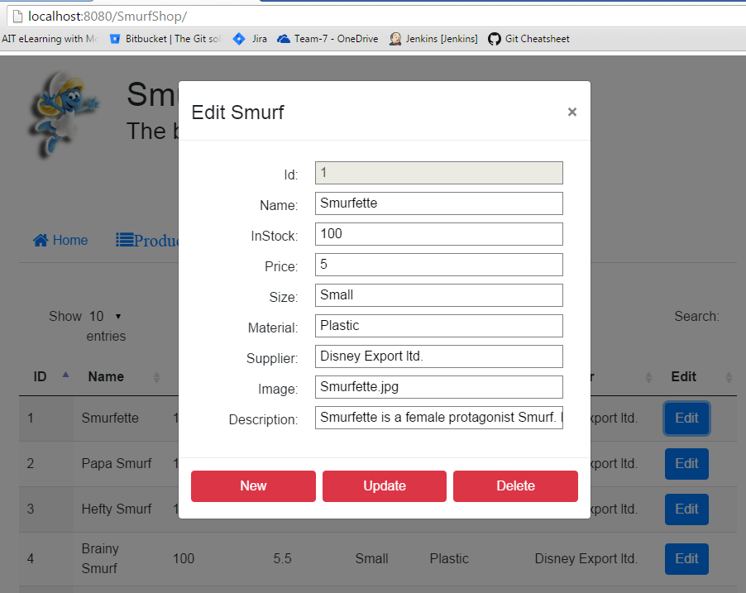

Test Documentation

# Manual Testing

|  |  |
| --- | --- |
| User Story | As the administrator, I want to select a product to update information, so that I can keep information updated. |
| Test Case ID | 7 |
| Description | Update Product |
| Preconditions | Server is running  The browser is open |
| Actions | The address ‘http://localhost:8080/SmurfShop/’ is entered in the browser  Click “Admin” tab  Click “Edit” for a selected product  Input with updated information  Click “Update” in popup window |
| Expected Results | Updated information is shown in products table |
| Test Status | Passed |

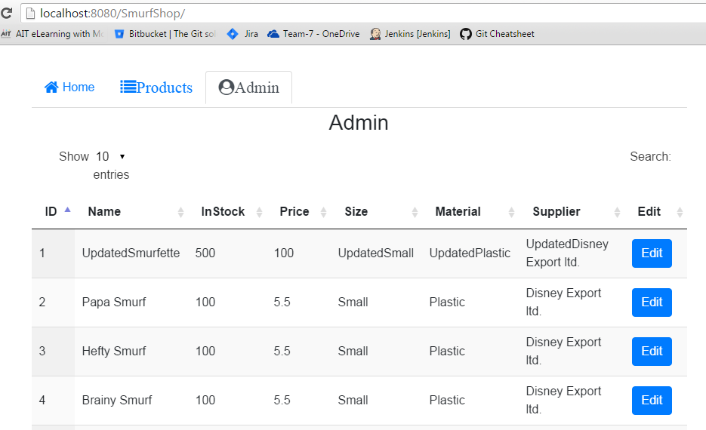

Test Documentation

# Manual Testing

|  |  |
| --- | --- |
| User Story | As the administrator, I want to delete a product, so that I can remove unavailable products. |
| Test Case ID | 8 |
| Description | Delete Product |
| Preconditions | Server is running  The browser is open |
| Actions | The address ‘http://localhost:8080/SmurfShop/’ is entered in the browser  Click “Admin” tab  Click “Edit” for a selected product  Click “Delete” in popup window |
| Expected Results | Selected product is removed from products table |
| Test Status | Passed |

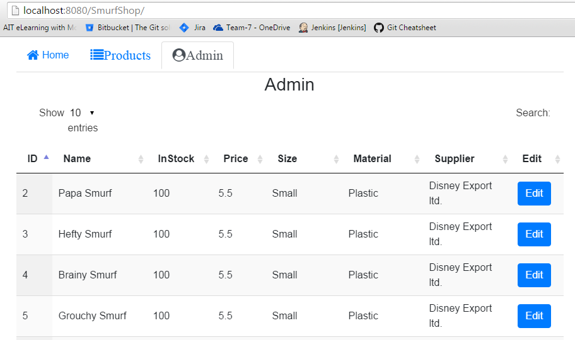

Test Documentation

# Manual Testing

|  |  |
| --- | --- |
| User Story | As the administrator, I want to create a new product, so that I can add new products. |
| Test Case ID | 9 |
| Description | Create Product |
| Preconditions | Server is running  The browser is open |
| Actions | The address ‘http://localhost:8080/SmurfShop/’ is entered in the browser  Click “Admin” tab  Click “Edit” for a selected product  Click “New” in popup window  Input details of new product  Click “Save” in popup window |
| Expected Results | New product is displayed in products table |
| Test Status | Passed |

# 

Test Documentation

# Manual Testing

|  |  |
| --- | --- |
| User Story | As the administrator, I want to be notified with the result when I tried to make any change, so that I am aware if the data in database has been modified |
| Test Case ID | 10 |
| Description | Display Notification |
| Preconditions | Server is running  The browser is open |
| Actions | The address ‘http://localhost:8080/SmurfShop/’ is entered in the browser  Click “Admin” tab  Click “Edit” for a selected product  Click “Delete” in popup window |
| Expected Results | Notification is displayed what has been done to the database |
| Test Status | Passed |

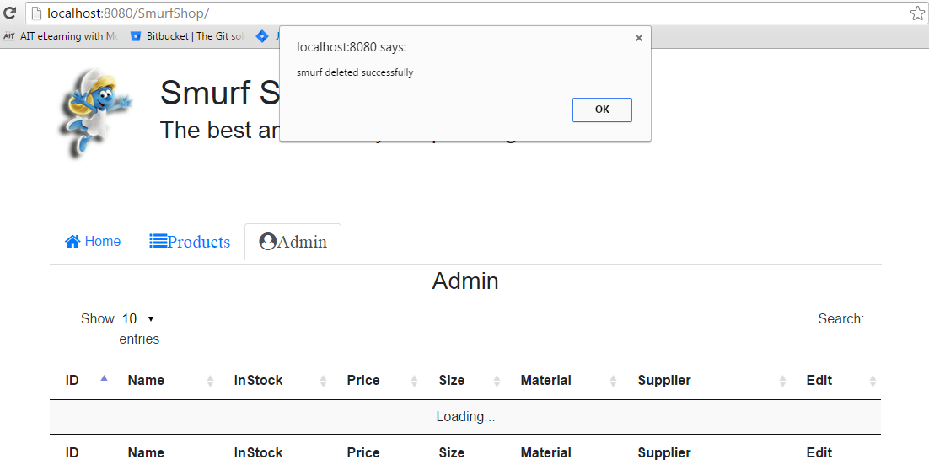

Test Documentation

# Manual Testing

|  |  |
| --- | --- |
| User Story | As the administrator, I want to be notified if the expected change has not been saved in the database, so that I am aware if the data in database has been modified |
| Test Case ID | 11 |
| Description | Display Notification |
| Preconditions | Server is running  The browser is open |
| Actions | The address ‘http://localhost:8080/SmurfShop/’ is entered in the browser  Click “Admin” tab  Click “Edit” for a selected product  Click “New” and input invalid price “1.adb0” |
| Expected Results | Notification is displayed data failed to save. |
| Test Status | Passed |

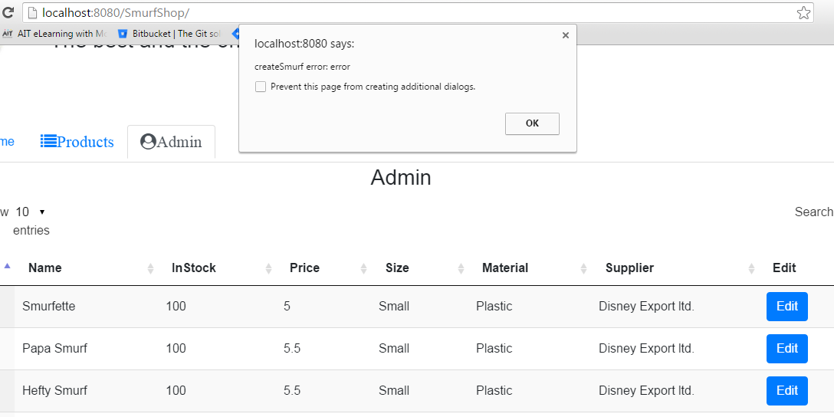

# Bug Report

There are currently no known existing bugs in this project.

# Backbone.js Implementation

**Overview**

BackboneJS, and UnderscoreJS are used in Sprint2, all functionalities are the same as in Sprint1.

Collections, Models, Views, and Templates are used to restructure client side java Script.

No changes are made on the server side.

Products page/tab

Collections smurfs fetch data from server, and when the fetch is success, it calls smurfsView.render()

smurfsView.render() use collection.each(…) to call each Model smurf -> smurfView ({model:smurf})

Admin page/tab

Call smurfsTableView.render() -> fetch data from Server for Collection smurfs,

smurfs is used to generate DataTable

When ‘Edit’ button is clicked, a Model smurf is created based on the data of the clicked row.

smurfModalView.render() is called by passing Model smurf to the View.

When ‘update’/’save’/’delete’ button is clicked, current input information in the popup modal will be used to generate a Model smurf, and save()/destroy() will be used to send Http request to the server for CRUD operations.

**Models**

Model Smurf is created for smurf object

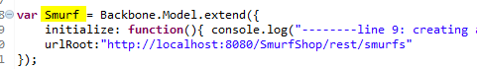

**Collections**

Collection Smurfs is created for all smurfs fetched from the server

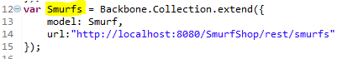

**Views**

4 Views are created

SmurfView is used to show a single smurf on Products page.

SmurfsView is used to show all the ‘single smurfs’ on Products page.

SmurfsTableView is used to generate DataTable on Admin page.

SmurfModalView is used to generate popup modal when ‘Edit’ button is clicked on Admin page.

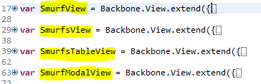

**Templates**

2 templates are used,

**#smurfTemplate** to show every smurf on Products page/tab

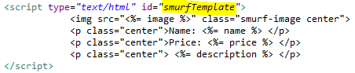

**#smurfModalTemplate** to show popup modal when ‘edit’ is clicked on Admin page/tab

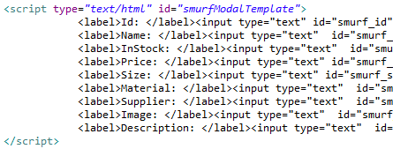

**Problems Encountered**

When click ‘edit’ button in datatable, I was expecting a model object will be returned based on the row/id. But couldn’t get it. I have to use the data to generate a new model, which I think it’s unnecessary.



The same issue when click the CRUD buttons on the popup modal window. I was expecting the data could be synced with the model automatically, but I have to generate a new model from all the input boxes.

I have to run smurfsTableView.render() after every CRUD operations. The sync events in collections should refresh datatable automatically. In my project, I only need to add one line of codes to refresh datatable, but I should use sync events in collections which is an important feature in Backbone JS.