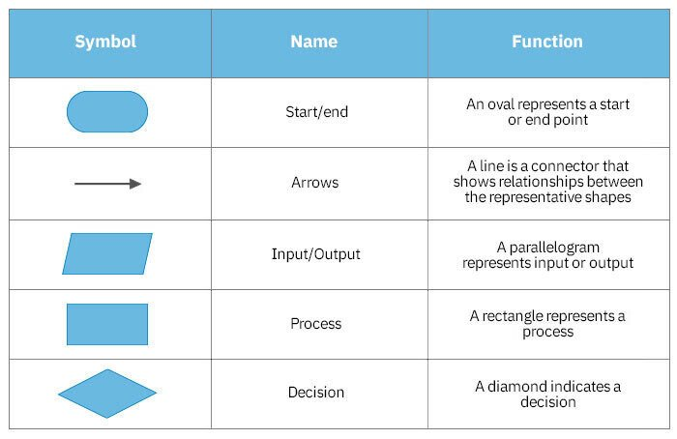Everything is explained further below

0

No, End or enemy interactions

Level passed

Player touch End

Death

process

7.Enemy touch player

Yes ,Did player die or finish

finish, load new level

Die, restart level

6.Is game over?

4.Process movement

3.Movement input

2.Everything is

Initialized And loaded

5.Player Moves

End reached

Player dies

First the game starts, the first level, the player, and the objects and entities are loaded in. The movements are inputted and the player moves as the output, the game then checks if the game is over, If it is, it checks if the player was killed by an enemy or the end has been reached, if the player died, the game is restarted. If the end was reached, the next level is loaded. If the game hasn’t ended, the game checks to see if the player has touched the enemy, if yes, player dies, and goes back to is game over decision. It also checks if the player has reached the end or not, then it goes to the is game over decision and processes the next level