МІНІСТЕРСТВО ОСВІТИ І НАУКИ УКРАЇНИ

НАЦІОНАЛЬНИЙ УНІВЕРСИТЕТ «ЛЬВІВСЬКА ПОЛІТЕХНІКА»

ІНСТИТУТ КОМП'ЮТЕРНИХ НАУК ТА ІНФОРМАЦІЙНИХ ТЕХНОЛОГІЙ

Кафедра ІСМ



Звіт

до лабораторної роботи №1

На тему “Введення в Python”

З дисципліни “Спеціалізовані мови програмування”

*Виконав:*

*ст. гр. ІТ-31*

*Лисецький Володимир*

*Прийняв:*

*Щербак С. С.*

*Львів - 2023*

**Мета роботи:** створення консольної програми-калькулятора за допомогою основних синтаксичних конструкцій Python, з іншим завданням на заміну тестуванню та валідації.

**Хід роботи**

**Програмний код:**

/math_operations/math_operations

import math

def calculate(operation, decimals):

first_number, second_number, operator = operation

try:

if operator == "+":

operation.append(first_number + second_number)

elif operator == "-":

operation.append(first_number - second_number)

elif operator == "*":

operation.append(first_number * second_number)

elif operator == "/":

operation.append(first_number / second_number)

elif operator == "^":

operation.append(first_number**second_number)

elif operator == "%":

operation.append(first_number % second_number)

elif operator == "sqrt":

print("Warning: Square root function takes only first number")

operation.pop(1)

operation.append(math.sqrt(first_number))

print("Result: " + str(round(operation[-1], decimals)))

return operation

except ZeroDivisionError:

print("error: you can not divide by zero")

def check():

operation = []

while True:

try:

first_number = float(input("Enter the first number: "))

second_number = float(input("Enter the second number: "))

if not (

isinstance(first_number, (int, float))

and isinstance(second_number, (int, float))

):

raise ValueError("Both inputs must be numbers (int or float).")

operation = [first_number, second_number]

except ValueError as e:

print(f"Error: {e}")

continue

while len(operation) == 2:

try:

operator = input("Enter the operator (+, -, /, *, ^, %, sqrt): ")

if operator not in ("+", "-", "/", "*", "^", "%", "sqrt"):

raise ValueError(

"Invalid operator. Please enter one of: +, -, /, *, ^, %, sqrt"

)

operation.append(operator)

return operation

except ValueError as e:

print(f"Error: {e}")

continue

def calculator(decimals):

operation = check()

result = calculate(operation, decimals)

return result

def get_operation(history, decimals):

while True:

try:

index = int(input("Insert number of operation from history: "))

if index < 1 or index > len(history):

print("Error: Index is out of range. Please enter a valid index.")

continue

operation = history[index - 1]

if len(operation) == 3:

print(

f"{index}. {operation[1]} {round(operation[0], decimals)} = {round(operation[-1], decimals)}"

)

else:

print(

f"{index}. {round(operation[0], decimals)} {operation[2]} {round(operation[1], decimals)} = {round(operation[-1], decimals)}"

)

return 0

except ValueError as e:

print(f"Error: {e}")

continue

def append_history(history, operation, history_limit):

history.append(operation)

if len(history) > history_limit:

history = history[-history_limit:]

return history

def print_history(history):

print("Calculations history:")

indexes = [0, 2, 1]

index_number = 1

for item in history:

if len(item) == 3:

print(f"{index_number}. {item[1]} {item[0]} = {item[-1]}")

elif len(item) == 4:

formatted_item = " ".join([str(item[i]) for i in indexes])

print(f"{index_number}. {formatted_item} = {item[-1]};")

index_number += 1

def settings(history_limit, decimals):

while True:

print(

f"""

===SETTINGS===

1 - Set history limit | Current: {history_limit}

2 - Set number of decimal digits | Current: {decimals}

0 - Exit to the menu

"""

)

choice = input("Insert a value: ")

if choice == "1":

# Set history limit

history_limit = int(input("Enter history limit: "))

print(f"History limit set to {history_limit}")

elif choice == "2":

# Set number of decimal digits

decimals = int(input("Enter the number of decimal digits: "))

print(f"Decimal digits set to {decimals}")

elif choice == "0":

break

else:

print("Choose a correct option.")

return decimals, history_limit

def menu():

# default settings

decimals = 1

history_limit = 10

history = []

while True:

print(

"""

Welcome to calculator!

Menu:

1 - Make a calculation

2 - Show history

3 - Show specific operation from history

4 - Settings

0 - Exit

"""

)

choice = input("Insert a value: ")

if choice == "1":

operation = calculator(decimals)

history = append_history(history, operation, history_limit)

elif choice == "2":

print_history(history)

elif choice == "3":

get_operation(history, decimals)

elif choice == "4":

decimals, history_limit = settings(history_limit, decimals)

elif choice == "0":

return 0

else:

print("Choose a correct option.")

if __name__ == "__main__":

menu()

Результат виконання програми:

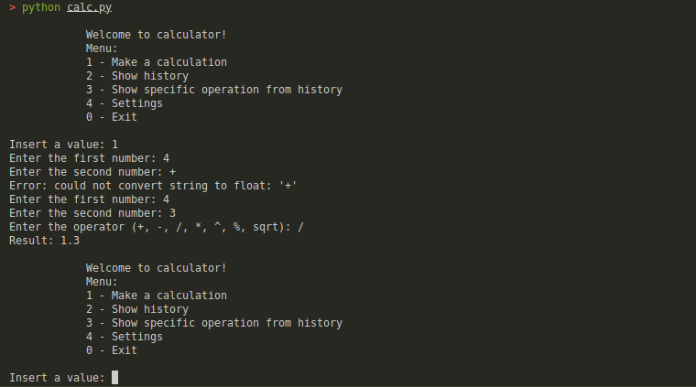

**Висновок:** Під час виконання даної лабораторної роботи було створено консольну програму-калькулятор за допомогою основних синтаксичних конструкцій Python.