МІНІСТЕРСТВО ОСВІТИ І НАУКИ УКРАЇНИ

НАЦІОНАЛЬНИЙ УНІВЕРСИТЕТ «ЛЬВІВСЬКА ПОЛІТЕХНІКА»

ІНСТИТУТ КОМП'ЮТЕРНИХ НАУК ТА ІНФОРМАЦІЙНИХ ТЕХНОЛОГІЙ

Кафедра ІСМ



Звіт

до лабораторної роботи №7

На тему “Робота з API та веб-сервісами”

З дисципліни “Спеціалізовані мови програмування”

*Виконав:*

*ст. гр. ІТ-31*

*Лисецький Володимир*

*Прийняв:*

*Щербак С. С.*

*Львів - 2023*

**Мета роботи:** Створення консольного об’єктно - орієнтованого додатка з використанням API.

**Хід роботи**

**Програмний код:**

/handlers/APIHandler.py

import requests

class APIHandler:

def __init__(self, api_url, api_key=None):

self.api_url = api_url

self.api_key = api_key

def set_api_key(self, api_key):

self.api_key = api_key

def fetch_data(self, endpoint, params=None):

try:

headers = {'Authorization': f'Bearer {self.api_key}'} if self.api_key else None

response = requests.get(f'{self.api_url}/{endpoint}', params=params, headers=headers)

response.raise_for_status() # Raise an error for non-200 status codes

return response.json()

except requests.RequestException as e:

print(f"Error fetching data: {e}")

return None

def post_data(self, endpoint, data=None):

try:

headers = {'Authorization': f'Bearer {self.api_key}'} if self.api_key else None

response = requests.post(f'{self.api_url}/{endpoint}', json=data, headers=headers)

response.raise_for_status()

return response.json()

except requests.RequestException as e:

print(f"Error posting data: {e}")

return None

def patch_data(self, endpoint, data=None):

try:

headers = {'Authorization': f'Bearer {self.api_key}'} if self.api_key else None

response = requests.patch(f'{self.api_url}/{endpoint}', json=data, headers=headers)

response.raise_for_status()

return response.json()

except requests.RequestException as e:

print(f"Error patching data: {e}")

return None

def delete_data(self, endpoint):

try:

headers = {'Authorization': f'Bearer {self.api_key}'} if self.api_key else None

response = requests.delete(f'{self.api_url}/{endpoint}', headers=headers)

response.raise_for_status()

return "Data deleted successfully"

except requests.RequestException as e:

print(f"Error deleting data: {e}")

return None

/dataprocess/DataParse.py

import json

from datetime import datetime

class JSONParser:

def __init__(self, json_data):

self.json_data = json_data

def json_output(self, data=None, level=0):

"""

Recursively formats and prints JSON data in a pretty way with dynamic indentation depth.

Parameters:

data (dict or list): The JSON data to format and print. If not provided, uses the data from the instance.

level (int): Current indentation level.

"""

data = data if data is not None else self.json_data

indent = 2 # Default indentation width

if level > 10: # Add a limit to recursion depth to avoid infinite loops

print("Warning: Maximum recursion depth reached.")

return

if isinstance(data, dict):

# Print curly braces for dictionaries

print("{")

for key, value in data.items():

# Indentation for each key-value pair

print(" " * (level + 1) * indent + f'"{key}": ', end="")

# Recursive call for nested structures

self.json_output(value, level + 1)

print(",")

# Closing curly brace

print(" " * level * indent + "}")

elif isinstance(data, list):

# Print square brackets for lists

print("[")

for item in data:

# Indentation for each list item

print(" " * (level + 1) * indent, end="")

# Recursive call for nested structures

self.json_output(item, level + 1)

print(",")

# Closing square bracket

print(" " * level * indent + "]")

else:

# Print primitive values

print(f'"{data}"' if isinstance(data, str) else str(data), end="")

def parse_timeline_items(self):

try:

data = self.json_data.get("data", [])

for item in data:

item_id = item.get("id")

item_type = item.get("type")

attributes = item.get("attributes", {})

item_type_attr = attributes.get("item_type")

at = attributes.get("at")

content = attributes.get("data", {}).get("content")

links = attributes.get("data", {}).get("links")

# Convert the timestamp to a datetime object

at_datetime = datetime.strptime(at, "%Y-%m-%dT%H:%M:%S.%fZ")

# Display or process the extracted information as needed

print(f"Item ID: {item_id}")

print(f"Item Type: {item_type}")

print(f"Item Type Attribute: {item_type_attr}")

print(f"At: {at_datetime}")

print(f"Content: {content}")

print(f"Links: {links}")

print("\n")

except Exception as e:

print(f"Error parsing JSON: {e}")

def parse_monitor_data(self):

try:

# Parse JSON data

parsed_data = self.json_data

# Extract monitors

monitors = parsed_data.get('data', [])

# Format and return readable output

output = ""

for monitor in monitors:

attributes = monitor.get('attributes', {})

monitor_id = monitor.get('id', '')

monitor_type = attributes.get('monitor_type', '')

status = attributes.get('status', '')

url = attributes.get('url', '')

output += f"Monitor ID: {monitor_id}\n"

output += f"Monitor Type: {monitor_type}\n"

output += f"Status: {status}\n"

output += f"URL: {url}\n"

output += "-" * 30 + "\n"

print(output)

return output

except json.JSONDecodeError as e:

return f"Error decoding JSON: {e}"

def parse_incidents(self):

incidents = self.json_data.get("data", [])

output = ""

for incident in incidents:

incident_id = incident.get("id", "N/A")

incident_type = incident.get("type", "N/A")

incident_attributes = incident.get("attributes", {})

name = incident_attributes.get("name", "N/A")

url = incident_attributes.get("url", "N/A")

http_method = incident_attributes.get("http_method", "N/A")

cause = incident_attributes.get("cause", "N/A")

started_at = incident_attributes.get("started_at", "N/A")

acknowledged_at = incident_attributes.get("acknowledged_at", "N/A")

acknowledged_by = incident_attributes.get("acknowledged_by", "N/A")

resolved_at = incident_attributes.get("resolved_at", "N/A")

resolved_by = incident_attributes.get("resolved_by", "N/A")

response_url = incident_attributes.get("response_url", "N/A")

output += f"""

Incident ID: {incident_id}

Type: {incident_type}

Name: {name}

URL: {url}

HTTP Method: {http_method}

Cause: {cause}

Started At: {started_at}

Acknowledged At: {acknowledged_at}

Acknowledged By: {acknowledged_by}

Resolved At: {resolved_at}

Resolved By: {resolved_by}

Response URL: {response_url}

"""

print(output)

return output.strip()

def parse_monitor_sla(self):

try:

data = self.json_data.get("data", {})

attributes = data.get("attributes", {})

monitor_sla = {

"id": data.get("id", "N/A"),

"type": data.get("type", "N/A"),

"availability": attributes.get("availability", "N/A"),

"total_downtime": attributes.get("total_downtime", "N/A"),

"number_of_incidents": attributes.get("number_of_incidents", "N/A"),

"longest_incident": attributes.get("longest_incident", "N/A"),

"average_incident": attributes.get("average_incident", "N/A"),

}

print("Parsed Monitor SLA:")

for key, value in monitor_sla.items():

print(f"{key}: {value}")

except Exception as e:

print(f"Error parsing Monitor SLA JSON: {e}")

Результат виконання програми:

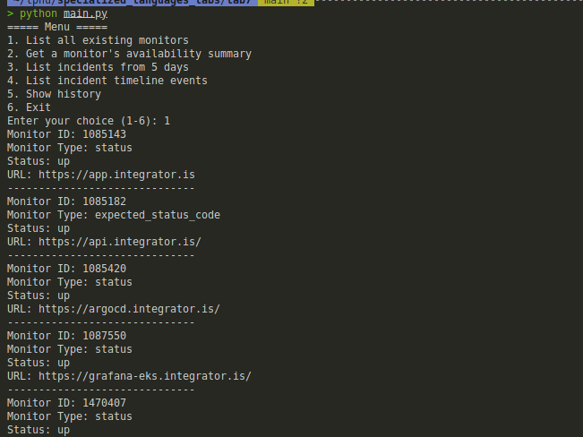

**Висновок:** Під час виконання даної лабораторної роботи було створено консольний об’єктно - орієнтований додаток÷ з використанням API.