Visual Vagrant

A Text Based Game

Nason nombrado | isham behl

2017

1. 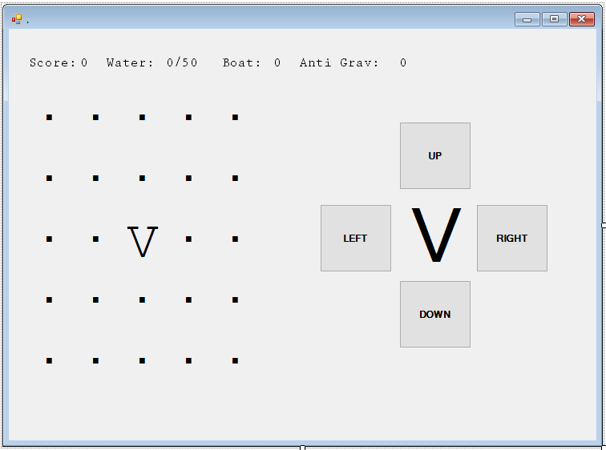Image of Designer Window (GUI)
2. Pseudocode of Application: Walking Function

The Walking feature works with variable defined memories of the each game state. Every time the player “moves” there is a change in the value of the memory.

The player is on a grid of 625 memories. The First memory is defined as 288 which is in the middle of the grid. If the player moves up, the memory will be 263 and down is 313. Left is 287 and right 289.

When Buttonup_Click

If memory = 288 Then

memory = 263

End If

When Buttondown_Click

If memory = 5 Then

memory = 313

End If

When Buttonright_Click

If memory = 1 Then

memory = memory + 1

End If

**Real Code:**

Private Sub Buttonleft_Click(ByVal sender As Object, ByVal e As System.EventArgs) Handles Buttonleft.Click

- Need to define each memory

If memory = 1 Then

memory = 1

Me.lbl1.Text = "P" Me.lbl2.Text = ","

Me.lbl3.Text = ","

Me.lbl4.Text = ","

Me.lbl5.Text = ","

Me.lbl6.Text = ","

End If

End Sub

1. Map for Visual Vagrant

|  |  |
| --- | --- |
| . . . . . . . . . . . . . . . . . . . . # # # # #  . . . . . . . . . . . . . U . . . . . . # . # D #  . . . . . . . . . . . . . . . . . . . . m . # . #  . # # # # # , # . . . . . . . . . . . . # . m . #  . # , m , / , # . . . . . . . . . . . . # # # # #  . # , # D # m # . . . . . . . . . . . . . . . . .  . # m # / # , # . . . . . . . . . . . . . . . . .  . # , , , m , # . . . . . . . . . . . . . . . . .  . # / # # # # U . . . . D . . . . . . . . T . . .  . . . . . . . . . . . . . . . . . . . . . . . . .  . . . . . . . . . . . . . . . . . . . . . . U . .  . . . . . . . . . D . . V . . D . . . . . . . . .  . . . . . . . . . . . . . . . . . . . . . . . . .  . . . U . . . . . . . . . . . . . . . . . . . . .  . . . . . . . . . . . . D . . . . . . . . . . . .  , , , . . . . . . . . . . . . U # # # # # # # # #  ~ , , . . . . . . . . . . . . # ~ ~ ~ ~ ~ ~ ~ ~ ~  ~ , , . . . . . . . . . . . . # ~ ~ ~ ~ ~ ~ ~ ~ ~  ~ , , D . . . . . . . . . . . # ~ ~ D ~ ~ ~ ~ ~ ~  ~ , , . . . . . . . . . . . . # ~ ~ ~ ~ ~ ~ ~ U ~  ~ , , . . . . . . . . . . . . # ~ ~ ~ ~ ~ ~ ~ ~ ~  , , , . . . . . . . . . . . . # # # # # # # # # #  . . . . . . . . . . . . . . . . . . . . T . . . .  . U . . . . . . . . . . . . . . . . . . . . . . .  . . . . . . . . . . . . . . . . . . . . . . . . . | Legend  Map  V - Player  . – Field: Area of random events  , – Gravel: Will use more water  # - Barrier: Cannot cross  / - Fence: Can jump over with pogo  ~ - Water: Needs boat to cross  D – Dungeon  T – Treasure  U – Well for water; water needed to travel  Entities  w - Boat  t – pogo stick  M – Boss  m – Mini Boss  E – Enemy  X – Toughened Enemy |

1. General Game Information

Camera/player (static)

Map (25 x 25) | FOV (5 x 5)

Threat chance (15%) case of 3/20

1. Objectives

The application is a game made for an entertaining experience.

Visual Vagrant is a hybrid between a text based game (Dungeon Man 2.0) and an open world, top down adventure game (The Legend of Zelda).

Players are faced with the tasks of having to survive by obtaining water, encountering enemies with different mini-games (each opening a separate form).

The game is used for a simple and meaningful narrative experience. As a heavily text-based game, players are able to experience a story while navigating through different mechanics, composed of various code structures.

The end-user of this application will be the demographic of gamers, both casual and dedicated. Due to our simple and straightforward interface and control mechanics, anyone who is willing to immerse themselves in the game can learn how to play without difficulty in comprehension.

The game is compatible with text-to-speech/screen reader software peripherals.