Capstone Project: Book-My-Show DevOps Lifecycle
Candidate Name: Sunmarsh Kumar

1. Project Overview
This document outlines the complete plan and implementation details for the Book-My-Show (BMS) DevOps Lifecycle Capstone Project. It follows a structured Agile methodology for project management using Jira and details the technical implementation of a full CI/CD pipeline, from code collaboration on GitHub to automated deployment on Docker and Kubernetes (EKS), concluding with monitoring and observability.

2. Step 1: Project Management (Jira Agile Workflow)

2.1. Project Setup and Backlog Grooming
This phase involves planning the entire project by breaking down large requirements into smaller, actionable pieces. The steps include creating Epics to represent large bodies of work, and breaking them into Stories and Tasks with effort estimation (using Story Points).

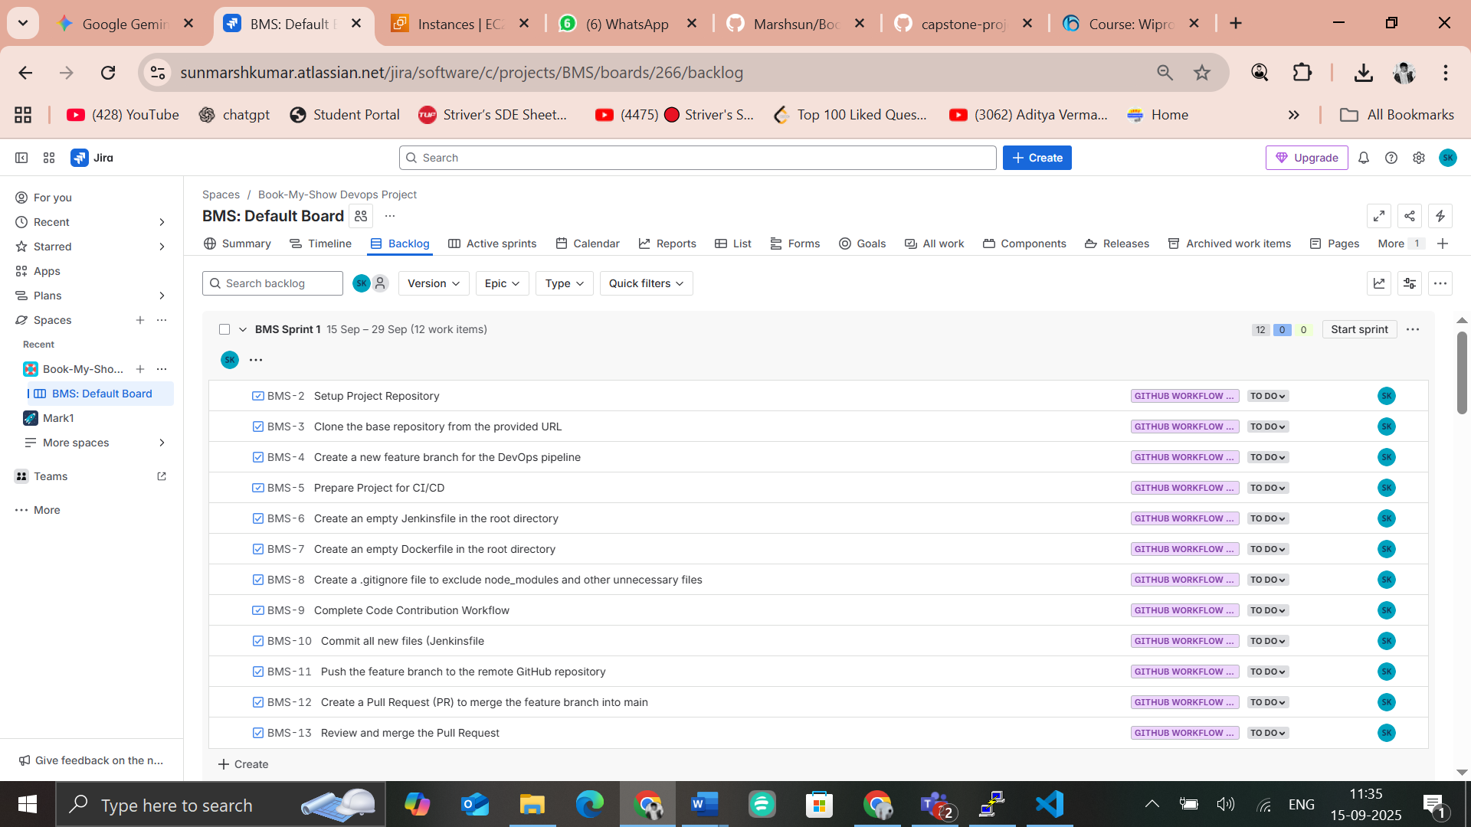
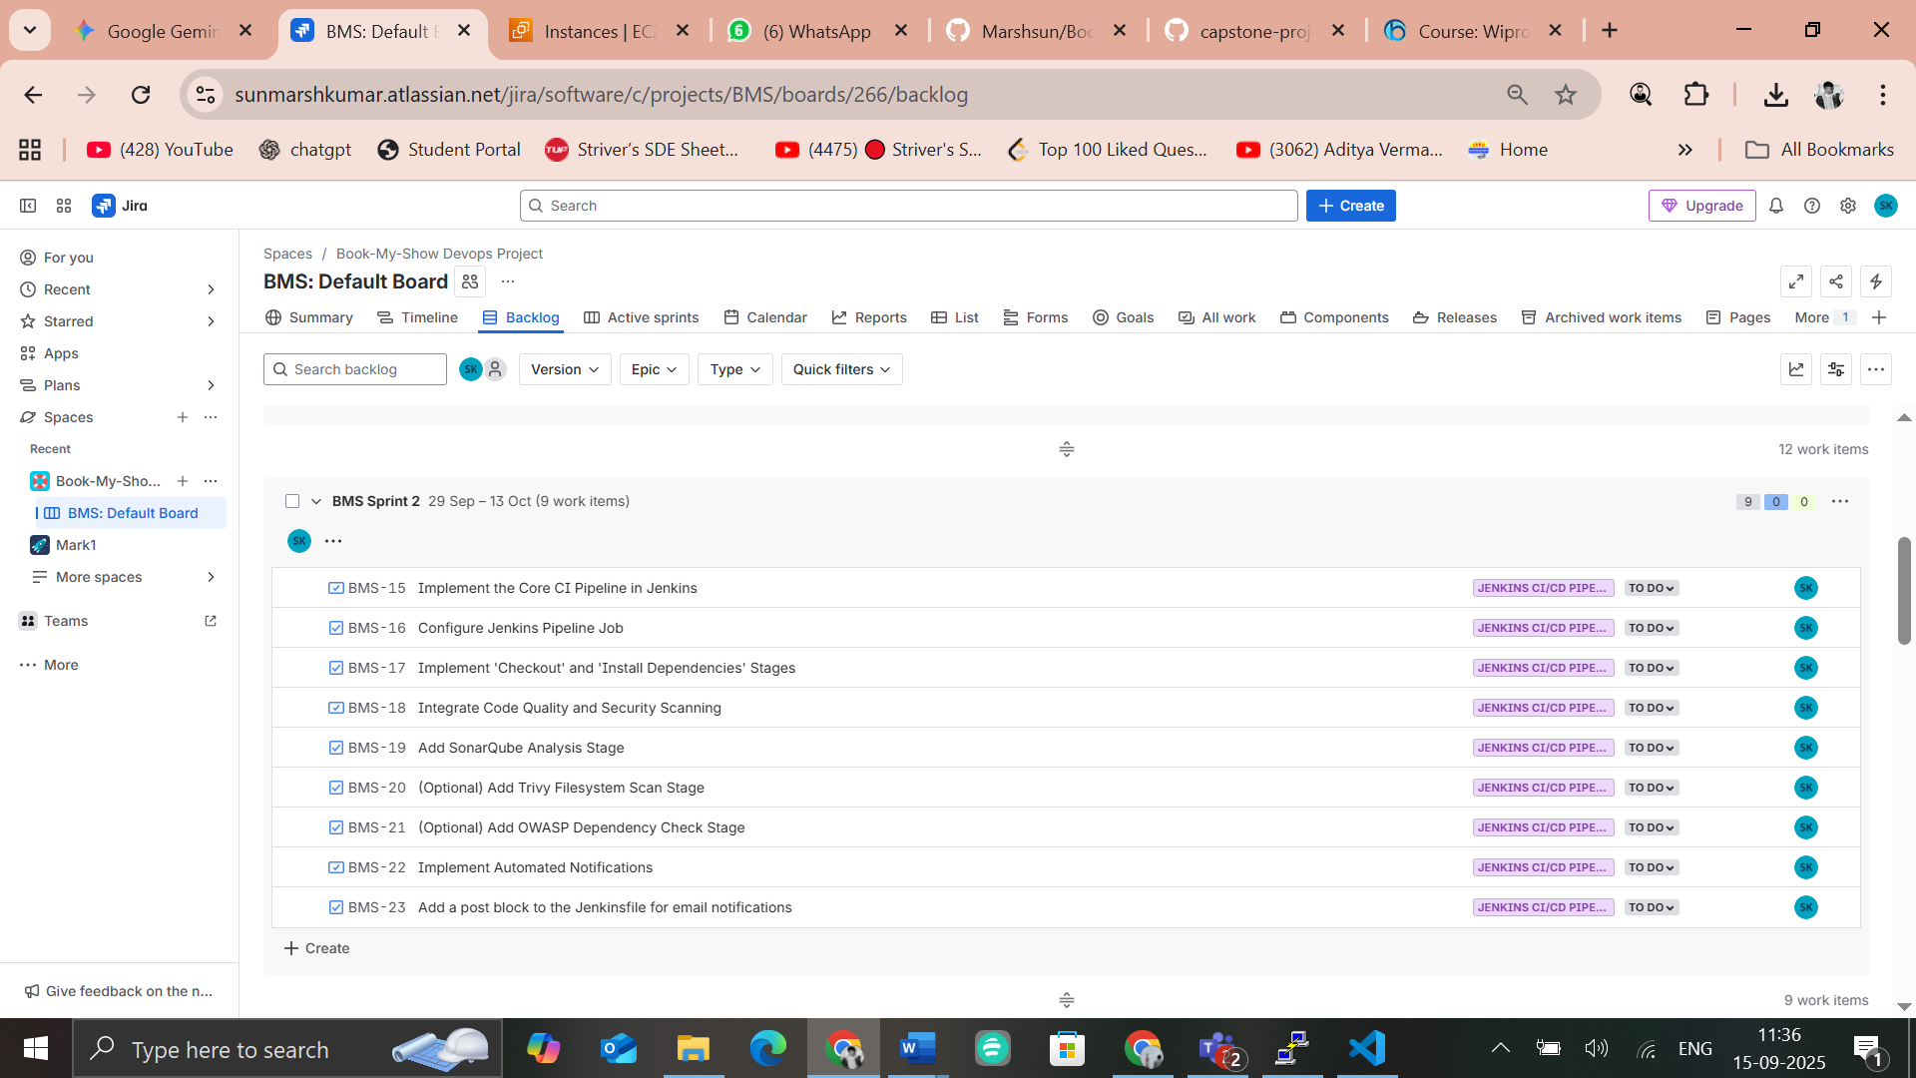
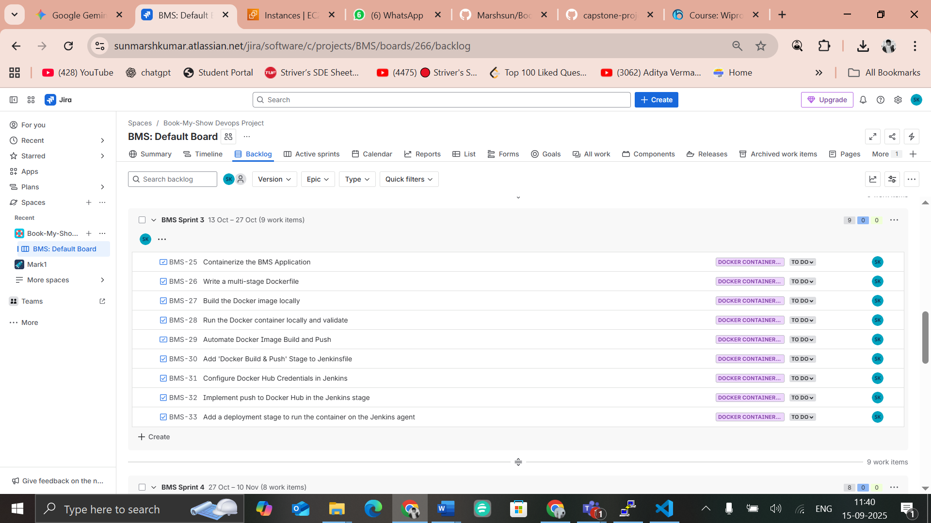
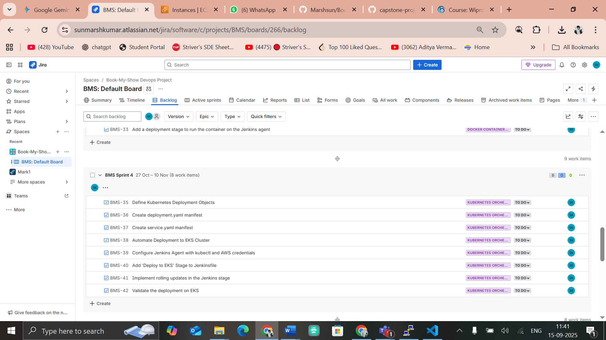
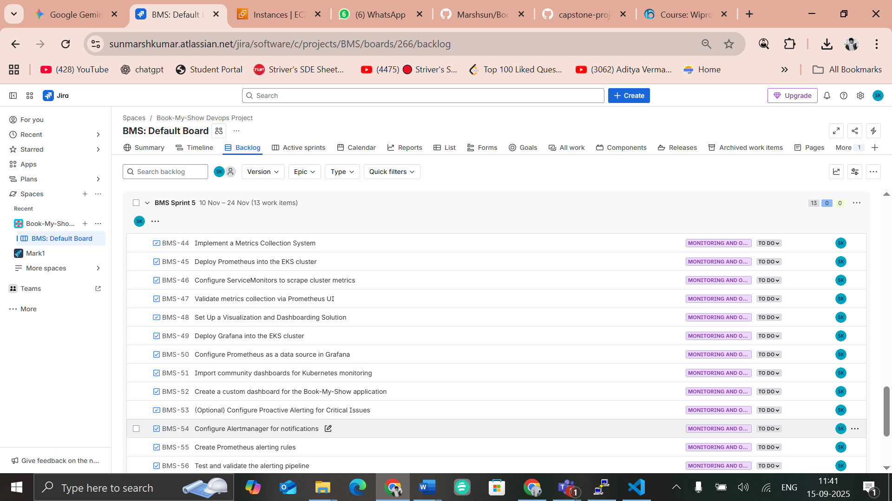

2.2. Sprint Execution and Reporting
Each 3-week sprint begins by moving tasks from the backlog into the Active Sprint board. Progress is tracked daily as tasks move (To Do → In Progress → Done). At sprint close, Jira generates deliverables: a final board view with all tasks marked “Done” and a Sprint Report with the burndown chart.

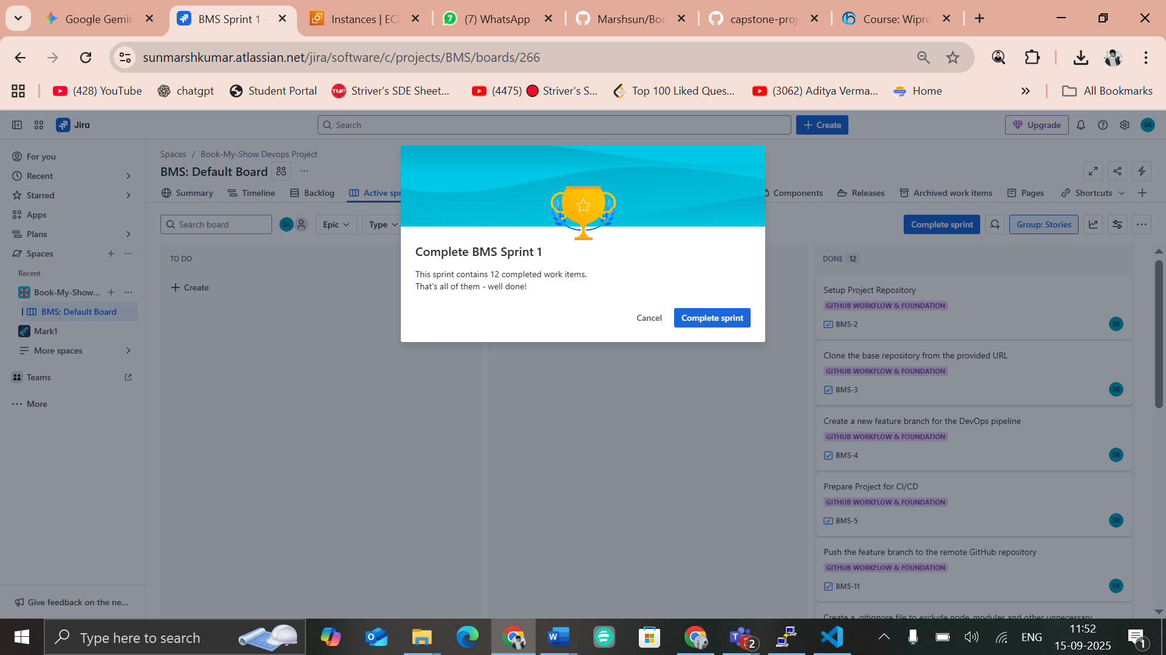
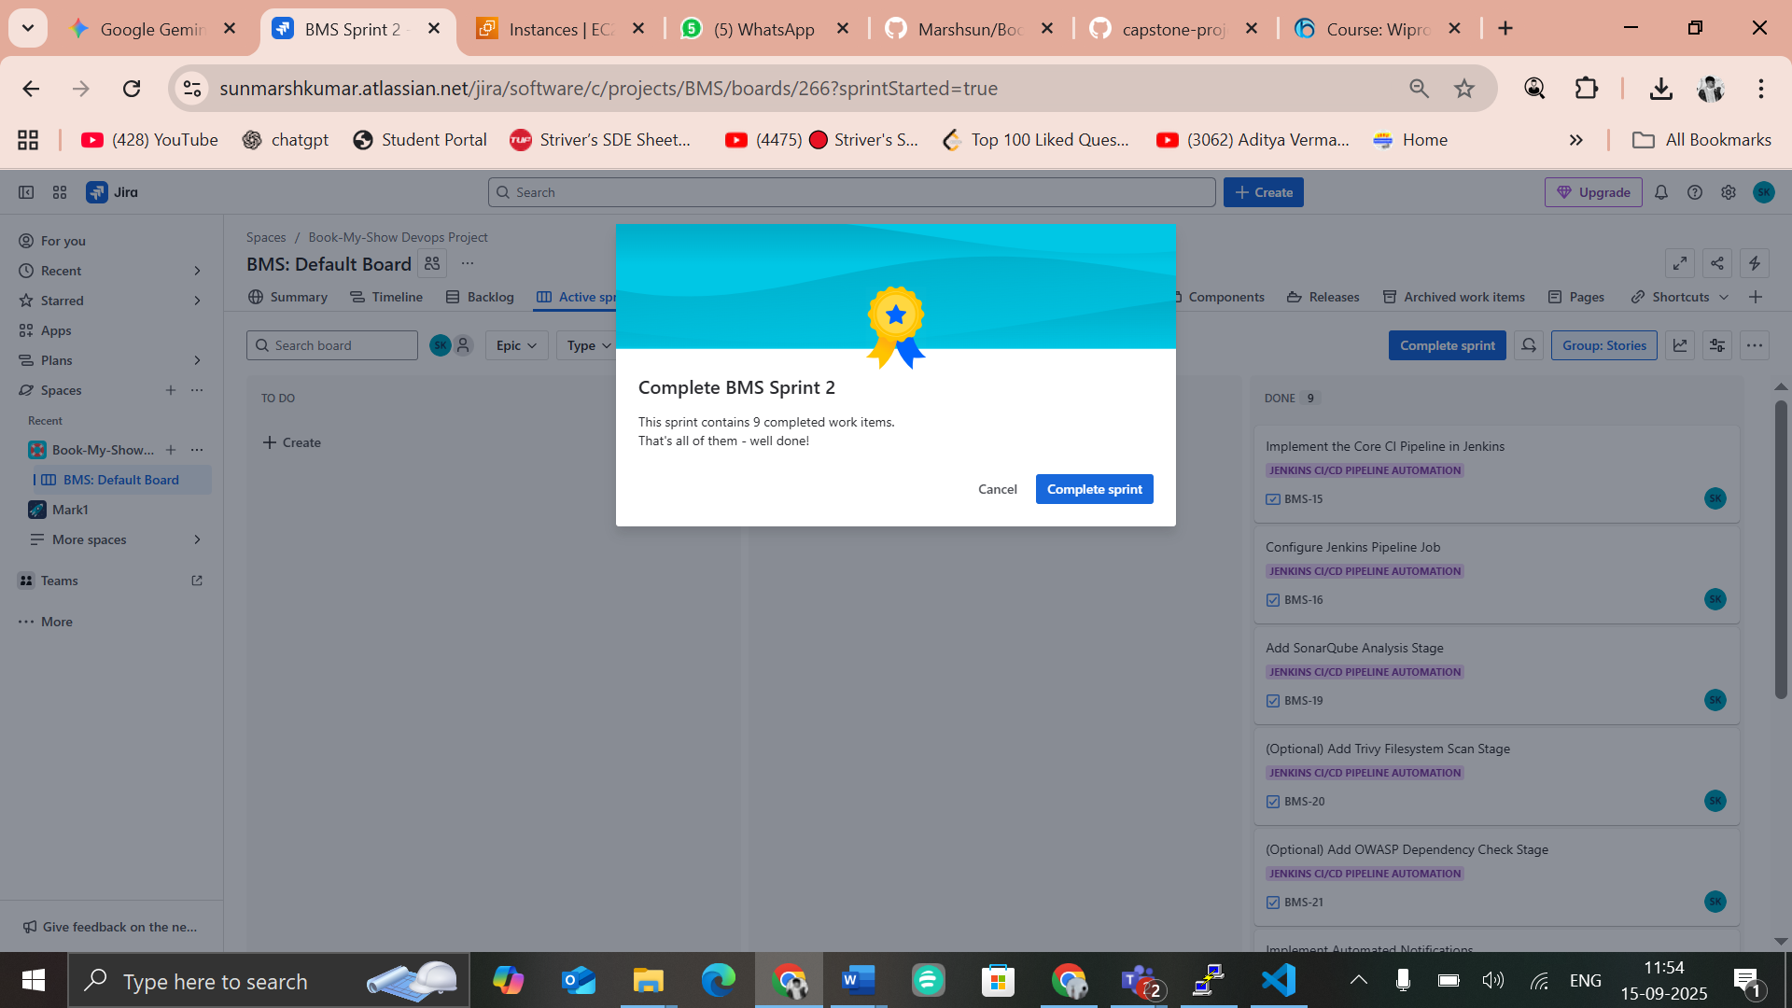
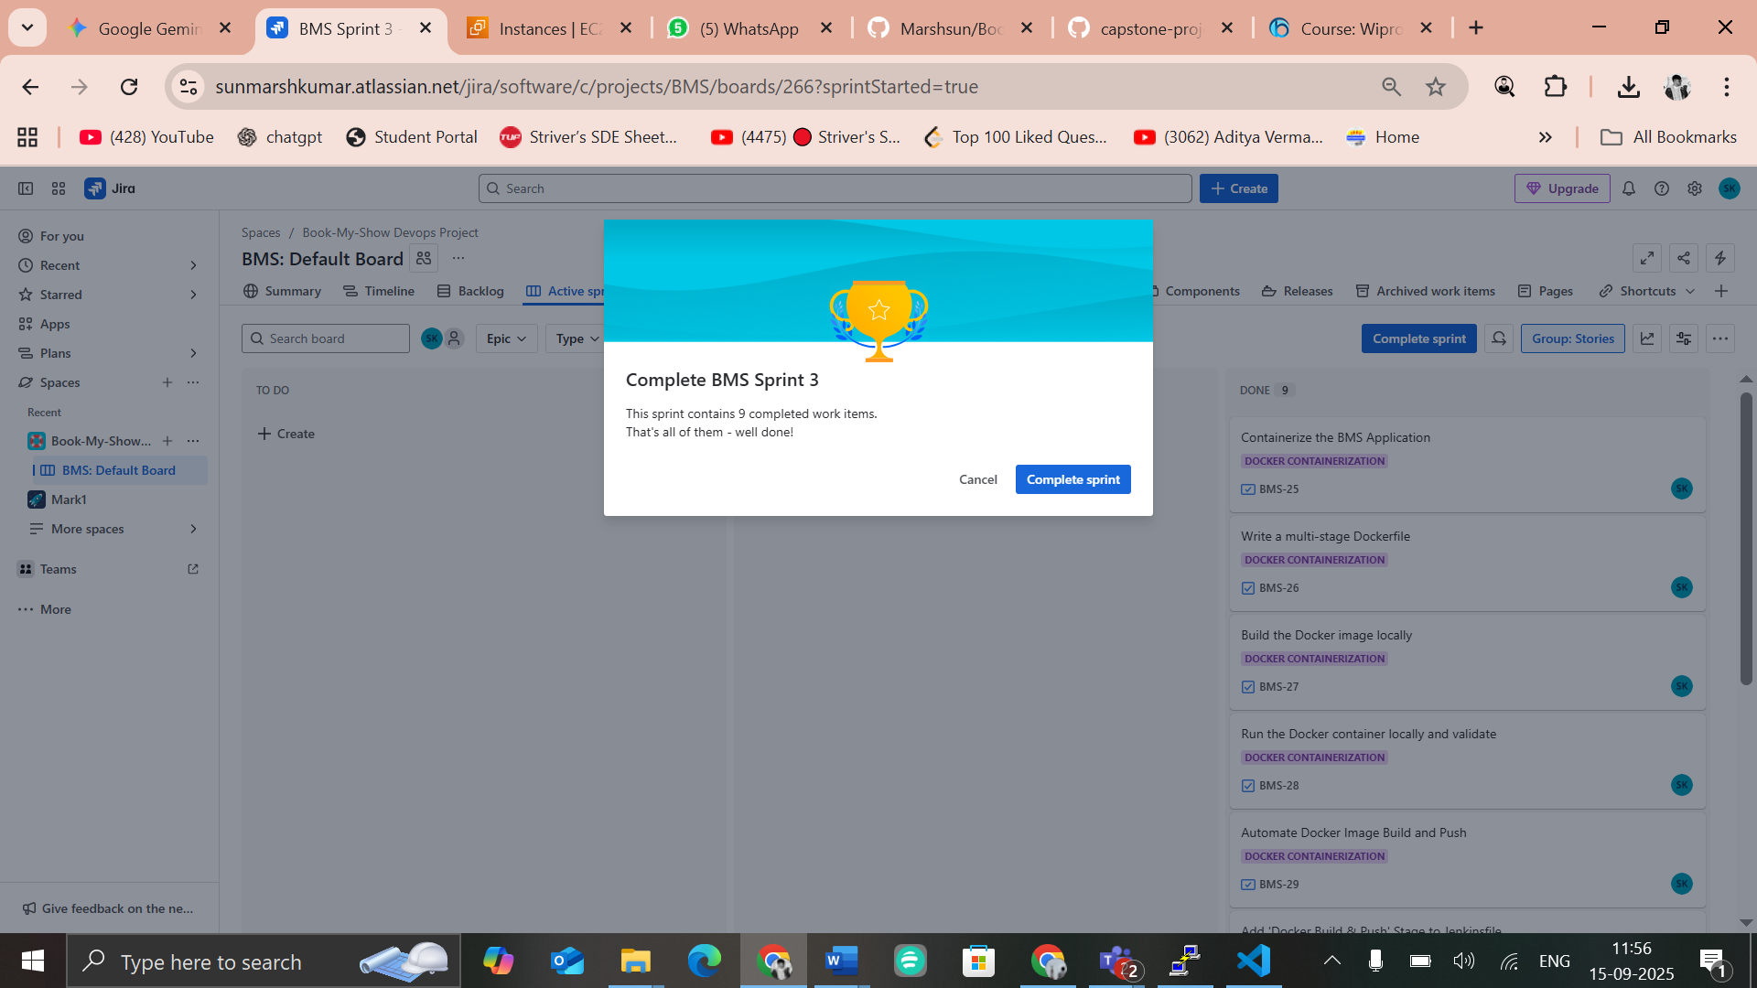
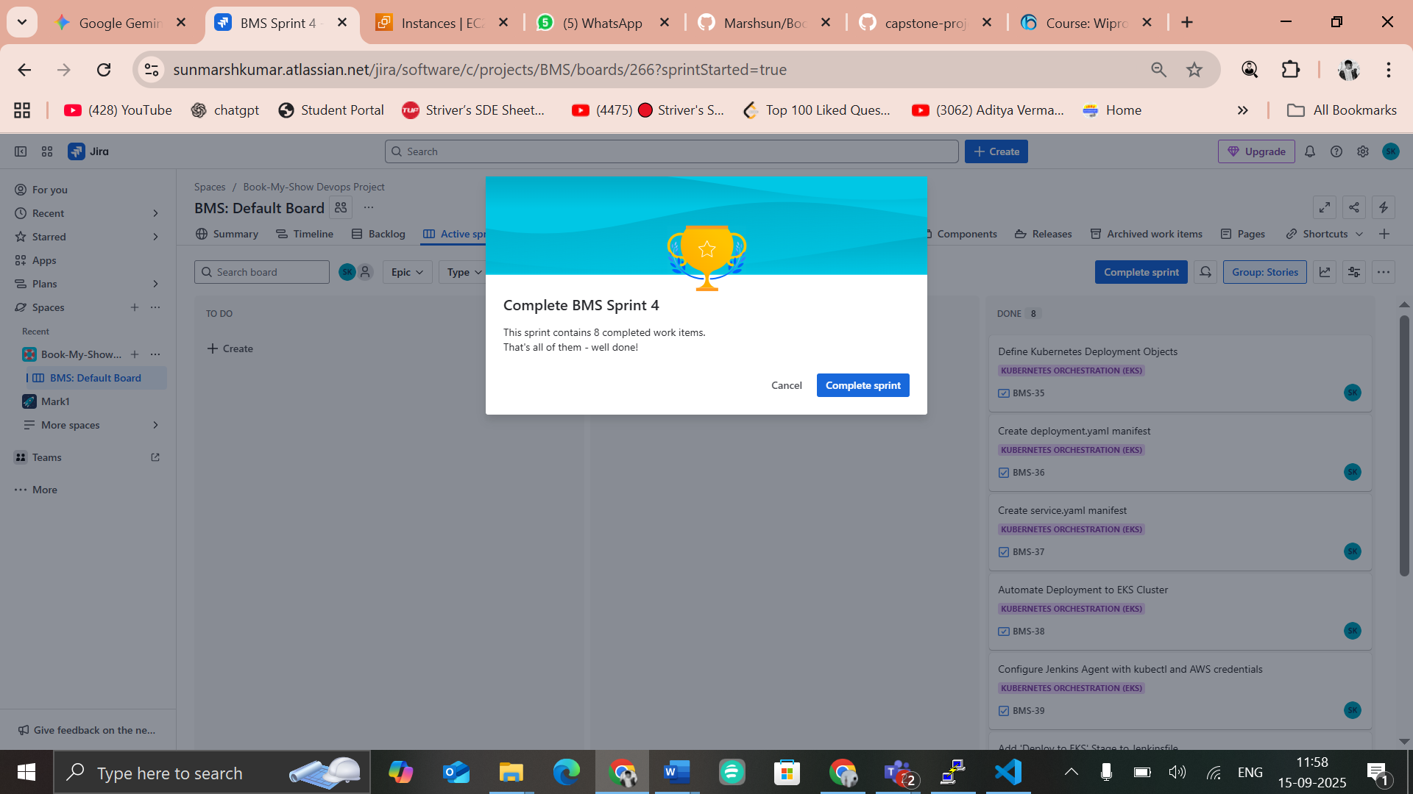
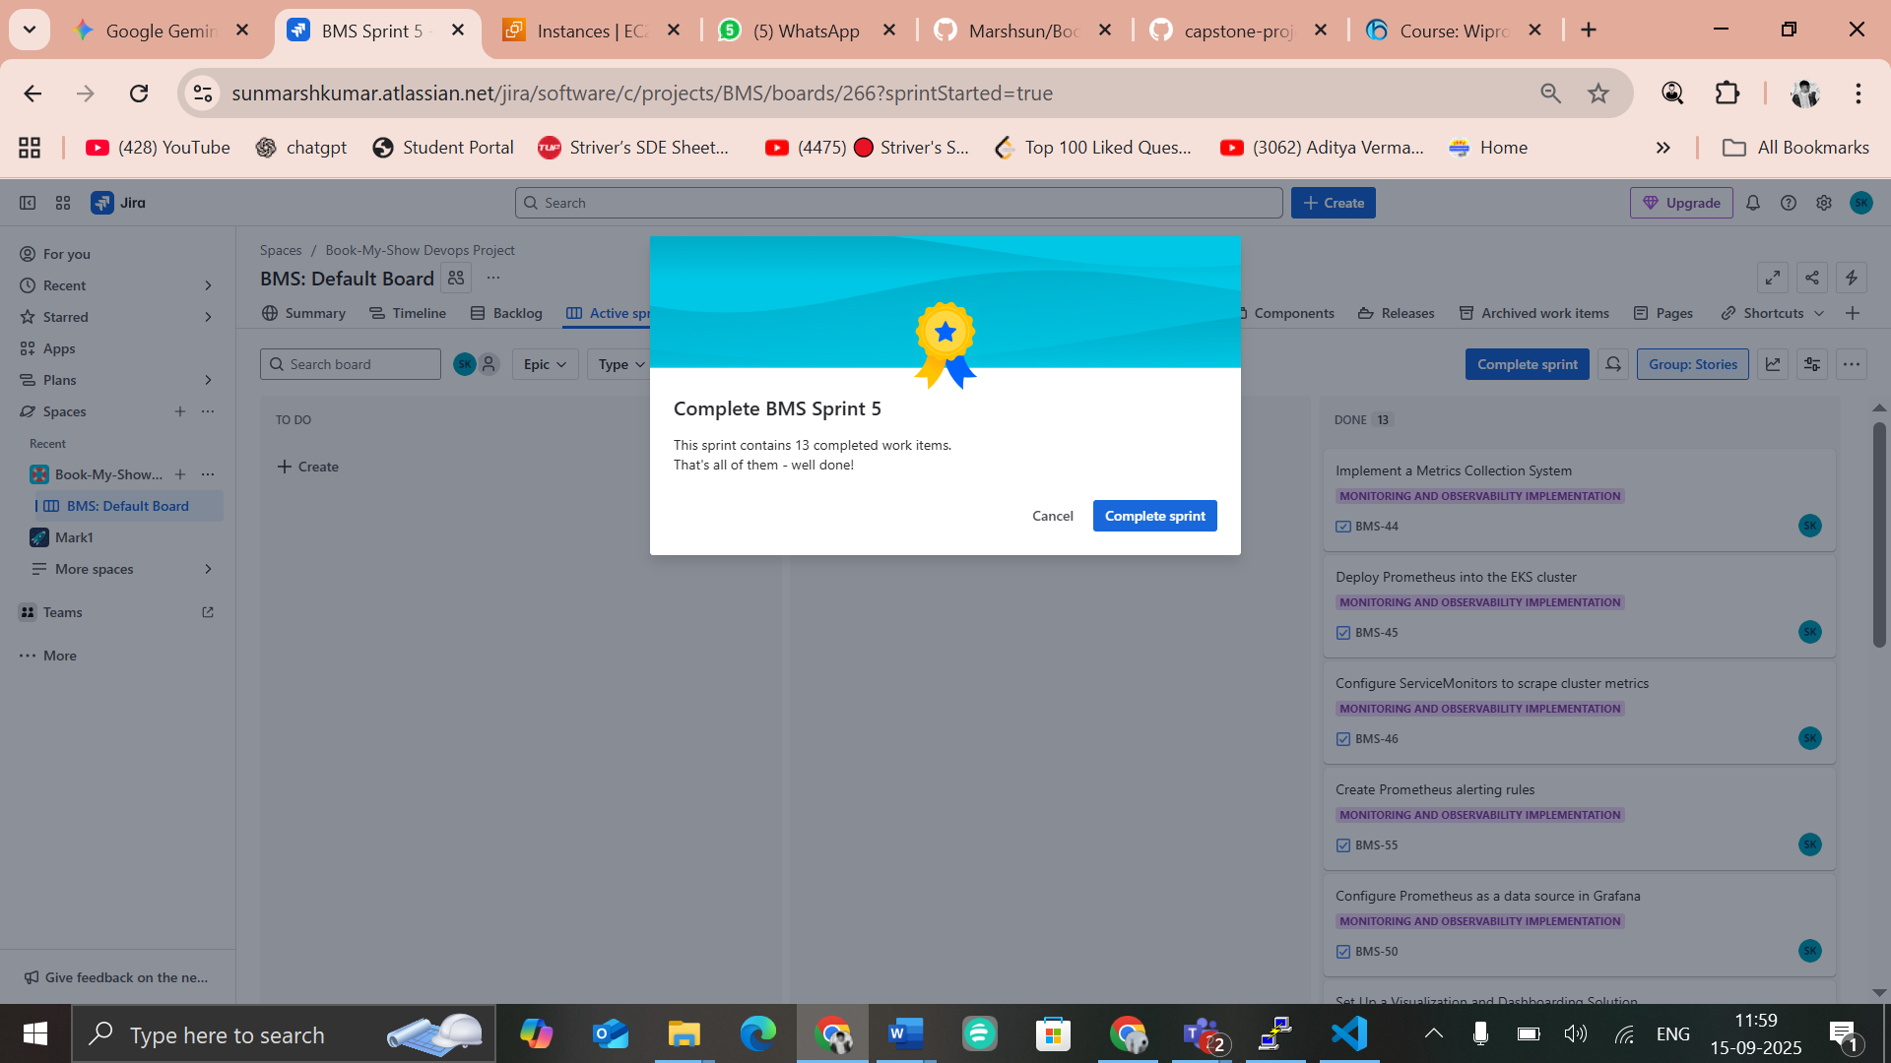
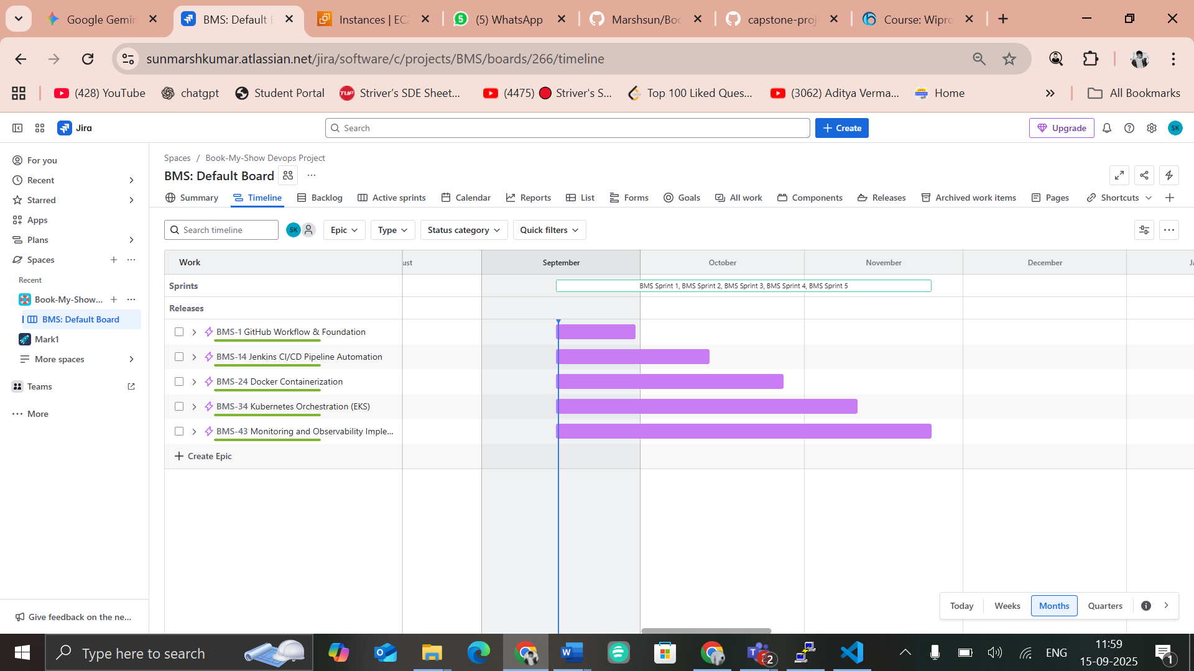

3. Step 2: GitHub Workflow

Workflow:
Clone Repo → Create Feature Branch → Make Changes → Commit & Push →
Raise Pull Request → Peer Review & Approval → Merge to Main

3.1. Step 1 – Fork Repository
- Go to: https://github.com/akshu20791/Book-My-Show
- Click Fork (top-right corner).
- Select your GitHub account → wait for fork to complete.
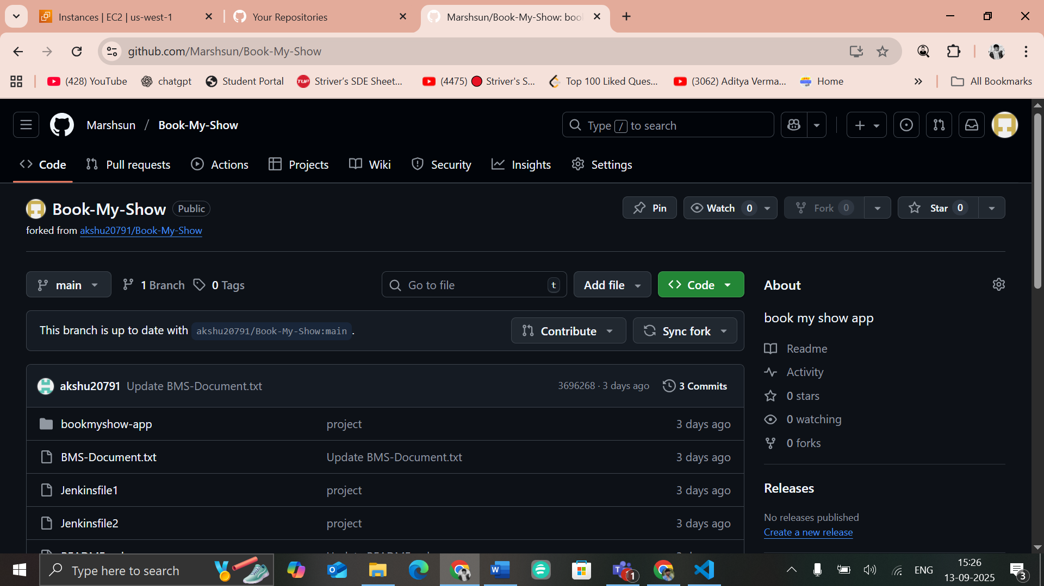
3.2. Step 2 – Clone Your Fork
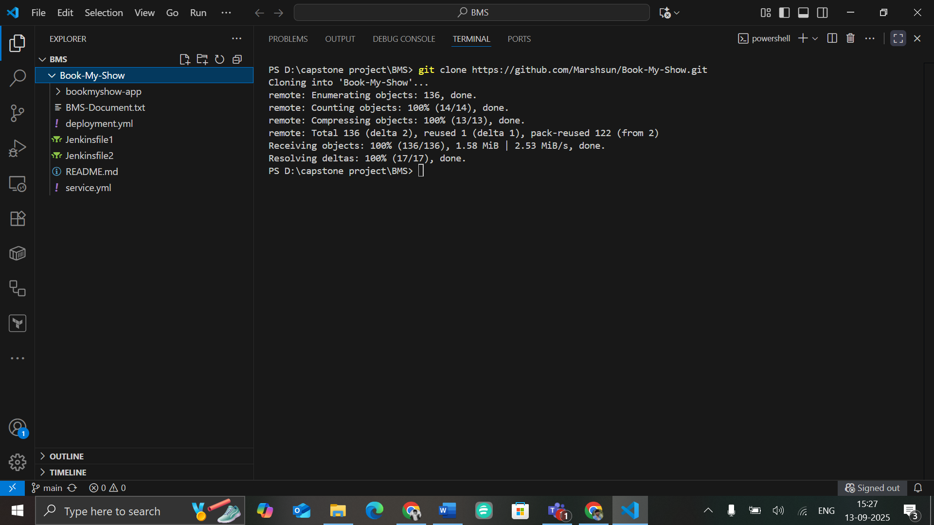
3.3. Step 3-Create Feature Branch and Commit Changes
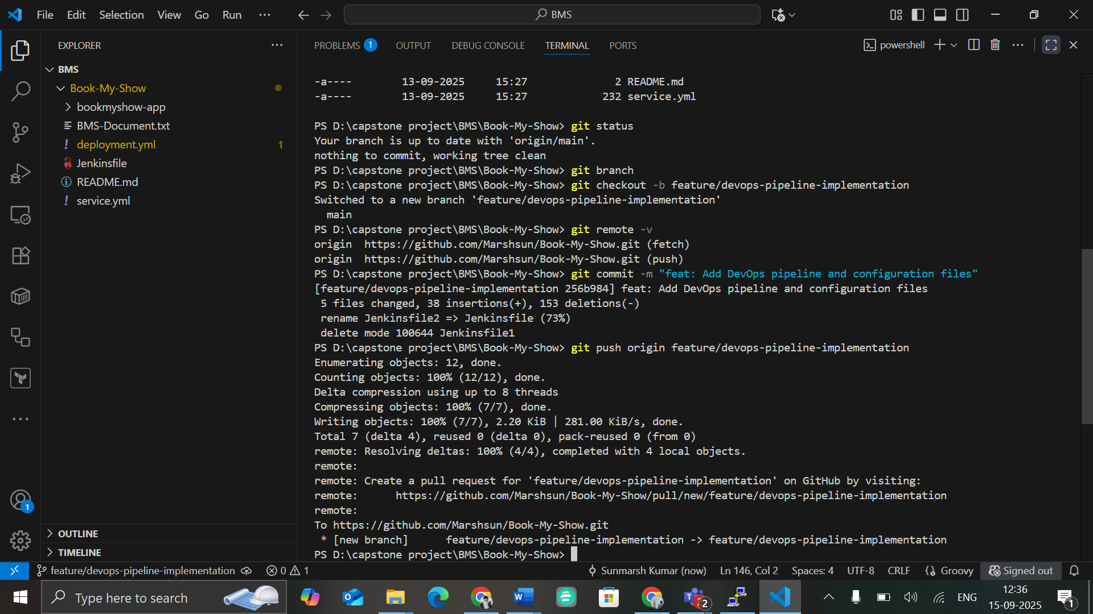
3.4. Step 4 – Open Pull Request
- Go to your fork → feature branch → click Compare & Pull Request.
- Base repo: akshu20791/Book-My-Show (main branch)
Head repo: Marshsun/Book-My-Show-capstone (feature branch)
- Add title + description → Submit PR.
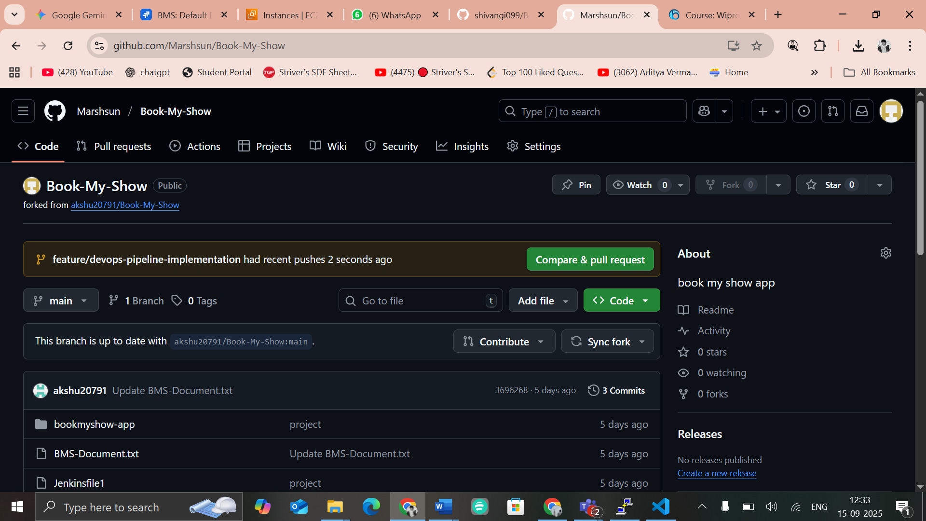

3.5. Step 5 – Copy the PR Link
- After submitting, you will land on the PR details page.
- PR link: https://github.com/Marshsun/Book-My-Show/pull/new/feature/devops-pipeline-implementation
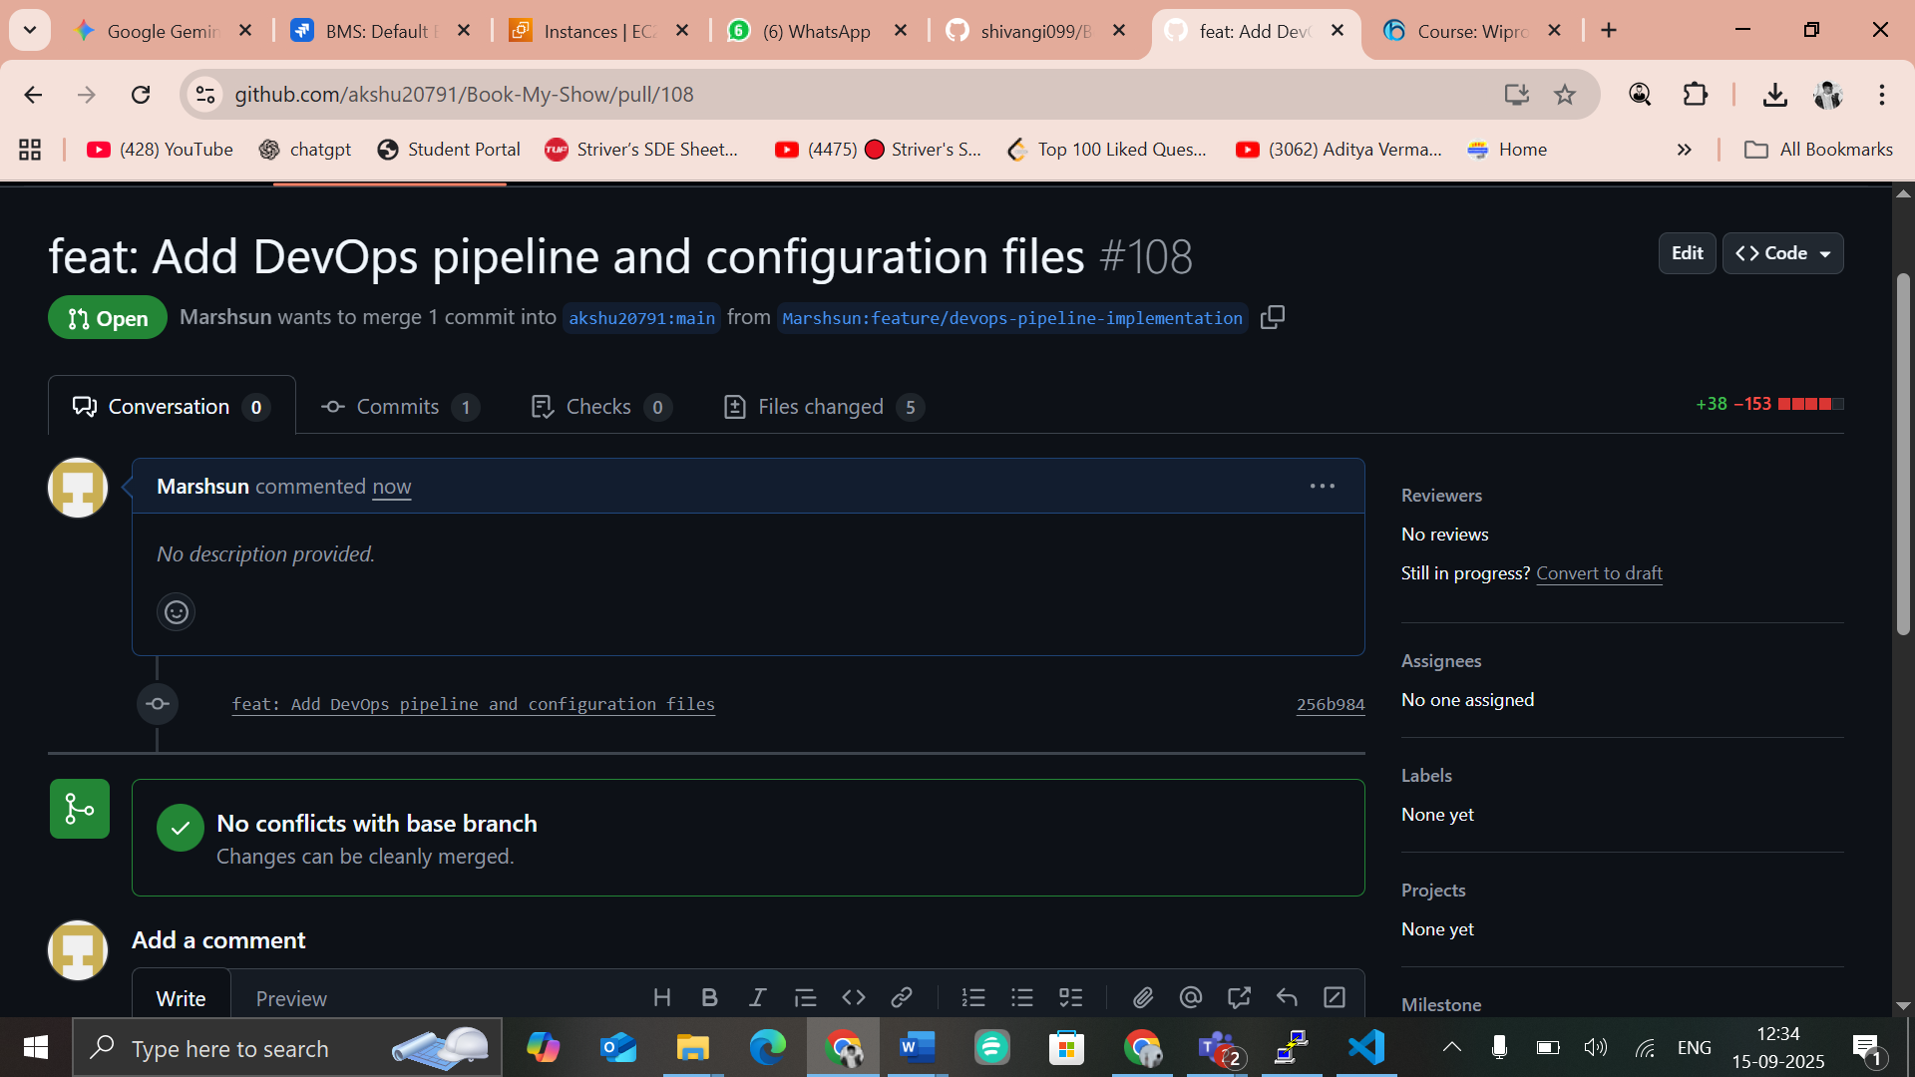

4. Step 4 - Jenkins CI/CD Pipeline

1. Jenkins and EKS Cluster Setup
Prerequisites:
- Infrastructure Requirements:
  - AWS EC2 instance (Ubuntu 20.04 or later) with Jenkins installed
  - Docker installed and configured
  - AWS CLI configured with appropriate credentials
  - kubectl installed (or installed dynamically by Jenkins during execution)
- Tools Required on Jenkins:
  - JDK 17
  - Node.js 23
  - SonarQube Scanner
  - Trivy (for container security scanning)
  - OWASP Dependency Check (for dependency vulnerability scanning)
EC2 Setup for Jenkins:
- Launch an EC2 instance for hosting Jenkins:
  - Name: Sunmarsh-Jenkins
  - AMI: Ubuntu
  - Instance Type: t2.medium
  - Select the required key pair, security group, and subnet
  - Click Launch Instance to complete the setup
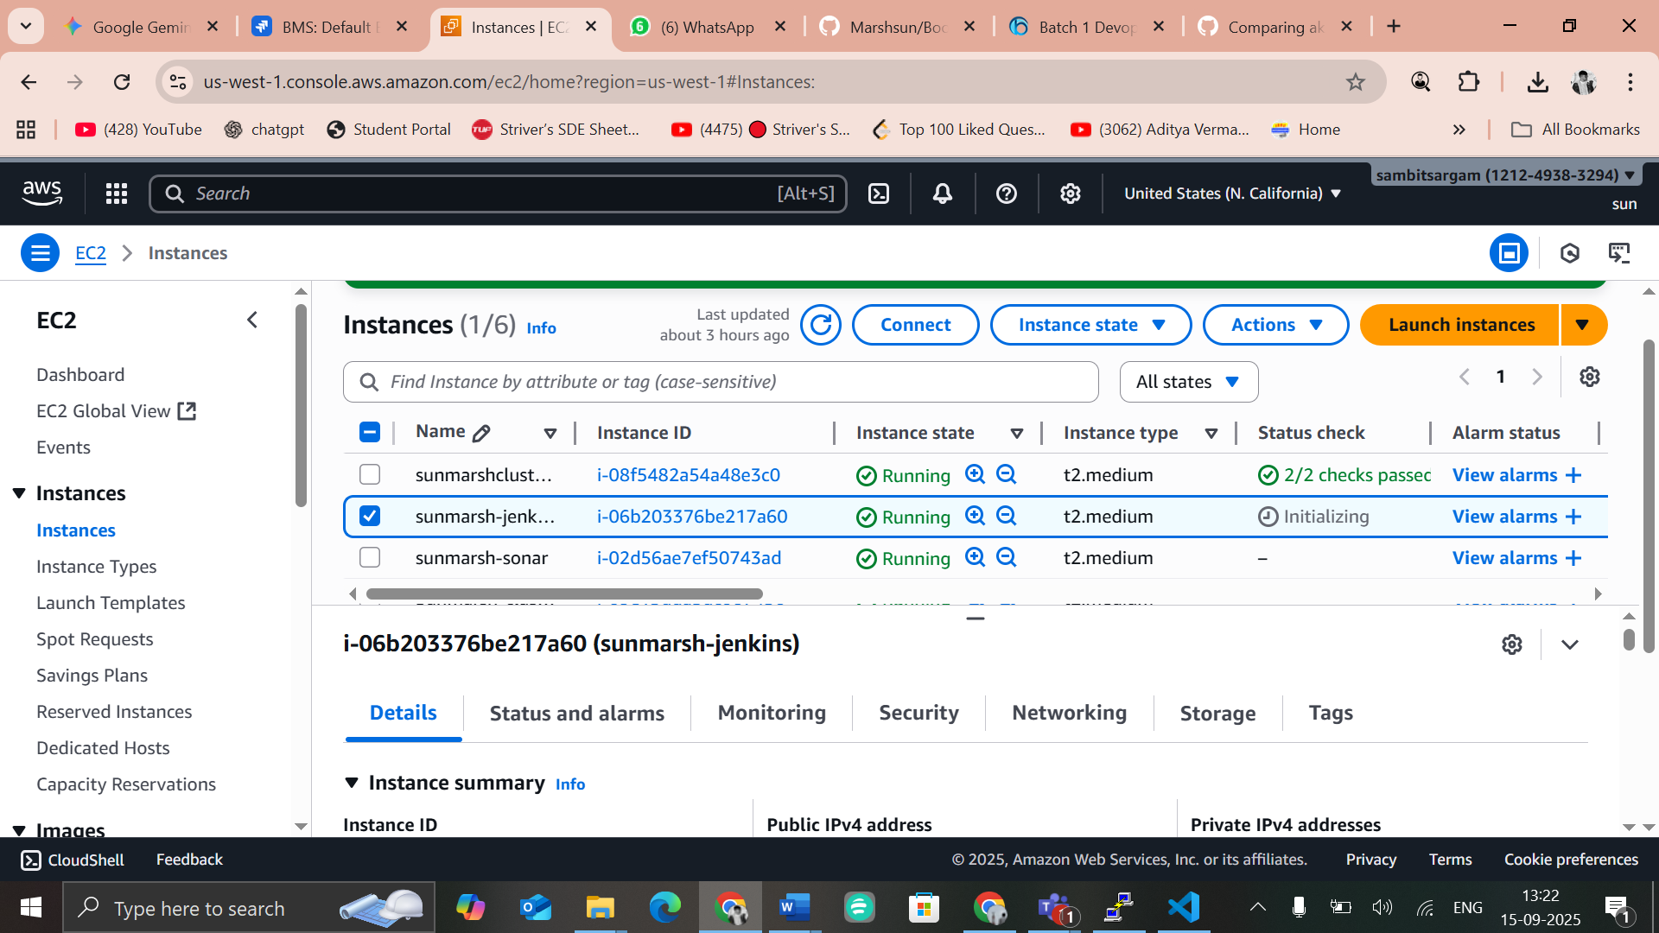

- Connect to the EC2 instance using an SSH client such as PuTTY.
- Install Java and Jenkins, then enable and start the Jenkins service. Ensure that both kubectl and the AWS CLI are also installed on the Jenkins server.
- Access the Jenkins web interface in a browser using the instance’s public IP address along with port 8080.
- Update the EC2 security group to allow inbound traffic on port 8080 for Jenkins access.
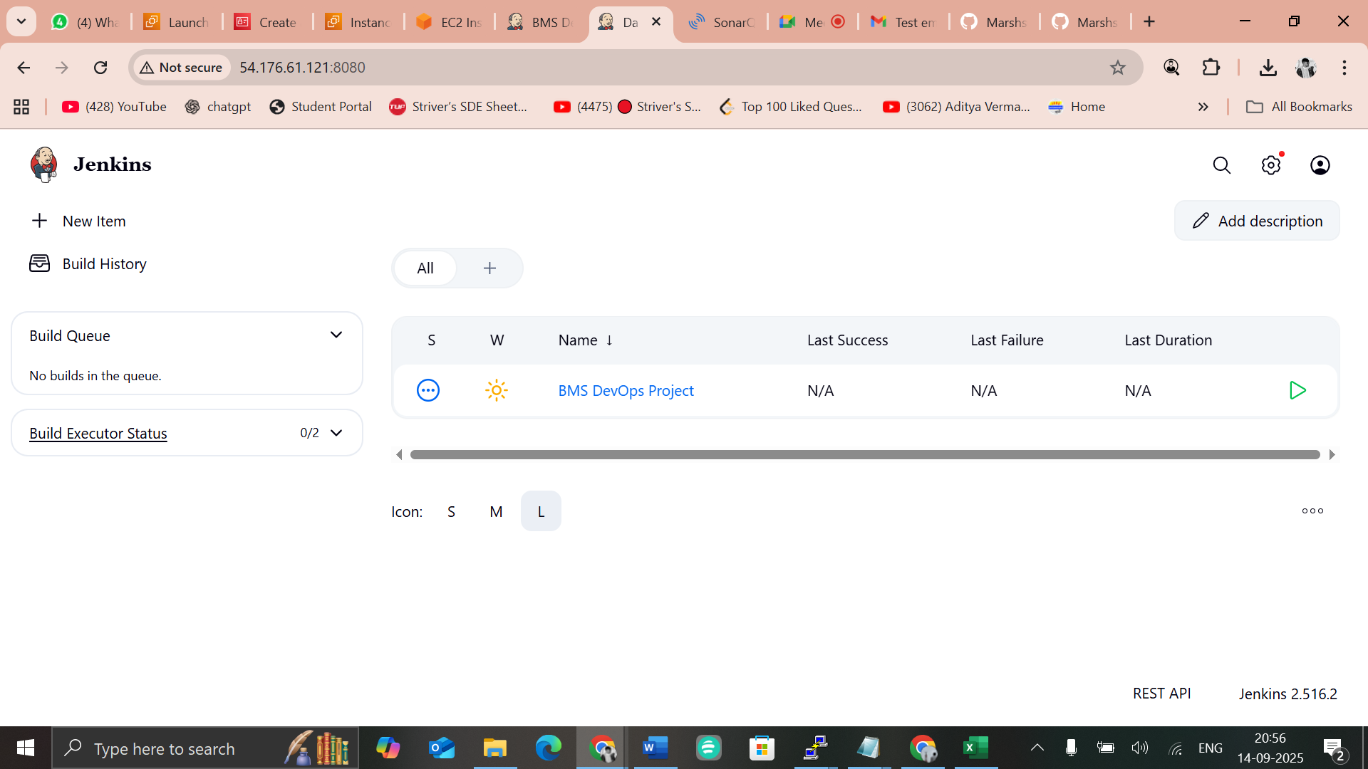
Set Up EKS Cluster and Integrate with Jenkins
1. Launch EC2 Instance for EKS Cluster Management
- Name: Sunmarsh-cluster
- AMI: Ubuntu
- Instance Type: t2.medium
- Configure key pair, security group, subnet, and set storage to 22 GB.
- Click Launch Instance.
2. Connect and Install Required Tools
- Connect to the instance via PuTTY (SSH client).
- Install the following tools:
  - kubectl
  - AWS CLI
  - eksctl
- Configure AWS credentials (Access Key and Secret Key).
3. Configure Cluster Access for Jenkins
- From the Jenkins server, update the kubeconfig file with:
- aws eks update-kubeconfig --name yashu-cluster --region us-west-1
- Copy the kubeconfig file to Jenkins home directory and set permissions:
- sudo mkdir -p /home/jenkins/.kube
- sudo cp /root/.kube/config /home/jenkins/.kube/config
- sudo chown -R jenkins:jenkins /home/jenkins/.kube
- sudo su - jenkins
- aws configure # provide AWS access keys here
4. Jenkins Configuration
- Install the required Kubernetes and AWS-related plugins in Jenkins.
- Copy the kubeconfig file to your local machine and store it securely.
- Add AWS access keys and the kubeconfig file into Jenkins as credentials for cluster access.

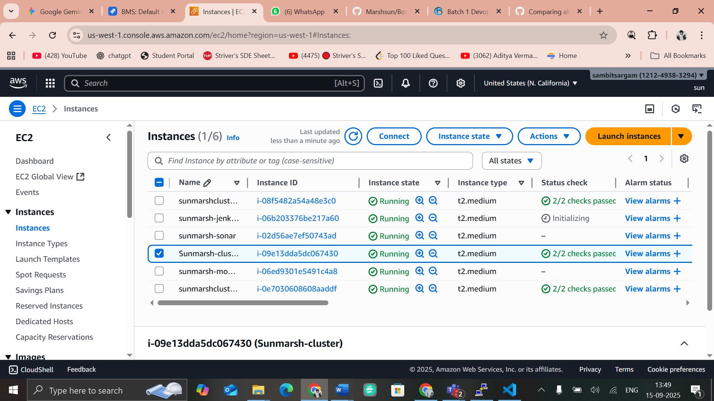
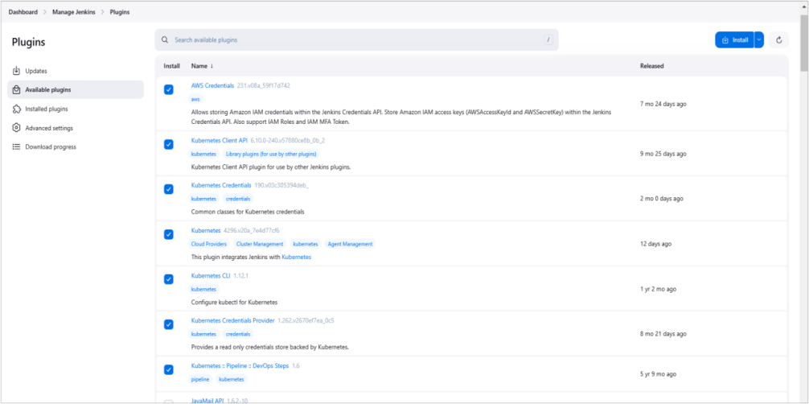

2. Pipeline Creation
- In Jenkins, click on “New Item” to create a new pipeline.
- Enter a BMS Devops Project, select Pipeline as the project type, and then click OK.

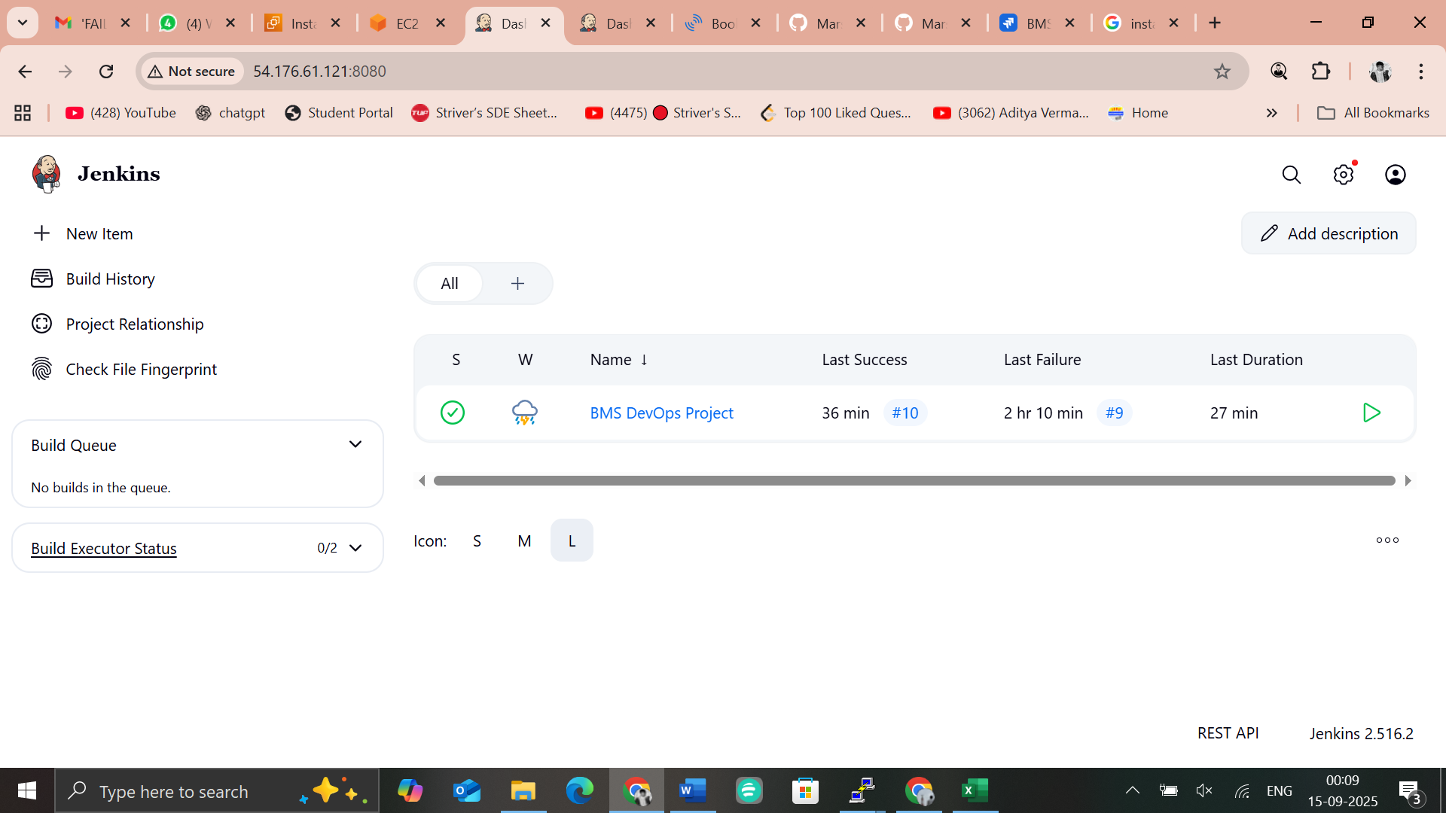

3. Write Pipeline Script
- Add the pipeline script in Jenkins by defining all the necessary stages (e.g., checkout, build, test, scan, package, deploy).
- Ensure each stage aligns with your CI/CD workflow requirements.
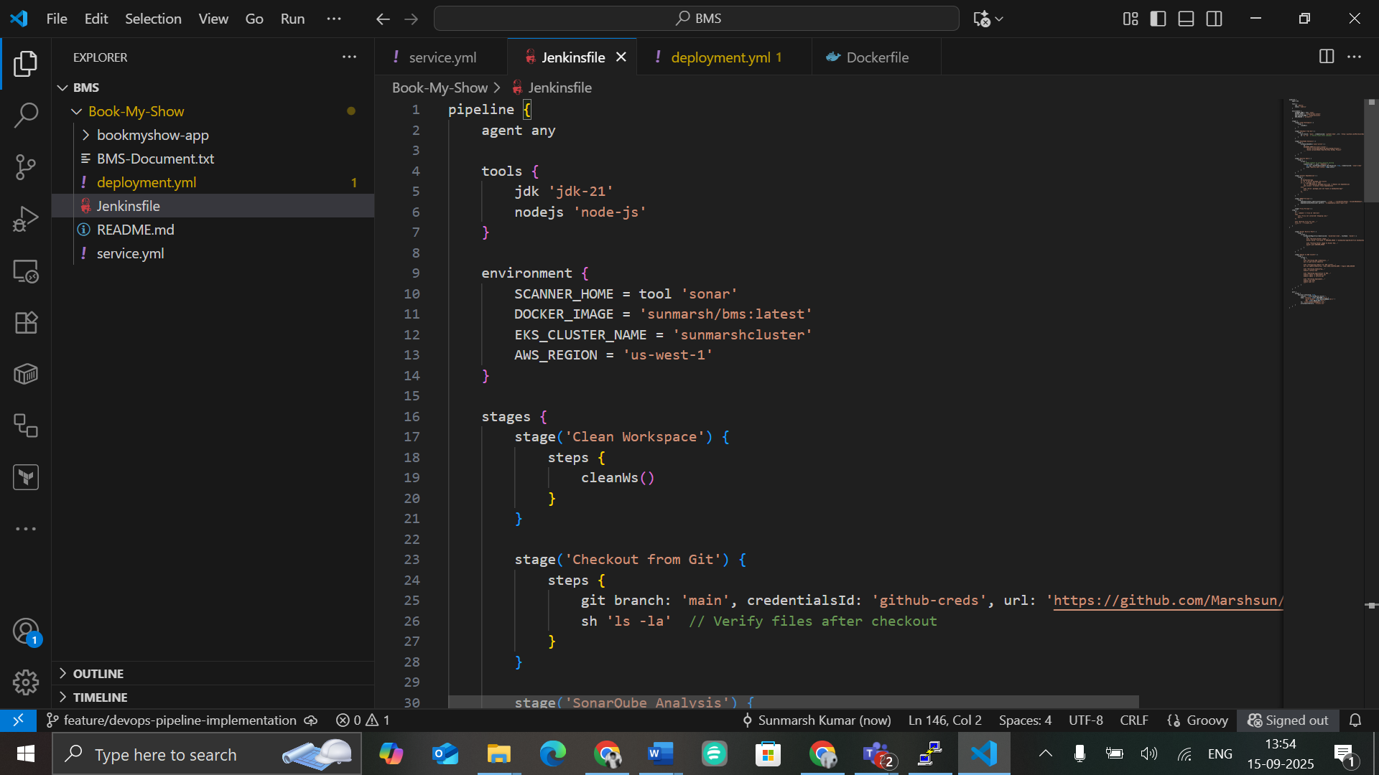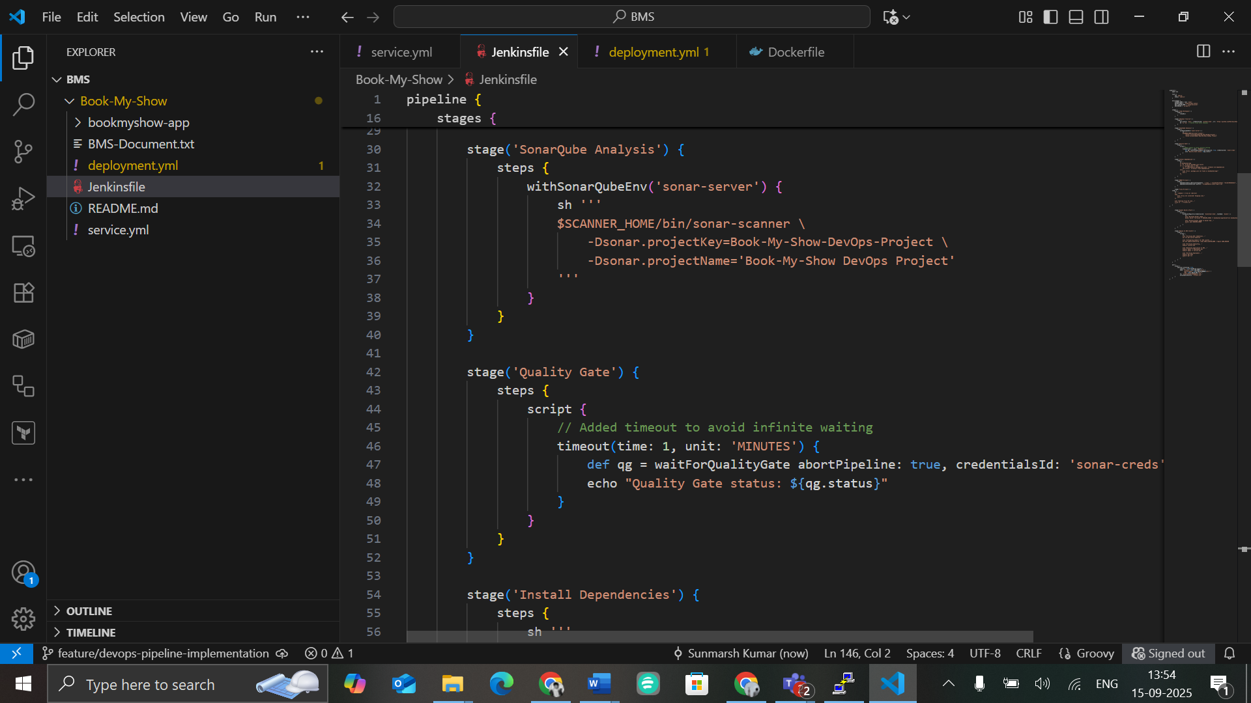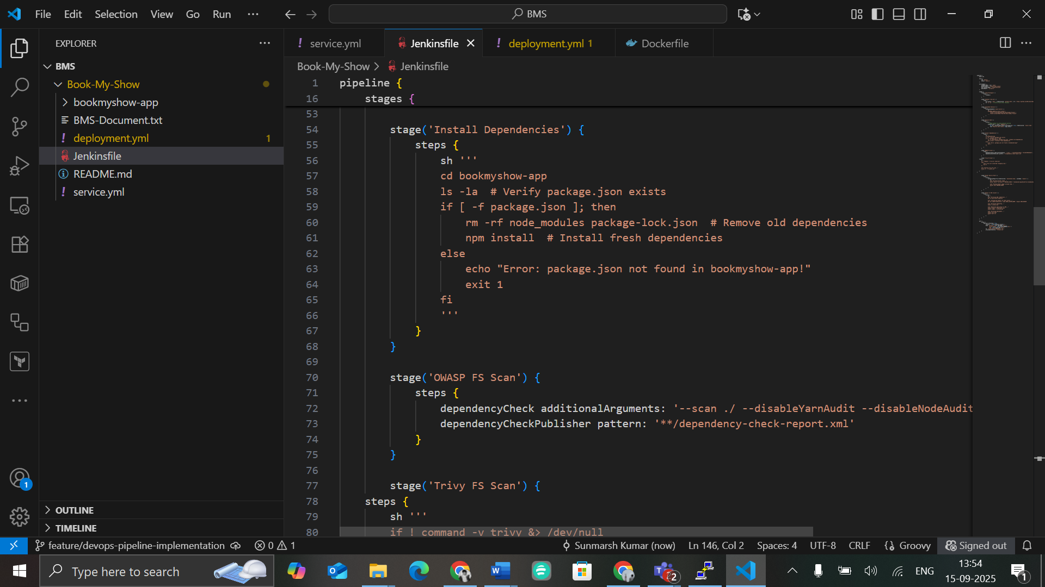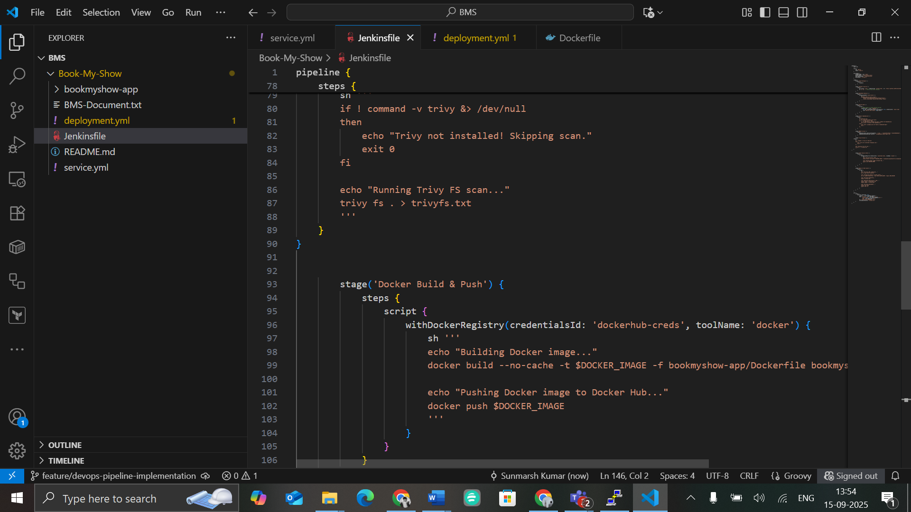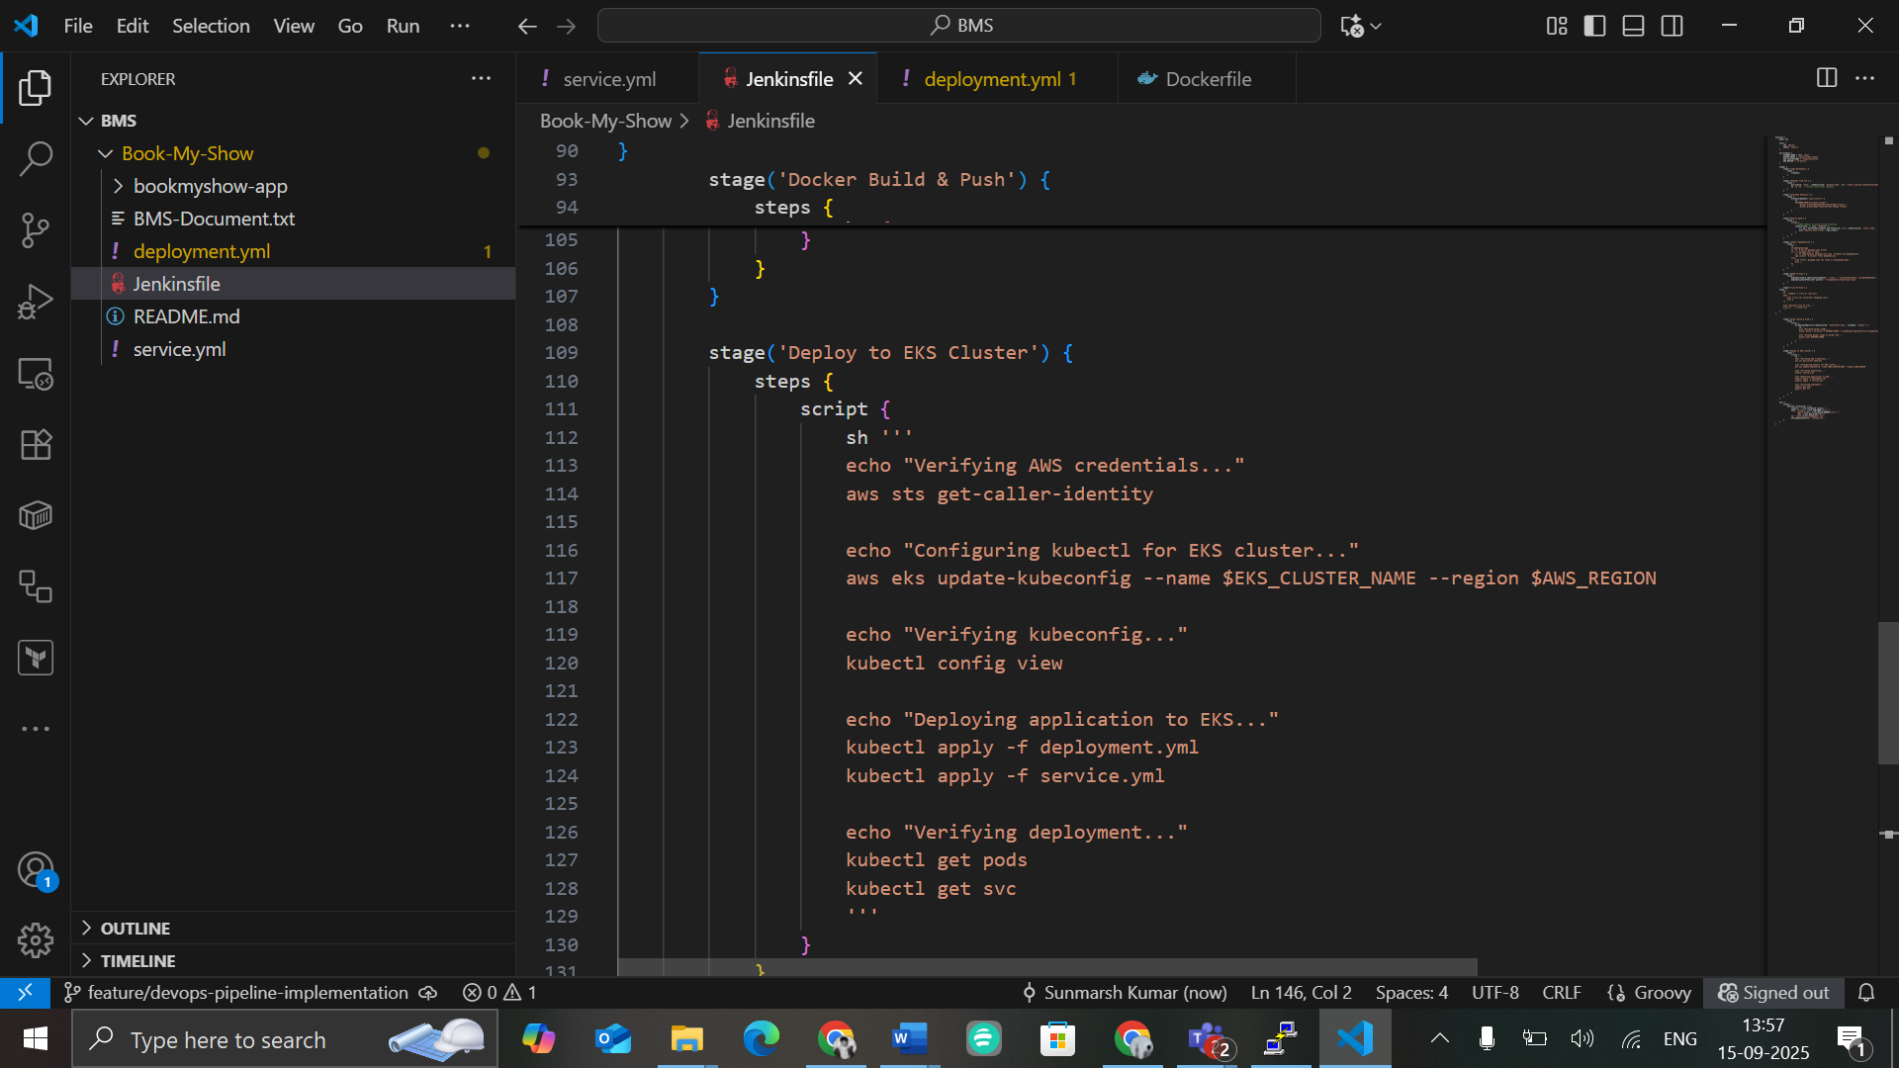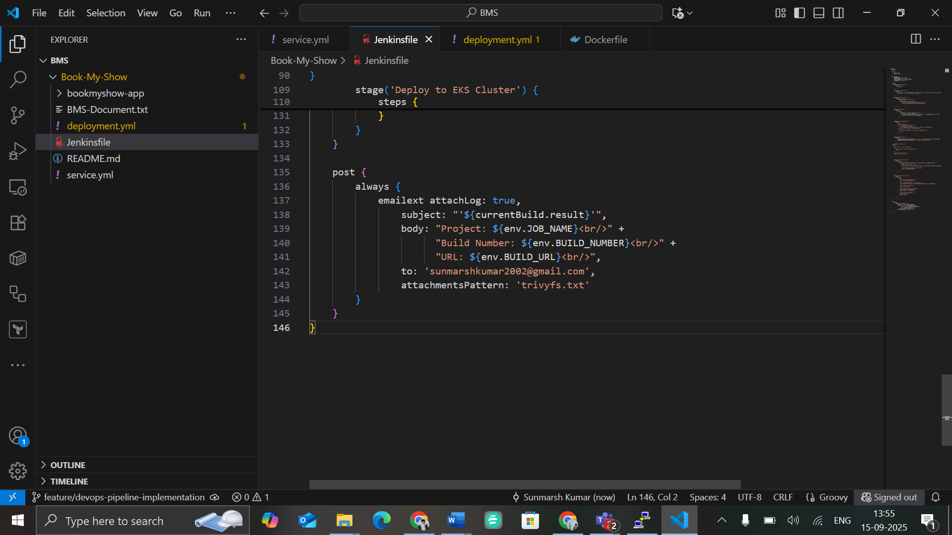

4. Run the Pipeline
- After saving your pipeline script, return to the pipeline dashboard.
- Click on “Build Now” to trigger the pipeline and observe its execution.

Outputs:


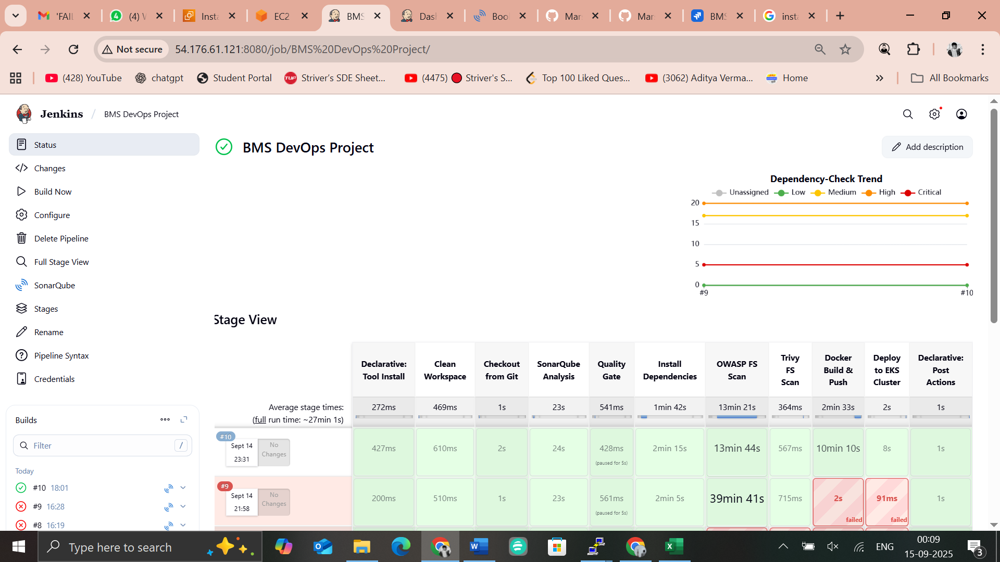

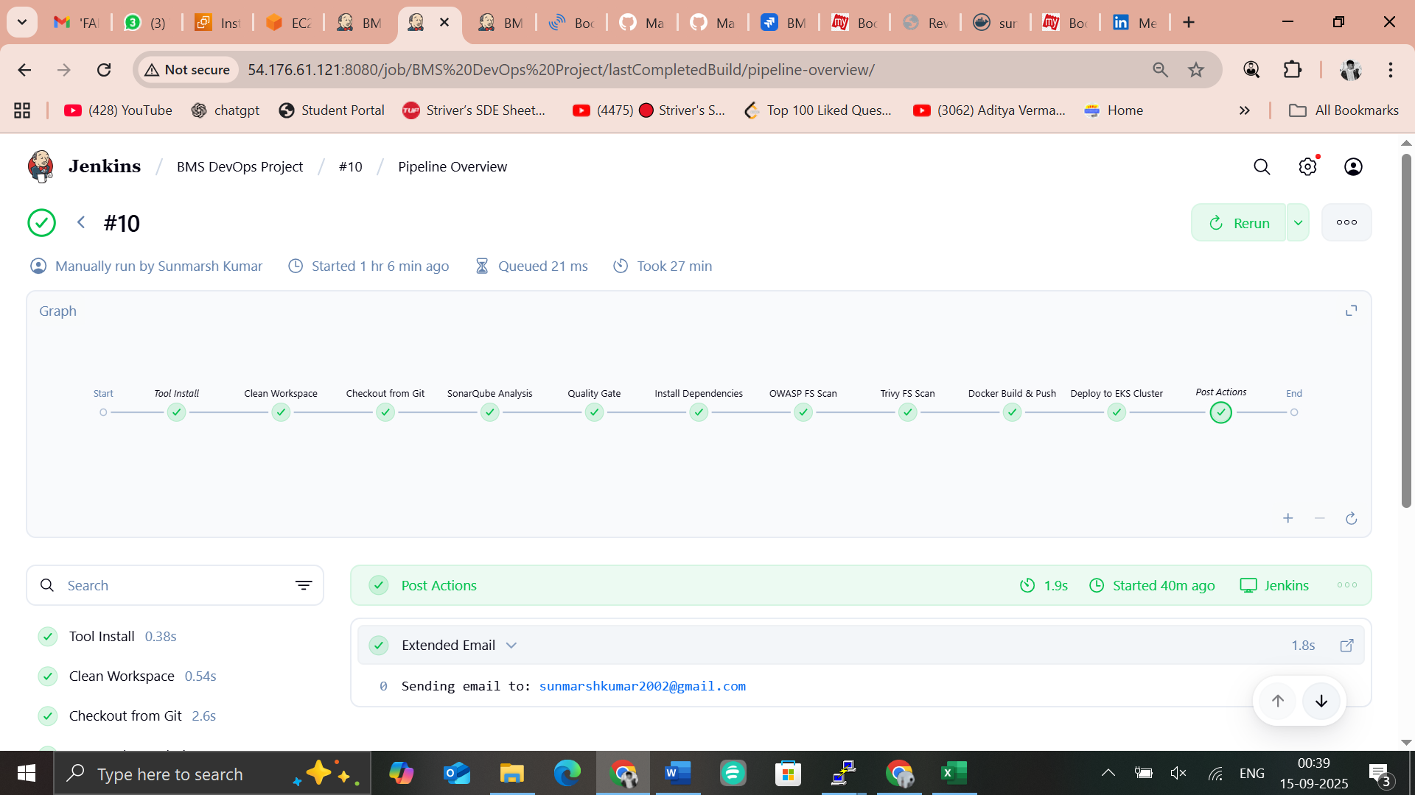
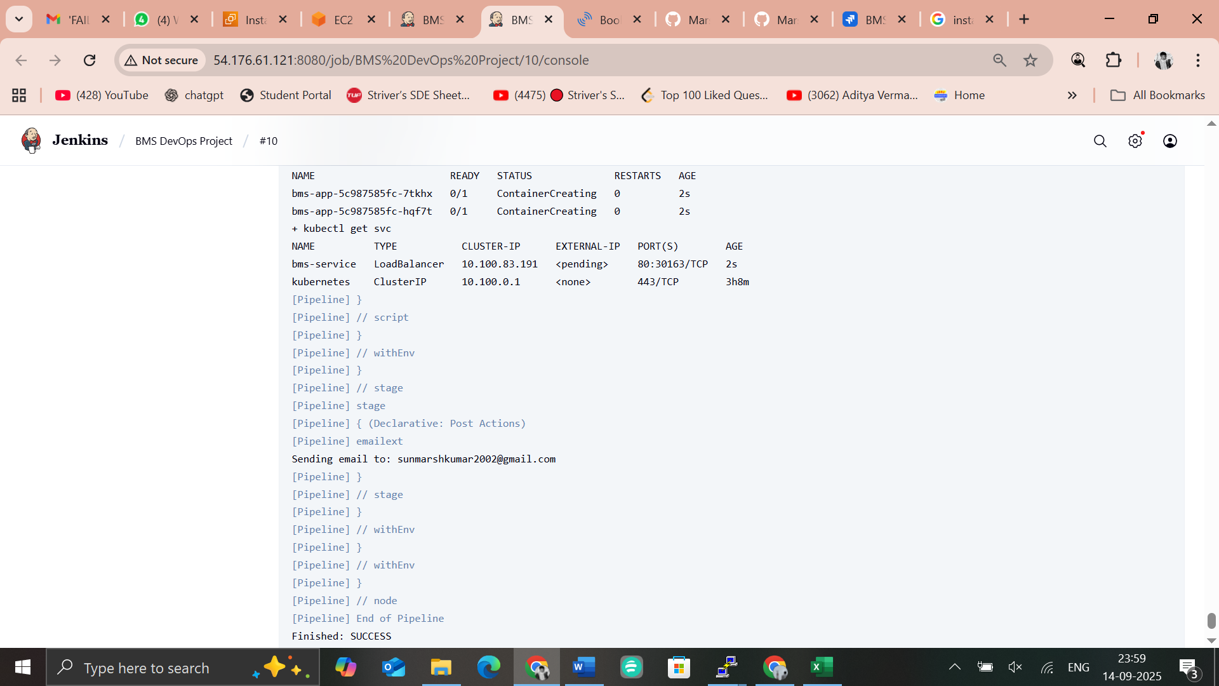

Sonarqube analysis
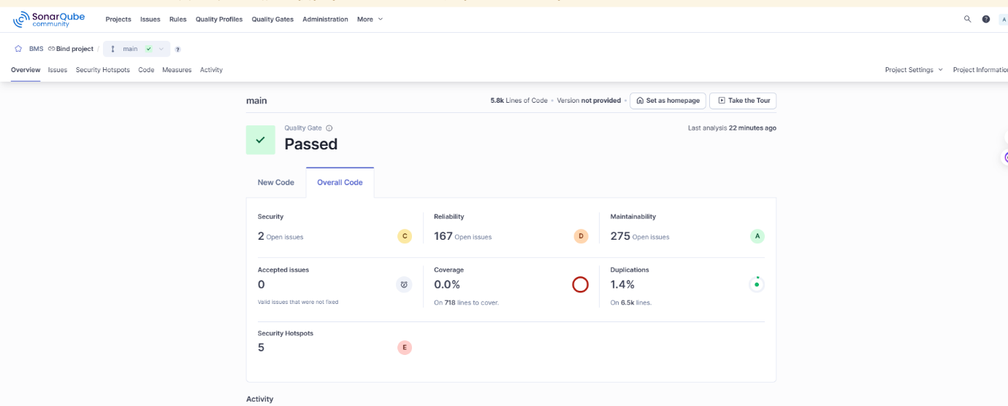

Dependency Check
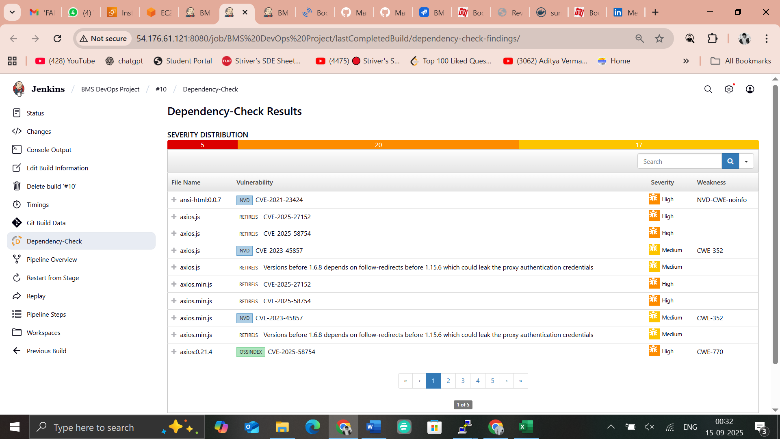

Docker Build & push

EKS Deployment
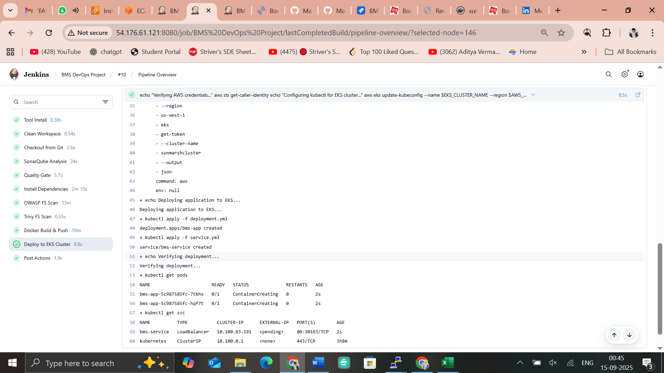
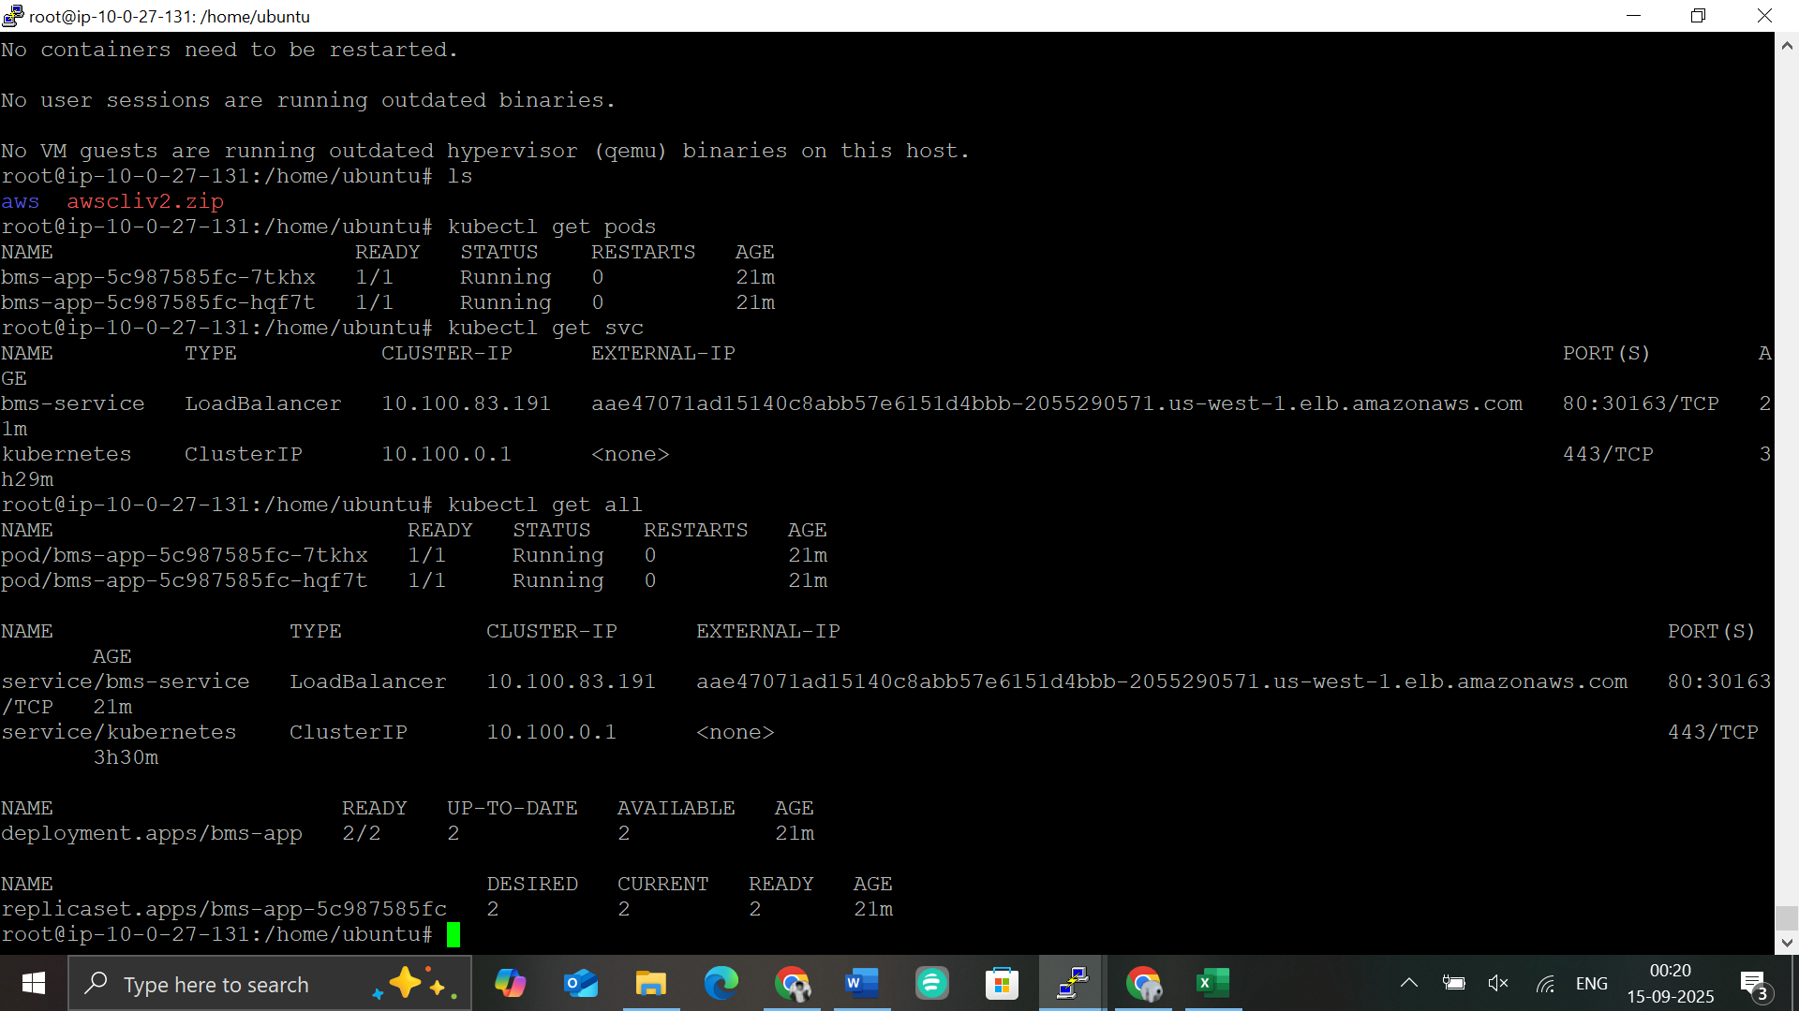

Email Notification
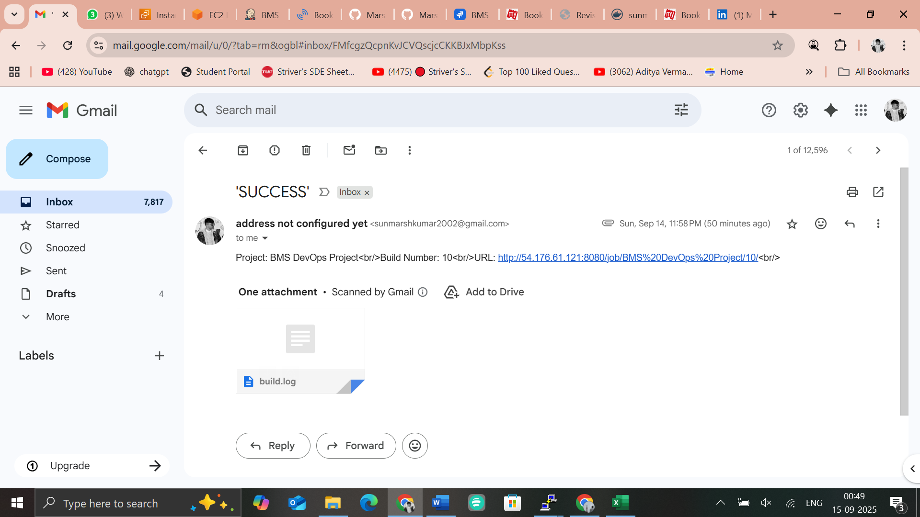

Step 4: Docker Deployment
Dockerfile
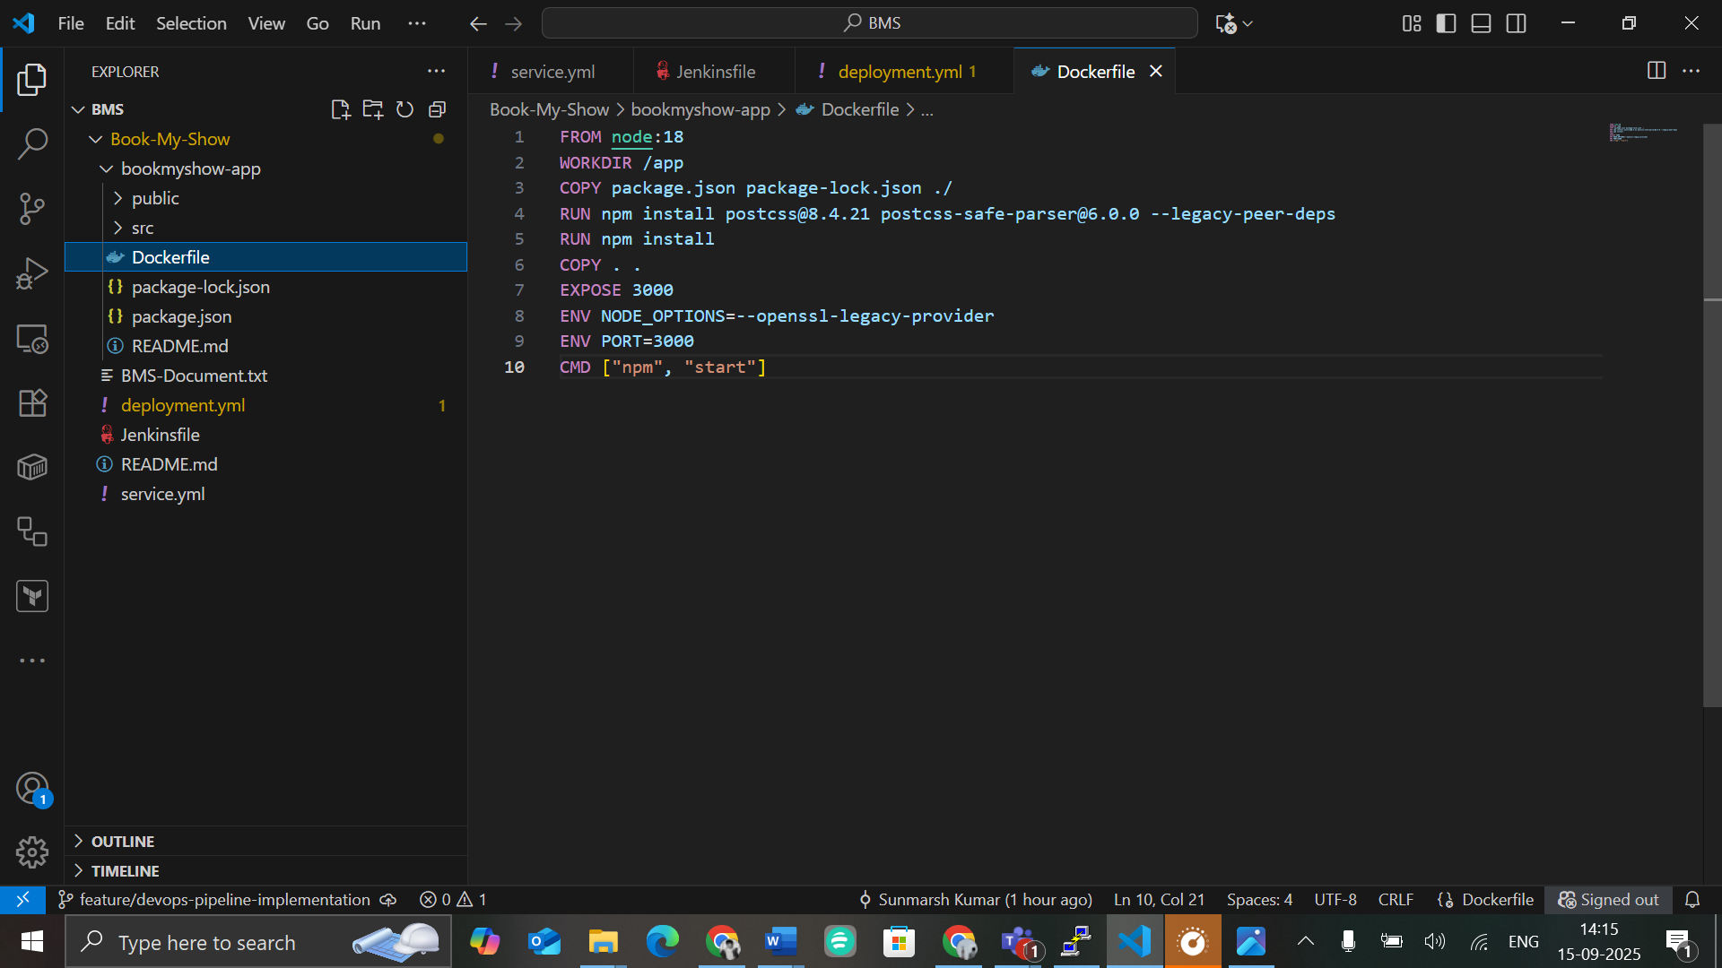
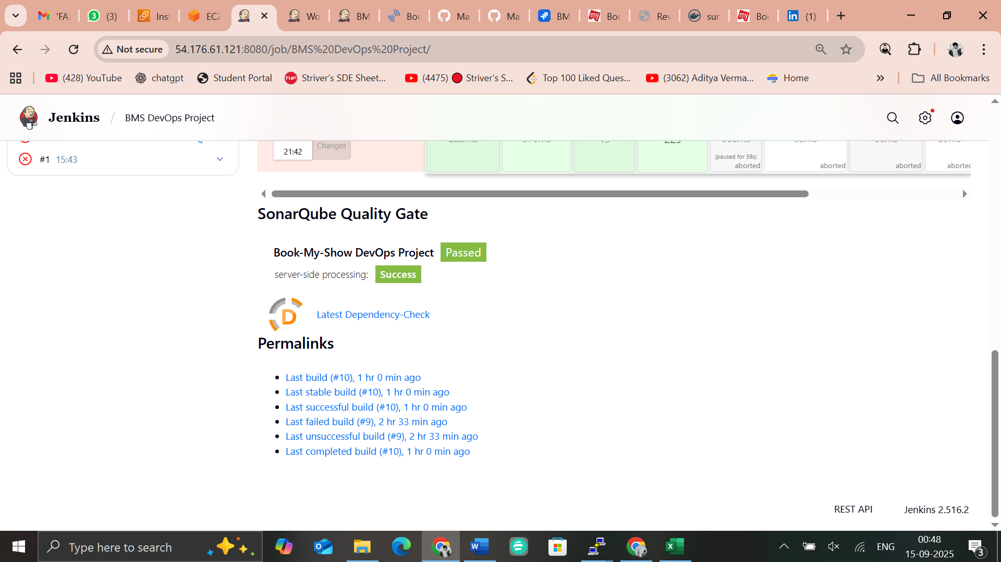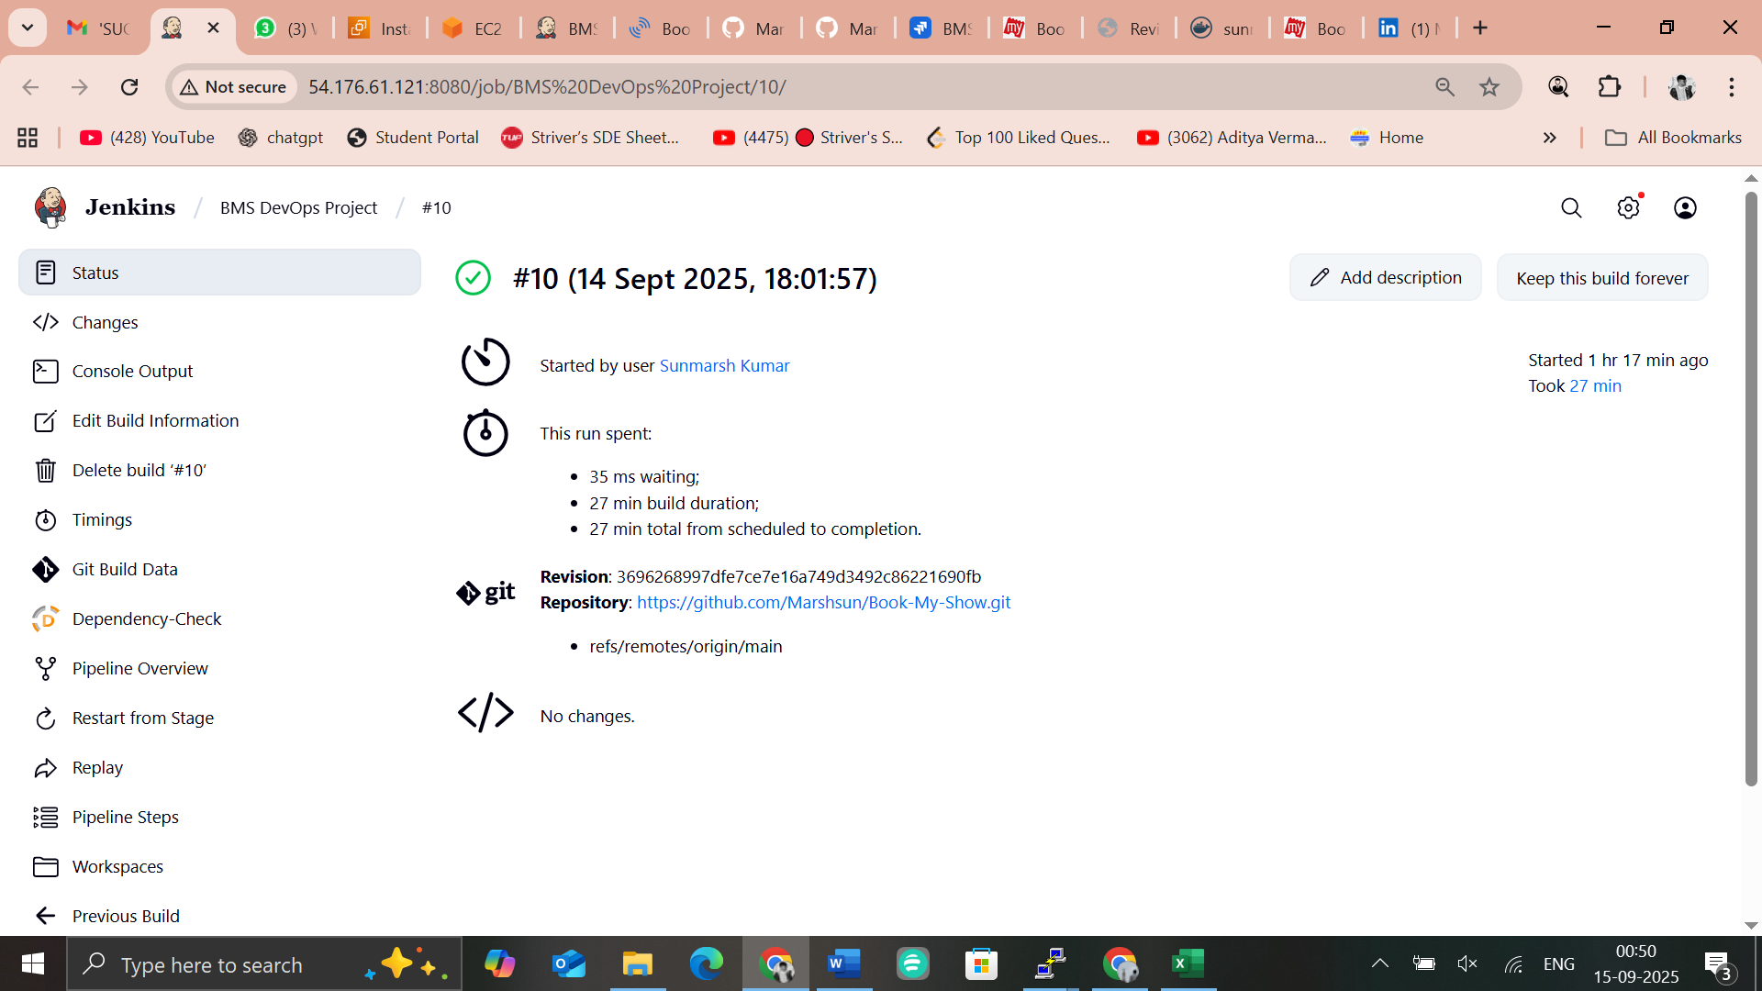

Image pushed to dockerhub
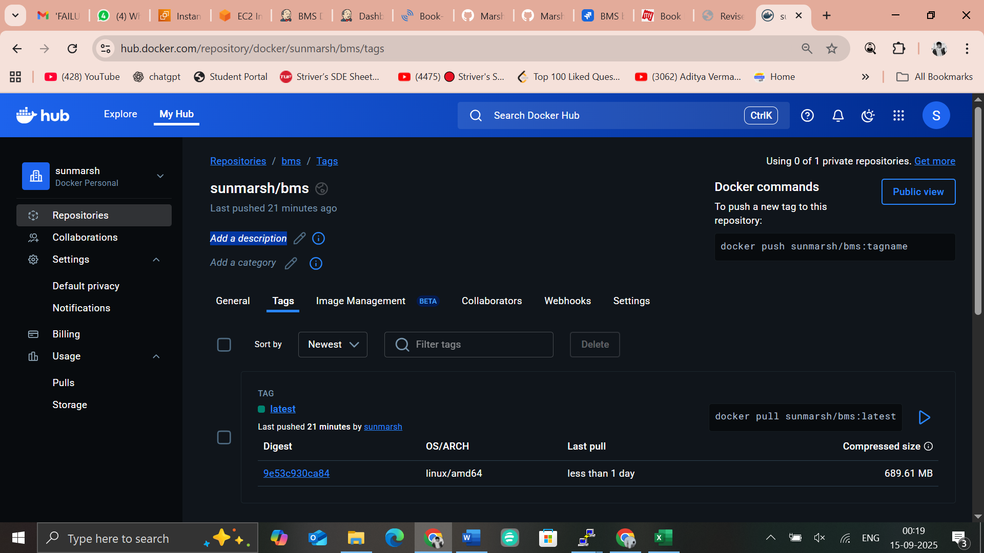

- Dockerhub repository link
- https://hub.docker.com/repository/docker/sunmarsh/bms/general
- Run container locally and validate accessibility


Step 5: Kubernetes Deployment EKS

Manifest Files:
- deployment.yml
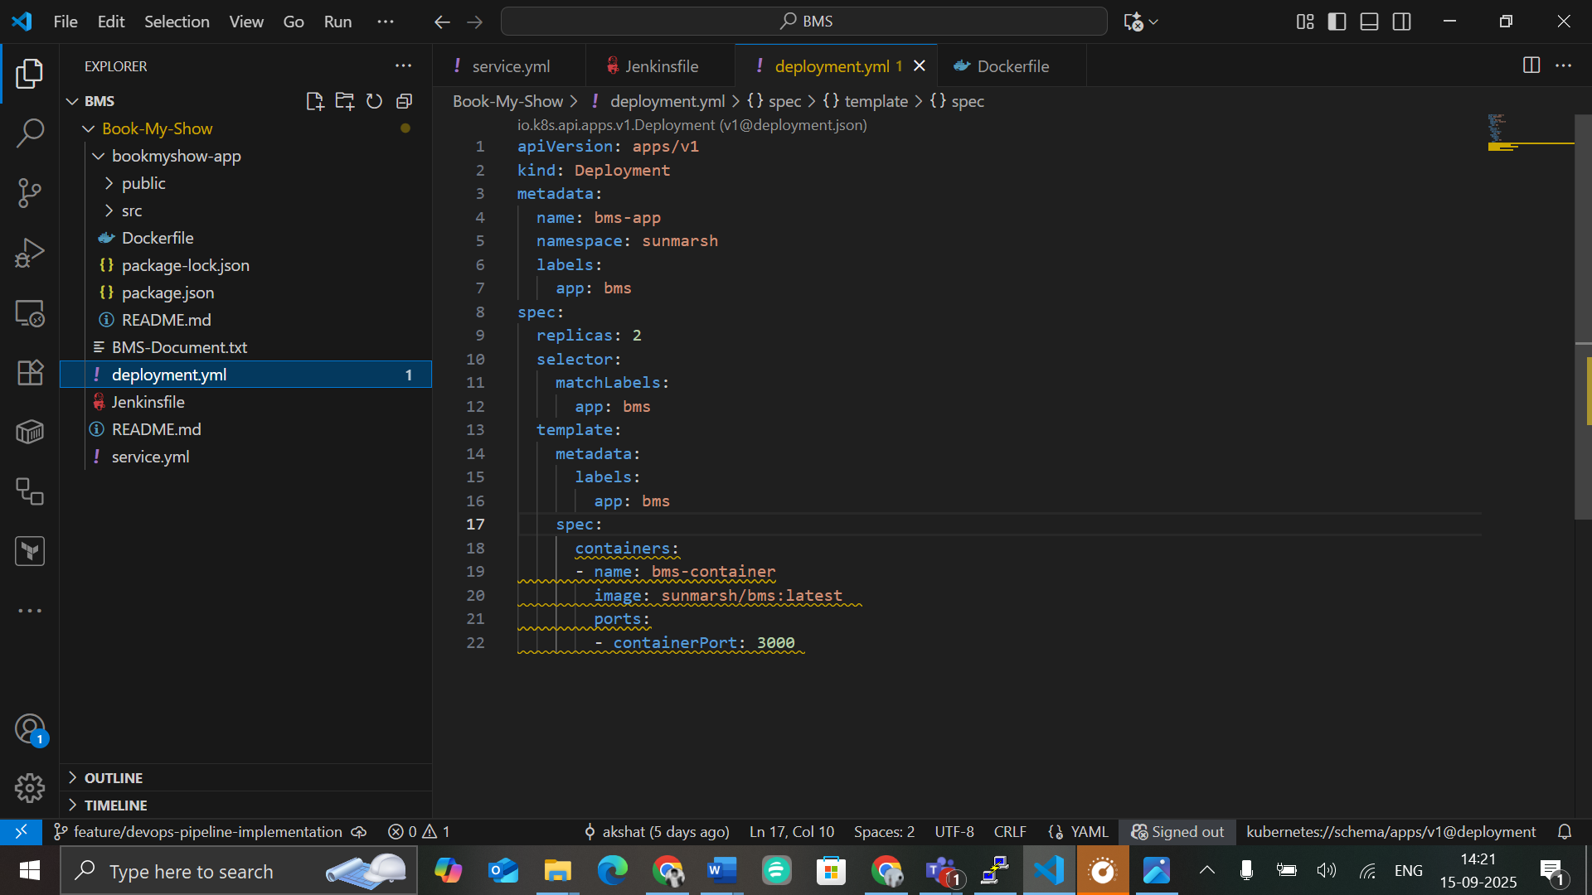

- Service.yaml
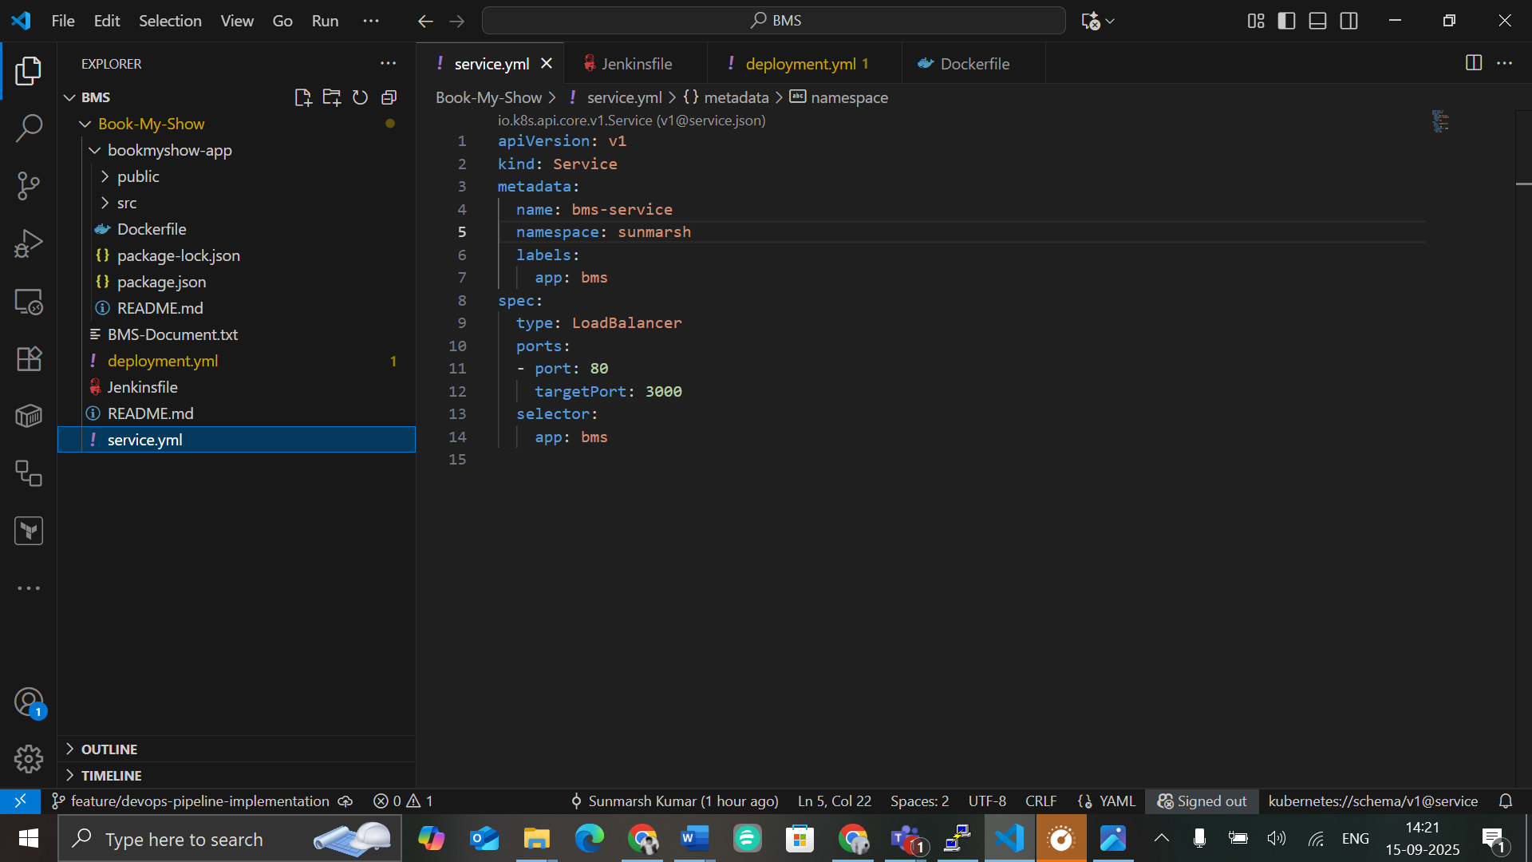


Step 6: Monitoring & Observability

- Launch an AWS EC2 Instance
- Install Prometheus, Grafana and Node Exporter on the server
- Add Jenkins Performance Dashboard
Install Jenkins Prometheus plugin on Jenkins server (if not already installed):
Go to Manage Jenkins → Plugins → Available → Search "Prometheus metrics" → Install
Enable metrics endpoint:
Go to Manage Jenkins → Configure System
Scroll to Prometheus section → Check Enable Prometheus metrics
Save
In Prometheus prometheus.yml, add:
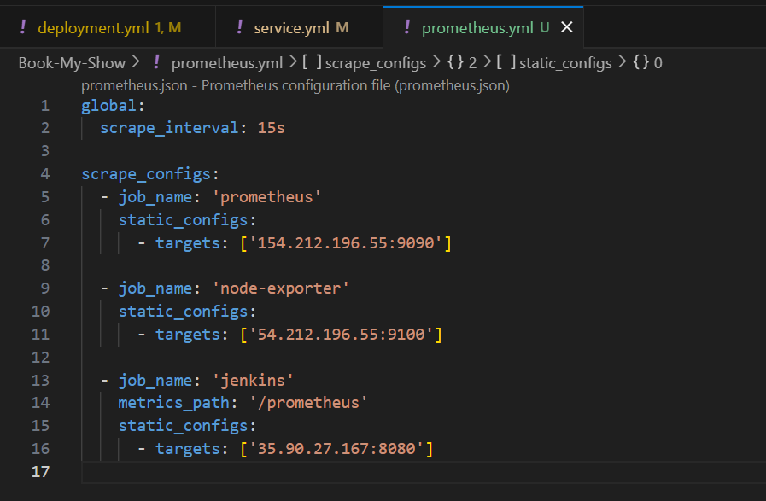

- Configure Grafana dashboards to visualize node health (CPU, memory, disk usage) and Jenkins performance metrics using Prometheus as a data source
- Open Prometheus UI:
http://18.236.253.59:9090
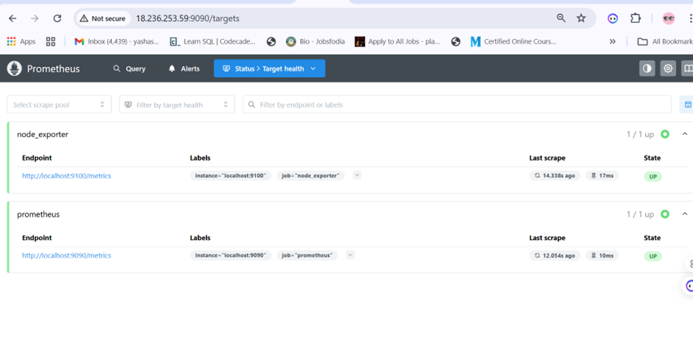
- Access Grafana UI → http://<server-ip>:3000
Default Login: admin / admin → Change password after first login.
Configure Prometheus as a Grafana Data Source
In Grafana:
Go to Connections → Data Sources → Add data source
Select Prometheus
URL → http://<prometheus-server>:9090
Click Save & Test

- Node Exporter metrics
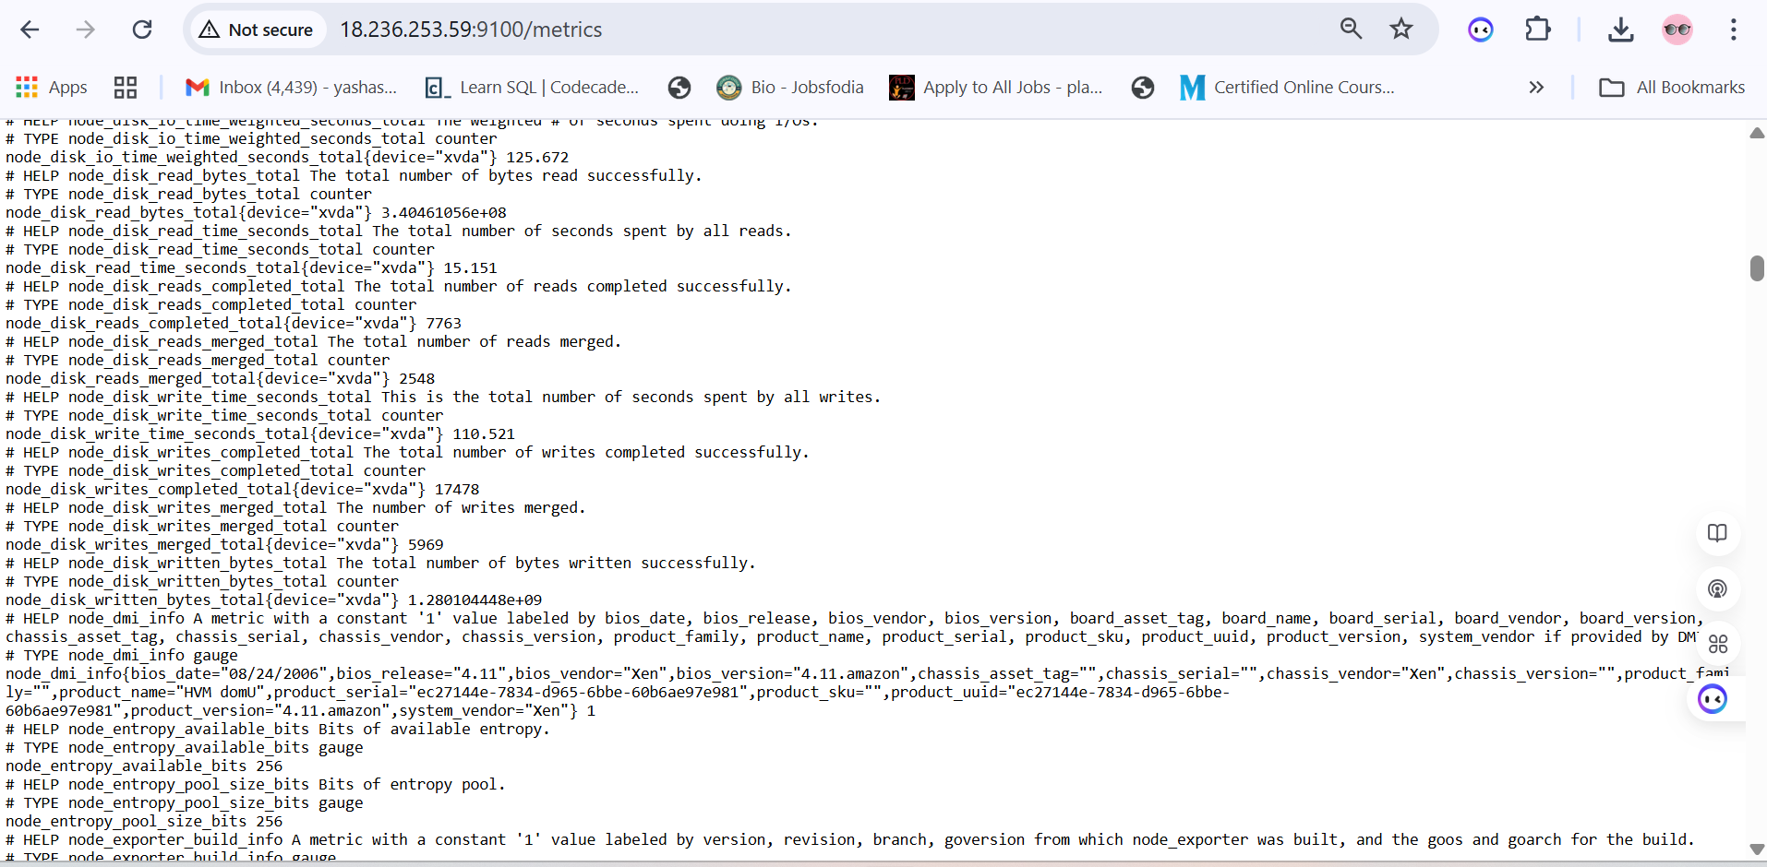
- Add Dashboards
Node Health Dashboard:
Import from Grafana’s dashboard library.
Recommended dashboard ID: 1860 (Node Exporter Full)
Grafana.com Dashboard

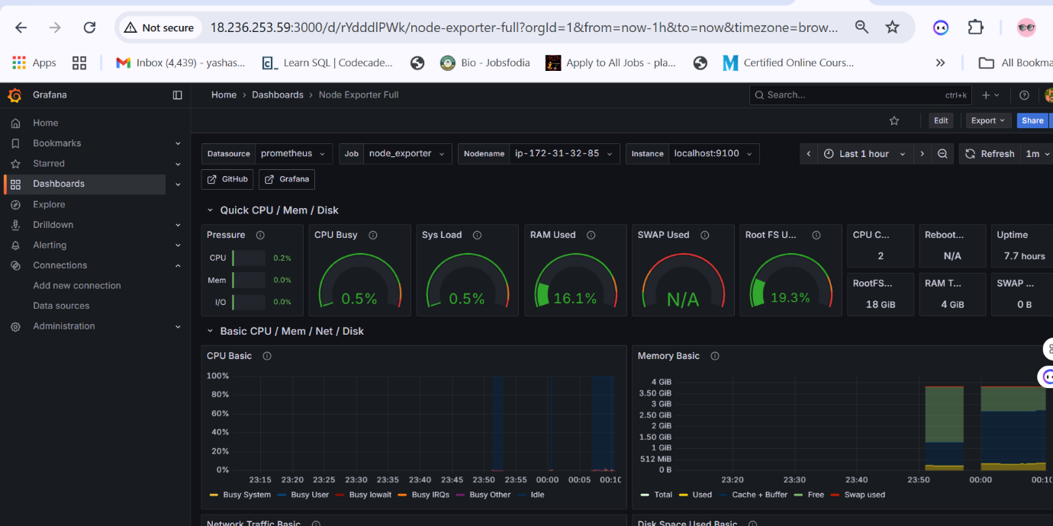
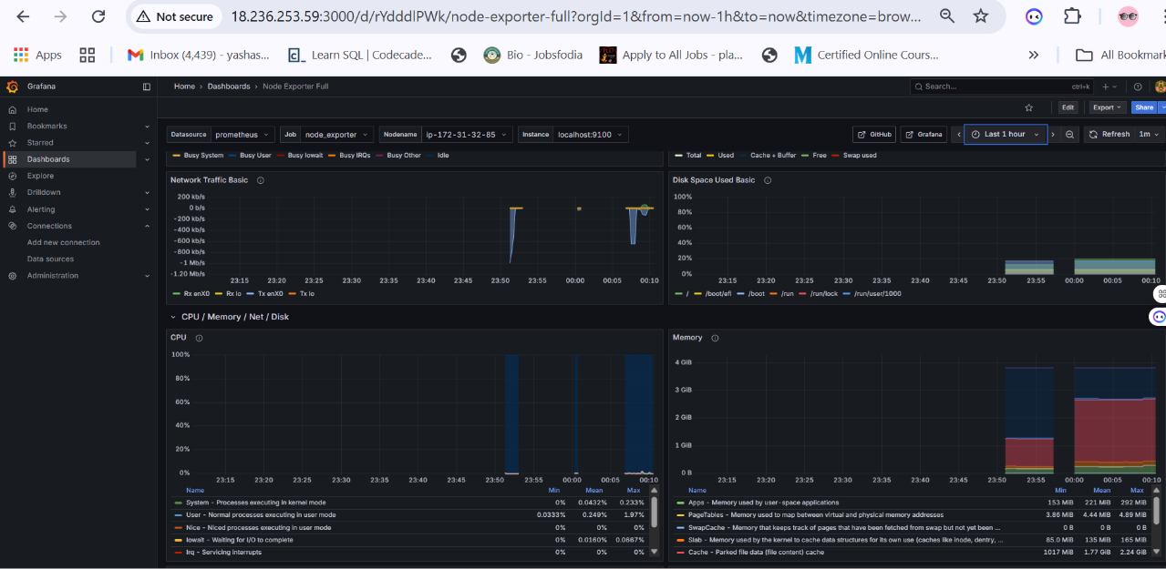
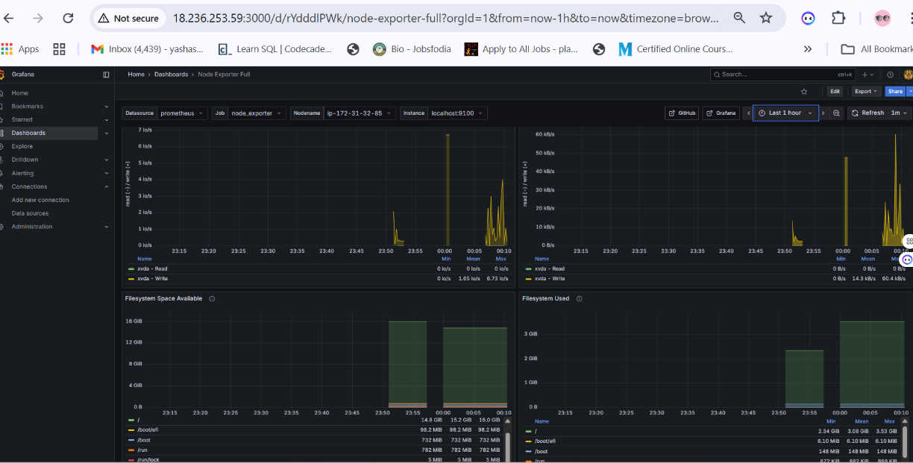

Jenkins Performance Dashboard:
Import dashboard ID: 9964 (Jenkins Prometheus Exporter Dashboard)
Click Import
